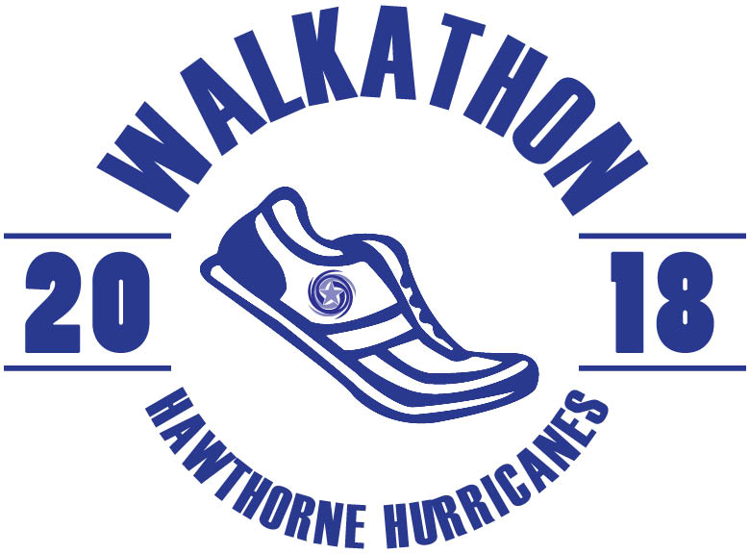
HAWTHORNE WALK-A-THON ON FRIDAY, OCTOBER 12. Don’t miss your chance to have your message on the 2018 Walk-A-Thon T-shirt. Don’t forget that the money raised from Walk-A-Thon allows the PTA to continue bridging the monetary gap of decreased funding to support things like technology in the classrooms, arts partnership program, funds for a new and improved playground and many, many more important things for our students. This year our fundraising goal is $40,000. We need YOUR help to reach our goal!
Family Sponsorship: $125
Every Hawthorne student, teacher and staff member receives a Hawthorne Walk-A-Thon 2018 T-shirt. Families can put their names or a message to their children on the back of the Walk-A-Thon 2018 T-shirt (limited to 35 characters)
Students Name: ___________________________________ Room Number: _____________
Parents Names: ______________________________________________________
Email: ____________________________
Check Enclosed: $_________ (Please make check payable to Hawthorne Scholastic Academy PTA or go to www.hawthorneacadpta.org and click DONATE)
What you would like printed on the T-Shirt (limited to 35 characters):
__ / __/ __/__ / __/ __ / __/ __/__ / __/ __ / __/ __/__ / __/ __ / __/ __/
__ / __/ __ / __/ __/__ / __/ __ / __/ __/__ / __/ __ / __/ __/__ / __/

ALL DONATIONS MUST BE RECEIVED BY FRIDAY, OCTOBER 12, 2018
If you have questions or need any additional information, please contact
Christine Lee (chrissoolee@yahoo.com)
Beth Lee (bethmlee@hotmail.com)

