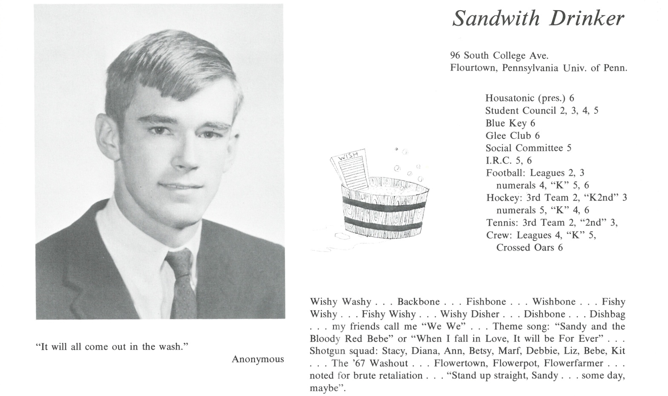

Sandwith Drinker

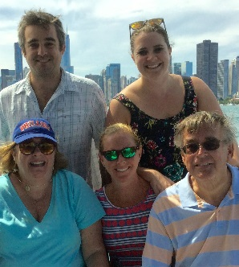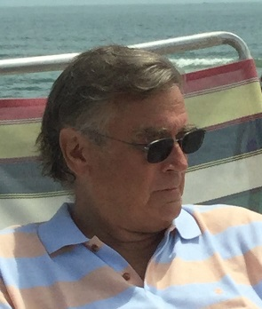With few exceptions, since my days at Kent, I have had an extremely happy personal life and productive professional life. I am now retired and I am searching for what the next chapter of my life might be. I am currently volunteering several days a week at Inglis House in Philadelphia which is a large residential facility for the physically disabled, all in wheelchairs. I am also eagerly anticipating my wife's retirement from IVF fertility nursing so that we can spend more time with our three children and five grandchildren at the Jersey Shore, Chicago and Charleston. We have high hopes for lots of travel and are debating where we may like to spend winters other than in Philadelphia. Without a doubt the greatest and most rewarding part of my life has been raising my children and enjoying my grandchildren. The following is a "pre-obituary” summary of my life up to now.

- I graduated from the University of Pennsylvania where I was a member of Phi

Gamma Delta fraternity along with Todd Seymour, Peter Farnum and

several other Kent grads. I lettered in hockey and I was also a member of the

Friars Senior Society and the Houston Hall Board.

- My first and only occupation has always been as a Realtor, a Broker

Associate, Appraiser, and owner of my own ten agent firm. Because of the

virtual collapse of the market, I sold out to a larger firm and spent the last ten years working for other brokerage firms.

* I continued to play senior club hockey at Wissahickon Skating Club for almost 20 years after my Kent life. After that I took up playing Platform Tennis, “paddle”, at both the club and regional levels. These activities have been curtailed somewhat by having 2 total hip replacements and 2 total knee replacements, however I still manage to get around pretty well, even though airport security has become quite a challenge. I also continue to be a most unsuccessful surf fisherman although I love pretending that I am a fabulous angler.
* My wife Rie and I will celebrate our 45th wedding anniversary this summer, being outdone only by Philadelphia friends Peter and Linda Farnum!

I loved almost all my time at Kent except for the unnecessary and unpleasant culture of upper class bullying of the younger "Rabble". I am glad that this tradition has apparently ended and the students can enjoy the school for its beauty as well as its opportunity for friendship and the remarkable education it offers.

I remember with fondness our classmates who are no longer with us. I miss them all!



______________________________________________________________

______________________________________________________________ ______________________________________________________________ ______________________________________________________________ ______________________________________________________________ ______________________________________________________________ ______________________________________________________________ ______________________________________________________________ ______________________________________________________________

Attach Picture in .jpg Format

______________________________________________________________

______________________________________________________________

___________________________________________________________________________________ _________________________________________________________________________________________________________________________________________________________________________________________________________________________________________________________________________________________________________________________________________________________________________________________________________________________________________________________________________________________________________________________________________________________________________________________________________________________________________________________________________________________________________________________________________________________________________________________________________________________________________________________________________________________________________________________________________________________________________________________________________________________________________________________________________________________________________________________________________________________________________________________________________________________________________________________________________________________________________________________________________________________________________________________________________________________________________________________________________________________________________________________________________________________________________________________________________________________________________

___________________________________________________________________________________