These numbers are to help you in selecting a cam.
You will notice as duration is increased the Torque below 3500rpm decreases.
Peek torque remains close, but climbs from 3500 to 5000rpm
Peek Horse power increases 80bhp moving from 5500rpm to 6300rpm (likely closer to 6600 in the real world)
SBC 420cid 10.5:1 / Intake Duration @ .050" Lobe Sep 108 degrees
224 230 236 242 248
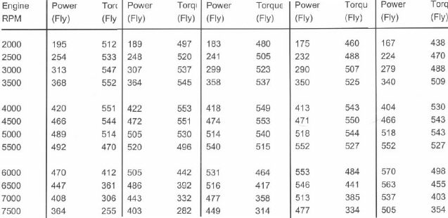
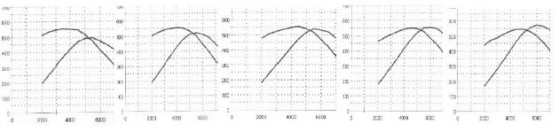
___________________________________________________________________________

This motor is a SBC 420cid 11.5:1 242/248 0.0645" Lift Lobe Sep 106 degrees.
Compared to the 242 cam above the short lobe Sep Angle increases throttle response, but can cost some TQ with a small bhp increase.
The increased compression was worth 18 TQ and 22bhp.
In the real world peek BHP is typically reached at a higher RPM,
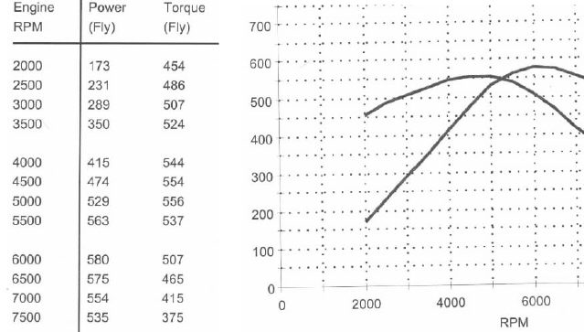
______________________________________________________________________________
Real World Test SBC 420cid 11:1 / 248/254 - 0.620" Lift - Lobe Sep Angle 108
SAE BHP
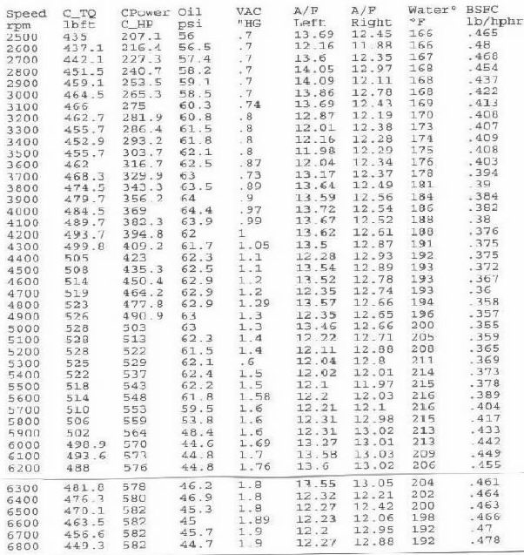
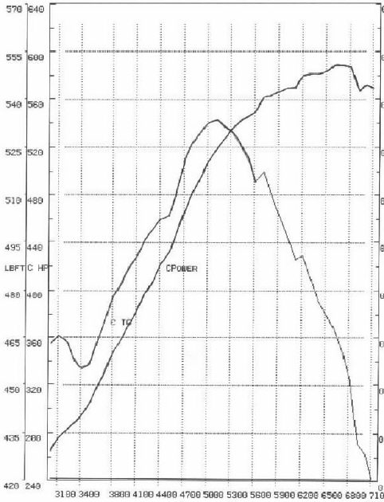
_________________________________________________________________________________
SuperFlow BHP
