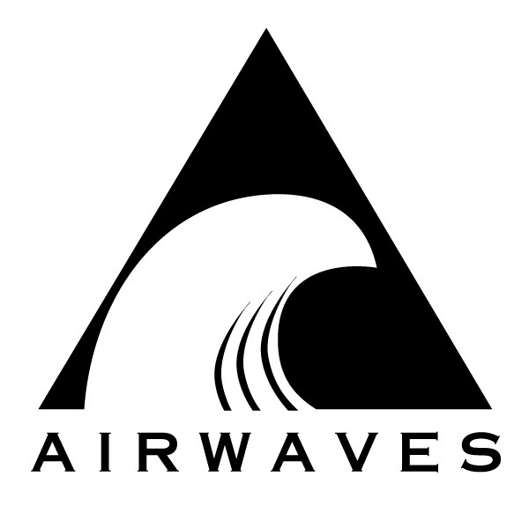
AIRWAVES CELLULAR
13400 Riverside Drive; Suite 103
Sherman Oaks, CA 91423
(818) 501-8200 FAX (818) 528-7686
credit@airwaveswireless.com

To: Airwaves Inc. Date:
Fax Number: 818-528-7686

CREDIT CARD AUTHORIZATION FORM

STATEMENT OF UNDERSTANDING

I, hereby authorize Airwaves Cellular to charge my credit card account for Airwaves Cellular security deposits, equipment rentals, and telephone services (I understand that airtime charges may be billed up to one hundred twenty days after the completion of actual equipment rentals).

Signature of Card Member Date

Name on Card

Cardholder’s
Billing Address*

Billing Phone

Type of Card Expiration Date

Credit Card Number

Security / Verification Code

*Please be sure the address you provide matches the address you have on your
credit card account.

Please e-mail back with a copy of cardholder’s credit card
(both front and back) and drivers license. See above

