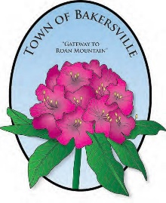
2021 CALENDAR OF EVENTS

NORTH CAROLINA RHODODENDRON FESTIVAL
FRIDAY & SATURDAY, JUNE 18-19

FOURTH OF JULY FIREWORKS
FRIDAY, JULY 2

TOWNWIDE YARDSALE
SATURDAY, JULY 3

NORTH CAROLINA MOUNTAINEER FESTIVAL
SATURDAY, SEPTEMBER 18

APPLE BUTTER FESTIVAL
SATURDAY, OCTOBER 9

HALLOWEEN SAFE CIRCLE
SATURDAY, OCT , 5:30PM-7:30PM

CHRISTMAS TREE LIGHTING
SATURDAY, NOVEMBER 27, 6PM

CHRISTMAS CONCERT
SATURDAY, NOVEMBER 27, 6:30PM

CHRISTMAS PARADE
SATURDAY, DECEMBER 4, 6PM

JOURNEY TO THE MANGER
FRIDAY & SATURDAY, DECEMBER 10 & 11

