


For membership information: Call Gyle Swentik (218) 780-8993 or print application off of the township website at www.townofwhit.com under East Range Sportsmens & Conservation Club and mail to P.O. Box 436, Hoyt Lakes, MN 55750
We are a non-profit organization (501c3) that opened our doors in 2010. Our facility was a joint project between the Town of White and the Club. The facility is owned by the Town of White and the Club maintains and runs it at no cost to taxpayers. The goal of the Club is continuing to grow and provide a safe and effective recreational shooting facility for all ages.
Membership fees vary for youth to adult and may contact us for cost.
Monthly Club meetings are every third Monday of the month. The time and location are listed on the club emails along with the Club Facebook page.
Membership form, liability forms, range rules, and bylaws can be found and printed from townofwhite.com under the Club listing on the home page. We send out emails with club updates and events to keep everyone informed.
For more information or questions, you may contact us at the following:
Facebook: @eastrangesportsmans
Email: gomer8993@gmail.com
Phone: 218-780-8993

East Range

Sportsmen’s

& Conservation Club
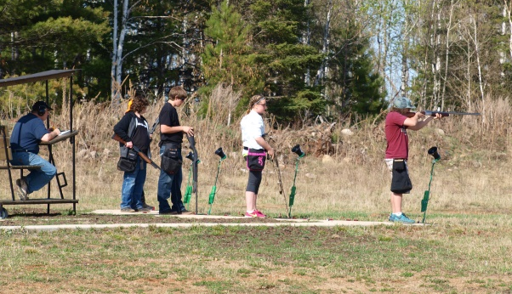


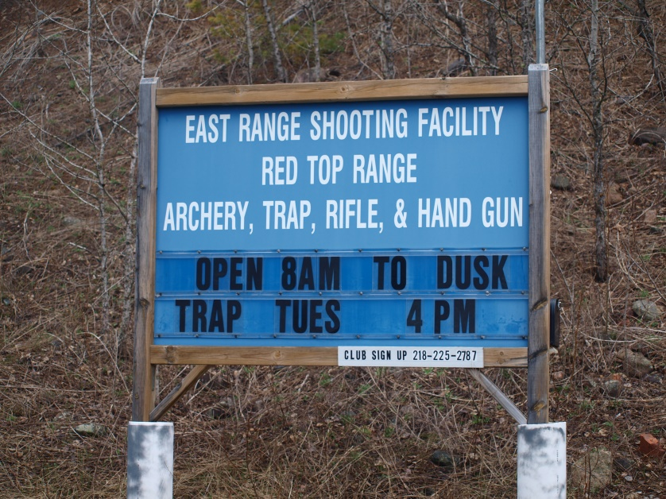
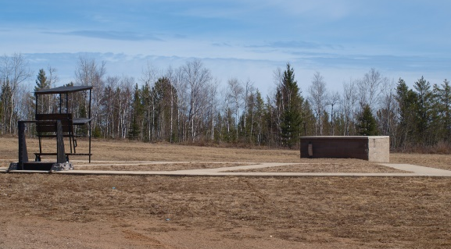

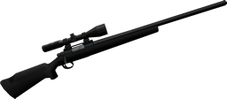
5610 Forestry Road, Aurora
P.O. Box 436, Hoyt Lakes, MN 55750
TRAP RANGE

Youth Trap Shooting starts in early April
Adult Trap Shooting starts mid-April thru September
3 Trap fields: Singles, Wobble, & Doubles

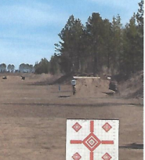
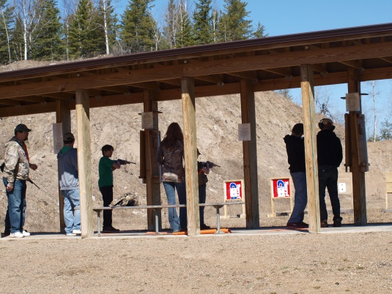
Clubhouse
Monthly Club meeting
(3rd Monday of each month)
Permit to Carry Classes
Youth Safety Classes
Youth Hunting Classes
Local, County, and
State Law Enforcement
Local Social Events


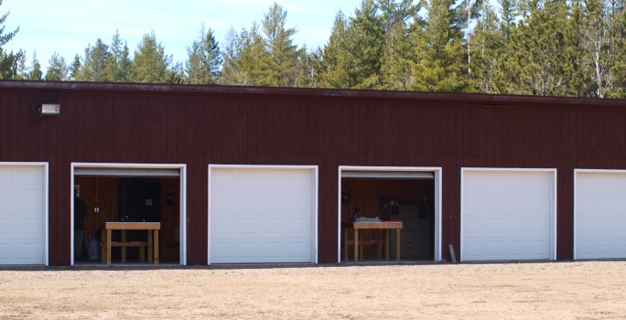
Pistols
Pistol target practice
Permit to Carry classes
Law enforcement qualifications
Small bore and pistol to 50 yards



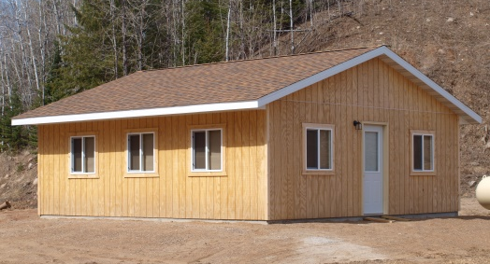

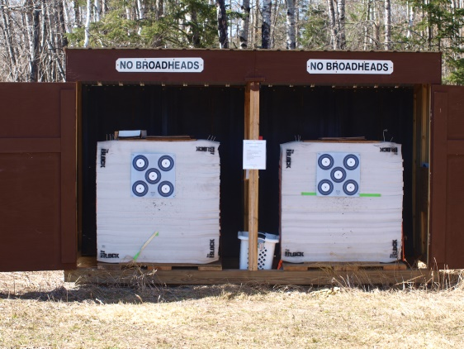
RIFLE RANGE
Rifle and shotgun target
practice
Firearms Safety Classes
for youth
Sight-in Days
(prior to deer opener)
8 enclosed shooting
stations
Rifle shooting to 600 yards

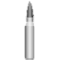
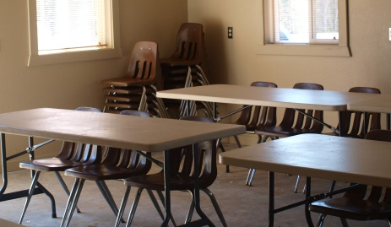

archery
Archery target practice
Archery stations 10-100 yards

Clubhouse is available to rent for Members or for Community Events for $25.00.
Call the Town of White Office at
(218)229-2813 to make reservations and pick up key.
5-6’ tables, 30 chairs, heat and electricity

