C:\Users\White1\AppData\Local\Microsoft\Windows\INetCache\IE\DW8V0XUB\urwald-Zielscheibe-target-aim[1].pngC:\Users\White1\AppData\Local\Microsoft\Windows\INetCache\IE\DW8V0XUB\urwald-Zielscheibe-target-aim[1].pngC:\Users\White1\AppData\Local\Microsoft\Windows\INetCache\IE\DW8V0XUB\urwald-Zielscheibe-target-aim[1].pngC:\Users\White1\AppData\Local\Microsoft\Windows\INetCache\IE\DW8V0XUB\urwald-Zielscheibe-target-aim[1].png

**For membership information: Call Gyle Swentik (218) 780-8993 or print application off of the township website at** [**www.townofwhit.com**](http://www.townofwhit.com) **under East Range Sportsmens & Conservation Club and mail to P.O. Box 436, Hoyt Lakes, MN 55750**

We are a non-profit organization (501c3) that opened our doors in 2010. Our facility was a joint project between the Town of White and the Club. The facility is owned by the Town of White and the Club maintains and runs it at no cost to taxpayers. The goal of the Club is continuing to grow and provide a safe and effective recreational shooting facility for all ages.

Membership fees vary for youth to adult and may contact us for cost.

Monthly Club meetings are every third Monday of the month. The time and location are listed on the club emails along with the Club Facebook page.

Membership form, liability forms, range rules, and bylaws can be found and printed from townofwhite.com under the Club listing on the home page. We send out emails with club updates and events to keep everyone informed.

For more information or questions, you may contact us at the following:   
Facebook: @eastrangesportsmans  
Email: [gomer8993@gmail.com](mailto:gomer8993@gmail.com)  
Phone: 218-780-8993

East Range

Sportsmen’s

& Conservation Club

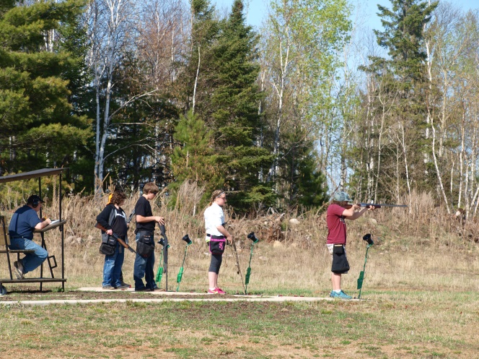

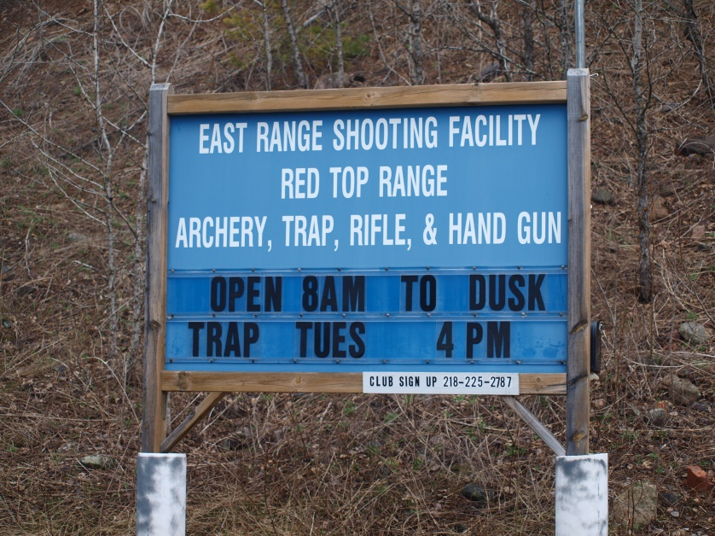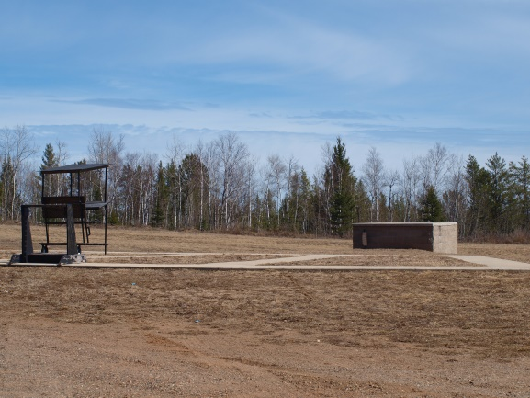Image result for shotgun shell clipartImage result for shotgun shell clipartImage result for shotgun shell clipart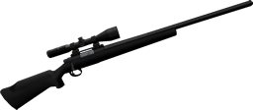

5610 Forestry Road, Aurora

P.O. Box 436, Hoyt Lakes, MN 55750

TRAP RANGE

Youth Trap Shooting starts in early April

Adult Trap Shooting starts mid-April thru September

3 Trap fields: Singles, Wobble, & Doubles

C:\Users\White1\AppData\Local\Microsoft\Windows\INetCache\IE\DW8V0XUB\urwald-Zielscheibe-target-aim[1].pngC:\Users\White1\AppData\Local\Microsoft\Windows\INetCache\IE\DW8V0XUB\urwald-Zielscheibe-target-aim[1].pngC:\Users\White1\AppData\Local\Microsoft\Windows\INetCache\IE\DW8V0XUB\urwald-Zielscheibe-target-aim[1].pngC:\Users\White1\AppData\Local\Microsoft\Windows\INetCache\IE\DW8V0XUB\urwald-Zielscheibe-target-aim[1].pngC:\Users\White1\AppData\Local\Microsoft\Windows\INetCache\IE\DW8V0XUB\urwald-Zielscheibe-target-aim[1].pngC:\Users\White1\AppData\Local\Microsoft\Windows\INetCache\IE\DW8V0XUB\urwald-Zielscheibe-target-aim[1].png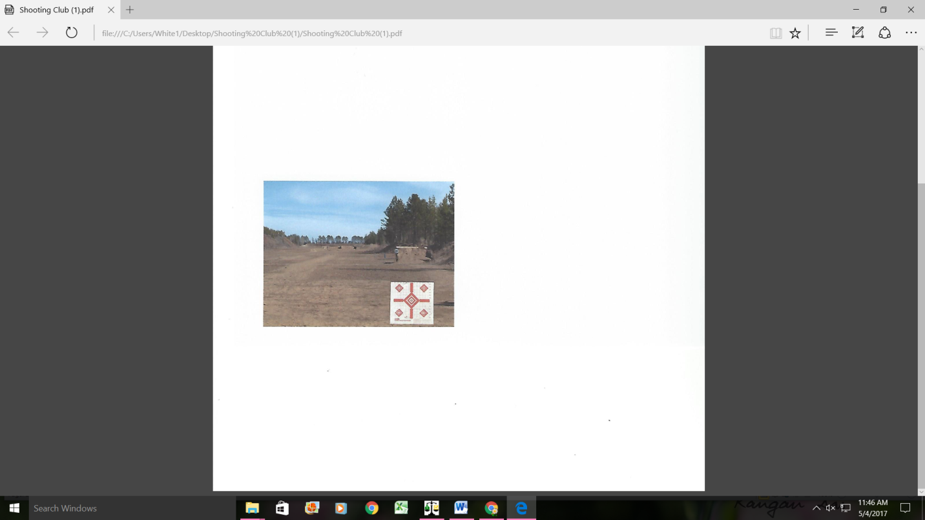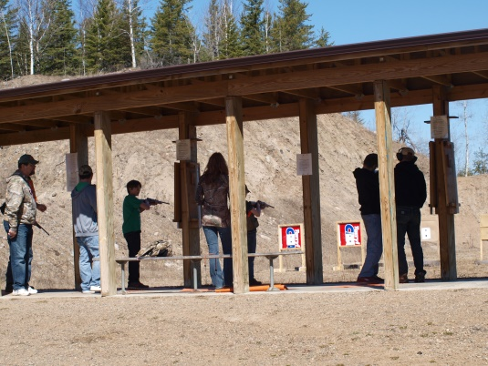

Clubhouse

Monthly Club meeting

(3rd Monday of each month)

Permit to Carry Classes

Youth Safety Classes

Youth Hunting Classes

Local, County, and

State Law Enforcement

Local Social Events

C:\Users\White1\AppData\Local\Microsoft\Windows\INetCache\IE\3HCNY4RC\tikigiki-pencil-office-001[1].png

C:\Users\White1\AppData\Local\Microsoft\Windows\INetCache\IE\3HCNY4RC\tikigiki-pencil-office-001[1].png

C:\Users\White1\AppData\Local\Microsoft\Windows\INetCache\IE\3HCNY4RC\tikigiki-pencil-office-001[1].png

C:\Users\White1\AppData\Local\Microsoft\Windows\INetCache\IE\3HCNY4RC\tikigiki-pencil-office-001[1].png

C:\Users\White1\AppData\Local\Microsoft\Windows\INetCache\IE\3HCNY4RC\tikigiki-pencil-office-001[1].png

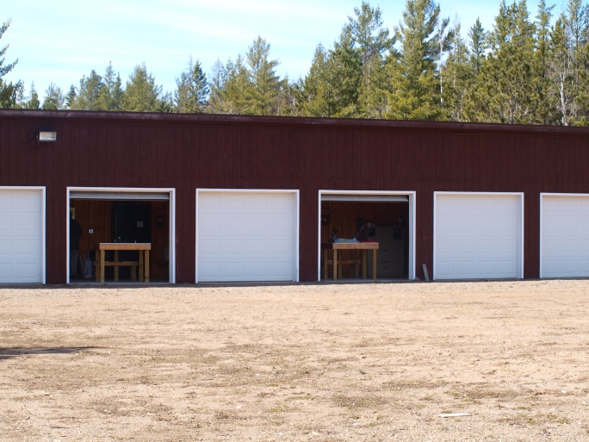

Pistols

Pistol target practice

Permit to Carry classes

Law enforcement qualifications

Small bore and pistol to 50 yards

C:\Users\White1\AppData\Local\Microsoft\Windows\INetCache\IE\3HCNY4RC\tikigiki-pencil-office-001[1].png



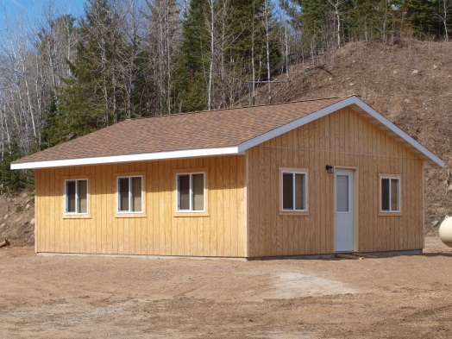



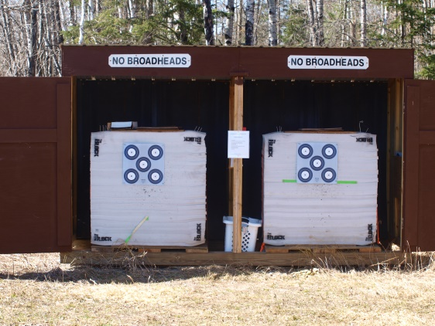

RIFLE RANGE

Rifle and shotgun target

practice

Firearms Safety Classes

for youth

Sight-in Days

(prior to deer opener)

8 enclosed shooting

stations

Rifle shooting to 600 yards

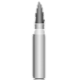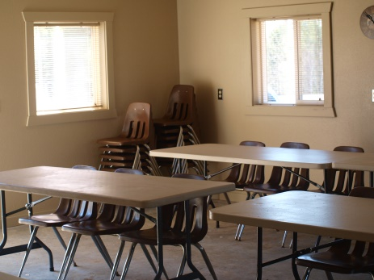

C:\Users\White1\AppData\Local\Microsoft\Windows\INetCache\IE\JGABVI8R\arrow-151103_960_720[1].pngC:\Users\White1\AppData\Local\Microsoft\Windows\INetCache\IE\JGABVI8R\arrow-151103_960_720[1].png

archery

Archery target practice

Archery stations 10-100 yards

Clubhouse is available to rent for Members or for Community Events for $25.00.

Call the Town of White Office at

(218)229-2813 to make reservations and pick up key.

5-6’ tables, 30 chairs, heat and electricity