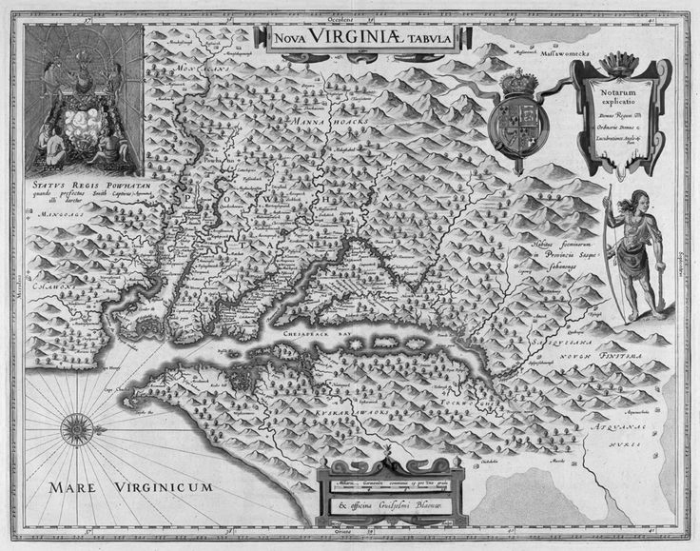East Central American Society for Eighteenth Century Studies 2025 Conference
Washington College, Chestertown, MD
October 9-11, 2025

We acknowledge that the lands and waters that are now known as Chestertown were the home of the Tockwogh peoples, who were historically erased from this landscape. We acknowledge histories of cultural assimilation, land theft, and genocide that caused their decease and erasure. We acknowledge their long-standing kinship with these lands and waters and that we are uninvited visitors on Indigenous lands. We acknowledge the degradation that continues to be wrought on the land and waters in pursuit of resources. We acknowledge the right of the land and waterways to heal so that they can continue to provide food and medicine for all. We acknowledge that it is our collective obligation to pursue policies and practices that respect the land and waters so that our reciprocal relationship with them can be fully restored. The organizers of this conference also acknowledge the place today known as Kent County exists as the result of duress. In 1652, Susquehannock leaders unwillingly transferred these lands to the English in an unsuccessful effort to stop English settlers encroaching up the Susquehanna River. We acknowledge that these places and their Indigenous inhabitants exist without rigid political borders and boundaries maintained by settlers and settler governments. We acknowledge the social, physical, spiritual, and kinship relationships this land continues to share with Indigenous nations of the Susquehanna River and Chesapeake Bay. We acknowledge the continuing presence of Indigenous nations, and the shelter and nourishment that this place continues to provide to all Native peoples who live here today. We acknowledge our responsibility to Indigenous nations to repair unhealthy relationships and to steward all life.

We invite you to learn more about historically erased tribes in MSAC.org and elsewhere, and to consider donating or making institutional resources available to the tribal peoples who still live in relationship with their traditional lands in the place now known as Maryland, as well as to reconsider in what ways you can improve your relationship with the lands and the waterways you steward.

Welcome to Washington College, to Kent County, and to the Chester River.

We are thrilled to host the ECASECS 2025 Conference in the first college chartered after the American Independence, the second royal port of entry in the Chesapeake Bay in the eighteenth-century, and one of the major water tributaries of the Chesapeake Bay in the Delmarva peninsula. We express our gratitude to the people and institutions who made this event possible: the Maryland 250 Commission Grant; the Starr Center for the American Experience; the Center for Environment and Society, the Departments of World Languages and Cultures and English; the William James Forum Fund, and Washington College.

We are thankful for your presence, and we wish you a stimulating and pleasant conference.

Organizers: Elena Deanda-Camacho (Professor of Spanish and Black Studies), Victoria Barnett-Woods (Associate Director of Experiential Learning at the Starr Center for the American Experience), Karen Manna (Assistant Professor of French), and Katherine Charles (Associate Professor of English).

ECASECS 2025 Exhibitors
Clemson University Press Lehigh University Press
University of Delaware Press
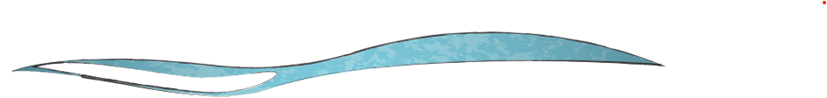
THURSDAY October 9, 2025

7:30 to 9:00 PM
Registration
Lobby at the Center for Environment and Society at Washington College
485 S Cross St, Chestertown, MD 21620

7:30 to 9:00 PM
Oral/Aural Experience led by Peter Staffel
Lobby at the Center for Environment and Society at Washington College
485 S Cross St, Chestertown, MD 21620

FRIDAY October 10, 2025

8:00 AM – 5:00 PM
REGISTRATION at Washington College Toll Science Center Atrium
ECASECS Book Exhibitors 200 West Campus Avenue, Chestertown, MD
8:30 AM – 9:20 AM
Panel 1.A Frances Burney at the Shore Goldstein Hall 207
Chair: Susan Howard, Duquesne Univ.
- Susan Wood, Midland Univ., “Frances Burney's The Wanderer and William Shakespeare's Pericles, Prince ot Tyre: Oceanic Odysseys of Virtue.”
- Hilary N. Fezzey, U of Wisconsin, Superior, “The Fluidity of Disability in Burney’s Camilla.”
- Susan Howard, Duquesne Univ., “Frances Burney and Mary Delany at the Court of King George III and Queen Charlotte: the Ebb and Flow of an Almost Literary Relationship.”

Panel 1.B. The Ebbs and Flows of Emotion Goldstein Hall 208
Chair: Courtney Rydel, Washington College.
- Karen Manna, Washington College, “Stage and Frame: Madame de Pompadour's Le Méchant in Versailles’ Théâtre des Petits Cabinets.”
- Mehl Penrose, Univ. of Maryland College Park, “Rococo Masculinities: ‘Serious Poems,’ and Egloga IV by José Iglesias de la Casa.”
- Courtney Rydel, Washington College, “American Girls: Desire and Colonization in the Framing Tale of La Belle et la Bête.”

9:30-10:20
Inaugural Panel Litrenta Hall at Toll Science Center
The Maryland 250 Commission
Welcome Remarks and Introductions: Elena Deanda, Victoria Barnett-Woods, and Darius Johnson, Washington College.

Coffee Break 10:20 AM
Toll Science Center Atrium

10:30 AM – 11:40 AM
Panel 2.A Women at Contact Zones Goldstein Hall 207
Chair: Fari Cannon, Howard Univ.
- Cathy Jaffe, Texas State Univ., “Philadelphia as Contact Zone for Works on Female Education: A Transatlantic Flow.”
- Unita Ahdifard, Univ. of California at Santa Barbara, “Grand Tours and Great Escapes: Captivity, Leisure, and Orientalism in the Travel Narratives of Elizabeth Marsh.”
- Margaret Musgrove, Univ. of Central Oklahoma, “Widowed Mothers from Ancient Rome in the Paintings of Angelica Kauffman.”
- Fari Cannon, Howard Univ., “Generative Possibilities and Identity Formations in Maryse Condé’s I, Tituba: The Black Witch of Salem.”

Panel 2.B Economy, Ecology, Irony Goldstein Hall 208
Chair: David M. Palumbo, Emmanuel College.
- David M. Palumbo, Emmanuel College, “The Satiric Vision of Esther Vanhomrigh.”
- Gene Hammond, SUNY Stonybrook, “Swift's Two Esthers.”
- Eugene Heath, SUNY New Paltz, “Self-Love in the Wealth of Nations.”
- Daniel H. Ferris, Miles Community College, “The Rambler and the Rebel: The Deistic Transformation of Alexander Wilson.”

11:40-12:30
Panel 3.A. Japan and the Sea Goldstein Hall 207
Chair: Susan Spencer, Univ. of Central Oklahoma.
- Yoshitaka Yamamoto, Yale Univ., “Emulation across the Seas: Imitation in Eighteenth-Century Japanese Poetry.”
- Susan Spencer, Univ. of Central Oklahoma, “The Waves Beneath “The Wave”: Currents of Transmission in Japanese Print Culture.”
- Christopher Hepburn, Univ. of Southern California, ““Waga Mi Sate” (And so, as it were): Sounding Grief and Constructing the Self at Water’s Edge.”

Panel 3.B Diving into History: A MD 250 Roundtable Goldstein Hall 208
Chair: Victoria Barnett-Woods, Washington College
- Sophia Clark, Washington College.
- Emily Stiles, Washington College.
- Caelan Scott, Washington College.
- Tristan Gage, Washington College.
- Jade Lee, Washington College.

Lunch Break. 12:30 PM – 2:30 PM
We have a reserved table at Bad Alfred’s (11-15 min. walking), but other options are available. Please refer to the restaurant recommendations in your package.

2:30 PM – 3:20 PM
Keynote Address Litrenta Hall at Toll Science Center
Paola Bertucci, Yale University
“Navigating Origin Stories: 18th-Century Invention Narratives and the Compass.”
Introduction: Elena Deanda, Washington College.

Coffee Break 3:20 PM
Toll Science Center Atrium

3:30 AM – 4:40 PM
Panel 4.A Homage to Cathy Jaffe Goldstein Hall 207
Chair: Karen Manna, Washington College.
- Betsy Lewis, Univ. of Mary Washington, “The Real Housewives of Madrid: The Social Lives of the Ladies of the Junta de Damas 1787-1808.”
- Elena Deanda, Washington College, “Female Lineages and the Jaffe’s Factor.”
- Reva Wolf, SUNY New Paltz, “Goya's Captions: Translating across Disciplines and Cultures.”
- Karen Stolley, Emory Univ., “The Black Legend of Spain and its Atlantic Empire in the Eighteenth Century: Further Reflections.”

Panel 4.B Immersion at Kiplin Hall Roundtable Goldstein Hall 208
Chair: Victoria Barnett-Woods, Washington College.
- Julianna Nelson-Gaudette, Washington College.
- Evelyn Lucado, Washington College.
- Sydney Walker, Washington College.
- Karlis Povilis, Washington College.
- Ella Kozlowski, Washington College.
- Siobhan Luckey, Washington College.

6:30 PM – 7:00 PM
Starr Center for the American Experience Custom House Tour
101 S Water St., Chestertown, MD

7:00 – 9:00 PM
ECASECS Cash Bar
The Kitchen at the Imperial
208 High Street, Chestertown, MD

SATURDAY October 11, 2025

8:00 AM – 5:00 PM
REGISTRATION at Washington College Toll Science Center Atrium
ECASECS Book Exhibitors

8:30-9:20 AM
Panel 5.A The Currents of Poetics Goldstein Hall 207
Chair: Victoria Barnett-Woods, Washington College.
- Michael Paul Berlin, Washington and Lee University “ “As in a palsied Druid’s harp unstrung”: Disabling Rhyme in the Late Poetry of John Keats.”
- Richard Gillin, Washington College, “John Clare and Ekphrasis.”

Panel 5.B. Book History, Bibliography, and Textual Studies I Goldstein Hall 208
Chair: Eleanor F. Shevlin, West Chester Univ.
- Leah M. Thomas, Virginia State Univ., “The Countess of Huntingdon and Transatlantic Black Print.”
- Eleanor F. Shevlin, West Chester Univ., “James Harrison’s Paternoster Row Bookshop and the Retail Trade.”
- Nancy Mace, US Naval Academy, “The Business of Selling Music in Late Eighteenth-Century England: An Analysis of the Welckers’ Stock in Trade.”

9:30 AM – 10:20 AM
Panel 6.A The Continuum of Performance Goldstein Hall 207
Chair: Terri Doerksen, Commonwealth Univ.
- Jane Wessel, US Naval Academy, “Puppet Shows and Human Labor: Samuel Foote’s Critique of Theatrical Working Conditions.”
- Chelsea Phillips, Villanova Univ., “New Play Collaboration: Elizabeth Inchbald, Mary Wells, and the Media.”
- Terri Doerksen, Commonwealth Univ., “Visual Teasers: Illustration Cards, Theatrical Intervention, and ‘Miss Tit-Ups Visits the Convent’.”

Panel 6.B Painting, Poetry, and Philanthropy Across Seas Goldstein Hall 208
Chair: Jessica A. Sheetz-Nguyen, Univ. of Central Oklahoma.
- Susan Clare Scott, McDaniel College, “Mountains and Water: The Flow of Daoism in Chinese Landscape Painting Through the Eighteenth Century.”
- Fay Beauchamp, Community College of Philadelphia, “Spots of Time: Chinese Landscape Art and Wordsworth’s 1798 Poem “Tintern Abbey”.”
- Jessica A. Sheetz-Nguyen, Univ. of Central Oklahoma, “The Sea and the London Foundling Hospital, 1741-1759.”

Coffee Break. 10:20 AM
Toll Science Center Atrium

10:30 AM – 11:20 AM
Panel 7.A Global Waves of Dissenting Voices Goldstein Hall 207
Chair: Victoria Barnett-Woods, Washington College.
- Kaushik Venkata, Binghamton Univ., “Kuyili and the Return to the Romantic Ballad.”
- Alick McCallum, Rutgers Univ., “Ashanti Folklore, Jamaican Anansi Stories, Obeah, Queen Nanny, and ‘Talkee Amy:’ The Epistemological Stakes of Robert Wedderburn’s Revolutionary Project.”
- Summer Tate, Howard Univ., “Legacies of Phyllis Wheatley.”

Panel 7.B Book History, Bibliography, and Textual Studies II Goldstein Hall 208
Chair: Eleanor F. Shevlin, West Chester Univ.
- Joseph Rudman, Carnegie Mellon Univ., “Can AI and LLMs (Large Language Models) Turn the Tide in Unravelling Authorship in the 18th Century?”
- James E. May, Lancaster PA, “Differences Between Several Early 18th Century London Printers.”
- Lorna Clark, Carleton Univ., “The Joys of Indexing.”

11:30 PM – 12:20 PM
Panel 8.A The Art of Flow: Playing the 18th Century Goldstein Hall 207
Chair: Victoria Barnett-Woods, Washington College.
- Emily M. N. Kugler, Howard Univ.
- Austin Anderson, Howard Univ., Stanford Univ.
- Emily C. Friedman, Auburn Univ.

Panel 8.B Water and the Human Condition Goldstein Hall 208
Chair: Elena Deanda, Washington College.
- John P. Heins, “Longevity and Impermanence in the Gartenreich Dessau-Wörlitz: The Elbe Floods of 1770 and 2013.”
- Kevin Cope, Louisiana State Univ., “Appearing and Disappearing Acts: Encounters, Epiphanic and Sometimes Submersive, Watery Wonders.”
- Laura Miller, West Georgia Univ., “18th Century Readers at the Spa.”

12:30 PM – 2:00 PM
Business Lunch, Awards Presentation, and Presidential Address Hynson Lounge
Brett Wilson, ECASECS President.
“Enchanting Insularity: Or, Stephano and Trinculo Are Dead.”

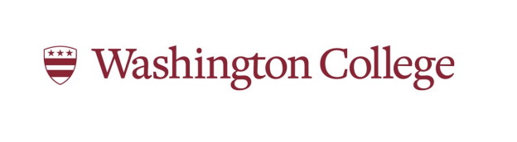

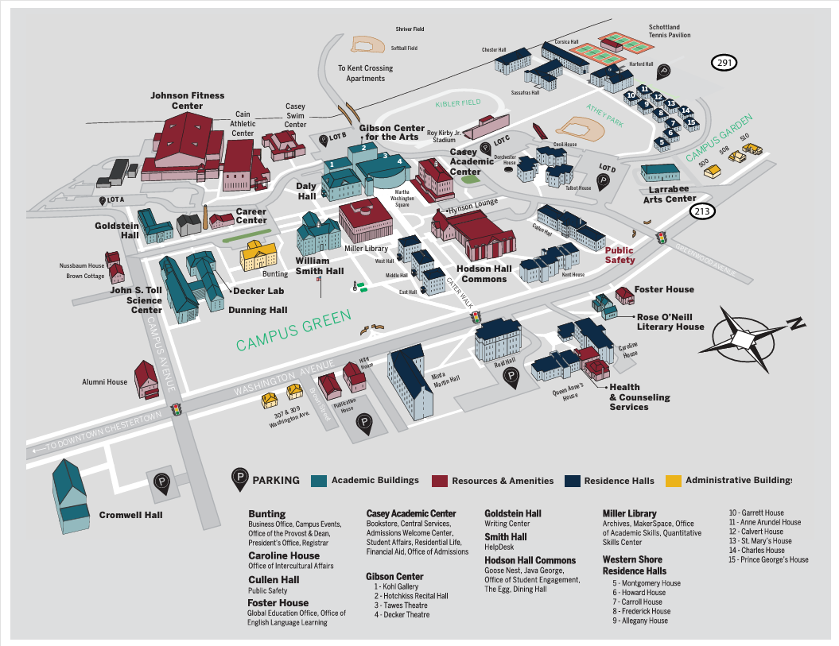

The conference takes place in two buildings that are located across each other: Goldstein Hall, for conference panels, and Toll Science Center, for lectures (Litrenta Hall), and for book exhibition and registration (Atrium). To find the location, put on your GPS: 210 West Campus Avenue, Chestertown, MD 21620, but this is approximative, as these buildings do not have addresses. For orientation, see map at the end of the program. Please note that there will be activities on the waterfront, too, for the Aural/Oral Experience (Center for the Environment and Society) and for the Custom House Tour (Starr Center for the American Experience).

