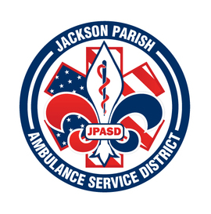
JACKSON PARISH AMBULANCE SERVICE DISTRICT
115 Watts Street
Jonesboro, LA 71251
Office: (318)-259-2877 Fax: (318)-259-2099
jacksonparishambulance@jpasd.com
Aaron Johnson BOARD MEMBERS
EMS Director Allen Lindsay, Chairman
Paula Parkerson , MD Joe Vail, Vice-Chairman
Medical Director Conchita Doyle
Alma Williams
Deidre Hollis
Notice Posted: Tuesday, February, 2023 @ 3:00 PM

NOTICE OF PUBLIC MEETING
Cancellation

