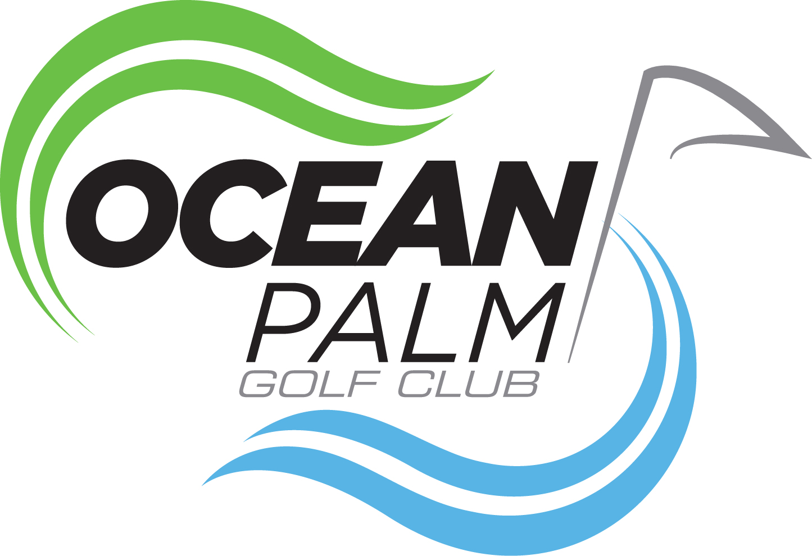

MIXED FUN GOLF OUTING

SUNDAY August 11th at 2:00pm
Enjoy a Sunday golf afternoon at
OCEAN PALM GOLF COURSE
With both new and old friends
Format will be a Scramble
Teams will be foursomes of A B C D players

The First Place Winning Team
Receives a free round of golf including a cart, per person

The Second Place Winning Team
Receives an appetizer or a beverage of any kind, per person

All of the Remaining Teams
Will have a lot of fun and will enjoy the day

Please use the Sign Up sheet in the clubhouse or call
Marianne Schuettler at (386) 299-2924

