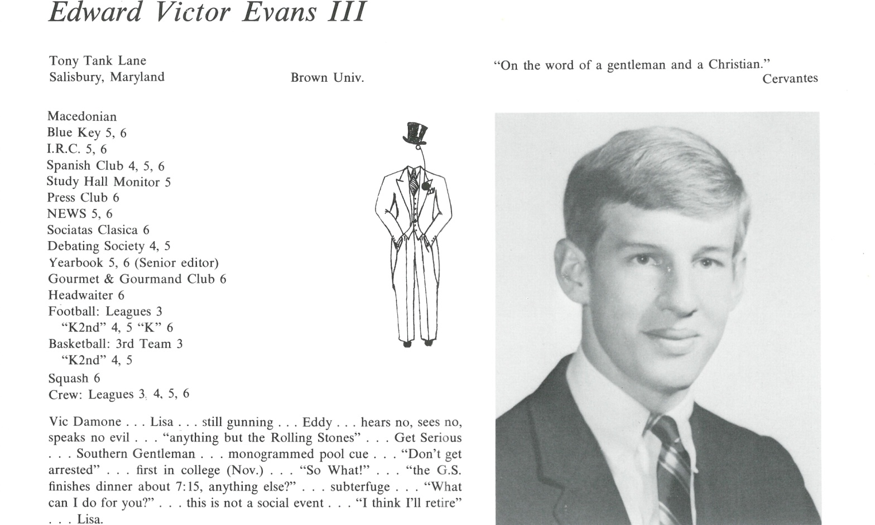

E. Victor Evans III

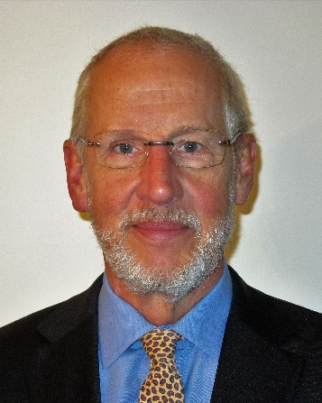Susan and I have been looking forward to seeing everyone at our big event in Kent now less than two weeks away.

We attended the fortieth reunion in 2007, and much water has passed over the dam since then. All seven children in our blended family have finished college (13 degrees), and except for the youngest, have fled the coop to pursue productive and fascinating lives in urban centers across the country. They are married or have significant others, and we have one grandson in Little Rock AR.

I am an architect and recently retired (1/1/2017) as a consultant after almost 40 years specializing in project and master planning for colleges, universities, schools, school districts and almost two dozen American curriculum international schools on five continents. It was niche work involving campus planning, space planning and programming for new construction and building renovation.

My work justified major capital expenditures and defined the scope and specifics for hundreds of projects designed by innumerable architects and engineers. Fortunately, most of the international work occurred when I was younger and before 9/11/2001, but even domestic contracts required travel. (BWI airport was only 20 minutes away). It was creative and challenging work that utilized the knowledge and skills gained from degrees in both English and Architecture. The last third of my career was largely focused on Mississippi where, in addition to public universities and research centers throughout the state, my work included office planning in the capital city of Jackson for much of the executive branch of the State of Mississippi when Haley Barber was governor. (The last is deliciously ironic because I’m a diehard Democrat).

The past 12 months have been especially busy. Last June we sold our house outside Annapolis where we had lived for the entire 20 years of our married life and returned to our hometown of Salisbury on Maryland’s Eastern Shore where we have many generations of local connections. We are still finalizing improvements to our current home that we have spent several years renovating and are also focused on landscape renewal. When not gardening or cooking, I play tennis, exercise and read. I’m still figuring out what I want to do in life.

The most surprising aspect of our move back to Salisbury is that the rector of our church, the Very Rev. Dr. Frieda Malcom, is the widow of one of our classmates, Steve Paul, who passed in 2000 at the young age of 51 from bone cancer, multiple myeloma, while rector of an Episcopal congregation in central Maryland. Frieda is an amazing pastor, preacher and human being. Their daughter Emily will be married this June.



______________________________________________________________

______________________________________________________________ ______________________________________________________________ ______________________________________________________________ ______________________________________________________________ ______________________________________________________________ ______________________________________________________________ ______________________________________________________________ ______________________________________________________________

Attach Picture in .jpg Format

______________________________________________________________

______________________________________________________________

___________________________________________________________________________________ _________________________________________________________________________________________________________________________________________________________________________________________________________________________________________________________________________________________________________________________________________________________________________________________________________________________________________________________________________________________________________________________________________________________________________________________________________________________________________________________________________________________________________________________________________________________________________________________________________________________________________________________________________________________________________________________________________________________________________________________________________________________________________________________________________________________________________________________________________________________________________________________________________________________________________________________________________________________________________________________________________________________________________________________________________________________________________________________________________________________________________________________________________________________________________________________________________________________________________

___________________________________________________________________________________