Mars UP Church

Apostles’ Creed
I believe in God the Father Almighty, Maker of heaven and earth; and in Jesus Christ His only Son our Lord; who was conceived by the Holy Ghost, born of the Virgin Mary, suffered under Pontius Pilate, was crucified, dead and buried; He descended into hell; the third day He rose again from the dead; He ascended into heaven, and sitteth on the right hand of God the Father Almighty; from thence He shall come to judge the quick and the dead. I believe in the Holy Ghost, the holy catholic church; the communion of saints; the forgiveness of sins; the resurrection of the body; and the life everlasting. Amen.

Gloria Patri
Glory be to the Father, and to the Son, and to the Holy Ghost. As it was in the beginning, is now and ever shall be,
world without end.
Amen. Amen.

Come Holy Spirit, Come
Before the Service – Speak to God!
During the Service – Let God speak to you!
After the Service – Speak to each other!

(*Please stand, if able)
Welcome and Mars Messages

Prelude

*Hymn 368
“He Lives”

*The Call to Worship
Leader: We believe in God, who made us in His image.
People: We live, we love, we laugh, because we are like
Him.
Leader: We believe in Jesus Christ, the Son of God, our
Lord and Savior.
People: He had the last laugh on the devil when He rose
from the dead.
Leader: We believe in the Holy Spirit, coequal and coeternal
with the Father and the Son.
People: Our counselor, our guide, our motivator – He is
our joy!
Leader: Forgive us, Lord, when we take ourselves too
seriously, when we don’t claim the happiness that is
rightfully ours as your children, when we forget that
you will have the last laugh in this world.
People: Restore to us the joy of our salvation, through
Jesus Christ our Lord.

*Hymn Trey Hixon
“Good Grace”

Call to Confession

Prayer of Confession
Almighty God, Creator of the heavens and earth, we confess that we do not always live into the message of hope and salvation, the promise of eternal life. We live in ways that make the here and now more important than the future. We live in ways that put ourselves and our own success first over the needs of others and the long-term needs of the world. Forgive us for our selfish ways and call us into the path of Christ, who humbled himself and gave himself up for us on the cross, so that death might be no more and that all can share the joy of salvation and eternal life, through Christ Jesus our Lord. Amen.
The
Lord’s Prayer

Our Father,
who art in heaven,

hallowed be Thy
name,

Thy kingdom come,
Thy will be done,
on earth
as it is in heaven.

Give us this day
our daily bread;

and forgive us
our debts,
as we forgive
our debtors;

and lead us not
into temptation,
but deliver us
from evil.

For Thine
is the kingdom,
and the power,
and the glory,
forever. Amen.

The Doxology

Praise God
from whom
all blessings flow;
praise Him
all creatures
here below;
praise Him above,
ye heavenly host;
praise Father, Son,
and Holy Ghost.
Amen.

Assurance of Pardon

Gloria Patri
Children’s Chat

Scripture John 20:19-31

Morning Message Rev. Brian Hauser
“Shared Belief”

*Song Trey Hixon
“Firm Foundation”

Prayers of the People and Lord’s Prayer

*Hymn 635
“In the Garden”

*Benediction

*Postlude
Church Staff
Rev. Brian Hauser
Pastor
pastor@mars-up.org
724-689-3412

Mrs. Shelly Bocheff
Administrative Assistant
marsup@mars-up.org

AV TEAM
Alma Staskiewicz, Lisa Barbour, Marie Matthews, Bill Guesman, John Ivory, Mike Bocheff, Herb Wellman

Mars United Presbyterian Church

232 Crowe Ave
PO Box 805
Mars, Pennsylvania 16046
724-625-1365
www.mars-up.org
marsup@mars-up.org

Church Office Hours:
Mon -Thurs from 9 a.m. -2:30 p.m.
Flowers today are presented to the Glory of God and in honor of our 40th Wedding Anniversary by Dave and Paula Gibson

MUP Session

Class of 2025 Class of 2024 Class of 2023
John Ivory Alma Staskiewicz Lisa Barbour
Susan Cox Louise Fox Mary Ann Croop
Jay Wilson Marie Matthews Don Lewis
Herb Wellman

Clerk of Session: Herb Wellman

MUP Deacons

Class of 2025 Class of 2024 Class of 2023
Jill Cooper Steve Martin Sharon Gibbs
Robyn Beckwith Marge Nicklas Carol Kopar
Missy Wells Pat Auld Alice Leonberg

Moderator: Steve Martin

Morning Worship:
10:00 am

2nd Sunday of Easter

Prayer of Preparation
Lord, we come to you today with so many things on our hearts.

You call us to be in relationship of trust and love with you and you offer healing to us for those portions of our lives that are broken and injured.

Help us to be open to your mercy and healing love. For we ask this in Jesus’ Name.
AMEN.

Mars United Presbyterian Church
Welcome!

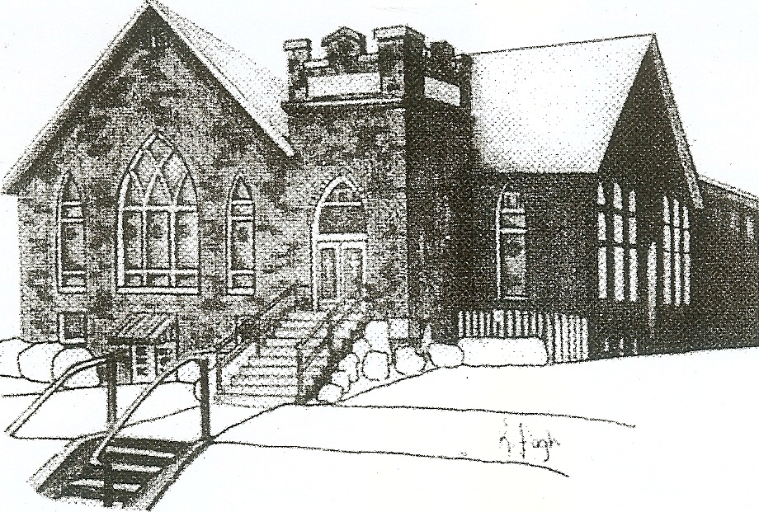
We are your hometown church: Faithful to Tradition, Loving in Fellowship, & Reaching for Tomorrow!

April 16, 2023
Holy Humor Sunday

We welcome you and we are glad you’ve chosen to Worship with us today!

CALENDAR: April 16th – April 23rd

Church Office Hours: Monday -Thursday from 9 a.m. – 2:30 p.m.

Today, April 16, 2023
VOLUNTEERS☺

LAST SUNDAY’S In-House ATTENDANCE: 97

LAST SUNDAY’S OFFERING:
Operating Funds: $2475.00
Kindness: $120.00
Bldg Improv: $10.00
Total: $2605.00

Tarry N Talk Hosts
Christian Ed/Mission Outreach

9:00 am Sunday School Hour
10:00 a.m. THE MORNING WORSHIP SERVICE
2:45 pm Girl Scouts
Monday, April 17, 2023
6:00pm Boy Scouts – 400
6:30 pm Grief Gathering
7:00 pm Boy Scouts
Tuesday, April 18, 2023
9:00 am A team
7:00 pm AA
Wednesday, April 19, 2023
9:00 am Material Girls
Thursday, April 20, 2023
7:00 pm Session Meeting
Friday, April 21, 2023
Saturday, April 22, 2023
Sunday, April 23, 2023 Combined Worship
9:00 am Sunday School Hour
10:00 am THE MORNING WORSHIP SERVICE
Welcome to all who are Worshiping with us today!

Guests
We sincerely hope our service is a blessing to you. We ask that our guests please take a few minutes to complete one of the Connect Cards found in the pew holder.

Should you have questions regarding any aspect of our church, including membership, please contact Pastor Brian or the church office during the week at 724-625-1365. Thank you for being with us today.

PRAYER – JOYS & CONCERNS
Lou Beckwith Paige Lauten
Paige Barbour (daughter of Andrew and Steph Barbour) Sandy Wahl
Reid Christopher Hall (June Stirling’s nephew) Sue Morris
Lindy McCartney (Lisa Barbour’s Sister)

ANNOUNCEMENTS
Bulletins are printed Thursday mornings; let us know if you have an announcement…

COMBINED WORSHIP SERVICE On Sunday, April 23rd we will have a combined Worship service with St. John’s Lutheran Church. Our Youth Group will be participating in the worship. The Sacrament of communion will also be offered this Sunday.

SPAGHETTI DINNER FUNDRAISER We will be holding a Spaghetti Dinner fundraiser on Saturday, April 29th from 11am until 7pm in the church Fellowship Hall. The fundraiser is for The Future Jimmy Ellis Fire Fighter Foundation. All proceeds go directly to the Adams Area Fire District Dept. for the Foundation. There will also be a basket raffle and 50/50 raffle. Any questions please contact the office or see Pastor Brian.

SPAGHETTI DINNER VOLUNTEER SIGN—UP If you would like to help with this fundraiser, please go to this site to pick a time to help. This will be a big event; many volunteers are needed. https://www.signupgenius.com/go/508084BA8AA2EABFF2-vfdmup
SAVE THE DATE – Vacation Bible School- July 9th thru July 13th
SAVE THE DATE Mars UP church annual picnic will be held Sunday, September 10th at Adams Township Park. More Details to Follow

