SEMAGLUTIDE DOSING SCHEDULE

Dosing Schedule for Ozempic®:

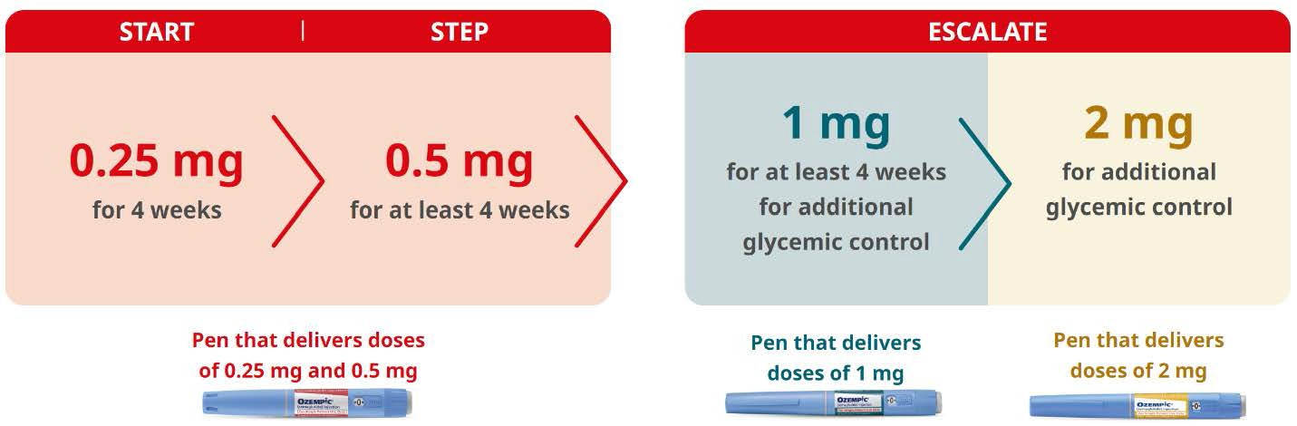

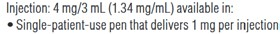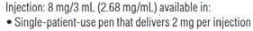

Dosing Schedule for Wegovy®:

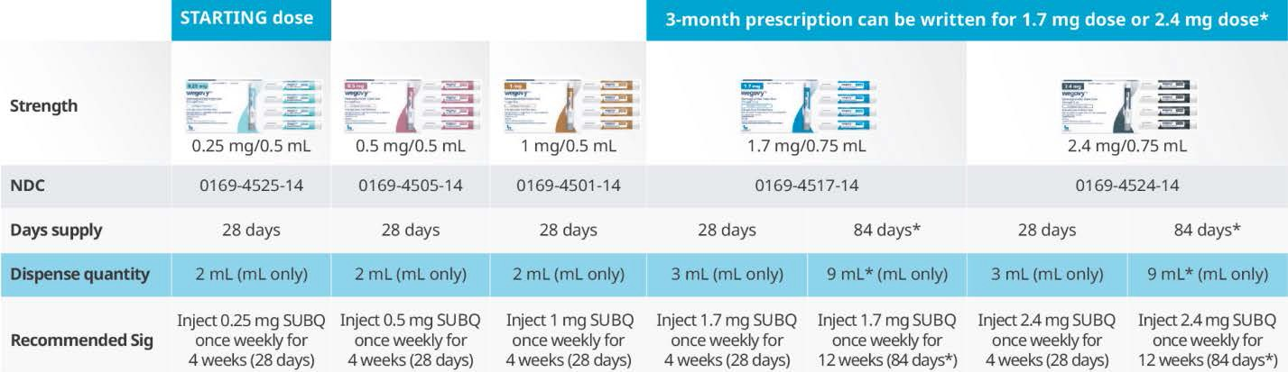

SEMAGLUTIDE INJECTION SITES

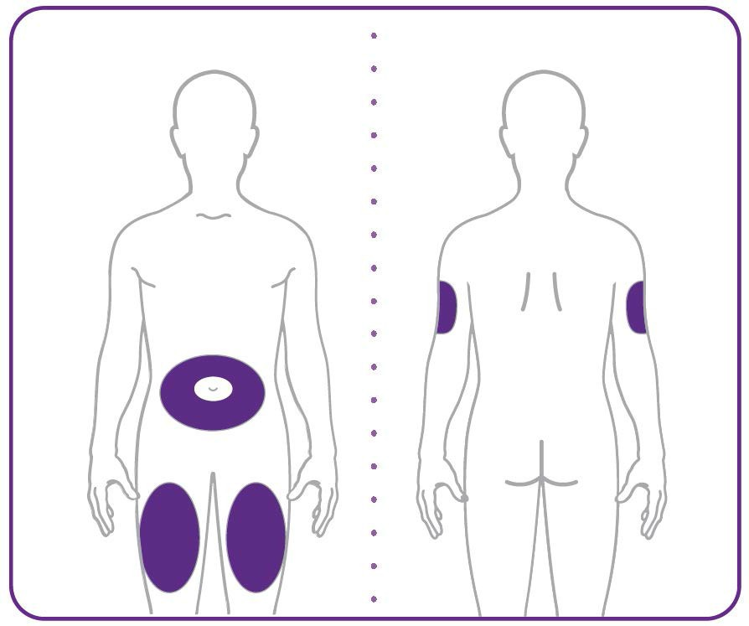

- Your healthcare provider can help you choose the injection site that is best for you.
- You or another person can inject the medicine into your stomach or thigh.
- Another person should give you the injection in the back of the upper arm.

OZEMPIC DOSING GUIDE 1.33 mg/ml | (100 Units = 1ml = 1cc)

MG | CC | UNITS | MG | CC | UNITS
0.133 | 0.1 | 10
0.26 | 0.2 | 20
0.40 | 0.3 | 30
0.53 | 0.4 | 40
0.66 | 0.5 | 50
0.80 | 0.6 | 60
0.93 | 0.7 | 70
1.00 | 0.75 | 75
1.06 | 0.8 | 80
1.20 | 0.9 | 90
1.33 | 1.0 | 100
1.46 | 1.1 | 110
1.60 | 1.2 | 120
1.73 | 1.3 | 130
1.86 | 1.4 | 140
2.00 | 1.5 | 150
2.13 | 1.6 | 160
2.26 | 1.7 | 170
2.40 | 1.8 | 180
2.53 | 1.9 | 190
2.66 | 2.0 | 200

SEMAGLUTIDE DOSING GUIDE 5 mg/ml | (100 Units = 1ml = 1cc)

 | MG | CC | UNITS | MG | CC | UNITS
 | 0.05 | 0.01 | 1.0 | 1.90 | 0.38 | 38
 | 0.10 | 0.02 | 2.0 | 1.95 | 0.39 | 39
 | 0.15 | 0.03 | 3.0 | 2.00 | 0.40 | 40
 | 0.20 | 0.04 | 4.0 | 2.05 | 0.41 | 41
 | 0.25 | 0.05 | 5.0  66 | 2.10 | 0.42 | 42
 | 0.30 | 0.06 | 6.0 | 2.15 | 0.43 | 43
 | 0.35  0.25 | 0.07 | 7.0 | 2.20 | 0.44 | 44
 | 0.40 | 0.08 | 8.0 | 2.25 | 0.45 | 45
 | 0.45 | 0.09 | 9.0 | 2.30 | 0.46 | 46
 | 0.50 | 0.10 | 10 | 2.35 | 0.47 | 47
 | 0.55 | 0.11 | 11 | 2.40 | 0.48 | 48
 | 0.60 | 0.12 | 12 | 2.45 | 0.49 | 49
 | 0.65 | 0.13 | 13 | 2.50 | 0.50 | 50
 | 0.70 | 0.14 | 14
 | 0.75 | 0.15 | 15
 | 0.80 | 0.16 | 16
 | 0.85 | 0.17 | 17
 | 0.90 | 0.18 | 18
 | 0.95 | 0.19 | 19
 | 1.00 | 0.20 | 20
 | 1.05 | 0.21 | 21
 | 1.10 | 0.22 | 22
 | 1.15 | 0.23 | 23
 | 1.20 | 0.24 | 24
 | 1.25 | 0.25 | 25
 | 1.30 | 0.26 | 26
 | 1.35 | 0.27 | 27
1.40 |  | 0.28 | 28
1.45 |  | 0.29 | 29
1.50 |  | 0.30 | 30
1.55 |  | 0.31 | 31
1.60 |  | 0.32 | 32
1.65 |  | 0.33 | 33
1.70 |  | 0.34 | 34
1.75 |  | 0.35 | 35
1.80 |  | 0.36 | 36
1.85 |  | 0.37 | 37

