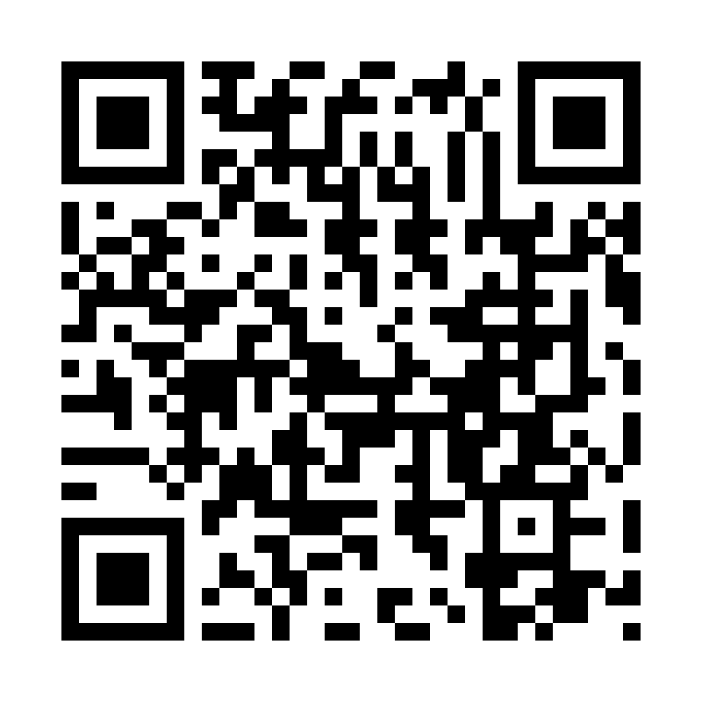

Catholic Church *cluster* of Davenport

St. Francis of Assisi – Harrington

Immaculate Conception Catholic Church – Davenport

St. Michael Catholic Church – Reardan

St. Kateri Tekawitha Catholic Church – Ford

Sacred Heart Catholic Church – Wellpinit

***Mailing Address***: Immaculate Conception Catholic Church - Davenport

1310 Adams St., Davenport, WA 99122-9454

(509)725-1761

***Office manager***: Jackie – [icdavenport@dioceseofspokane.org](mailto:icdavenport@dioceseofspokane.org)

Immaculateconceptiondavenport.org

***Pastor*** - Fr. Sean Thomson  [sthomson@dioceseofspokane.org](mailto:sthomson@dioceseofspokane.org)

Sacramental requests:Call Fr. Sean (509)688-5784

**The Holy Sacrifice of the Mass**

**Daily** Postponed until further notice…

**Saturday**  Harrington mass will be suspended for Sept. and Oct **Sunday** Rosary at 8am in Davenport

Davenport at 8:30am**,** Reardan at 10:30am, Ford 12:30pm (1st-2nd-3rd Sunday in Ford) (4th Sunday in Wellpinit)

**Confessions** - by appointment only via visiting priest.

**Tuesday** Davenport 5:30pm Eucharistic Adoration.

**Catechism of the Catholic**  **The Unity and Indissolubility of Marriage 1644** The love of the spouses requires, of its very nature, the unity and indissolubility of the spouses' community of persons, which embraces their entire life: "so they are no longer two, but one flesh." They "are called to grow continually in their communion through day-to-day fidelity to their marriage promise of total mutual self-giving. This human communion is confirmed, purified, and completed by communion in Jesus Christ, given through the sacrament of Matrimony. It is deepened by lives of the common faith and by the Eucharist received together. **1645** "The unity of marriage, distinctly recognized by our Lord, is made clear in the equal personal dignity which must be accorded to man and wife in mutual and unreserved affection." 

**Faith formation: contacts to call for First Communion prep is Scott Hansen 509-559-9091. Lorin Lathrop is 360-991-8585. For on-line classes for 10 yrs and up, including adults, is Michael Crow** [**crowme@comcast.net**](mailto:crowme@comcast.net)**.**

AED training in Davenport at 9:30am October 13. Reardan the 27th October at 11:30am.

Time to update Parish registry! **Please fill out the form in back of church** with updated phone numbers and emails.

Reardan fall clean up will be October 12 at noon. Please come!

Our Lady of Fatima prayer group meets first Saturday of each month. The next meeting is at Maria Nilles’ house. All are welcome! Contact Scott Hansen for more details.

**Mass Intentions:** Oct. 5 Sat. (5:00pm) For Fr Sean’s recovery Oct. 6 Sun. (8:30am) For Fr Sean’s recovery (10:30am) For Fr Sean’s recovery (12:30pm) For Fr Sean’s recovery Oct. 8 Tues. (9:00am) For Fr Sean’s recovery Oct. 9 Wed. (9:00am) For Fr Sean’s recovery Oct. 10 Thur. (9:00am) For Fr Sean’s recovery Oct. 411 Fri. (9:00am) For Fr Sean’s recovery