Mars UP Church
Come Holy Spirit, Come
Before the Service – Speak to God!
During the Service – Let God speak to you!
After the Service – Speak to each other!

(*Please stand, if able)
Welcome and Mars Messages

Prelude

Apostles’ Creed
I believe in God the Father Almighty, Maker of heaven and earth; and in Jesus Christ His only Son our Lord; who was conceived by the Holy Ghost, born of the Virgin Mary, suffered under Pontius Pilate, was crucified, dead and buried; He descended into hell; the third day He rose again from the dead; He ascended into heaven, and sitteth on the right hand of God the Father Almighty; from thence He shall come to judge the quick and the dead. I believe in the Holy Ghost, the holy catholic church; the communion of saints; the forgiveness of sins; the resurrection of the body; and the life everlasting. Amen.

Gloria Patri
Glory be to the Father, and to the Son, and to the Holy Ghost. As it was in the beginning, is now and ever shall be,
world without end.
Amen. Amen.

The
Lord’s Prayer

Our Father,
who art in heaven,

hallowed be Thy
name,

Thy kingdom come,
Thy will be done,
on earth
as it is in heaven.

Give us this day
our daily bread;

and forgive us
our debts,
as we forgive
our debtors;

and lead us not
into temptation,
but deliver us
from evil.

For Thine
is the kingdom,
and the power,
and the glory,
forever. Amen.

The Doxology

Praise God
from whom
all blessings flow;
praise Him
all creatures
here below;
praise Him above,
ye heavenly host;
praise Father, Son,
and Holy Ghost.
Amen.

Pastoral Invocation (adapted from Psalm 146)

The Call to Worship
Leader: Praise the LORD! Praise the LORD! O my Soul!
People: I will praise the LORD as long as I live; I will
sing praises to my God all my life long.
Leader: Do not put your trust in princes, in mortals, in
whom there is no help.
People: Happy are those whose help is the God of
Jacob, whose hope is in the LORD there God,
Leader: The LORD will reign forever, your God, O Zion,
for all generations.
People: Praise the LORD!

*Hymn of Praise 169
“Rejoice, Ye Pure in Heart”

*Prayer of Confession
Merciful God, forgive us when we are paralyzed by confusion and doubt. Strengthen our faith, that we may not only believe, but may be filled with the power to help and heal. When others reject or refuse our ministry, help us to be forgiving and grace-filled. Grant us the courage to accept those things that cannot be changed, that we may be freed from anger and resentment. Forgive us when our disappointment clouds our wisdom and confuses our actions. Guide us on this path of ministry, that we may be filled with the joy of our ministry.

*Assurance of Pardon
*Gloria Patri

*Sharing the Peace of Christ
Leader: May the grace of our Lord Jesus Christ, the love of God, and the fellowship of the Holy Spirit be with you all!
People: And also with you.

Children’s Chat

*Doxology
*Prayer for the Offering

*Hymn of Praise 406
“Wonderful Words of Life”

Prayer for Illumination

Scripture Mark 7:24-37

Morning Message Rev. Brian Hauser
“All Syrophoenician Dogs Go To Heaven”

Prayers of the People and Lord’s Prayer

*Communion Hymn 462 (v. 1-2)
“Come, Share the Lord”

Celebration of the Lord’s Supper

*Hymn of Commitment 401
“The Church’s One Foundation”

*Benediction

*Congregational Response (Everyone sings)
May the God of hope go with us every day.
Filling all our lives with love and joy and peace.
May the God of justice speed us on our way,
Bringing light and hope to every land and race.
Praying, let us work for peace,
Singing, share our joy with all,
Working for a world that’s new,
Faithful when we hear Christ’s call.

Church Staff
Rev. Brian Hauser
Pastor
pastor@mars-up.org
724-689-3412

Ms. Jamie Daugherty
Choir Director & Organist
JamieD0714@gmail.com

Mrs. Shelly Bocheff
Administrative Assistant
marsup@mars-up.org

AV TEAM
Alma Staskiewicz, Lisa Barbour, Marie Matthews, Bill Guesman, John Ivory, Keith Nichols, Mike Bocheff, Herb Wellman

Mars United Presbyterian Church

232 Crowe Ave
PO Box 805
Mars, Pennsylvania 16046
724-625-1365
www.mars-up.org
marsup@mars-up.org

Church Office Hours:
Mon -Thurs from 9 a.m. -2:30 p.m.
Morning Worship:
10:00 am

15th Sunday after Pentecost

Prayer of Preparation
Lord, we come to you today with so many things on our hearts.

You call us to be in relationship of trust and love with you and you offer healing to us for those portions of our lives that are broken and injured.

Help us to be open to your mercy and healing love. For we ask this in Jesus’ Name.
AMEN.

*Postlude

Flowers are presented to the Glory of God and in loving memory of Butch Leonberg by his family.

Mars United Presbyterian Church
Welcome!

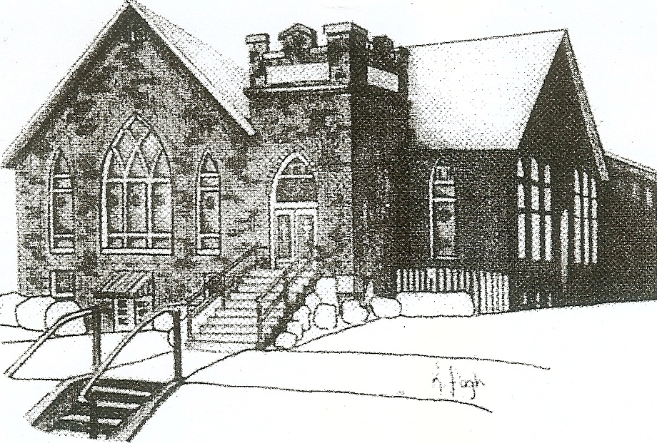
We are your hometown church: Faithful to Tradition, Loving in Fellowship, & Reaching for Tomorrow!

September 5, 2021

We welcome you and we are glad you’ve chosen to worship with us today!

CALENDAR: September 5th – September 12th

Church Office Hours: Monday -Thursday from 9 a.m. – 2:30 p.m.

Today, September 5, 2021 Communion
VOLUNTEERS☺

LAST SUNDAY’S In-House ATTENDANCE: 54

LAST SUNDAY’S OFFERING:
Operating Funds: $2070.17
Mission: $10.00
Total: $2080.17

10:00 a.m. THE MORNING WORSHIP SERVICE
Monday, September 6, 2021
LABOR DAY – OFFICE CLOSED
Tuesday, September 7, 2021
9:00 am A team
First Day MSPS
Wednesday, September 8, 2021
9:00 am Material Girls
7:00 pm Chancel Choir Rehearsal
Thursday, September 9, 2021
Friday, September 10, 2021
Saturday, September 11, 2021
Sunday, September 12, 2021
10:00 am THE MORNING WORSHIP SERVICE
11:15 am Worship Meeting
11:15 am Deacon Meeting

Welcome to all who are Worshiping with us today!

Guests
We sincerely hope our service is a blessing to you. We ask that our guests please take a few minutes to complete one of the Connect Cards found in the pew holder.

Should you have questions regarding any aspect of our church, including membership, please contact the church office during the week at 724-625-1365. Thank you for being with us today.

PRAYER – JOYS & CONCERNS
Lou Beckwith Kennedy (Great Granddaughter of Marlene Edwards
Paige Barbour (daughter of Andrew and Steph Barbour) Karen Davidson
Reid Christopher Hall (June Stirling’s nephew) Maria Elizabeth McKaveney (June Stirling’s niece)
Lindy McCartney (Lisa Barbour’s Sister) Jan Balentine (sister of Karen Purvis)

ANNOUNCEMENTS
Bulletins are printed Thursday mornings; let us know if you have an announcement…

YOUTH GROUP will begin on Sunday, September 12th at Mars UP Church. Youth Group will meet every other Sunday from 1:00pm to 2:30pm. Mars UP Church will be working together with St. John Lutheran Church to bring Youth Group to all youth in the community. We are also looking for volunteers to help with Youth Group a few Sundays. For further info, please contact Pastor Brian or the office.

SAVE THE DATE Pastor Brian’s installation service will be at 2:00 p.m. on Sunday, September 19th at the church. There will be a reception following the installation in the Fellowship Hall. Light refreshments will be available. All are welcome!

CHANCEL CHOIR BEGINS! Are you looking for a new way to serve your church? Can't read music? No problem! We rehearse each Wednesday evening at 7 pm and
would love to have you join our choir! Please consider making a joyful noise in a different way. See Jamie for more details or come to our first rehearsal Wednesday, September 8th
at 7 p.m. in the choir room.

QUIET HOUR DEVOTIONALS The new Fall devotionals are available in Tarry N Talk. Please feel free to take one.

SEPTEMBER NEWSLETTER Hard copies of the September Newsletter are available in Tarry N Talk. If you would like added to our mailing list, please contact the office.

RALLY DAY Our 2021-2022 kick-off will be held on Sunday, September 12th, Sunday School teachers will be recognized during the worship service. Sunday School will start on September 19th at 9am.

CPR/AED TRAINING Buildings and Grounds committee are looking to schedule a combined class of CPR and AED training. They are looking to have the class after church, preferable in Sept. or Oct. If you are interested in attending, please contact the office or Pastor Brian.

