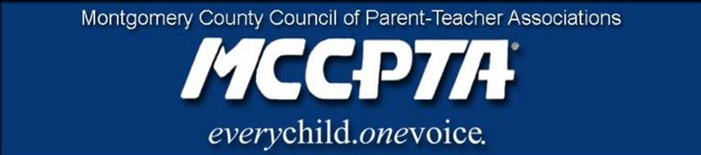

MCCPTA Statement regarding Recent Sex Abuse Criminal Charges
Against MCPS Staff
This statement contains references to physical and sexual abuse that may be disturbing and may trigger reactions for survivors. Resources for help and support are available and listed below.
“Time and resources should focus solely on repairing harm, making whole, holding to account, and establishing protocols and practices that ensure the protection of all children from all forms of abuse.” MCCPTA Statement, August 2021
The MCCPTA Board of Directors was alarmed to learn of more cases of felony sex abuse crimes allegedly committed against MCPS students by MCPS staff. The most recent charges filed against Whitman Social Studies teacher and club crew (rowing) coach, Kirkland Shipley as well as Northwood school security staff member and track coach, Giovanni Di Angelo Reumante, elevate our already heightened concerns about MCPS’s ability to properly safeguard students and respond swiftly to abuse claims. We urge MCPS to streamline the pathways for reporting and communicating when assaults occur. MCPS protections should be in place regardless of whether or not the abuse happens during the academic day, school-sanctioned athletics, or club-affiliated activities.
MCPS staff knew of formal complaints against Mr. Shipley as early as 2018. However, MCPS allowed Mr. Shipley to remain in a power-position as a teacher and coach for three additional years. MCCPTA is appalled at the lack of immediate response and community notice, which directly jeopardized the well-being and safety of the students taught and coached by him. In the case of Mr. Reumante, the MCPD has encouraged the school community and public at-large to come forward if there are additional claims. MCCPTA also strongly condemns coaching methods that foster unhealthy and abusive team environments. These toxic conditions may give way to predatory behavior and sexual abuse in MCPS athletics, at any level, either school-sanctioned or club-affiliated.

Most importantly, these recent cases illuminate the urgent need for MCPS:
- To move swiftly to communicate abuse claims to school communities;
- To adhere to the requirements of the Mental Health subsection of the 2018 Maryland Safe-to-Learn Act by MCPS, with regard to notifying students of how to report suspected cases of abuse and how to access mental health resources;
- To establish clear and widely communicated MCPS partnerships with social service agencies, law enforcement, and other mental health supports; and
- To IMMEDIATELY implement all available US SafeSport training as well as leadership development programs for all MCPS athletic coaches and athletes, as previously urged by MCCPTA, including MCCPTA's recommendation from 2019 to scale-up the free evidence-based programs Coaching Boys To Men and Athletes as Leaders, offered by the Montgomery County Justice Center, in all MCPS middle school and high school athletic departments.

Resources for immediate help and assistance:
- To make a report of child abuse and neglect or mental injury, call Child Welfare Services (240) 777-4417 (open 24 hours).
- To make a report of child sexual abuse, call Child Welfare Services (240) 777-4417 and the Special Victims Investigation Division of the Montgomery County police Department (240) 773-5400 (open 24 hours).
- The Childhelp National Child Abuse Hotline – 1-800-4-A-CHILD (1-800-422-4453) – is dedicated to the prevention of child abuse. The hotline is staffed 24 hours a day, 7 days a week with professional crisis counselors who, through interpreters, can provide assistance in over 200 languages. The hotline offers crisis intervention, information, literature, and referrals to thousands of emergency, social service, and support resources. All calls are confidential.
- RAINN (Rape, Abuse & Incest National Network) is the nation's largest anti-sexual violence organization. RAINN operates the National Sexual Assault Hotline -- 1-800-656-HOPE and works in partnership with more than 1,000 local sexual assault service providers across the country.
- Darkness to Light – 1-866-FOR-LIGHT (866-367-5444) – provides a toll-free number for individuals living in the United States who need information and resources about sexual abuse. Any individual, child or adult who needs information about sexual abuse can call the helpline.
- SafeSport is committed to ending all forms of abuse in sport. This includes bullying, harassment, hazing, physical abuse, emotional abuse, and sexual misconduct and abuse. Both the SafeSport Trained course and the Parent Training help you to recognize if an athlete is being abused.

The Montgomery County Council of PTAs (MCCPTA) is an association of local PT(S)As in Montgomery County, representing 194 local PT(S)As. ​​MCCPTA advocates for the education and welfare of the children, families, and schools in Montgomery County, ensuring that the issues of concern to our community are raised with Montgomery County Public Schools (MCPS), the Montgomery County Board of Education (BOE), Montgomery County Council and the Maryland General Assembly. We advocate for students, parents, and teachers of MCPS based on our annual advocacy priorities, which is approved by our membership.

For information about the MCCPTA or this statement, please contact: Cynthia Simonson, President, MCCPTA, president@mccpta.org.

