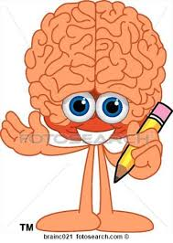
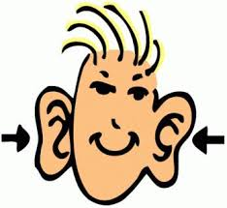
REVISING
Wheel
Remember:
Revise with
Your EARS!
www.kbumreading.com
Is my writing focused on a topic?
Does it make sense?
Did I make the best word choices?
What details can I add to “show” the reader? Actions, feelings, descriptions, vivid words, relevant examples, or EVIDENCE?
Are there any words, sentences, or parts
in my writing that
do not make sense
or are out of place?
Do I have a clear introduction?
Did I include a relevant concluding statement or paragraph?
REVISING WHEEL

