SANCTUS
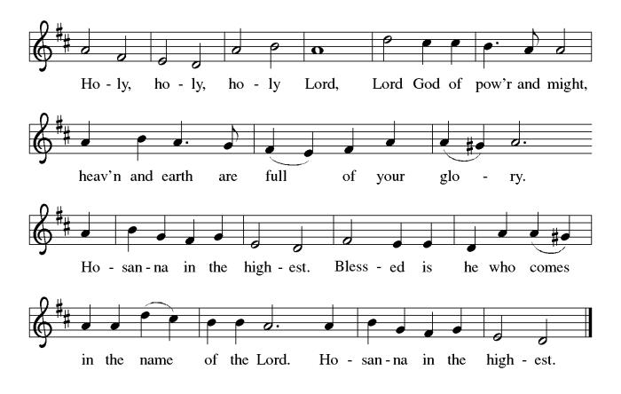

THE EUCHARISTIC PRAYER
V. Blessed are you, Lord of heaven and earth, in mercy for our fallen world you gave
your only Son, that all those who believe in Him should not perish, but have
eternal life. We give thanks to you for the salvation you have prepared for us
through Jesus Christ. Send now your Holy Spirit into our hearts that we may
receive our Lord with a living faith as He comes to us in His holy supper.
C. Amen. Come, Lord Jesus.

V. In the night in which he was betrayed our Lord Jesus took bread,
he gave thanks; broke it, and gave it to his disciples, saying:
Take and eat; this is my body, given for you.
Do this for the remembrance of me.


V. Again, after supper, He took the cup, he gave thanks,
and gave it for all to drink, saying:
This cup is the new covenant in my blood,
shed for you and for all people for the forgiveness of sin.
Do this for the remembrance of me.


THE LORD’S PRAYER
(We ring the bell throughout the Lord’s Prayer at all services to
invite those in the community to join in praying the Lord’s Prayer.)
V. May we now join with one another and pray together as Jesus has taught us.
C. Our Father, who art in heaven, hallowed be thy name, thy kingdom come,
thy will be done, on earth as it is in heaven. Give us this day our daily
bread; and forgive us our trespasses, as we forgive those who trespass
against us; and lead us not into temptation, but deliver us from evil. For
thine is the kingdom, and the power, and the glory, forever and ever.
Amen.

LAMB OF GOD
(We invite you to be seated.)

HOLY COMMUNION
V. Communion here is pretty simple, and all who are baptized and believe in Jesus
Christ are welcome at the table.

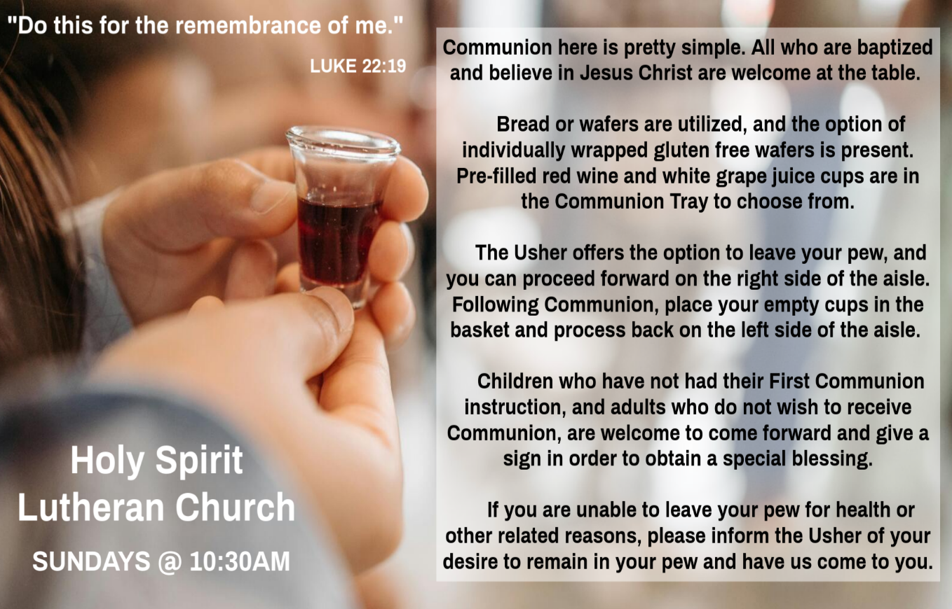

INVITATION TO COMMUNION
V. There is a place for you at the table of God.
Come, receive the food that does not perish,
a taste of life eternal.
C. Amen.

(Distribution of Holy Communion)
V. We invite you to stand as you are able.

OFFERING PRAYER
V. Let us pray,
God of healing and hope,
you bless those who are hungry,
promising to fill them with good things.
Fulfill that promise through us and these your gifts.
Nourish us with the abundance of your feast
and unite us into the blessed body of Jesus Christ our Savior,
now and forever.
C. Amen.

GREAT THANKSGIVING
V. The Lord be with you.
C. And also with you.

V. Lift up your hearts.
C. We lift them to the Lord.

V. Let us give thanks to the Lord our God.
C. It is right to give him thanks and praise.

V. It is indeed right and salutary that we should at all times and in all places offer
thanks and praise to you, O Lord, holy Father, through Christ our Lord; who rose
beyond the bounds of death and, as he promised, poured out your Spirit of life
and power upon the chosen disciples. At this the whole earth exults in boundless
joy. And so, with the Church on earth and the hosts of heaven, we praise your
name and join their unending hymn:

OFFERING SONG
(We invite you to sing along.)
Worship & Praise
156—What Have We to Offer?
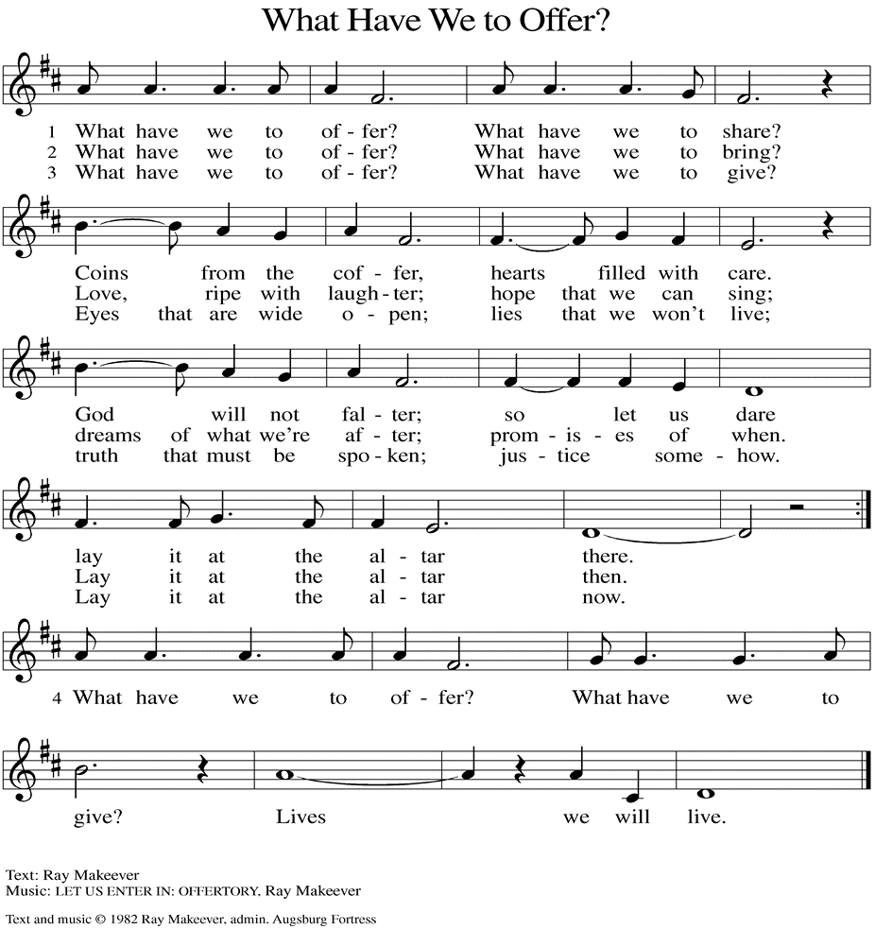
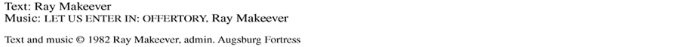

(Usher(s) brings the Tithes and Offerings up front to the Assistant.)
COMMUNION HYMN
(Please enjoy various music offered by our Organist during your
quiet time, prayer, and reflection following Holy Communion.)

(Vicar and Assistant remove Communion Vessels from the Altar.)

V. We invite you to stand as you are able.

POST COMMUNION BLESSING
V. May the body and blood of our Lord Jesus Christ strengthen us and keep us
always in His grace.
C. Amen.

POST COMMUNION CANTICLE
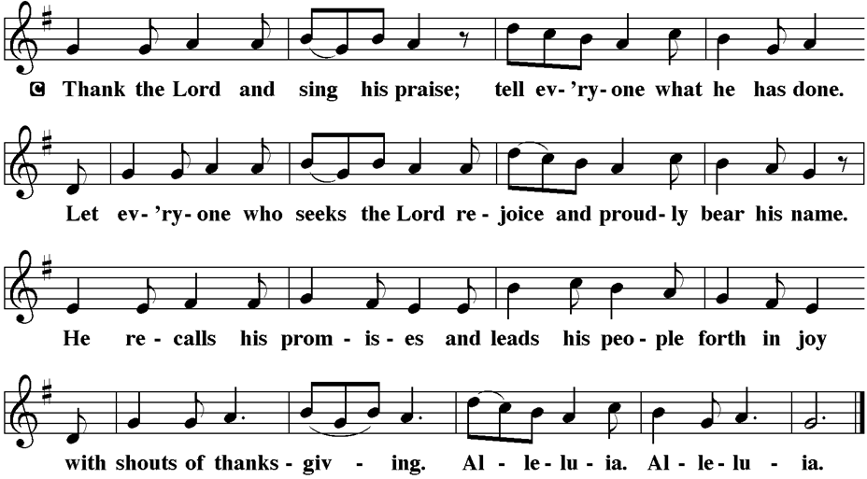

PRAYER AFTER COMMUNION
A. Let us pray,
God of field and flower, wheat and grape,
you have nourished us with the bread of heaven
that gives life to the world.
Strengthened by the body and blood of your Son,
send us out to gather your good gifts for all who
hunger and thirst,
and embolden us to love and serve in Christ’s name.
C. Amen.

BLESSING
V. The love of God the Sovereign strengthen you,
God the Son save you,
and God the Holy Spirit anoint you for the work ahead.

The holy Trinity bless you ☩
and grant you a faithful and courageous heart
now and forever.
C. Amen.


SENDING HYMN
(We invite you to sing along.)
With One Voice—Blue Book
699—Blessed Assurance

(Assistant extinguishes the Altar Candles half way through the Sending Hymn.)

(Vicar processes out once the Altar Candles have been extinguished.)

(We invite you to be seated.)

V. Watch over all of us who are worried and suffering, and especially those whose
names we now say aloud or hold within our hearts (pause). Hear us, O God.
C. Your mercy is great.

V. We offer these and all our prayers to you, O God, trusting in your grace and
unyielding love; through Jesus Christ, our Lord.
C. Amen.

SHARING OF THE PEACE
V. May the peace of the Lord be with you always.
C. And also with you.
V. Now, let us share God’s Peace with one another.



(Please respect your neighbor if they desire to still only offer a peace sign or wave.)

(Following the Sharing of the Peace, we invite you to be seated.)

OFFERING
V. We now worship God with our tithes and offerings, wine and bread for use in holy
communion, and monetary gifts to support our ministry for service in God’s name.
Our Ushers will be around to your pews to pass the Offering Plates.

(Ushers come forward to get the Offering Plates from the Assistant.)

(Vicar and Assistant prepare the Altar for Communion.)

Patrick Davenport (Sue Waltz's Friend)
Thish Kelly (Theresa & Kim McGinley's Family)
Edward Chapleski (Allison Call's Family)
Scott Levin (Rose Lang's Friend)
Lynne Curlett (Del McKenna's Family)
Alice Ann Dennis (Diana DeNote's Family)
Nancy Taylor (Ted & Diane Bell's Family)
Santa Isabel Lutheran Church (Elizabeth, NJ)
Messiah Lutheran Church (Oakland, NJ)
Carol Brand (Skip & Bonnie Millard’s Friend)
Joyce Thompson (TDPWC Member)
Barbara Paynter (Leon Stitt’s Family)
Ruth (Anthony & Vincent Bruno's Family)
Tom M (Philomena Noak's Family)
William T Hodgetts (Pastor William Hodgetts’ Family)
Paul Bowker (Church Member)
BettyAnn & Bill Whitman (Mary Melnicoff's Friends)
Bob Poole (Kathy Poehler's Family)
David Smith (Heather & Vicar Vince Piekarski’s Family)
Joe Smith (Heather & Vicar Vince Piekarski's Family)
Barbara Hoitink (Lucas & Sabrina Munson's Family)
Kathy Raynor (Philomena Noak & Mary Melnicoff’s Friend)
Ed Cox (Church Family)
Audrey Knott (Judy Brannan’s Family)
(Additional Names Added Prior to the Worship Service.)
A. Comfort those who suffer from trauma and exposure to traumatic events. Hear us,
O God.
C. Your mercy is great.

A. God who gathers us together, we give thanks for our pastors and deacons,
teachers and musicians, administrators, and building caretakers. May they find
joy in leadership as we grow in faith together. Hear us, O God.
C. Your mercy is great.

A. God of the saints, we give thanks for all who have died in faith. Uplift us as we
honor their memory and await your coming in glory. Hear us, O God.
C. Your mercy is great.

(Here other intercessions may be offered.)
BIRTHDAYS, ANNIVERSARIES, & ANNOUNCEMENTS
(Offered by Assistant and Congregation.)

BIRTHDAY
14th Judy Brannan

DISMISSAL
A. Go in peace. Share the harvest.
C. Thanks be to God.

POSTLUDE
(Music offered by our Organist as we depart following our Worship Service.)
Eternal Father, Strong to Save

LICENSES & EXPIRATION DATES
Worship Service Content is used via permission through Augsburg Fortress Liturgies Annual License #SB144368. The next Subscription Renewal Date is 2/28/2026.
Our Hymns and Worship Music are used via permission through CCLI One
License #11327166. The next Subscription Renewal Date is 1/31/2026.


CONFIRMATION & SUNDAY SCHOOL
“Here We Stand” allows our young folks to go through a 2-year process while focusing on the Bible and Luther’s Small Catechism. Studies for year two
have resumed, and we meet each Sunday from 9-10AM.

WORSHIP MINISTRY
The most important thing we do each week is gather together as God's people to Worship. God is the center and focus of everything we do. Participating in Worship is active, as Liturgy means the work and actions of the people gathered. Everything we do during the week to prepare for Worship, and everything we do as we Assist in leading Worship is important. We are thankful for all the wonderful work being done. If you have questions, or are interested in any position, reach out to Vicar Vince.
Sign-up sheets are located on the bulletin board between the church offices.

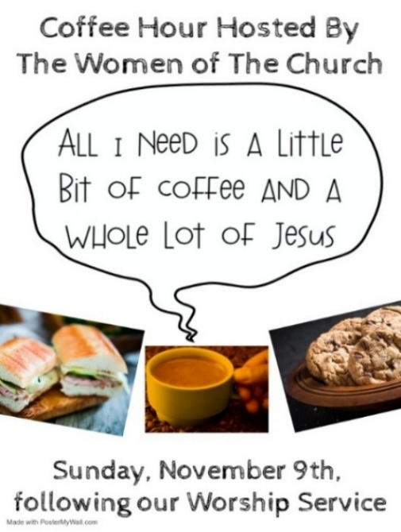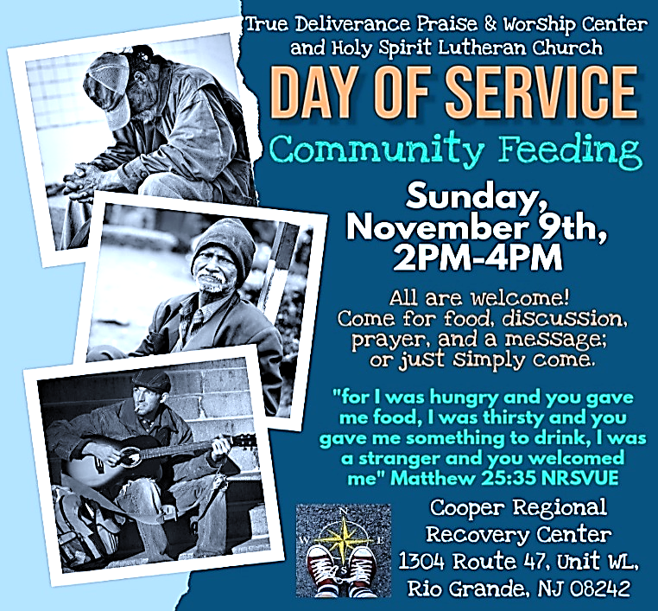
Francis Clock (Dianna DeNote’s Family)
Andrew Hudak (Rose Lang’s Friend)
Viena Murtha (Bob Fritsch’s Friend)
Sharon Waicus (Skip & Bonnie Millard's Friend)
Karen O'Brien (Paul Bowker's Friend)
Dustin Irizzary (Mary Melnicoff's Family)
The Bryan Family (Wanda Bryan's Family)
Craig Brearey (Judy Brannan & Mary Melnicoff's Friend)
Sarah Dutton (Frank Ford's Family)
Christina McNasby (Fran Green’s Family)
The Kinkson Family (Judy Brannan's Friends)
Mark Stephen Dennis (Diana DeNote's Family)
Bill Lodge (Skip & Bonnie Millard's Friend)
Ron Anderson (Bill Kelly's Friend)
Bud Brearey (Judy Brannan & Mary Melnicoff's Friend)
Mary Skain (Kathy Poehler's Friend)
Robert Chaplin (Mary Melnicoff's Friend)
Jack Wieckouski (Theresa & Kim McGinley's Family)
Carolyn Santarpio (Bob Fritsch's Friend)
Harry (Judy Brannan's Friend)
Janet K (Philomena Noak's Friend)
Michael Hart (Diana DeNote's Friend)
Rocco Leonard DeNote (Diana DeNote's Family)
Al Singer & Family (Frank Ford's Friends)
Sherri Lynn (Bob Fritsch's Friend)
John Bannco (Bob Fritsch's Friend)
Nancy Pazarinie (Bob Fritsch's Family)
Jane & Paul Eiben (Rose Lang's Friend)
Joe DiMassimo (Judy Brannan & Mary Melnicoff's Friend)
Tommy Stanford (Sue Waltz's Family)
Audrey McAlister (Sue Waltz's Family)
Joe Waltz (Sue Waltz's Family)
Denny Papst (Rose Lang’s Friend)
Mike & Alice Rhoades (Rose Lang’s Friends)
Chris (Judy Brannan's Friend)
Helen Ehlers (Judy Brannan's Friend)
Hailey (Fran Green's Friend)
Leanne Bueth (Joan Kilcoyne's Family)
Janett MacFarlane (Carol Amundsen's Friend)
PRAYERS OF INTERCESSION
(The prayers are prepared locally for each occasion.)
V. Gathered with one voice, we offer our prayers for the church, the world, and all
who are in need.

(A brief silence.)

A. God our Redeemer, bless your church universal and its leaders. Set all hearts on
you from generation to generation in anticipation of Christ’s return. Hear us, O
God.
C. Your mercy is great.

A. God of life, we give thanks for the fruits and grains of harvest, for rivers and
streams, for all that is made of rock and iron. Renew the earth’s natural resources
and the lands from which they come. Hear us, O God.
C. Your mercy is great.

A. God of justice, we give thanks for the service of our veterans and pray for those
needing support for wounds of any kind. Strengthen those charged with the
governance and protection of vulnerable populations. Bring an end to war
throughout the world. Hear us, O God.
C. Your mercy is great.

A. God who leads us to belief and truth, we give thanks that you are always and
already here. Nurture and support those who are unsteady in mind, unsafe in
spirit, or unwell in body; especially:
BettyAnn Rich-White (Church Member)
Chip & Marie Hand (Church Members)
Lynn Bargstadt (Church Member)
Frank Ford (Church Member)
Carol Amundsen (Church Member)
Kim McGinley (Church Member)
Anthony DeLuca (Church Member)
Frank Brunner (Church Member)
Joan Sommerman (Church Family)
Arleen Kinka (Church Family)
Rick Lang (Church Family)
Suzie Clark (Rose Lang's Friend)
CLINICAL PASTORAL EDUCATION
Vicar Vince has been blessed with the opportunity of joining Chaplain Stephen Faller on-line for CPE classes on Sunday afternoons from 4PM-8:30PM on Zoom. Please be respectful of this if you happen to see his car at the church.

BIBLE STUDY & FAITH DISCUSSIONS
Bible Study & Faith Discussions was started in order to focus on various readings,
books, Bible verses, people of faith, and other general topics. Group Members offer
various points of view while reviewing the Bible and various aspects of faith while
being respectful and supportive of each other. Join us on Tuesdays at 6PM.

FOOD PANTRY
Open every Thursday, and the last Saturday of every month, from 10AM to 1PM. 96 people were served in October and 734 people have been served in 2025. Donations can be dropped in the outdoor drop-box, in the money jug in the back of the Church, mailed into the Church Office, or placed in the Offering Plate. Volunteers are needed. Sign-up sheets are located on the bulletin board between the church offices. If you have questions or need training see Heather, Vicar Vince, or Bonnie.
A special thank you goes out to all who donate, pray, and help in any way!

Thursday, 11/13 | Thursday, 11/20 | Thursday, 11/27
Garnet & Cathie | Tori & Joe | Closed due to Thanksgiving

COMMUNITY FOOD DONATIONS, DELIVERIES, & MORE
Our local North Cape May Acme provides us with Expiring Soon, Recently Expired, and Slightly Damaged Food and Items weekly. Kathy helps those in need by delivering items each Saturday in the community, brings leftover items to the Church for church members in need, and those who visit the food pantry during the week. Additional items are taken over to the Branches Outreach in Rio Grande on Monday.

BULLETIN ENTRY DEADLINE
The Bulletin is Printed on Thursdays during Church Office Hours. Changes need to be submitted to Vicar Vince or Heather no later than Thursday by 4PM. Thank you!

CHURCH OFFICE HOURS
Open Thursdays from 6PM to 8PM to serve the Congregation, the Community,
and to continue handling the business of the Church. Feel free to stop in to talk,
pick-up or drop off something, pray in the Sanctuary, or for whatever reason.
PREACHING AT BROOKDALE
Vicar Vince preaches at Brookdale Senior Living in Cape May Court House again on Sunday, November 16th, at 1PM. Holy Communion will follow the service.

CHURCH COUNCIL
Share your comments, concerns, questions, or joys with one of our Church Council Members who can bring them back to our meetings. Visitors are always welcome to attend and listen to what is going on in and around the church. Join us In- Person or on our Conference Call at our next Meeting on Tuesday, November 18th, at 6PM.

MUSIC MEETING
There will be a meeting to discuss the process of hymn choices and other things. We will be meeting on Saturday, November 22nd, at 4:30PM.

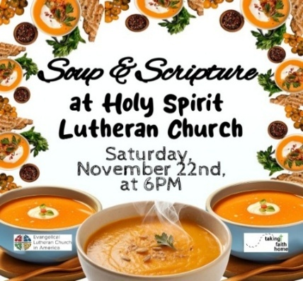

INTINCTION DURING COMMUNION
Intinction while communing together will occur in the months that have a fifth Sunday. If you have any questions please see Vicar Vince. Our next time doing this will be on Sunday, November 30th, during our 10:30AM Worship Service.

DONATION STATION
Get on the train and place all purchased items in the specified project donation bins located on the counter by the front doors. See Heather for more information.
HYMN OF THE DAY
(We invite you to sing along.)
With One Voice—Blue Book
690—Shall We Gather at the River

APOSTLES’ CREED
V. God has indeed made us his people through our Baptism into Christ. Living
together in trust and hope let us confess our faith together using the Apostles’
Creed.
C. I believe in God, the Father almighty,
creator of heaven and earth.

I believe in Jesus Christ, God’s only Son, our Lord,
who was conceived by the Holy Spirit,
born of the Virgin Mary,
suffered under Pontius Pilate,
was crucified, died, and was buried;
he descended to the dead.
On the third day he rose again;
he ascended into heaven,
he is seated at the right hand of the Father,
and he will come to judge the living and the dead.

I believe in the Holy Spirit,
the holy catholic church,
the communion of saints,
the forgiveness of sins,
the resurrection of the body
and the life everlasting.
Amen.

GOSPEL READING
Some Sadducees, who do not believe in the resurrection of the dead, try to trap
Jesus. They formulate the convoluted case of a serial widow who marries a
succession of seven brothers. Jesus responds by teaching about God to whom
all are alive and in whom all relationships are fulfilled.

V. The Holy Gospel According to Luke, the 20th Chapter (Verses 27-38).
C. Glory to you, O Lord.

V. 27 Some Sadducees, those who say there is no resurrection, came to [Jesus]
28 and asked him a question: “Teacher, Moses wrote for us that if a man’s
brother dies leaving a wife but no children, the man shall marry the widow and
raise up children for his brother. 29 Now there were seven brothers; the first
married a woman and died childless; 30 then the second 31 and the third married
her, and so in the same way all seven died childless. 32 Finally the woman also
died. 33 In the resurrection, therefore, whose wife will the woman be? For the
seven had married her.”

34 Jesus said to them, “Those who belong to this age marry and are given in
marriage, 35 but those who are considered worthy of a place in that age and in
the resurrection from the dead neither marry nor are given in marriage.
36 Indeed, they cannot die anymore, because they are like angels and are
children of God, being children of the resurrection. 37 And the fact that the dead
are raised Moses himself showed, in the story about the bush, where he speaks
of the Lord as the God of Abraham, the God of Isaac, and the God of Jacob.
38 Now he is God not of the dead but of the living, for to him all of them are alive.”

V. This is the Gospel of the Lord,
C. Praise to you, O Christ.

(We invite you to be seated.)

SERMON
(Delivered by Vicar Vince Piekarski.)

(Following the Sermon we invite you to stand as you are able.)

WOMEN OF THE CHURCH
The next monthly meeting will be on Monday, December 1st, at 6PM. Come join us for our Annual Cookie Exchange. We are also looking for a few more $5 or $10 gift cards for our Christmas Stockings to hand out in December. New members are always welcome to attend! Contact Judy for more information.

NEWSLETTER
Collect information, stories, pictures, and reports for our next seasonal publication. Winter starts on Sunday, December 21st. All information needs submitted to Vicar Vince in-person or via email at vpie8282@gmail.com no later than December 14th.

PRAYER LIST
Our Prayer List continues to lengthen and we realize the important need for prayers and healing. Sometimes the unfortunate result is that someone has passed away, and the words “The Family & Friends of” appear before someone’s name. However, sometimes we forget names are still on the list and their health has improved or the they are no longer struggling, and they can be removed. Please share the good and bad stories as we continue to pray for strength and healing. Names can be added or removed from the list on the clipboard in the Narthex prior to the Worship Service, by calling the church office, or addressing it on the Conference Call. Please let us know the relation to the person(s) you listed so we can be more mindful with our prayers. Names will stay on the list until removed by the person(s) who requested prayer.

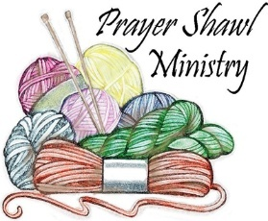
Prayer Shawls, Lap Quilts, Scarves, and other items have been made with love. Blessed items are located in the Narthex, and are free for anyone. Members of the group continue working at home on new stitches and patterns. We are blessed to be able to continue collecting new items. We have a donation station of yarn and other items located in the Narthex. You can find some new supplies for your next creation!

HOME COMMUNION MINISTRY
A Minister is available if you have a loved one, or if you desire services. We look forward in sharing the Word and Holy Communion! Please inform Vicar Vince, Kathy, or the Church Office so plans can be made for visits.
TITHES, OFFERINGS, & ENVELOPES
2025 Offering Envelopes are available. Please see Heather if you have not received yours, or would like to have some. For we do indeed worship God with our tithes and offerings. We hear this in scripture, “Each of you must give as you have made up your mind, not reluctantly or under compulsion, for God loves a cheerful giver.”
(2 Corinthians 9:7) Feel free to drop your envelopes in the offering plate, mail them to the church, or drop them off in the locked mailbox. Thanks for your continued support in the mission of our church, its ministries, the NJ Synod, and other needs!

ED GREEN CAPITAL IMPROVEMENT FUND
We continue raising money for unforeseen costs or repairs. Kathy has been selling Wawa Tickets for $6, but we have learned the program will end in 2025. Please use your tickets that you have purchased before the end of the year. We will seek out a new fundraiser. We still have the donation bin in the back of the church and our Church Rummage Sale. Thanks for your continued donations, prayers, and support!

SPACE AVAILABLE
​​​​​Do you know anyone interested in utilizing our Fellowship Hall for a Party or Event?
It is a suggested $50 refundable security deposit, and $250 for facility use. There is no alcohol or games of chance permitted due to ELCA policy. Please contact Vicar Vince or the Church Office with questions, for info, or to reserve a date and time.

INTERESTED IN BECOMING A NEW MEMBER
Have you been attending our church for a while? Have you just recently returned to church after being away for a bit? Maybe you transitioned from another church,
or just started to recently attend our church. We are glad to have you, and would love to have you as a member of our Congregation. See Vicar Vince for more info.

BAPTISM
We are a church whose unity is in Jesus Christ, who gathers us around word and water, wine and bread. Baptism is a significant part of our faith journey as we come from the baptismal waters to live a new life as children of God. Our baptism sets us out on a lifelong journey that is characterized by our relationship to God, our relationship to our faith community, our relationships in our community and the wider world. Living our baptismal covenant means living a life of growth in the faith practices of discipleship. Please see Vicar Vince for more information.

R. 1 As to the coming of our Lord Jesus Christ and our being gathered together to
him, we beg you, brothers and sisters, 2 not to be quickly shaken in mind or
alarmed, either by spirit or by word or by letter, as though from us, to the effect
that the day of the Lord is already here. 3 Let no one deceive you in any way, for
that day will not come unless the rebellion comes first and the lawless one is
revealed, the one destined for destruction. 4 He opposes and exalts himself
above every so-called god or object of worship, so that he takes his seat in the
temple of God, declaring himself to be God. 5 Do you not remember that I told
you these things when I was still with you?

13 But we must always give thanks to God for you, brothers and sisters beloved
by the Lord, because God chose you as the first fruits for salvation through
sanctification by the Spirit and through belief in the truth. 14 For this purpose he
called you through our gospel, so that you may obtain the glory of our Lord Jesus
Christ. 15 So then, brothers and sisters, stand firm and hold fast to the traditions
that you were taught by us, either by word of mouth or by our letter.

16 Now may our Lord Jesus Christ himself and God our Father, who loved us and
through grace gave us eternal comfort and good hope, 17 comfort your hearts
and strengthen them in every good work and word.

R. This is the Word of the Lord.
C. Thanks be to God.

V. I invite you to stand as you are able, and I invite you to announce the Gospel
Acclamation with me.

GOSPEL ACCLAMATION
C. Alleluia. Jesus Christ is the firstborn of the dead; to him be glory and
dominion forever and ever. Alleluia. (Rev. 1:5, 6)

PSALM
R. Our Responsorial Psalm is from the 17th Psalm (Verses 1-9).
C. Keep me as the apple of your eye; hide me under the shadow of your wings.
(Ps. 17:8)

R. 1 Hear a just cause, O Lord; give heed to my cry;
listen to my prayer, which does not come from lying lips.
2 Let my vindication come forth from your presence;
let your eyes be fixed on justice.
3 Examine my heart, visit me by night,
melt me down; you will find no impurity in me.
4 I have not regarded what others do;
at the word of your lips I have avoided the ways of the violent.
C. Keep me as the apple of your eye; hide me under the shadow of your wings.
(Ps. 17:8)

R. 5 My footsteps hold fast to your well-worn path;
and my feet do not slip.
6 I call upon you, O God, for you will answer me;
incline your ear to me and hear my words.
7 Show me your marvelous lovingkindness,
O Savior of those who take refuge at your right hand from those
who rise against them.
8 Keep me as the apple of your eye;
hide me under the shadow of your wings,
9 from the wicked who assault me,
from my deadly enemies who surround me.
C. Keep me as the apple of your eye; hide me under the shadow of your wings.
(Ps. 17:8)

SECOND READING
This portion of the letter provides encouragement for the church at Thessalonica
during a time of confusion and opposition, as some allowed their concern over
Jesus’ imminent return to divert them from the central teachings of the gospel.

R. Our Second Reading is from the 2nd Chapter of 2nd Thessalonians
(Verses 1-5, 13-17).

FIRST COMMUNION
Although no particular age for first communion is prescribed by The Use of the Means of Grace, one guideline is offered. Because admission to the Sacrament is by invitation of the Lord to the baptized, "baptized children begin to commune on a regular basis at a time determined through mutual conversation that includes the pastor/vicar, the child, and the parents or sponsors involved, within the accepted practices of the congregation.” Each congregation is encouraged to ask the question of readiness for first communion, establish their own policies regarding age and practice, and accompany that practice with catechesis appropriate to the age of the communicant. If anyone has questions, please see Vicar Vince.

LIBRARY
New books are added to our library from time to time. Several are borrowed and read and exchanged. Who knows, you might find one particularly interesting and share that with someone as well. Reading is a great way to pass spare time, learn, and explore. You may find some fresh ideas for prayer, ways to grow more spiritually, ways to grow closer to God, or some opportunities to understand our faith more. Visit the library between the church offices and see what books are there!

We also have an extended library located in Vicar Vince’s office. There are Bibles of various translations, books from his personal collection, books inherited from Pastor Leah, movies, past Bible Study Curriculums, and more. Just ask to check things out!

TAKING FAITH HOME
Vicar Vince was introduced to Milestones Ministries weekly guides for faith-filled studies and conversations through a Seminary class. A decision was made to pass these along to you. If you missed a week, or lost your insert, check our website for past issues. Feel free to ask questions and provide feedback to Vicar Vince.

FAVORITE HYMNS
Carol is willing to play some of your favorite hymns for the Prelude & Postlude each Sunday during our Worship Service. Feel free to let her know of your suggestions.

2025 CHURCH DIRECTORY
Additional copies are by the Church Office on the bookshelves. We continue keeping it updated and undoubtedly miss a few changes or have made a few errors. There are spaces for changes in info, new people’s info, notes, and your favorite Bible verses. Please continue to inform the Church Office of any changes or updates.
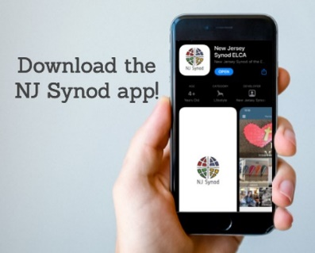
Weekly e-newsletter connecting our synod together with weekly prayer, upcoming events, synod and churchwide activities, mission stories, congregational activities, and more. Sign up https://www.njsynod.org/stay-connected or download the app.

VICAR APPOINTMENT ON MARCH 19TH, 2023
A Memorandum of Understanding on the Matter of Pastoral Appointment
In Theological Education for Emerging Ministries (TEEM) Candidacy
TO: Congregation Council, Holy Spirit Lutheran Church, Villas
FROM: The Rev. Tracie L. Bartholomew, Bishop, New Jersey Synod

Dear Brother and Sisters in Christ,
This memorandum is in support of your discussions with Vincent Piekarski as pastor of Holy Spirit, Villas. Because this is not the usual pattern for completing the educational and candidacy requirements for ordination, it is my hope that this memorandum will both provide guidelines and engage in conversation with those who are invested in this process.

I would say at the outset that because Vincent is an outstanding candidate for the Ministry of Word and Sacrament, we will all want to do whatever is necessary to assure that his placement serves the mission of the church in the best possible fashion.

The following notes reflect my own understanding of this matter:
(1) The appointment for Vincent will begin on April 1, 2023. At this time, Vincent
will assume all responsibilities of a regularly called pastor, including presiding at
the Sacrament of Holy Communion and Baptism at Holy Spirit, Villas.
(2) A pastoral appointment in the TEEM process is an option for completing
seminary educational requirements and the steps of the candidacy process.
Upon completion of the candidacy process and seminary education, the
candidate may receive and accept a call to ordained ministry from the
congregation where the appointment is being served.
PRAYER OF THE DAY
V. The Lord be with you.
C. And also with you.

V. Let us pray,
O God, our eternal redeemer, by the presence of your Spirit you renew and direct
our hearts. Keep always in our mind the end of all things and the day of
judgment. Inspire us for a holy life here, and bring us to the joy of the
resurrection, through Jesus Christ, our Savior and Lord.
C. Amen.

(We invite you to be seated for our Readings and Psalm.)

FIRST READING
Job suffers the loss of children, wealth, and health. Accused by his companions
of wrongdoing, he knows himself to be innocent. Here, in the midst of his
suffering, Job clings to the radical hope that his vindicator, his redeemer, lives;
and that one day he himself will see God.

R. Our First Reading is from the 19th Chapter of Job (Verses 23-27a).

R. 23 “O that my words were written down!
O that they were inscribed in a book!
24 O that with an iron pen and with lead
they were engraved on a rock forever!
25 For I know that my vindicator lives
and that in the end he will stand upon the earth;
26 and after my skin has been destroyed,
then in my flesh I shall see God,
27a whom I shall see on my side,
and my eyes shall behold, and not another.”

R. This is the Word of the Lord.
C. Thanks be to God.

HYMN OF PRAISE
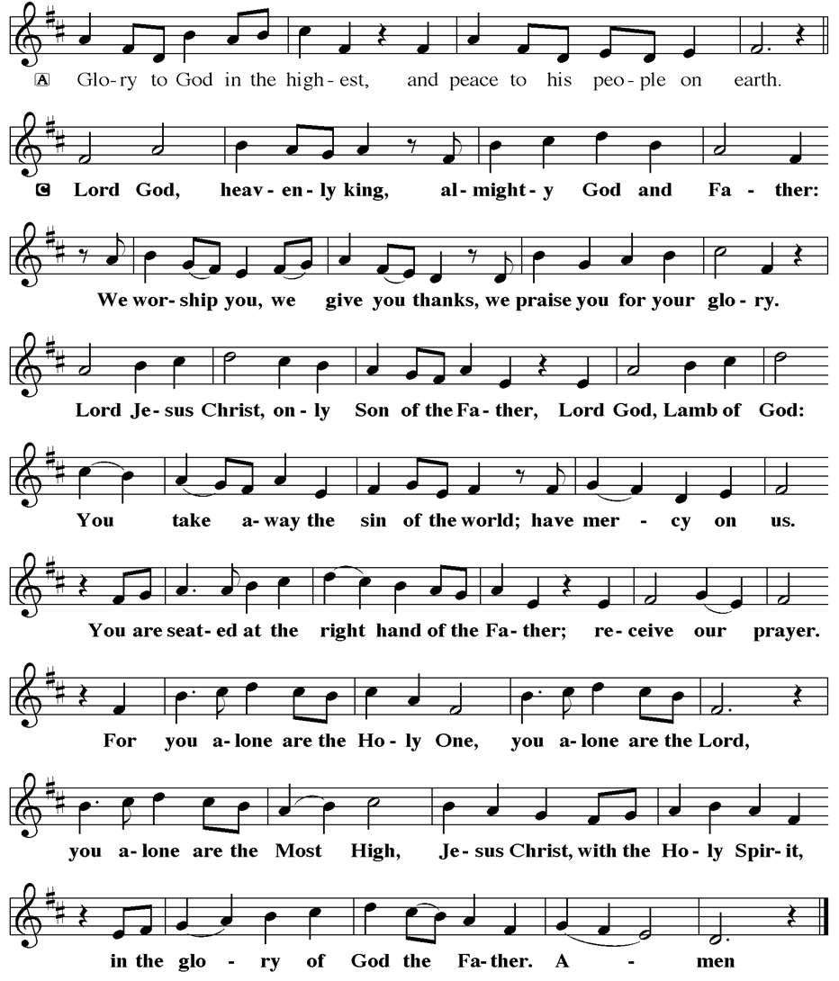
(3) This appointment is jointly supervised by the Office of the Bishop and the TEEM
pastor’s seminary. A mentoring relationship with a local pastor is required for the
length of this appointment.
(4) The synod of candidacy origin will be responsible for the approval process.
(5) Upon approval for ordination, the congregation would be expected to extend a
call to the pastoral appointee.
(6) Compensation for the TEEM pastor will be according to the guidelines of the New
Jersey Synod. All normal forms of compensation should be in place for the term
of the appointment, including stipulation that base salary and housing shall be in
accord with synod guidelines for first call at time of ordination.
(7) The ELCA Portico benefit plan for lay persons in full-time church service should
be used for the pastoral appointee up to the time of ordination, whereupon the
benefit package is to be converted to the plan for ELCA clergy.
(8) A decision for Pastoral Appointment is made with the agreement of a synod and
its candidacy committee, and the ELCA, normally represented by the regional
staff person of each in consultation with the seminary and its Director for
Contextual Education.
(9) Pastoral Appointment in a TEEM Candidacy is an option that is to serve the
mission of the Church in a particular and vital way and is not to be viewed or
used as a means to circumvent the normal candidacy process and/or first call
placement process.

In the specific case of Vincent, the New Jersey Synod remains responsible for the candidacy and approval process, and has agreed to this proposal for Appointment at Holy Spirit, Villas.

Continued blessings to both Holy Spirit and Vincent Piekarski as you embark on this journey of mutual ministry. As partners in ministry, we walk with you and rejoice in this new relationship.

VICAR VINCE’S DAY OF REST
A day of rest can have physical, mental, and spiritual beneficial. “Mittwoch,” German for mid-week, or Wednesday, is the day that Vicar Vince will use to recharge and do some other things. Please do not hesitate to reach out if there is an emergency!

VICE PASTOR UPDATE
Pastor William Hodgetts continues to attend our Church Council Meetings
and provides Supervision and Support to Vicar Vince.
TRUE DELIVERANCE PRAISE & WORSHIP CENTER
Reverend Maria Brooks and True Deliverance Praise & Worship Center utilize our facilities from 1-4PM on Sundays. TDPWC hosts or assists with other events throughout the year. TDPWC hosts a Prayer Line on Mondays, Wednesdays, & Fridays at 5PM on the Conference Call 1-657-390-7957; & Bible Study on Thursdays at 6:30PM on Zoom. See Rev. Brooks for more information.

ADDITIONAL OFFERINGS FROM OUR NEIGHBORS
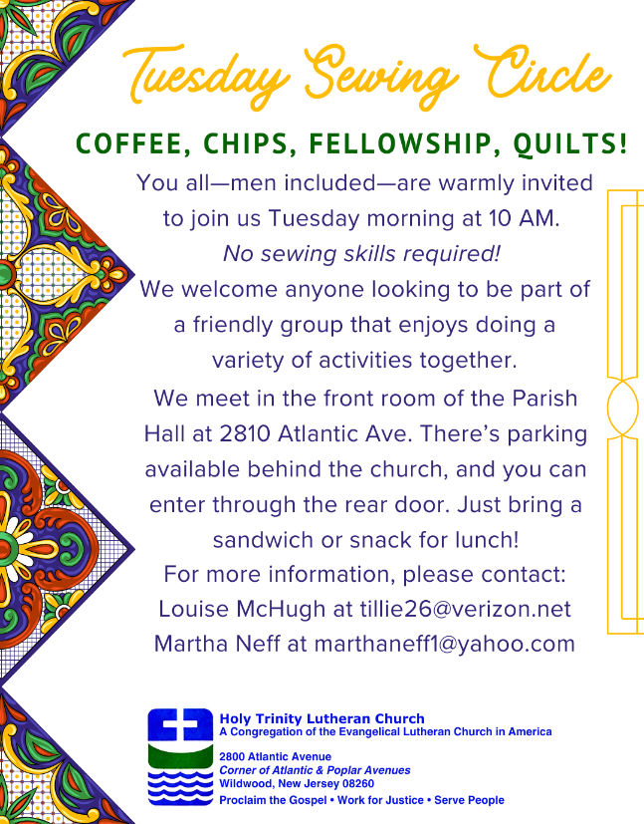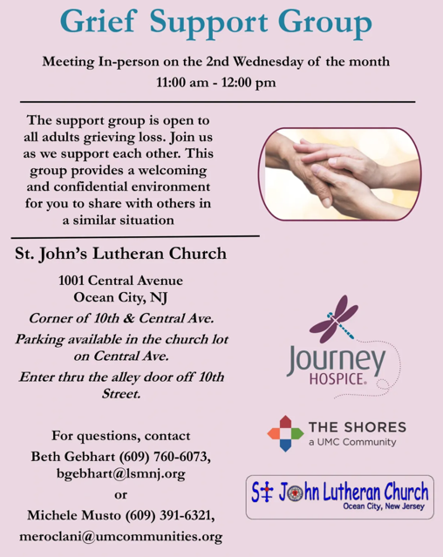

ST. BARNABAS CARES THRIFT STORE
Are you a person who enjoys staying active, interacting with others, likes the flexibility of working an hour or two per month and would like to support a good cause? If so, then St. Barnabas Cares Thrift Store is looking for you! The store in the Villas is looking for friendly, outgoing people to volunteer and sell clothing. There is no heavy lifting, but instead you would be arranging clothing attractively for sale. The Thrift Store is open 11-3 Monday through Saturday so even volunteering a few hours a month will help. If interested, please call Maureen Kersch 609-425-1317.

APOSTOLIC GREETING
V. May the grace of our Lord Jesus Christ, the love of God,
and the communion of the Holy Spirit be with you all.
C. And also with you.


V. In peace, let us pray to the Lord.
C. Lord, have mercy.

V. For the peace from above, and for our salvation, let us pray to the Lord.
C. Lord, have mercy.

V. For the peace of the whole world, for the well-being of the church of God,
and for the unity of all, let us pray to the Lord.
C. Lord, have mercy.

V. For this holy house, and for all who offer here their worship and praise,
let us pray to the Lord.
C. Lord, have mercy.

V. Help, save, comfort, and defend us, gracious Lord.
C. Amen.
V. Faithful God,
C. you have shown us the ways of your heart,
yet we stray from your paths.
We are stuck in sinful systems of oppression
and do not embrace the freedom
of your faithful promises.
We ignore our neighbors.
We exploit the earth.
We reject your abundance,
trusting our impulses instead of your steadfast love.
Repair our relationships,
restore what we have broken,
renew our hearts,
and bring us to new life.
Amen.

V. Hear the good news:
God the Faithful One loves you,
☩ in Christ Jesus your sins are forgiven,
and by the power of the Holy Spirit you are set free.
C. Amen.

GATHERING HYMN
(We invite you to sing along.)
Lutheran Book of Worship—Green Book
352—I Know that My Redeemer Lives
(4 Verses)

JUST FRIENDS
Promotes a spirit of fellowship among adults 50 years and older. Bring your own lunch to enjoy, beverages and deserts are provided. Everyone is welcome regardless of faith or parish affiliation. The group meets in Our Lady Star of The Sea Parish Hall on the last Wednesday of the month from 12Noon to 2PM from September through May. For more info call Martine Simonis 609-884-5312 x 110.


EVANGELICAL LUTHERAN CHURCH IN AMERICA & NJ SYNOD
The ELCA was formed in 1987 by the merger of three Lutheran Church bodies –
the ALC (American Lutheran Church), the LCA (Lutheran Church in America),
and the AELC (Association of Evangelical Lutheran Churches).
To learn more, go to the ELCA's website at www.elca.org.

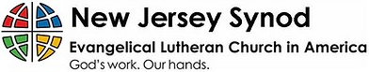
WHAT IS THE NEW JERSEY SYNOD?
The New Jersey Synod is a geographical grouping of Evangelical Lutheran Church in America (ELCA) congregations that share the mission and ministry of the Church on the New Jersey territory. It is one of 65 synods in the ELCA. The NJ Synod is comprised of 143 congregations, which include over 45,000 baptized members.

2025 FINANCIAL STANDING
OCTOBER INCOME | $10,356.00
OCTOBER SPENDING | $16,460.45
OCTOBER GAIN OR (LOSS) | ($6,104.45)
2025 INCOME | $54,214.38
2025 SPENDING | $68,708.32
2025 GAIN OR (LOSS) | ($14,493.94)
ED GREEN CAPITAL IMPROVEMENT FUND | ($546.45)
FOOD PANTRY FUND (SOCIAL MINISTRY) | $11,212.04
CD | $26,245.92
75TH ANNIVERSARY | $4,585.43

CHURCH STAFF & VOLUNTEERS
VICAR, BIBLE STUDY & FAITH DISCUSSIONS, NEWSLETTER, & WEBSITE
Vicar Vince Piekarski
VICE PASTOR
Pastor William Hodgetts
ORGANIST & PIANIST
Carol Amundsen
CHURCH OFFICE, SUNDAY SCHOOL, & FOOD PANTRY
Heather Piekarski
CHURCH COUNCIL PRESIDENT
Mary Melnicoff
CHURCH COUNCIL VICE PRESIDENT
Judy Brannan
CHURCH COUNCIL TREASURER
Bonnie Millard
CHURCH COUNCIL SECRETARY
Vicki Rinier
CHURCH PROPERTY
Frank Ford & Wayne Rand

CONFERENCE CALL CHECK-IN
(Roll Call and Attendance.)

WELCOME & ANNOUNCEMENTS
(Vicar (V), Assistant (A), Reader (R), and Congregation (C).)

INTRODUCTION
A. We worship on the first day of the week because Jesus was raised on that day.
Every Sunday is a little Easter. This Sunday feels more like Easter than many as
the appointed texts celebrate the reality of the resurrection. Live it up this Lord’s
day. Our God is the God of the living.

PRELUDE
(Music offered by our Organist at the start of our Worship Service.)
O For a Thousand Tongues to Sing

CHIMES
(Music offered by our Organist at the start of our Worship Service.)
My Country Tis of Thee

V. We invite you to stand as you are able.

CONFESSION & FORGIVENESS
(All may make the sign of the cross, the sign that is marked at baptism.)
V. Blessed be the holy Trinity, ☩ one God,
who forgives all our sin,
whose mercy endures forever.
C. Amen.

V. Let us confess our sin in the presence of God
and of one another.

(Silence is kept for reflection.)


We, the Evangelical Lutheran Church of the Holy Spirit, are People of God, who
are called by the Holy Spirit to pray, worship, joyfully proclaim Jesus Christ,
and compassionately witness and serve others in Christian Love.


We are glad that you joined us for Worship today! Thank you for enriching our time together! We would like to get to know you better, and for you to get to know us better too. Brochures, welcome gifts, prayer shawls, Bibles, and other items are available throughout the church. We would be happy to show you around and share about our ministries. Please do not hesitate to speak up and ask questions.
Also, please make sure you sign-in on our clipboard on the podium in the lobby.


Our Worship Services are conducted in coordination with our Conference Call.
Join us at 657-390-7423 or 701-802-5170, with access code 8221190#.
You may need to dial 1 first depending on your phone plan. After logging in please announce your name and feel free to talk with others until we get started.

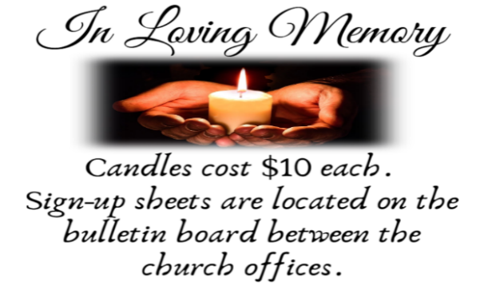
SANCTUARY CANDLE FOR NOVEMBER
Given to the Glory of God & In Memory of ED GREEN by Fran Green & Family.
ALTAR CANDLES FOR NOVEMBER
Given to the Glory of God & In Memory of PHILIP ZIMMERMAN, JR.
by Jean Zimmerman.

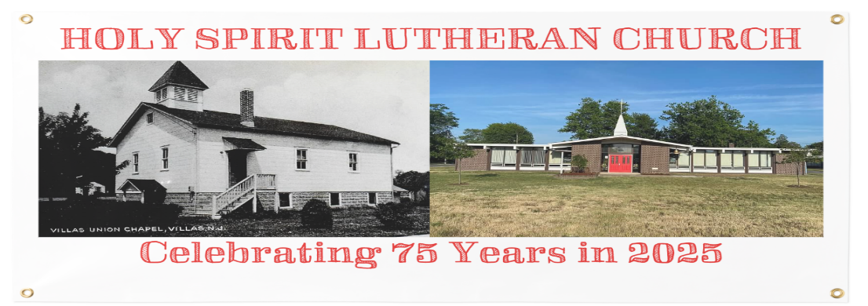

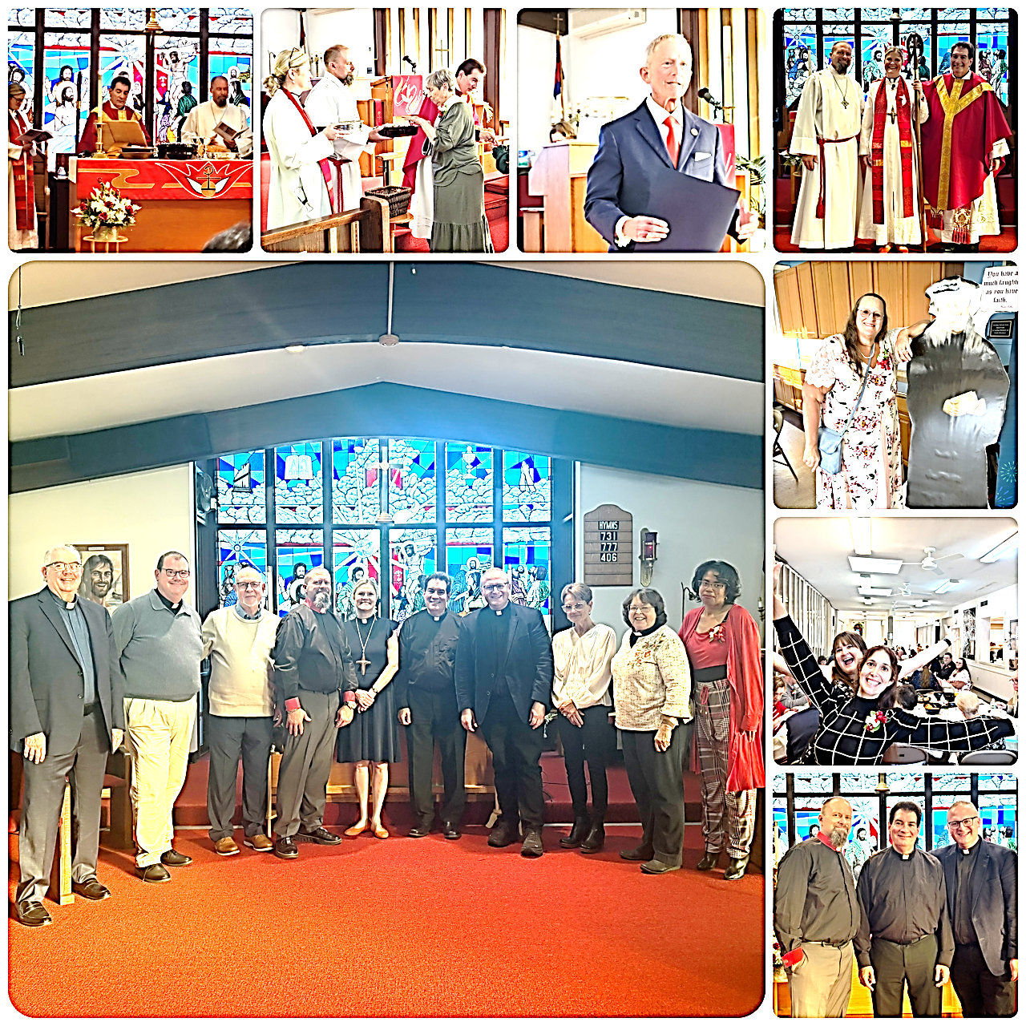

WELCOME TO
HOLY SPIRIT LUTHERAN CHURCH
A Member of the Evangelical Lutheran Church in America, New Jersey Synod
1220 Bayshore Rd., Villas, NJ 08251, 609-886-2414,
holyspiritlutheran@comcast.net, holyspiritvillas.com, facebook.com/holyspiritvillas
Vicar Vince Piekarski can be contacted at any time for conversation or prayer through call or text at 412-225-0287, or through email at vpie8282@gmail.com.
SUNDAY, NOVEMBER 9TH, 2025
22ND SUNDAY AFTER PENTECOST
10:30AM WORSHIP SERVICE WITH HOLY COMMUNION 