l 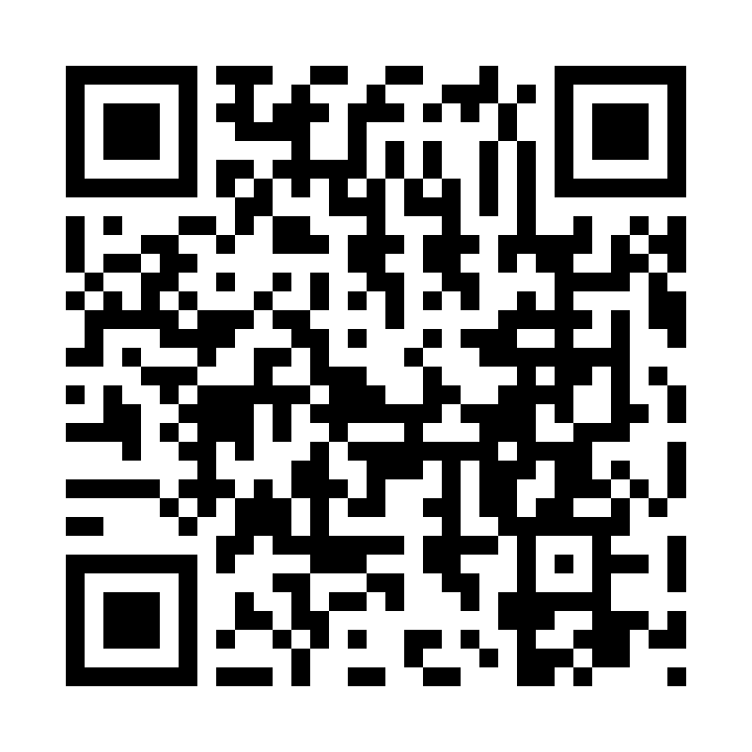
Catholic Church cluster of Davenport
St. Francis of Assisi – Harrington
Immaculate Conception Catholic Church – Davenport
St. Michael Catholic Church – Reardan
St. Kateri Tekawitha Catholic Church – Ford
Sacred Heart Catholic Church – Wellpinit
Mailing Address: Immaculate Conception Catholic Church - Davenport
1310 Adams St., Davenport, WA 99122-9454
(509)725-1761
Office manager: Jackie – icdavenport@dioceseofspokane.org
Immaculateconceptiondavenport.org
Any information for the bulletin needs to be to Jackie
Pastor – Fr. Brian Sattler – bsattler@dioceseofspokane.org
Sacramental requests: Call Fr. Brian 503-989-7585

The Holy Sacrifice of the Mass
Daily Tues., Wed., Fri. Davenport at 9am, Reardan Thurs. 9am.
Saturday Harrington mass at 5:30pm - Sunday Rosary at 8am in Davenport
Davenport at 8:30am, Reardan at 10:30am, Ford 12:30pm (1st-2nd-3rd Sunday in Ford) (4th Sunday in Wellpinit)
Confessions – half hour before Sunday mass.

*ACA for ICC is $14,060, St. Michael’s $ 8,900 and St Francis $ 3,900

Fr Brian reflections:

Sunday, January 18, 2026 2nd Sunday OT A
Mass 7102, 5:30 PM St. Francis Saturday Vigil intention Pro Populo, Adam and Johnny 14, Brett Bray 14, Robin 14, Sam Klein 14, Bob Davis 14, Pam Boyd 14, James Ryan 14, Mike H 14, Cindi B 15, Mark 17, Eileen Murphy 19, Kenny Flett+ and family 29, Mike M 30, and Fr. Floch+and family 37
Mass 7103, 8:30 AM Immaculate Conception intention Pro Populo, Adam and Johnny 15, Brett Bray 15, Robin 15, Sam Klein 15, Bob Davis 15, Pam Boyd 15, James Ryan 15, Mike H 15, Cindi B 16, Mark 18, Eileen Murphy 20, Kenny Flett+ and family 30, Mike M 31, and Fr. Floch+and family 38
Mass 7104, 10:30 AM St. Michael intention Pro Populo, Adam and Johnny 16, Brett Bray 16, Robin 16, Sam Klein 16, Bob Davis 16, Pam Boyd 16, James Ryan 16, Mike H 16, Cindi B 17, Mark 19, Eileen Murphy 21, Kenny Flett+ and family 31, Mike M 32, and Fr. Floch+and family 39
Mass 7105, 12:30 PM St. Kateri intention Pro Populo, Adam and Johnny 17, Brett Bray 17, Robin 17, Sam Klein 17, Bob Davis 17, Pam Boyd 17, James Ryan 17, Mike H 17, Cindi B 18, Mark 20, Eileen Murphy 22, Kenny Flett+ and family 32, Mike M 33, and Fr. Floch+and family 40
Isaiah 49:3, 5-6/Psalm 40/1 Corinthians 1:1-3/John 1:29-34
The Lord through Isaiah is revealing that we are to serve him by being a light to the nations. The Psalmist is encouraging us to do the will of God. The Holy Spirit through 1 Corinthians is reminding us we are, “sanctified in Christ Jesus,” and to call on the name of the Lord so we grow in holiness. The Holy Spirit through John the Baptist in the Gospel of John is revealing Jesus is the “Lamb of God who takes away the sins of the world…the Son of God.” Father open the hearts of all your children to call upon you daily so your will be done through us each day. I ask you this in Jesus. Amen. Most Holy Virgin Mary pray for us. St. Joseph pray for us. St. Francis pray for us. St. Michael pray for us, St. Kateri pray for us.

CYC26 in Spokane, Wa March 14, 2026! See Fr Brian for registration information.

Mass Intentions: Jan. 17 Sat. 5:30pm Jan. 18 Sun. 8:30, 10:30 12:30 Jan. 20 Tues. 9am Jan. 21 Wed. 9am Jan. 22 Thurs. 9am Reardan Jan. 23 Fri. 9am

