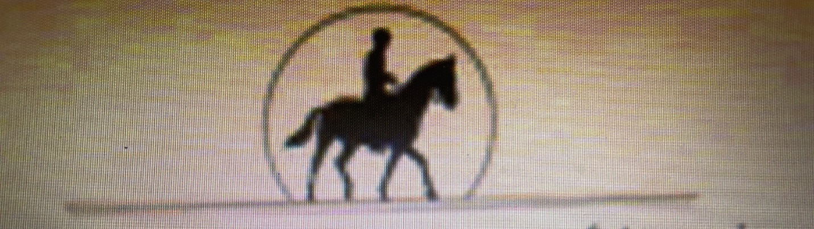
BACK COUNTRY HORSEMEN OF AMERICA PO BOX 202
LOWER RIO GRANDE CHAPTER MESILLA, NM 88046
MEMBERSHIP APPLICATION
NAME________________________________________________________________AGE________ SEX__________
NAME________________________________________________________________AGE________SEX___________
ADDRESS________________________________________________________________________________________
HOME PHONE______________________________________ WORK PHONE_____________________________
EMAIL ADDRESS____________________________________CELL PHONE__________________________________
TYPE OF MEMBERSHIP: ( ) INDIVIDUAL 45.00/YEAR, ( ) FAMILY $55.00/ YEAR
PHYSICIAN________________________________________PREFERRED HOSPITAL__________________________
EMERGENCY CONTACT__________________________________________PHONE___________________________
SIGNIFICANT HEALTH ISSUES ( ) SEVERE ALLERGIC REACTIONS
( ) INSULIN DEPENDENT DIABETES
( ) HEART DISEASE
OTHER_______________________________________________________________________
Do you have a way to transport your equines? ( ) Yes ( ) No
Release of Liability Statement
I/We realize there are inherent risks involved in all activities with equine animals and I/we hereby release Back Country Horsemen of America of New Mexico and the Lower Rio Grande Chapter from liability for any accident, injury or death that may occur to myself, ourselves, or my/our equine by participation on any Back Country Horsemen of America activity.
I/we further understand that I/we are fully responsible for our minor children and release Back Country Horsemen of America of New Mexico and of the Lower Rio Grande Chapter of all liability for any injury, accident, and /or death of any minor child. Children under the age of eighteen (18) years are not allowed to participate in any BCHA activity unless accompanied by a parent or legal guardian.
SIGNATURE____________________DATE_______ SIGNATURE_______________________DATE________

