BOARD NOTICES
A BIG THANK YOU
If you’ve never attended an annual meeting you are most likely unaware of all the work that goes into making the meeting happen. The goal is to make it appear seamless and effortless; sometimes there are glitches, but they are usually small enough that they happen and are gone from sight before anyone notices.
It all starts with the Board of Directors: We are the ones who determine the date and work on getting all the materials together and out to the membership, so you are prepared to come to the meeting with all the information you need to ask questions and make informed decisions. Thanks to Dorrie, Odie and Karen who helped collate and stuff packets. And to Peggy Hatfield who happened to be the volunteer on duty in the reception office and was highjacked to help.
Office Volunteers: Thanks to Pam Gallagher who did all the photocopying of all the materials that were stuffed into the envelopes that were labeled by Carol Hallworth. And to all the other office volunteers who answered countless questions by our members and who gave out 45 absentee ballots.
Food & Beverage Team: Without Barbara McDermott and Diane Lamarre there would have been nothing to eat and drink that day; they did the shopping, ordering and transporting of everything that available to meeting attendees. Thanks to Rita Villemure for helping to setup and serving everyone who came through the lunch line. And there would not have been any coffee or Munchkins if not for Rich Piccolo making the round-trip Dunkin`s run.
Thanks to my good friend Karen Fudala who took control of all the details relating to check-in and balloting.
And thanks to her team members:
Registration–Stan Fudala, Pam Gallagher and Rachael Hogan, Joan Roy, Sue Soule, and Judy Sullivan
Ballot Counting–Evelyn Connor, Patty Gamache, Dolly Piccolo and Rich Piccolo
Observers–Karen Fudala, Stan Fudala and Tony Roy
Ballot Box Attendant–Judy Patrick
Audio Team–Dick Gamache (audience microphone) and Dave Kirkpatrick (equipment setup and breakdown.)
And finally, my husband Jack Cyr. He’s the guy who always shows up to collate and stuff the materials, takes them to the post office, loads our car with the audio equipment and all the things I need to make the meeting happen, helps with setup and runs the microphone and then breaks it all down, puts it back in the car unloads it all back at the office. . .the list goes on and on. He does it all without me having to ask and overlooks the fact that I don’t always use “please” and “thank you” so that’s why I wanted to take this opportunity to tell him, “I could never do it without you.”
Debbie Cyr Director at Large
AND THE WINNERS ARE:
Just in case you haven’t heard.
With over 150 ballots cast, your 2019-2020 Board of Directors is as follows:
President – Kim Capen (re-elected for 2-year term)
Vice President – Odie Perron
Secretary – Karen Kirkpatrick (re-elected for 2-year term)
Your overflowing generosity! Photo: Deb Cyr
Treasurer – Dorrie Kossuth
Operations Director – Michael O’Brien (newly elected for 2-year term)
Directors At Large –
Ellyn Barnard (newly elected for 2-year term)
Debbie Cyr (re-elected for 1-year term)
Jim Eddinger (newly elected for 2-year term)
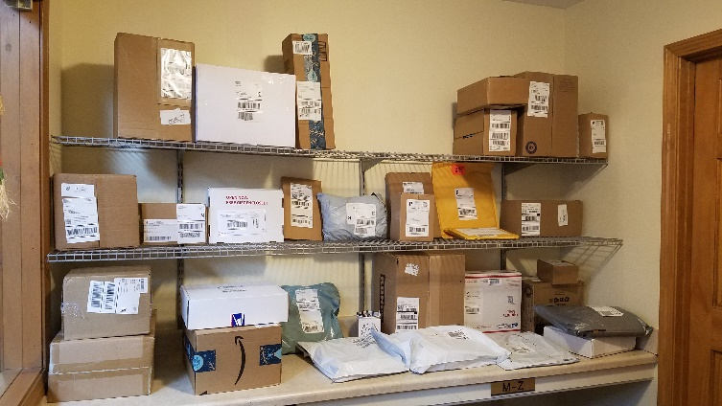
Sonja Fuller

THIS AND THAT

Food Drive–Thanks to all the Medvil residents who donated to the food drive that was held recently for the Goffstown Food Pantry. We delivered 16 boxes and 6 large shopping bags of food.

Is there an organization for which you would like to host a charity drive? In the past, Medvil has collected for the Manchester Animal Shelter, Liberty House, Glen Lake Elementary School, Toys for Tots and of course, several times to the Goffstown Food Pantry. If you’d like to chair a drive, the Newsletter Committee will be happy to help with notices, flyers, etc., and the occasional email blast can be provided as well. Send an email to medvilmessenger@comcast.net with the name of your organization, what the drive will consist of (food, clothes, etc.) and the time frame in which you’d like to host the drive…and don’t forget to include your name and phone number so we can contact you.
Your overflowing mail room! Photo: Deb Cyr
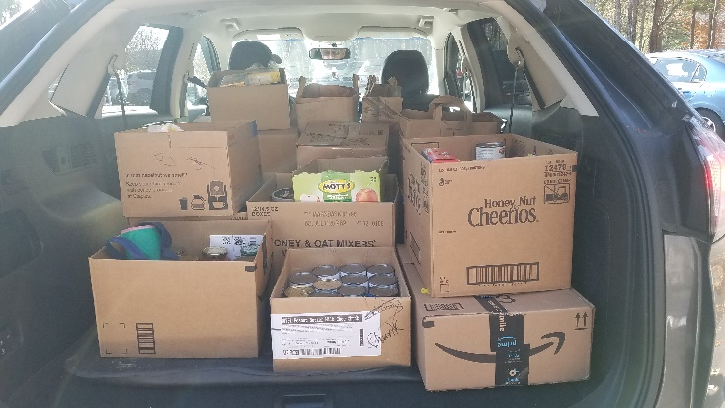

Stakes with Reflectors–These stakes are already beginning to ‘blossom’ throughout Medvil. Our Maintenance Team uses these as a guide for plowing and strives to keep one foot between the plow and the stakes; if you put them too close to the edge of the road, the plows will not be clearing the roads to their optimum width so please place these reflectors 12 inches back from the road.

Tis the season for…packages! With just a month to go until Christmas, packages have already started to arrive in Medvil by the dozens; here is a photo taken a couple of weeks ago and there will be plenty more arriving between now and December 25th. If you are online shopping and expecting packages please be sure to pick them up at the office as soon as they arrive so room can be made for the packages being delivered right behind yours.

A Special Request from the Events Committee:

With the downstairs renovation of the Donald Drive Club House almost complete, the Events Committee is looking for old photos from days gone by here in Medvil. Back in the day, the former owners put on plays, cabaret nights, costume parties, etc. and the committee is looking for photos of these days gone by. The plan is to develop photo collages depicting these “blasts from the past” along with pictures from more recent events. If you have pictures you’d like to donate, please put them in an envelope, write ‘Events Committee’ on the front and drop them off at the Receptionist Office. If you’d like your photos returned, please write your name on the back of each one and once copies are made, the originals will be returned to you. Thank you.
A Couple of Reminders: Check to make sure the heat tape under your house is working and if it isn’t, call a repair man or family member to fix it. This is important as heat tape keeps the water line coming into your home from freezing. It’s also a good idea to make sure the insulation under your home is intact and in place.

As you begin decorating your home for the holidays keep in mind that inflatable lawn ornaments are not allowed at any time. (Community Rules, D. Sites, #4)

Overnight parking on the streets is never allowed and there is no street parking at all from November 15th to April 15th. (Community Rules, E. Vehicles, #2)
Metal Monday is just that: the first Monday of each month. So please refrain from putting your metal objects in with the trash. Here are the dates of the next four Metal Mondays; December 2nd, January 6th, February 3rd and March 2nd. If for some reason the maintenance team needs to reschedule the pickup, a notice will be posted at each mail house. Thank you.

And Finally–We’ve been asked to give a shout out and a big thank you to Rolande Moore and Odie Perron. Rolande has been working on setting up the Winter Village that was donated to our community when the Wilsons moved to Medvil and no longer had the room to set it up in their home. It’s a big endeavor with lots of pieces and LOTS of wires and extension cords. Odie set up a Christmas village at the Donald Drive Club House and made sure the Christmas tree was set up in time for the pictures with Santa event; she is also responsible for all the other decorations you see in the clubhouses. If either of you had a ‘crew’ helping you out, please be sure to thank them for us; we appreciate all the work that’s been done to help get our community into the holiday spirit.
OTHER NOTICES

A NIGHT OUT FOR SENIORS

Those of you who’ve enjoyed the free festivities hosted in past years by your Goffstown Police Department will welcome another opportunity to celebrate with Officer Jackie. This year’s hospitality will be offered on Friday, December 13th from 5 to 8 PM at Goffstown High School and will include music, dance presentations, and a visit by Santa Claus! Your very own Medvil Strummers will be there with their ukuleles! And you can sit back and let someone else drive, because bus transportation there and back will be offered. Watch your email and mail house postings for more info.
BOARD & COMMITTEE REPORTS

BOARD OF DIRECTORS

As happens all too often, the board reporter arrived late to the fray due to the combined effects of heavy traffic and working in distant Burlington, MA. Consequently, until the membership report is reached this report will tell what was discussed according to the agenda, but will not cover the actual discussion. Apologies, and if someone would like to volunteer to write the board report, pleased let the office know.
The November Medvil Board of Directors meeting began with the Pledge of allegiance at 6:00 PM on November 19, 2019.
Member comments were entertained and addressed.
The Treasurer's Report resulted in acceptance of the October financials by the board, and an update was given on our new office administrator, Andrea.
In the Secretary's Report the minutes to the October 15th board meeting, the October 31st Special Meeting, and the November 2nd Special Orientation meeting were accepted by the board.
During the Operations Report, any requests for home or shed improvements were voted on by the board. The board received an update on quotes for next year's pedestal replacements. An update for security camera installation was also given to the board. The board discussed whether to have the clubhouse bathrooms cleaned and stocked by volunteers or a paid contractor. The board discussed the cost of putting pole lights Constitution Road. Any salt shed quotes we have obtained were discussed. Drainage issues currently being addressed were put before the board, and the need for tires on our backhoe was discussed.
When the board reporter arrived, a vote was being held on using archers to kill coyotes that have been seen on Medvil property. The measure passed unanimously.
The Membership Committee had the board ratify a written vote on a new proposed member. Also announced was that a potential new Membership Committee member is being vetted.
Other committee announcements include a free Thanksgiving Meal (members only) and the Christmas party which will not be free, but will be available to non-members.
Old Business: Siding estimates were higher than seemed reasonable. More estimates will be obtained. Preferred vendor and bidding will be taken up at a special board meeting on the first Tuesday in January at 5:00PM. Annual Meeting quorum was met earlier than any other meeting, and 156 ballots were cast. The school will not be available in the future for our Annual Membership meeting. Medvil is apparently the only entity that rents the school, and the school plans to dispose of the chairs and tables and cease renting their space out. The food drive did very well with 16 boxes and 6 large grocery bags of food delivered to the Goffstown Food Pantry.
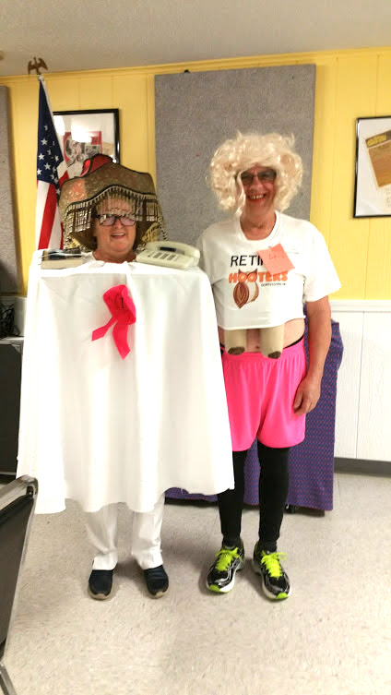
New Business: The board wants to be sure that new members of the cooperative understand that they have to keep their property up. Membership will exercise additional scrutiny into prospective member's financial capabilities. The board wants to ensure that street informational signs are always subject to the board discussion and decision process. Board of each ROC-affiliated cooperative will vote for one of three candidates running to be ROC Association representative and Board Member of ROC USA. Our board voted for two by-law changes for the ROC USA Organization, and also voted for the most local of the three candidates; Medvil's Kim Capen. Board did not vote to change the current office hours for winter; office hours remain at 9-4 for the winter. Board discussed two trailers on Constitution Drive. The owners cannot be identified, and if they board cannot find out who the trailers belong to, the trailers will be towed.
In the final member's comments section of the meeting, it was asked if the new rules will be delivered to cooperative members. The answer was in the affirmative.
The meeting was adjourned for executive session at 7:20 PM, 11/19/2019. Alyn Miller reporting
EVENTS COMMITTEE

Have you all been eager to find out who won the Best Costume Contest at the Annual Medvil Halloween Party? Well, the wait is over—first prize went to Joe Lamarre whose costume as a Retired Hooker was created by his wife, Diane, who won second prize for her own creation as a One Night Stand. Evelyn Connor won third prize for her Ghostly Apparition. The Spookghetti and Eyeballs Dinner was delicious, and everyone had an eerily good time.
Hallowe’en Photo: Cat Pragoff

While we were ready with cookies and hot chocolate for the Photos with Santa afternoon on
November 3, unfortunately not very many folks came to visit, so we had enough left over to share with the nice people who attended Meat Bingo on November 16.
The Omelet Breakfast on November 9 was a huge success. We served 104 meals in the clubhouse, sent two meals home for a neighbor who was recovering from cancer surgery, and for her caregiver, and shared our half of the 50/50 with Cathy Thellen, who had just lost her home to a devastating fire. The winner of the 50/50 also donated part of her winnings to help Cathy.
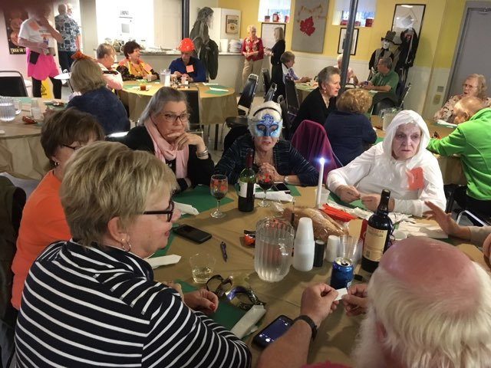
Several of us will be helping Kim with Thanksgiving dinner again this year and hope to see some of you there. If not, we wish you all a very happy, healthy Thanksgiving for you and your family and friends.

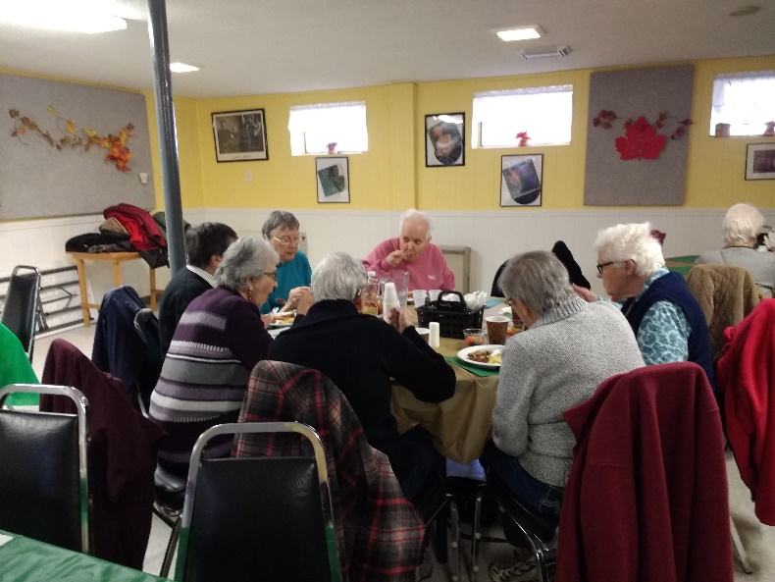
In December we have three, count 'em, three lovely events for our community. First is our Annual Christmas Party on December 7 from noon to 4 pm. Again this year we're holding it at the Derryfield Country Club, and again this year the Events Committee is subsidizing the ticket prices to allow as many of our friends and neighbors as possible to attend. The tickets are $15 for Medvil residents and $30 for non-residents; and if you wish to reserve a table, you must take all the names, and all the money, into the office when you're ready to make the reservation. Only full tables of 8 can be reserved. The Derryfield requires a final head count by Friday, November 29, so please be sure to let the office know as soon as possible if you plan to attend.
Breakfast Photographer: Diane Lamarre

Next up is a Christmas concert by the Northern Voices a Cappella group on December 18 at 7 PM at Partridge Lane Clubhouse. Since this is a free event, it will be for Medvil residents only, please.
Hallowe’en Photo: Cat Pragoff
Finally, Allen Brown, of Brown Excavating, has once again very generously offered to cater a holiday dinner on the Sunday before Christmas. This year there will be two seatings: 11 AM and 12:30 PM. For ease of serving, Allen prefers Partridge Lane Clubhouse. an appearance again this year—so until then, you'd all better be on your very best behavior.
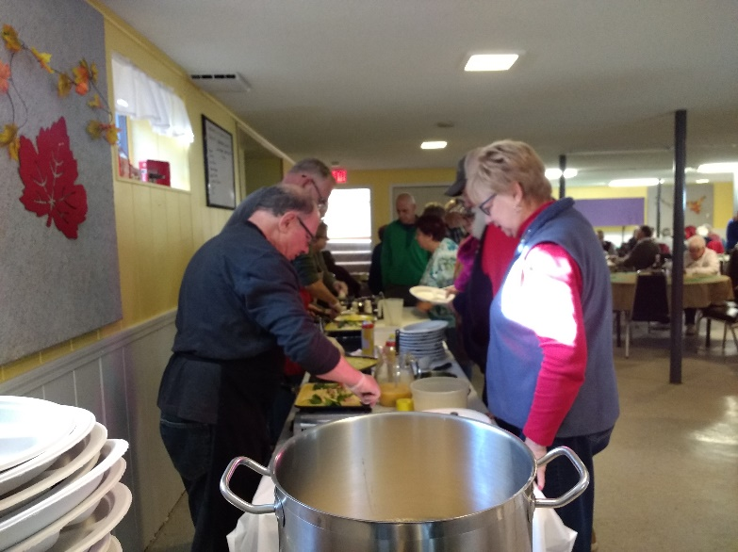
CP

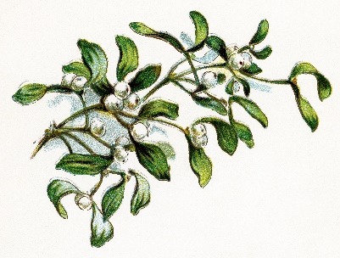
Breakfast Photo: Diane Lamarre
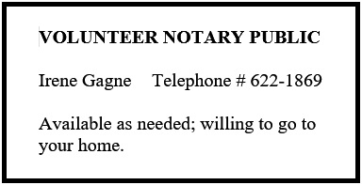

FUNDRAISING COMMITTEE

Contact Irene Gagne at 622-1869

Fundraising Pool

The 11/1 winner was Beth Tibbetts for $250. All numbers are being played with a guaranteed winner. There are currently 5 residents on the wait list but more are needed. Please call the office at 497-4440, Option “0” to place your name on the list. It’s only $5/month and you can play more than one number.

Consignment Store/Yard Sale

If you have items to donate please contact Irene. What doesn’t get accepted by the consignment stores or sold on Ebay will be placed in the 4/4/20 yard sale. However, we do not take electronics, TV’s, large appliances, furniture, or exercise equipment. Please do not place any items in the mail houses.

Committee Members

We are a committee of 9. We are looking for more members with fresh ideas and help with yard sales.

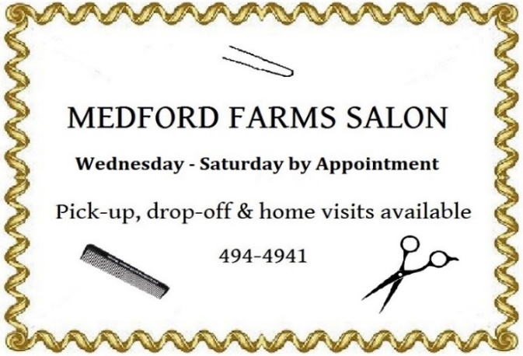
Ideas Needed

You don’t have to be a committee member to give us suggestions for projects to use our funds for the benefit of the Medvil community – call Irene with suggestions, including cost. IG
REAL ESTATE COMMITTEE

During the month of November, we had 2 closings, 1 listing and 9 showings.

The Medvil Real Estate had a prosperous year for during 2019. There are people driving through our community and stopping into the office asking to see our homes for sale. We are always available to show them our listings. We also get website and phone inquiries requesting information about Medvil Cooperative living. Medvil is a sought-after community.

If you are thinking of selling your home, the first
step is to fill out the Intent to Sell form and return it to the office. The second step is to locate a realtor. Please consider Medvil Real Estate to help you sell your home. Sales benefit Medvil community.

Medvil RE Committee - 497-4440 Prompt 2

Website: www.medvilcooperative.com Homes for Sale

Dorrie Kossuth, Chairperson
WELCOME TO MEDVIL!

Here is a list of all our friends and neighbors who came to our community during 2019. We hope they are enjoying their life here in Medvil.

- John W. and John P. Armstrong on Donald Drive
- Frank and Janet Berube on Roger Road
- David and Judith Coburn on Donald Drive
- James and Elaine Davis on Donald Drive
- Charles “Chuck” French on Lovers Lane
- Ed Gass and Nancy Seager on Partridge Lane
- Robert and Anita Girard on My Way
- Rachel Hogan on Kelley Court
- Maurice and Janice Janelle on Country Way
- Debra Lodge on Country Way
- Gerald and Claire Montminy on Donald Drive
- Wendy Myler on Donald Drive
- Karolina Nolan on Donald Drive
- Judith Owens on Country Way
- Lucille and Raymond Pelletier on Brandon Lane
- Frederick Plett on My Way
- Alfred and Constance Roukey on Donald Drive
- Andre and Murial St Laurent on Williams Way
- Barbara Stuart on Riverledge Drive
- James and Brenda White on Riverledge Drive
- Darlene Willard on Donald Drive

The Membership Committee

SINCERE CONDOLENCES

Heartfelt condolences to those who have recently lost a loved one:
- Imogen Goldthwaite, who lost her husband.
- Bill Biggs, who lost his brother.
- Raymond and Lucille Pelletier, who lost Raymond's brother.

We meet them in the lives they’ve shaped. We enjoy them in the jokes and wisdom they’ve passed down. Be active in the community they’ve built. It is a way of walking with them into the future. It is a way of never losing them. LR
HOW TO BE HEALTHY
COLDS AND FLU BY THE NUMBERS

200+
The number of viruses that can cause the so-called “common cold.”

24+ Hours
How long some cold and flu viruses can last on hard surfaces.

43%
How much you can reduce the number of days you feel sick with cold symptoms if you stay active (five or more days of aerobic exercise a week) as opposed to being largely sedentary (one day of exercise weekly, or less.)

2.94 Times
How much more likely you are to get a cold if you sleep fewer than seven hours per night, compared with people who get eight or more hours of zzz’s.

20
The number of seconds for which you should wash your hands, using warm or cold water and soap, to avoid spreading germs.
6 Feet
The radius within which a person with the flu can spread it to other through talking or sneezing.

100%
The percentage of people over 6 months old that should get the flu shot. If you are not feeling well, have ever had Guillain-Barré syndrome or have allergies to ingredients in the vaccine, talk to your doctor first.

–Reprinted from the November 2019 issue of Good Housekeeping magazine.
THE LIGHT BULB HAT
SIMPLE PRESSURE TEST FOR DRAFTS

So you know you should locate and seal areas of air infiltration in your home, but like many people in Medvil, you’re a warm heart/cold hands type and literally everything feels like a draft to you: How can you trust your judgement on where to tighten up your house? You can hark back to those days of beads and minis and bells we all remember with varying degrees of mortification and light a stick of incense! (You know you’ve still got some!) Run it slowly in front of window frames, door frames, phone lines, cable lines, gaps around pipes under your kitchen sink-- any potential opening from your home to the exterior. Wherever you see the smoke go wavy, you have a draft. Seal that area with caulk, weather stripping or whatever is appropriate, and you will be warmer and save $$$ on heat.

AND. . .

Speaking of gaps around pipes, do you know what else infiltrates those besides cold air? Mice! Here’s an even better way to seal them in order to keep the fauna in the flora where they belong: Get yourself a bag of fine steel wool—the kind used for wet-sanding. Pack those gaps as tightly as you can with that steel wool. I mean, REALLY stuff them! Tamp it down and pack in some more, stopping only to leave an area around the top that you can fill with silicone sealant. Mice desperate for winter shelter will gnaw through sealant if that’s all you pack those gaps with. But they don’t like to chew on steel! I had mice a couple of years ago, followed this procedure, and no more mice! MBW
MYSTERIES SOLVED

WHY WERE THERE SO MANY ACORNS IN MY YARD THIS YEAR?

In answer to the question some of you have been asking, one of our resident gardeners, Jane Von Geldern has found that biologists in New England have declared this year a local “mast year” for oaks. A mast year is when all the acorns in a region produce tons of acorns at the same time. They do this in response to a combination of weather conditions, production-and-rest cycles, and biochemical signals from tree to tree signaling the readiness to synchronize acorn production.

A mast year–as well as its reverse, a year with very low acorn production–has consequences noticeable up and down the food chain. For example, you may remember last year’s remarkable squirrel apocalypse on our local roads and highways. This was the result of a rodent population swollen by an acorn mast of the previous year, facing last year a more modest acorn crop. Competition for food supplies prompted the squirrels to attempt to forage farther and farther from their nests, resulting in many losing fights with General Motors and Toyota.

Why do they call it a “mast year?” Look to linguistics for the answer: Nuts like acorns are known as “hard mast,” signifying foods requiring effort to chew. “Mast” comes from “masticate.”

Now armed with this knowledge, perhaps you have an insight into why our resident crow and turkey vulture populations seem to be especially high this year. Remember what these birds eat? All those yummy squirrel entrees last year meant more crows and vultures hatching eggs this year!

Thanks to Jane for helping us to understand nature’s ways a little bit better. If you would like to learn more, there is a very well-written article at:

https://theconversation.com/tons-of-acorns-it-must-be-a-mast-year-126711
MBW
SEASONAL THINGS WE FIND

Blue Winter
Winter uses all the blues there are.
One shade of blue for water, one for ice,
Another blue for shadows over snow.
The clear or cloudy sky uses blue twice–
Both different blues. And hills row after row
Are colored blue according to how far.
You know the blue-jay's double-blur device
Shows best when there are no green leaves to show.
And Sirius is a winterbluegreen star.
Robert Francis

The Medvil Messenger encourages members to submit articles for consideration. Recipes, helpful hints, reminiscences, jokes, poems--please keep it upbeat and positive. Due to space considerations, original material will take precedence over reprints from other sources, including printouts of email pass-arounds. If you submit previously published material, please try to cite a source. We reserve the right to reject material that may offend, divide our community or cause political arguments. Please submit your items to our email: medvilnewsletter@comcast.net Or place a copy in the Messenger mailbox in the Reception Office in the DDC.

Deadline for submissions not from the Board is noon the day of the Board Meeting (3rd Tuesdays.) Board submissions deadline is noon of the Wednesday.

Medvil Messenger Staff: Debbie Cyr, and MB. Wulf

Medvil Messenger Writers this issue: Debbie Cyr, Irene Gagne, Alyn Miller, Cat Pragoff, Linda Robinson

Special thanks to Irene Gagne for additional proofreading.

