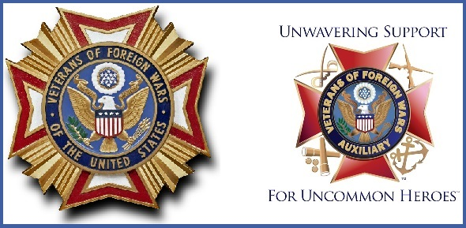
VFW POST 445 and AUXILIARY
November 2018 Newsletter

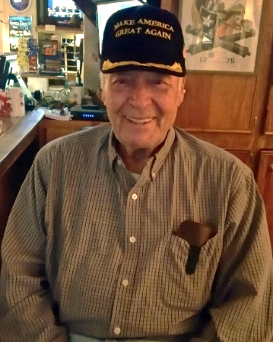
COMMANDER’S COMMENT
Comrades, Auxiliary and Supporters
Congressional Elections are approaching and many of you may have already cast your votes but for those who haven’t I urge you to do so. There are several Veterans issues that affect all of us and recent disclosures in the VA Healthcare system demand our participation. Vote!! It is a privilege you certainly earned!
We will be presenting Awards to Scouts of Troop 44 at St James Church on Camp Road on November 5th. We are recognizing their efforts in placing flags on Veterans Graves for Memorial Day. We will also present Certificates to our entries in the VFW Scout of the Year Program.
We will conduct Veterans Day Services here at the Post on November 11 at 11am. This joint ceremony is held annually partnering with American Legion Post 147. While this is dedicated to members of both organizations we also invite the Public to participate.
We will be attending District 1 meeting on November 17th at Post 8760 in Beaufort; SC members and Officers are invited.
Our initial drawing for a Life or Legacy Membership was held at the closing of our October 9th Membership Meeting. The unlucky Member was Number 170 Thomas McCarter who was not present. To recap if you are present at General Membership Meetings and your number is drawn the Post will present you with a Life Membership if you are already a Life Member we will present you with a Bronze Legacy Membership. Both memberships result in annual stipends to the post from National.
God Bless America and the VFW – Jim

MADAM PRESIDENT’S COMMENTS:
I will start with a thank you to all my Auxiliary Officers, Committee Chairmen, Auxiliary members and supporters that have supported me thus far with all that you do and sending in all your reports.
Also, a special thank you to Greg Ingalls for the wonderful hams he prepared for us and everyone that brought in all the delicious covered dishes for our Ham and Pot Luck Dinner night on October 19. It was a great success, and everyone told me how wonderful it was.
Coming up, our next dinner will be on Friday, November 16. Please don't miss it! The dinner will include grilled T-Bone Steak and baked potato prepared by Greg Ingalls, Barbara Barger's wonderful salad, rolls and a fruit cobbler by Richard Hunt. If the cobbler is as good as the banana pudding Richard prepared for our October dinner, it must be good! A sign-up sheet is on the bulletin board by the bar at the Post.
Now that the food is out of the way, let's talk about the Turkey Shoot the Auxiliary will be hosting this year. Starting on Friday, November 2, we will begin the shoot from 7:00 to 9:00 p.m., which will continue every Wednesday and Friday through November 22. We will then start the shoot again beginning Wednesday, December 5 through Friday, December 21. Please spread the word and come out and support this event. We will also need volunteers to help each of these evenings. Please contact me at 843-297-1847 if you can assist. The funds raised from this event will be used to support our Veterans. Thank you to all in advance.

As you all know, I have been working hard to reach 100% in membership. Thanks to all who have paid your dues thus far. Anyone who hasn't paid their renewal for 2019, please do so to help us reach this goal for our Auxiliary.
The donation box for the Veterans Administration Hospital is still in the Post. The list of items needed for the Veterans being served at the VA Hospital are as follows:
Women’s X-Large, XX-Large Underwear
Men’s Deodorant
Boost or Ensure
Sturdy Backpacks (big need)
Fixodent or other denture adhesive
Chess & Dominoes Sets
Men’s Large Shoes (Sizes 10, 11 and 12)
Men's medium, large & x-large sweatpants and sweatshirts

Please drop your items off at the Post or contact me if you need someone to pick them up and deliver them to the Post. Please help us with this important donation effort.
Barbara Barger is providing a life membership drive for the National Home for Children. She has offered that for the first ten people who sign up for this, she will pay for each person to receive a pin. Please visit their website at https://www.vfwnationalhome.org for information regarding this wonderful cause.
Don't forget to get out and vote on Tuesday, November 6. Please let Tamme Suggs know if you do in order that she may include it in her Legislation Report. Stickers are available at the Post to wear on Election Day to show your support in voting in honor of a past, present and current Veterans.
Very sorry that our Chaplain Jan Maria Pittman had to resign due to illness. We hope everything goes well for you, Jan. We will miss you at the meetings and hope you can return soon. Thanks to Georgia Lacson for being our Chaplain for the rest of our fiscal year.
Also - don't forget to attend the VFW Post 445 and American Legion Post 147 joint Veteran's Day Ceremony on Sunday, November 11 at 11:00 a.m. Food will follow. Always a great turnout and we look forward to you being there to honor our Veterans.
Shout out of thanks to Christian Simmons for his generous donation to the purchase of a Christmas tree for the Post.
I hope I haven't forgotten to thank anyone else – your generosity of time, treasure and talent is very much appreciated.
Our next Auxiliary meeting will be Thursday, November 8. Please come out and support your Auxiliary.
I will close with asking that we continue supporting our Veterans. God Bless our Veterans and Troops Past, Present and Future, God Bless the VFW, God Bless the United States of America and God Bless all of you! Happy Thanksgiving.
Madam President
Joyce Simmons

