Barn Buddy Application Form
Personal Information
Name
Company
Address or Land Location
City Prov Postal Code
Home Phone Work Phone Cell Phone
Email Address:
By providing your e-mail, you are granting the Lloydminster and District SPCA permission to email you on the latest events, fundraisers and other SPCA news. If you do not wish to receive these updates, please check the “Opt out” box. ____ Opt-out
Other Information
- Do you have a barn or other safe heated shelter?
Yes No
- Can you attend to the animal at least once in a 24-hour period to provide items such as food and fresh water?
Yes No
- Would you be willing to provide veterinary care should the animal require it?
Yes No
- Are you able to pick up the cat(s) within 24 hours of receiving a call from the Lloydminster and District SPCA?
Yes No
- Are you able to provide a secure place for the cat(s) to be kept for approximately two weeks while they acclimatize to their surroundings?
Yes No

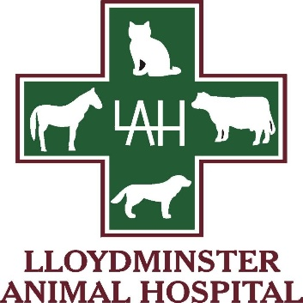
Date Received Staff Signature

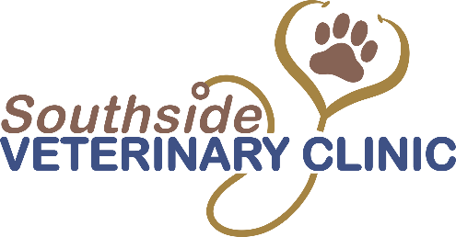
Person I.D. Signature

Proudly Sponsored by

