TBLA – Bass Unlimited Debuts 2022 Painting
By Ramona Moore
Local artist Eddie Pastureau’s poster, “Double Jeopardy on Toledo Bend”, is already a hit among TBLA Bass Unlimited – Back-A-Great-Fighter poster collectors and the general public. His original artwork and the poster number one sold for big bucks at the Poster Unveiling and Auction held Thursday evening, April 7, at Cypress Bend Resort. The event kicked off Toledo Bend Lake Association’s Bass Unlimited Fundraiser that will culminate with the Banquet and Auction on Friday, April 22, at Cypress Bend Park Pavilion.
The crowd of supporters gathered to enjoy fabulous food and beverages, visit with friends, and view the art displayed for the auction in the Grand Ballroom, which was professionally decorated by Lauren Moore and the talented staff of Nichols. Cypress Bend prepared a delicious variety of hors d’oeuvres and desserts. TBLA President Gary Moore welcomed the guests and introduced Mr. Pastureau. Then he welcomed this year’s poster sponsor, Dayna Yeldell, Owner/Broker of First Choice Real Estate Services, her husband Ricky, and agents Karen Harrison and Teresa Moreau, to the podium, and together they revealed the original painting and the signed number one poster.
The painting incorporates above and below water level scenes of skilled predators going through their everyday routines for survival on Toledo Bend. Mr. Moore thanked Dayna and Ricky and presented them with the signed poster number two.
Because TBLA was unable to hold the 2020 Poster Unveiling due to Covid, the Don Edwards’ number one poster titled “Easy Catch” recognizing TBLA’s 50th anniversary was presented for auction as well. Mr. Edwards’ original painting from 2020 will be auctioned on April 22 at the Bass Unlimited Banquet.
In addition to the poster sponsor, many organizations and people were instrumental in making the Gala a huge success. Mr. Moore recognized Poster Coordinators Mike and Carolyn Scheurich for organizing this year’s Poster Unveiling and acknowledged these sponsors:
Silver Sponsor – Cypress Bend Golf Resort, Spa & Conference Center
Bronze Sponsor – Town of Many
Poster Patrons – Randy & Deb Pennington, Mike & Carolyn Scheurich, and Lonnie & Carolyn Harper

Auctioneer Kelly Stewart took the podium and energized the crowd, prompting the highest possible bids for all three pieces of art. Artist Eddie Pastureau was present to sign and personalize purchased posters. The posters will be available for purchase at Nichols store in Many and at the Bass Unlimited Banquet on April 22.

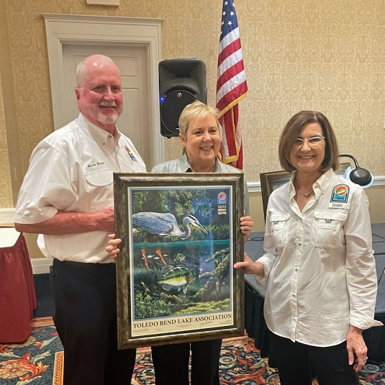
(Photo Caption) Dayna Yeldell, Owner/Broker of First Choice Real Estate Services and this year’s poster sponsor, is presented with the number two poster by Carolyn Scheurich, poster unveiling chairman. Pictured from left is Ricky and Dayna Yeldell, Carolyn Scheurich.
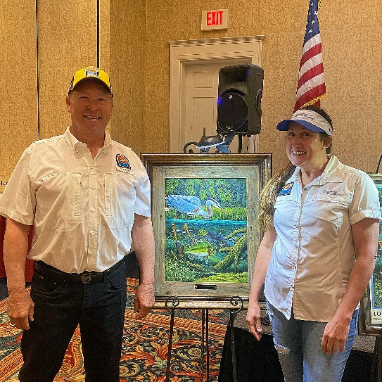
(Photo Caption) Bruce and Denise Rogers placed the highest bid on artist Eddie Pastureau’s original painting titled “Double Jeopardy on Toledo Bend.”

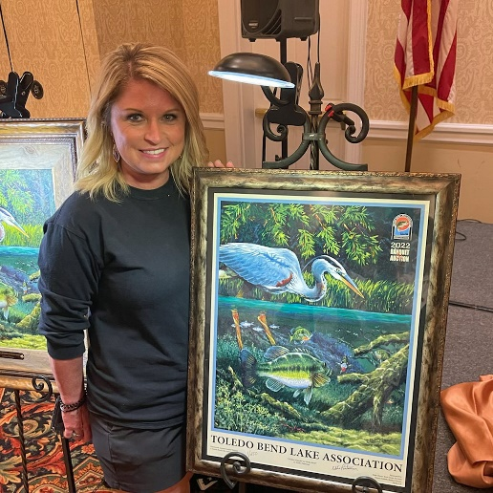
(Photo Caption) Tori Cathey, Owner/Broker of Toledo Town Realty, placed the winning bid on the signed number one poster.
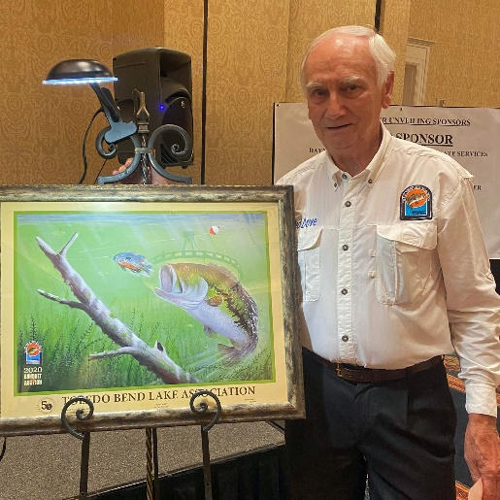
(Photo Caption) Ted Dove placed the highest bid on Don Edwards’ number one poster from 2020 “Easy Catch”.

