

2020

Liberation Super 7’s Cup Report

We were pleased to be able to put on this year’s competition held on a regular club evening with 22 club members taking part. The Super 7’s involves playing 7 rounds of matches and in each match playing 7 ends, this results in some interesting scores.

In round one three big shocks occurred as champion Toby Northern lost 8 – 6 to Brandon De La Haye who is making a habit of beating big name players. Matt Pinel a later entry to replace the Ill Brian Harris lost to Alex Stewart 9 – 6. Neil Selby also lost to Lorna Limbrick 7-4.
The biggest win of the round went to Matt Hutchings 9 – 1 over Tom Le Sueur.

Round 2 saw Toby score the most points in a match so far in his 10-4 win over Daniel Villalard. Neil lost again, this time to Wendy Ritzema. Laurent Pellaton won big over Alex Stewart 8 – 1 and Matt Hutchings made it two in a row against Andrew Limbrick and Geoffroy Buffetrille beat Callum Stewart for two big wins. Brandon also won again, this time beating Ross Payne.

Round 3 saw Matt Hutchings beat Brandon De La Haye 6 – 5 for three from three but Geoffroy failed to join him on three wins losing for the third competition in a row to Toby 7- 2. Some close matches as Gary Cowburn beat Lorna 7 – 6 and Laurent beat Tim Jackson 6 – 4 but Matt Pinel made double figures in his 10 – 2 win over Ross.

Some surprises as Tom Le Sueur beat Jake Romeril and James Villalard beat Jean Stewart.

Round 4 saw Daniel become just the third player to hit double figures in his 10 – 2 win over Cassie. Toby beat Paul Bell 9 – 2 and Laurent beat former doubles partner Matt Hutchings 7 – 2 for his first defeat and Matt Pinel beat Brandon.

Round 5 saw three players score 11 points as Tim Jackson beat doubles partner Brandon 11 – 5, Andrew Limbrick beat Callum Stewart 11 – 1 and Geoffroy beat Matt Hutchings 11 – 2. Toby lost a very close match on the last end 5 – 6 to Matt Pinel.

Round 6 saw Jake Romeril move into contention beating Toby, with Andrew Limbrick winning again 6 – 5 against Gary. Daniel won again but Cassie reversed her loss against Daniel by beating James 11 – 2 and Geoffroy defeated Laurent.

Round 7 despite losing 13 – 1 to Matt Pinel, Andrew Limbrick finished 4th place with five wins. Geoffroy the 2018 champion finished top of the rankings on six wins by beating Gary who despite this loss finished 7th. Matt Pinel finished 2nd also with 6 wins.

Jake Romeril finished 3rd after a win over Laurent who still made the top 8 with 4 wins, finishing 6th place. Matt Hutchings beat 2019 champion Toby to finish 5th with Toby missing out on a top 8 spot failing in his attempt to defend his title. Paul Bell 8- 3 win over Tom Le Sueur gave him 8th place.

FINAL RANKINGS
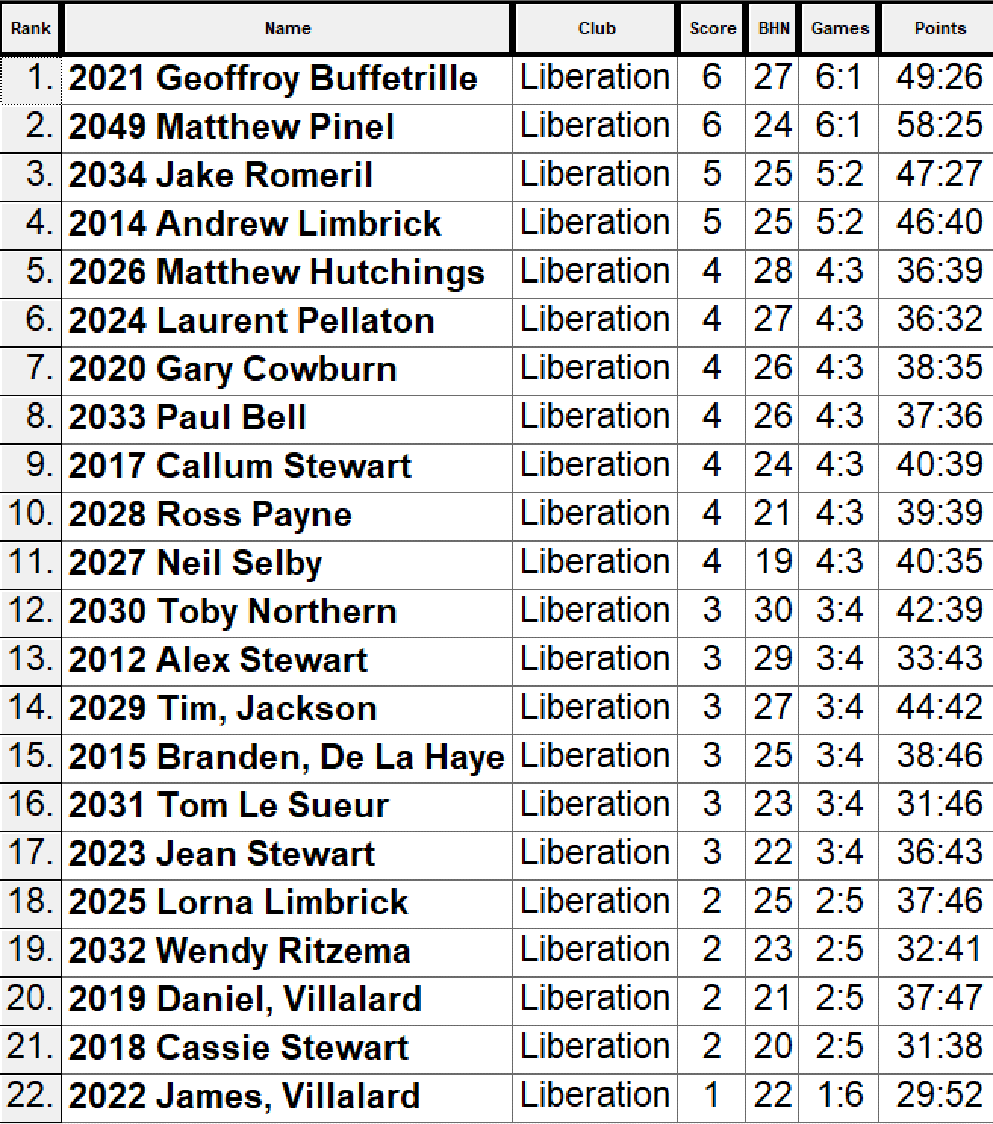

So, the Quarter Finals were as followed.

Ranked 1st Geoffroy Buffetrille V Paul Bell Ranked 8th
Ranked 2nd Matt Pinel V Gary Cowburn Ranked 7th
Ranked 3rd Jake Romeril V Laurent Pellaton Ranked 6th
Ranked 4th Andrew Limbrick V Matt Hutchings Ranked 5th

Geoffroy kept up his form in the quarter finals against Paul, winning comfortably 7 – 1, second placed Matt Pinel also won 7 – 3 against Gary who struggled with the fading light.

Jake Romeril beat Laurent for the second time making the semi-finals with a 6 – 4 win and Andrew Limbrick gained revenge against Matt Hutchings for his 7 – 5 lost in round 2 with a 5 – 4 win.

Jake couldn’t match Matt’s firing power as he fell 8 – 4 in his semi-final and Andrew Limbrick sprung a shock making the final with a 6 – 5 win over Geoffroy.

Jake took third place with a 7 – 4 win over Geoffroy and Matt didn’t let up in the final as the last-minute entrant took the title with a 8 – 4 win over Andrew.

Congratulations to everyone who took part and huge thanks to all those who helped on the day.

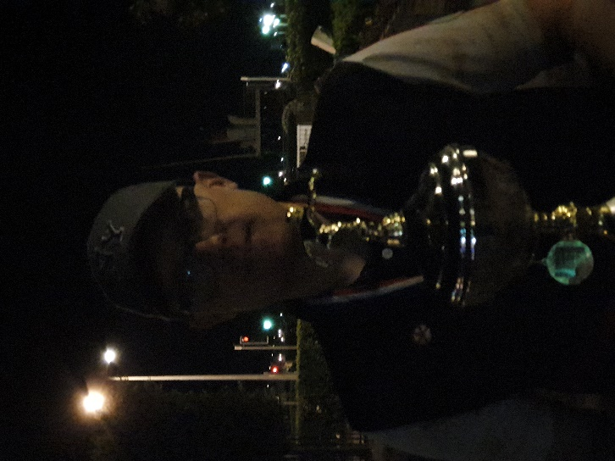

WEBSITE www.liberationpetanque.co.uk
EMAIL liberationpc@gmail.com

Kind Regards
Toby Northern
Chairman
Liberation Petanque Club

SPONSORED BY 