Educate a Girl - Change a Country!
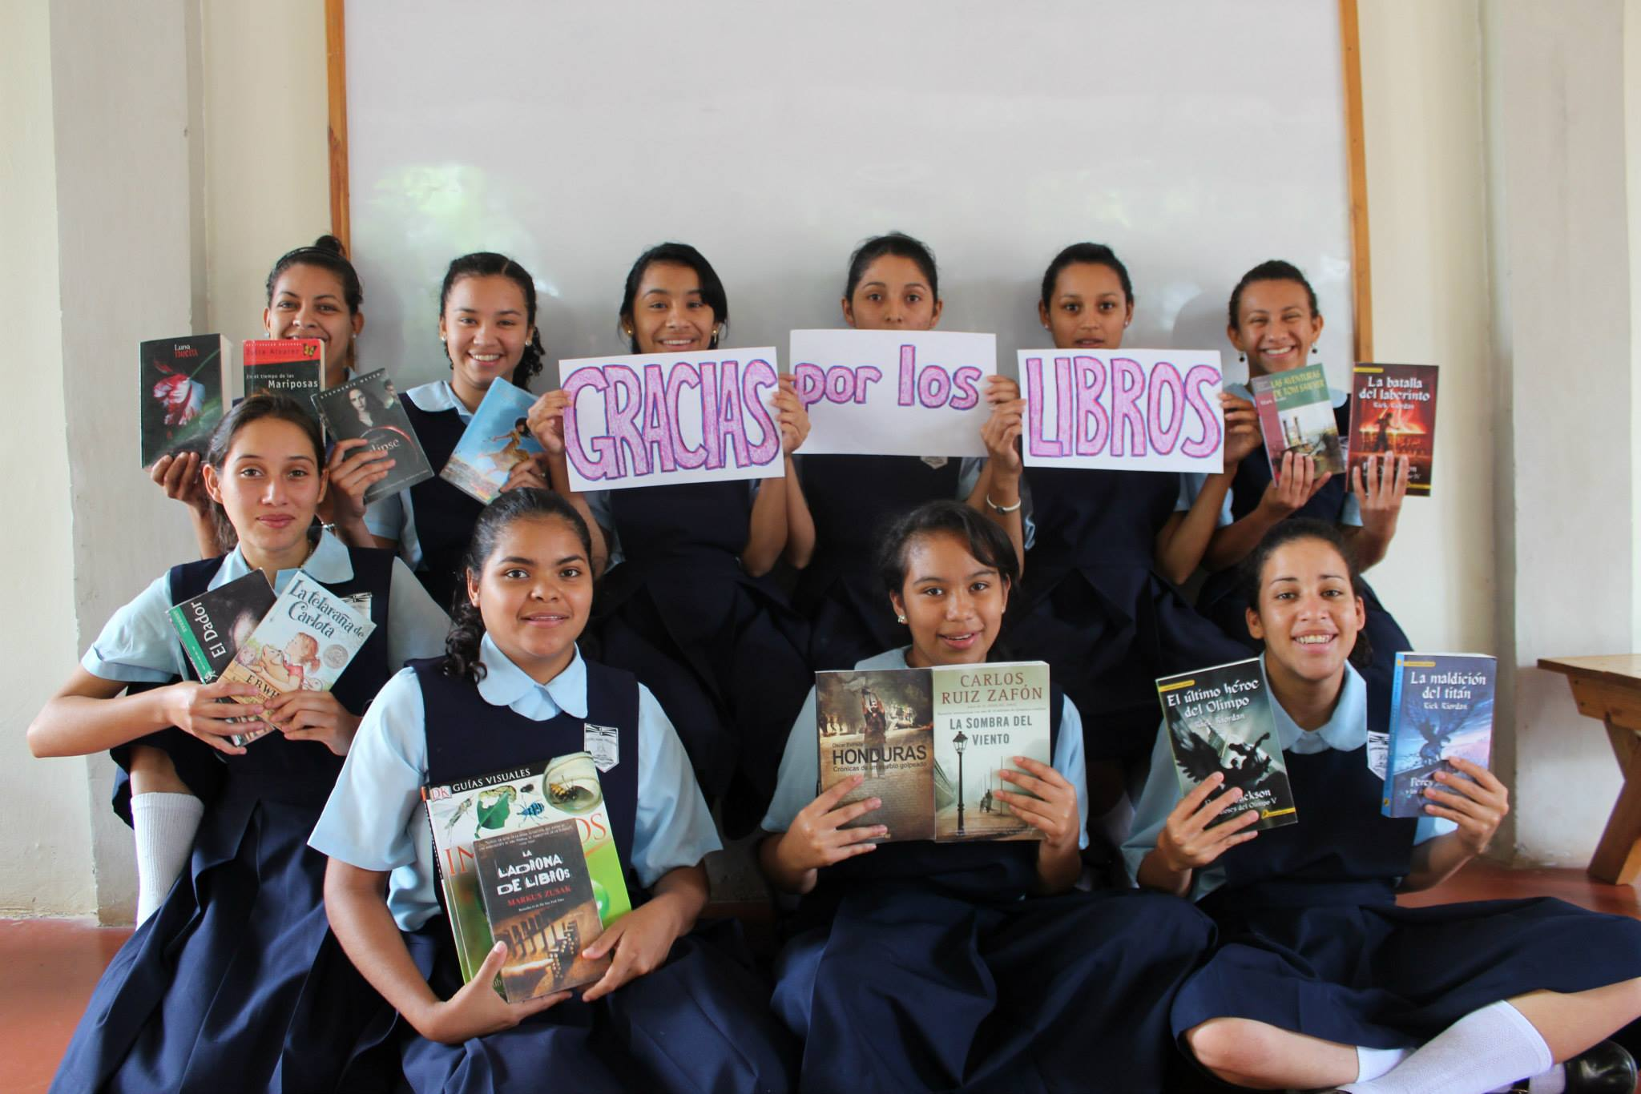

The donation of school supplies will help a girl from a rural village in the outskirts of Guaimaca, Honduras receive an education at the Marie Poussepin Center. Most of these girls would not receive an education past the third grade if it were not for this Center.
School supplies will be given to a girl at the Marie Poussepin Center in your name.

