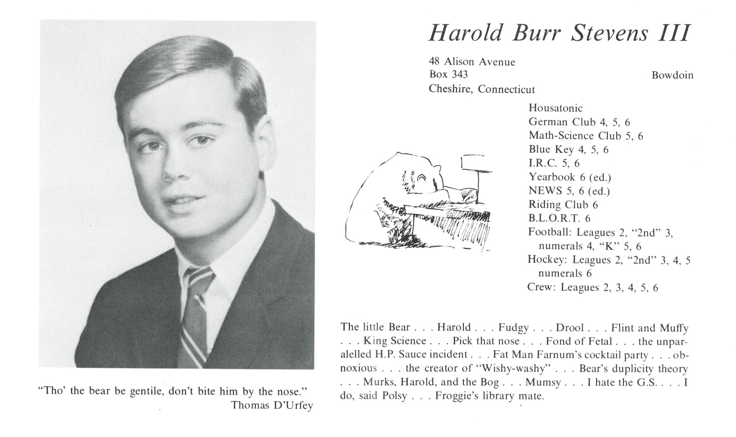

Harold B. Stevens III

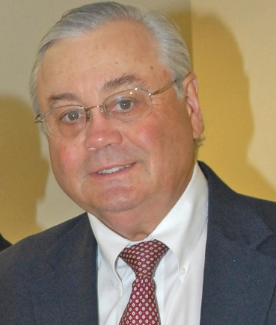Harold “Hal” Stevens” a/k/a Polar Bear graduated Bowdoin College after Kent School in 1967. He married Carol Deckelman in Cleveland in 1974. After law school he moved to New Haven, Connecticut and then to Stowe, Vermont.

He founded Stevens Law Office in 1980. He has two children. Christopher born 1984 and Katherine born 1986. His areas of practice include: Litigation in all courts, Real Estate, Residential and Commercial Zoning & Planning, Estates and Trusts, Corporations, Business formation & sale, as well as Foreclosure & Collections. Hal is a graduate of Kent School (1967) Bowdoin College (B.A. 1971), Cleveland Marshall College of Law (J.D. 1975), and New York University (LLM, Corporate Law, 1977), and is admitted to practice in Vermont, Connecticut, U.S. District Court of New York, District of Vermont, U.S. Court of Appeals, Second Circuit, and the United States Supreme Court, as well as being a member of the Vermont and American Bar Associations.

He has been an active member of the local community holding such offices as President, Stowe Rotary, 1989-1990, President, Lamoille Home Health, 1990-1993, Vice President, Stowe Community Church, 1990-1991, and President, Out and About 1992-1993.

Hal is an avid skier, tennis player, golfer and hiker. He now has two grandchildren by Chris Gage and Gunnar Stevens and enjoys traveling with Carol.



______________________________________________________________

______________________________________________________________ ______________________________________________________________ ______________________________________________________________ ______________________________________________________________ ______________________________________________________________ ______________________________________________________________ ______________________________________________________________ ______________________________________________________________

Attach Picture in .jpg Format

______________________________________________________________

______________________________________________________________

___________________________________________________________________________________ _________________________________________________________________________________________________________________________________________________________________________________________________________________________________________________________________________________________________________________________________________________________________________________________________________________________________________________________________________________________________________________________________________________________________________________________________________________________________________________________________________________________________________________________________________________________________________________________________________________________________________________________________________________________________________________________________________________________________________________________________________________________________________________________________________________________________________________________________________________________________________________________________________________________________________________________________________________________________________________________________________________________________________________________________________________________________________________________________________________________________________________________________________________________________________________________________________________________________________

___________________________________________________________________________________