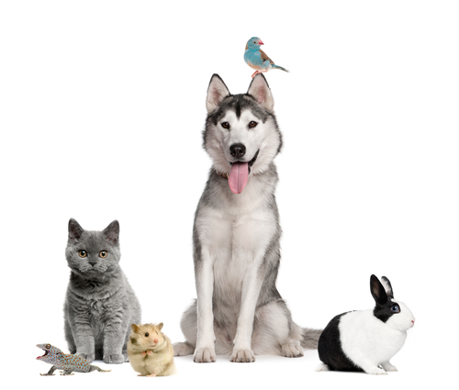
Tail Waggin Good Pet Services
“Happy Pets…One Tail at a Time”

Legal Considerations Agreement

For the purposes of this document, the terms client, owner, pet owner, and customer are synonymous with the person contracting services for one or more domestic animals.
- A signed service request must be provided to Tail Waggin Good Pet Services L.L.C. before service will be provided for any period.
- Payment, in full, is due prior to the start of service. Reservations are not held until full payment is received by Tail Waggin Good Pet Services L.L.C.
- There will be a $25 service charge for each returned check.
- Cancellation Charge Schedule
0 - 48 hours prior to any service, and/or holidays: Payment in full is non-refundable.
49 hours+ prior to service: Payment fully refunded.
- Reservations are made to plan sitter availability to clients. Therefore, clients returning home early may be required to pay for entire reservation. Clients will not have to pay for scheduled Special Services not preformed.
- Tail Waggin Good Pet Services L.L.C. is not responsible for wilted, dead or otherwise unhealthy plants. Tail Waggin Good Pet Services L.L.C. will work hard to follow your written directions as precisely as possible, but cannot be responsible if the results are not favorable. Please place all indoor plants together on a waterproof surface in plain sight, as Tail Waggin Good Pet Services L.L.C. is not responsible for water damaged areas or missed plants.
- Tail Waggin Good Pet Services L.L.C. is not responsible for damage to the home beyond the control of the Pet Sitter. This includes, but is not limited to leaks, electrical problems, and acts of nature. In these situations, the company will attempt to contact the customer and then the emergency contact.
- Tail Waggin Good Pet Services L.L.C. is not responsible for any damage to property of the client or others unless such damage is caused by the negligent act of the Pet Sitter. Tail Waggin Good Pet Services L.L.C. agrees to remain fully insured through PSA or a comparable entity, including optional Special Property Endorsement (protects against theft, breakage, etc as caused by an employee) or bonding. Tail Waggin Good Pet Services L.L.C. accepts no responsibility for security of the premises or loss if other individuals have access to a client’s home, or if the home is not properly secured.
- All other individuals that visit the home will leave a log of their visit.
- Tail Waggin Good Pet Services L.L.C. is not liable for any loss or damage in the event a burglary or other crime that should occur while under this contract. Pet Owner agrees to secure home prior to leaving the premises. Tail Waggin Good Pet Services L.L.C. will re-secure the home to the best of its ability at the end of each visit. While keys are in the possession of a Pet Sitter, they will be either on the Sitter’s physical person, or be properly stored in an undisclosed location. Tail Waggin Good Pet Services L.L.C. subscribes to insurance coverage through PSA for lost key lock replacements.
- Pet Owner must have legal rights to place the animals in the care of Pet Sitters, Kennels, and Veterinary Clinics. The Pet Sitter cannot service a home with “Visiting” pets or animals that do not belong to the resident of the service site without separate sets of agreement forms, including a Legal Considerations Agreement, accepted and signed by each rightful owner(s).
- The terms of this document apply to all the pets owned by the client, including any and all new pets that the customer obtains on or after the date this document was signed, at any and all locations the owner designates for service.
- Pet Owner is responsible for pet-proofing house and yard, and the security fences/gates/latches. Tail Waggin Good Pet Services L.L.C. will not be responsible for the safety of any pets and will not be liable for the injury, disappearance, death, or fines of any pet with unsupervised access to the outdoors.
- Tail Waggin Good Pet Services L.L.C. is authorized to seek any emergency veterinarian assistance needed during visits, at the cost of the client, from any veterinarian as chosen by the sitter. However, the company is not responsible for the health/well being of the animal.
- Pet Owner is responsible for supplying the necessary, safe equipment/supplies needed for care of their pet(s), including but not limited to a sturdy, well-fit harness (halter, collar, etc…) for walks or in case of emergencies, firmly affixed vaccination tags, leash, pooper-scoopers, litter boxes, food, cleaning supplies, medicines, pet food, and cat litter. Pet Owner authorizes any purchases necessary for the satisfactory performance of duties. Pet Owner agrees to be responsible for the payment of such items, as well as service fees for obtaining items, and will reimburse Tail Waggin Good Pet Services L.L.C. within 14 days for all purchases made.
- Pet Owner will be responsible for all medical expenses and a damage resulting from an injury to a Pet Sitter, or other persons, by the Pet. Customer agrees to indemnify, hold harmless, and defend Tail Waggin Good Pet Services L.L.C., in the event of a claim by any person injured by the Pet.
- It is suggested that arrangements be made with someone to evacuate your pets in case of a disaster or weather related event/crisis/”Code Red”. Tail Waggin Good Pet Services L.L.C. will try to see to your pets safety/care should such events occur, but cannot guarantee it.
- Future Services: I authorize this contract to be valid approval for services so as to permit Tail Waggin Good Pet Services L.L.C. to accept all future telephone, online, mail or email reservations and enter my home without additional signed contracts or written authorizations.
- Tail Waggin Good Pet Services L.L.C. reserves the right to terminate this contract at any time, if the Pet Sitter, in his/her sole discretion, determines that Owner’s pet poses a danger to the health or safety of itself, other pets, other people, or the Pet Sitter. If concerns prohibit the Pet Sitter from caring for the pet, the Owner authorizes the pet to be placed in a kennel (or previously arranged locale), with all charges (including but not limited to transportation, kenneling, tranquilizing, treating, accessing, and liability) to be the responsibility of the Owner.
- Tail Waggin Good Pet Services L.L.C. agrees to provide services stated in this agreement in a reliable, caring and trustworthy manner. In consideration of the services as an express condition thereof, the client expressly waives and relinquishes any and all claims against the company and its employees, except those arising from negligence. Claims of negligence that involve a hired Independent Contractor, hired by Tail Waggin Good Pet Services L.L.C. will be the responsibility of the Independent Contractor.
- Client agrees to notify Tail Waggin Good Pet Services L.L.C. of any concerns within 24 hours of return.
- This agreement is valid from the date signed, and replaces any prior Legal Considerations agreements. Client agrees to any future Tail Waggin Good Pet Services L.L.C. term changes relayed verbally to the client, mailed or emailed in writing to the client, or posted on our website.
- The owner states that he/she as read this agreement in its entirety and fully understands and accepts its terms and conditions.

Client/Owner Name: _______________________________________________________________
Signature: _____________________________________________ Date: _____________________

