Arkansas Tobacco Prevention Hotline

1-800-QUIT_NOW

Drug Treatment 24 hour National Helpline

1-877-476-7777

Family Counseling & Recovery Center

1-501-450-3910

STD Hotline

1-800-232-4636

**Jacksonville**

2600 John Harden Drive

Jacksonville, AR 72076

501.982.8987

**Pine Bluff**

2710 Commerce Circle

Pine Bluff, AR 71601

870.534.0498

**Conway**

2320 Washington Avenue

Conway, AR 72032

501.329.7770

**Fort Smith**

2000 North B Street

Fort Smith, AR 72901

479.783.3301

**Jonesboro**

1903 Grant Avenue Suite K

Jonesboro AR. 72401

870.932.4330

**Drugs: The Facts**

What is a drug?

A drug is a substance, other than food, that will change the way the body and mind operate. Mood altering drugs are called psychoactive drugs. They will affect the way a person thinks, acts, and feels. These drugs usually have physical effects as well, but what makes them very different is that they work on the mind and your senses.

Types of Drugs: Legal & Illegal Drugs

Legal: Such as alcohol, caffeine, nicotine, and various prescribed and over the counter medications, are legal. Although these drugs are legal, there are laws that restrict their procession, quality and the cost.

Illegal Drugs: such as ecstasy, cocaine, heroin, amphetamines, marijuana, are all illegal. This means they cannot be subject to quality or price controls. A person using illegal drugs can never be sure of how strong the drug is, or what is actually in it.

Types of Drug use:

Experimental, Recreational, Situational, Intensive, bingeing, & dependent use.

THE LAW ON DRUGS

Federal and state laws provide penalties for possessing, using, making, selling or driving under the influence of illicit drugs. Penalties can include fines, imprisonment and disqualification from driving.

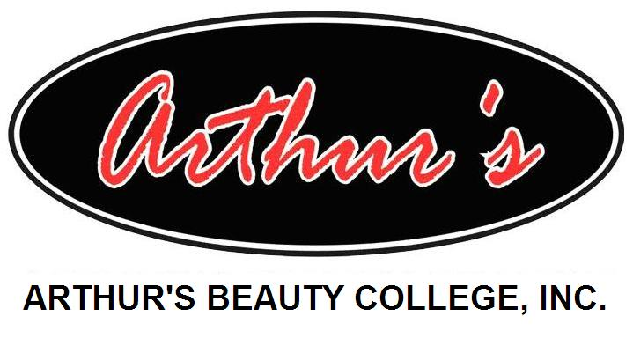

# Product/Service Information

#### Back Panel Heading

Student & Staff

Drug Prevention

Program

SD

Training students for 21st century

1.800.CUT.CLASS

(1.800.288.2527)

Jacksonville-Conway-Fort Smith-Pine Bluff-Jonesboro

[www.arthursbeautycollege.com](http://www.arthursbeautycollege.com)

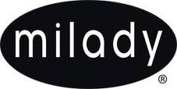

Bottom of Form

**Five**

**LOCATIONS**

**Jacksonville**

The Jacksonville campus is conveniently located off the Jacksonville Air Force Base Exit (Hwy 67-167) on John Harden Drive. Jacksonville campus offers day and night classes for Cosmetology and Cosmetology Instructor training.

**Fort Smith**

The Fort Smith campus was purchases in March 2005 and is located one block off Rogers Avenue on North B Street. Fort Smith campus offers day programs for Cosmetology and Cosmetology Instructor training.

**Conway**

The Conway campus was purchased in February 2004 and is located off I-40 exit 125 on Washington Avenue. Conway campus offers day programs for Cosmetology and Cosmetology Instructor training.

**Pine Bluff**

The Pine Bluff campus opened in July 2003 and is conveniently located off Hwy 65B on Commerce Circle. The Pine Bluff campus offers day programs for Cosmetology and Cosmetology Instructor training.

**Jonesboro**

The Jonesboro campus was purchased in February 2013 and is located in Jonesboro Arkansas at 1903 Grant Avenue suite “K”. Jonesboro has 4,000 square feet with state of the art equipment and a spacious styling area. The Jonesboro campus offers day programs for Cosmetology and Cosmetology instructor training.







**Drugs and the workplace**

**Under the OCCUPATIONAL HEALTH AND SAFETY Legislation, ALL EMPLOYEES/Students HAVE A RESPONSIBILITY TO MAKE SURE THEY LOOk after THE safety of their co-workers.**

**The effects of drugs and the symptoms of coming down from a high coupled withdrawal can affect a person’s ability to work safely and effectively.**

**REVISED January 2013**

**Drug Policy**

Arthur’s Beauty College Inc. reserves the right to ask students and or staff to submit to random drug/alcohol testing. Should you be witnessed by another person (supervisor if possible) the student or staff member may be required to submit to drug/alcohol test immediately. Refusal to submit to a test will result in immediate suspension of the student or discharge of the staff member.

No drugs, alcohol or any weapons are allowed on the premises of any school in the State of Arkansas. Any student or staff found in violation of this rule may be dismissed immediately.



“We Encourage Our Students To Meet Their Highest Potential.”