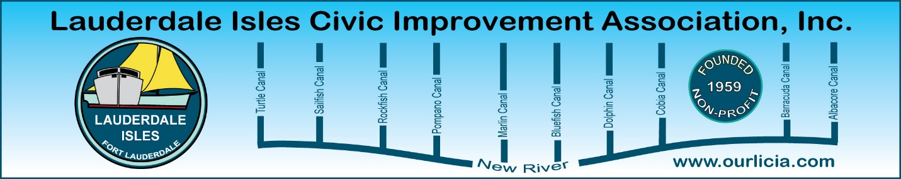
Minutes of the Lauderdale Isles Civic Improvement Association Board Meeting Zoom call July 16, 2025
The meeting was called to order by President Earl Prizlee at 7:05pm.
Roll call was taken.
Present: Earl Prizlee, Geoff Rames, Karen Rames, Dick Cahoon, Joann Kratky, Trent Simpson, Rick Cunningham, Penny Shea, Jackie Zumwalt, Andrew Silverman
Absent: Aynsley Geramanis, Dawn Hannah, Eric Silva, Julie Gordon, Glo Knowles
FLPD report: Officer Antje Jackson reported that there were no part one crimes in the neighborhood since the last meeting. A suspicious incident occurred on July 11th outside the neighborhood, but it was resolved. Officer Jackson has been patrolling the area and meeting residents. Penny raised concerns about speeding on Flamingo Lane, particularly by new young renters, and Officer Jackson promised to monitor the situation.
Code Compliance: Inspector Bernstein Sambert, a senior inspector for District 4, discussed the process of removing the abandoned boat near the park. Geoff explained that the City has implemented a new system with preferred vendors for boat towing, which should expedite the process. Earl expresses frustration with the lengthy removal time and requested a written procedure for future incidents. Inspector Sambert also mentiond that the neighborhood has been generally good, with the night team addressing vacation rental issues on weekends. Penny talked about parking violations on Flamingo Lane and Inspector Sambert explained that cars can be parked on the street unless they obstruct traffic or are abandoned for over 24 hours, but parking near fire hydrants is prohibited. He will go to Flamingo Lane to see the car that continues to park at the fire hydrant.
Treasurer reports: Earl received from Andrew and will review first and then send to the Board to approve at the next Board Meeting.
Secretary report - Board Meeting Minutes for June: Karen advised she will make a correction to the date of the next General Meeting. Geoff made the motion to approve with the correction, Dick seconded the motion, and we all approved.

Community Center Update: Earl presented the newly received architectural plans for the Community Center, showing the layout, safety features, and capacity, plus elevations and landscape designs. The plans include storage rooms, restroom, a warming kitchen, and a covered patio. Earl discussed various aspects of the design, such as the roof line, nautical theme details, and large windows, and expresseed excitement about the progress but notes that they need to review certain elements, including the boat parking area, a walkway to the back and the pump station, and potential cost increases. Rick suggested meeting on-site to better visualize the plans, as he finds it difficult to understand the drawings fully. Earl gave an update on the project timeline, highlighting key dates. He mentioned that construction documents are already 60% complete and estimates groundbreaking to occur in about a year.
Duck Key sign replacement: Earl discussed a recent accident involving the Duck Key sign. Geoff went to the Police Station in Coral Ridge to get the police report. He explained the sign is owned and maintained by our neighborhood. Earl presented two quotes for replacing the sign; one for $3,600 and another for approximately $4,300, both including installation. He has submitted a claim to Geico for potential reimbursement. Earl proposed paying for the sign upfront, and potentially recouping costs later, also suggesting a fundraiser as an option. Rick is tasked with heading the fundraising efforts, while Earl will handle the logistics with the sign manufacturer. The Board considered various approaches, including appealing to residents' sentiments, seeking local business sponsorships, and using the newsletter to promote the initiative. Karen suggested Rick work with the residents on Duck Key Lane to pay dues, with half going towards the sign fund. Andrew noted that only 11 of the lane's residents have paid dues. Trent mentions using LICIA funds. Rick will write an article for the next newsletter about his ideas to help fund the cost to replace the sign on Duck Key Lane. July 25 is the deadline for articles.
Next General meeting August 21: Earl and Geoff discussed plans for the upcoming August General Meeting with City Manager Rickelle Williams as the headliner guest. It was decided to present community issues first, focusing on code enforcement for vacation rentals, particularly the need for coverage on Monday, Tuesday, and Wednesday nights. Geoff suggested providing specific examples of recent problems. The Board agreed to give Manager Williams an overview of our concerns before allowing her to speak about her vision for the City, ensuring she addresses our key issues.

Next Newsletter: Geoff advised the deadline for articles is July 25. Geoff said Dawn did a FIXITFTL article and is working on finding more information about the early days in Lauderdale Isles to continue with the theme of the newsletter being about the neighborhood. Let Geoff know in advance what your article is about and the length as he is now working on the layout. Geoff noted there is a mangrove planting day at Coontie Hatchee Park soon and remember we could receive $45 when volunteering with the Green Your Routine initiatives.

Boat Pump-Out Grant and Removal: Geoff announced the City, through Marco Aguilera, is applying for a grant to acquire a pump-out vessel, with LIWMD contributing $5,000 towards its first year of operation. This free service will benefit the neighborhood, which currently lacks a pump-out facility. This will be free to our neighborhood, and we just need to call when needed.

Code Enforcement and Infrastructure Updates: Geoff shared several pictures and updates on problem vacation rentals. At 2612 key Largo Lane, there is a pending 545-day suspension for the property with 9 violations. 2518 Whale Harbor Lane has accrued $16,000 in fines, and counting, for no Vacation Rental certificate. 2518 Key Largo Lane is a long-term renter that had a valet service to park all of the cars at a party and received 2 nuisance violations, with $30,000 in fines imposed by Code. Geoff explained that property violations and suspended certificates transfer to new owners upon sale. Earl shared plans for improvements to the Lauderdale Isles Landing boat dock, including floating docks and expanded facilities. Geoff mentioned an upcoming meeting with the Florida Inland Navigation District to discuss concerns about the Riverwalk project and a controversial land lease deal with the Marine Industries Association of South Florida.
Motion made by Geoff to adjourn the meeting. Penny seconded and all approved. The meeting ended at 8:25pm.
Submitted by Karen Rames, Secretary

