

P20W Education Standards Council

Implementation Guide
Academic Credential & Experiential Learning
Version 1.0

November 2016
Mei Hung (meihung@stanford.edu)
Version History

Version | Date | Changed By | Changes
1.0 | October 2016 | Mei Hung | Initial version submitted for PESC review and approval
1.0 | November 2016 | Mei Hung | Added message contributed by Jim Farmer
1.0 | December 2016 | Mei Hung | Updates based on latest CoreMain, AcademicRecord, and iso_3166 libraries.

Terms and Conditions of Use
1. How You May Not Use the PESC Intellectual Property (IP)
In using the Service, you may not: (a) use the PESC IP for any purpose not expressly permitted by us; (b) engage in, facilitate, or further unlawful conduct; (c) use the PESC IP in a way that harms us or our advertisers, sponsors, affiliates, members, or partners; (d) damage, disable, overburden, or impair the PESC IP or any aspect thereof, or interfere with anyone else's ability to access or use the PESC IP; (e) resell or redistribute the PESC IP, or any part of the PESC IP; (f) disrupt, or try to gain unauthorized access to: any account, computer, hardware, or network related to the PESC IP; (g) obtain (or try to obtain) any data from the PESC IP or related hardware, except data that we intend to provide or make available to you; (h) defame, abuse, harass, stalk, threaten, or otherwise violate the legal rights (such as rights of privacy and publicity) of others; (i) publish, distribute, or disseminate any inappropriate, profane, defamatory, infringing, obscene, indecent, or unlawful content, topic, name, material, file, or information; (j) publish, distribute, or disseminate any content, topic, name, material, file, or information that incites, advocates, promotes, depicts, constitutes, or expresses child pornography, profanity, hatred, bigotry, racism, illegal drug use, gratuitous or graphic violence, or criminal or fraudulent activity; (k) use the PESC IP or any material or information made available through the PESC IP in any manner that infringes any copyright, trademark, patent, trade secret, or other proprietary right of us or any third party; (l) download or use any material sent or provided by another user of the PESC IP that you know, or reasonably should know, cannot be legally shared or distributed in such manner (except as expressly permitted by us); (m) view, intercept, or attempt to intercept private communications not intended for you; or (n) violate any relevant law or posted guidelines or codes relating to the use of the PESC IP.
2. Privacy
In order to operate and provide the PESC IP, we collect certain information about you. In particular, we may access or disclose information about you, including the content of your communications, in order to: (a) comply with the law or respond to lawful requests or legal process; (b) protect the rights or property of PESC or our members, including the enforcement of our agreements or policies governing your use of the PESC IP; or (c) act on a good faith belief that such access or disclosure is necessary to protect the personal safety of PESC employees, customers, or the public. We may use technology or other means to protect the PESC IP, protect our members, or stop you from breaching this Agreement. These means may include, for example, filtering to stop spam or increase security. These means may hinder or break your use of the PESC IP.
3. Intellectual Property
If you receive from us PESC IP in the form of any software, programs, download or other content (for purposes of this Section 3, we refer to all of these, as applicable, as “software”), your use of that software is under the terms of this Agreement (including any statement of specific authorized uses or restrictions). Unless otherwise stated in this Agreement, then we grant you a limited, personal, non-exclusive, revocable license to use the software only for and during the term of this Agreement. You may not copy, download, modify or create derivative works, publish, transmit, sell or attempt to sell or transfer, or otherwise use or exploit any software unless we have expressly allowed you to do so. Copyright and other intellectual property laws and treaties protect the software and all other aspects of your use of the PESC IP. We own the title, copyright, and other intellectual property rights in the software and the PESC IP, and the software and PESC IP are solely licensed and not sold. You do not have ownership rights to any software made available or accessible on or in relation to the PESC IP, regardless of how the software and PESC IP are used, accessed, downloaded, or otherwise made available to you. Unless we notify you otherwise, your license to use the software will end on the date you cease to be a Member of PESC, if applicable, and you must promptly uninstall and delete the software.
4. Interpreting this Agreement
All parts of this Agreement apply to the maximum extent permitted by law. A court may hold that we cannot enforce a part of this contract as written. If this happens, then we will replace that part with terms that most closely match the intent of the part that we cannot enforce. The rest of this contract will not change. This is the entire contract between you and us regarding your use of the PESC IP. It supersedes any prior contract or statements regarding your use of the PESC IP. If you have confidentiality obligations related to the PESC IP, those obligations remain in force even after termination or cancellation of the PESC IP (for example, you may have been a beta tester). The section titles in the contract do not limit the other terms of this contract.
5. Assignment
We may assign this Agreement, in whole or in part, at any time with or without notice to you. You may not assign this Agreement, or any part of it, to any other person. Any attempt by you to do so is void. You may not transfer to anyone else, either temporarily or permanently, any rights to use the PESC IP or any part of the PESC IP.
6. Claim Must Be Filed Within One Year
Any claim related to this Agreement or the PESC IP may not be brought unless brought within one year after the claim arises. If it is not filed in time, then that claim is permanently barred. This applies to you and your successors. It also applies to us and our successors and assigns.
7. Choice of Law and Location for Resolving Disputes
Claims for breach of this Agreement will be subject to the laws of the District of Columbia, without reference to conflict of laws principles. You consent to the exclusive jurisdiction and venue of the District of Columbia for all disputes relating to this Agreement or the PESC IP.
Table of Contents
1 Introduction 5
2 Development History 7
3 Acknowledgments 8
4 Other Standards or Schema Referenced 9
5 Terminology 9
6 Schema Organization, Format, and Implementation 10
7 Overview of Academic Credential and Experiential Learning Components 11
7.1 TransmissionData 11
7.2 DocumentProduction 12
7.3 LearningRecordDetail 13
7.4 AcademicLearning 13
8 Academic Credential and Experiential Learning Details 15
8.1 Elements 15
8.2 Types 15
8.3 Schema Diagrams 16
Appendix A: Sample XML Document 72

Introduction
Considering that the rise of a more skilled and more demanding workforce requires stronger and more targeted talent and skills, the Academic Credential and Experiential Learning Task Force has been focused on the emergence of innovative ideas and processes that might better capture potential skills and talents not included in the traditional digital record. "As registrars, many of us struggle constantly to maintain consistency in the face of faculty and student demands for a more comprehensive credential that documents the student academic experience in greater depth," Dr. Rodney Parks, Registrar at Elon University, states in winning PESC’s 16th Annual Best Practices Competition. The final mission of the Task Force with its goals and outputs will be determined by the Task Force as it prepares for its inaugural meeting. Initial tasks include:
- serving as a resource for the education community and archiving all relevant articles, statuses and regulations, guides, and references developed throughout the sector by various stakeholders;
- identifying and monitoring emerging innovations, best practices, and prototypes to ensure awareness and transparency; and,
- collaborating with all other stakeholders that are leading the space in academic credential and experiential learning.
The current transcript, designed to record learning in the form of course enrollments, course credits, and grades, is no longer a sufficiently robust approach to satisfy the needs of the modern learner. Higher Education institutions have long adopted the Carnegie Unit as a policy which specifies that learning be recorded in the form of time. The GPA (grade point average), a calculation based on that standard, was commonly used to demonstrate a student’s achievement. While the transcript and the Carnegie Unit have served the academy well for over a hundred years, changes in pedagogy and technology have caused a greater awareness that learning should not be measured just as course credits and grades, but should be more descriptive. Learning outcomes and a variety of other assessment methods are a means to describe learning more in the form of skills, capacities, and abilities mastered.
While there are new ideas about what should be recorded, higher education has not coalesced around a single approach, or even a handful of approaches. It will take time to come to broad agreement on the best way to describe and record the learning that takes place on campuses. Further, noncurricular or experiential learning, arguably counting among the most important activities in which students can engage, is increasingly considered worthy of noting and recording alongside the curricular learning that leads to majors and minors and, ultimately, degrees.
Starting over twenty-five years ago, transcript and course inventory standards were promulgated to enable the portability of the established records of the academy as data. EDI, XML, and PDF formats have been employed in a variety of use cases to make data exchange common at least within higher education. Certainly, many students benefit from the ease with which courses and credit information can be shared between institutions. And the use of the PDF format has made it easier for the exchange of student achievement information with third parties outside higher education.
Thus, it is not too early to think about how to capture and convey learning data that describes experiential learning alongside one of its most common expressions of acknowledgment, the certificate credential. Paper certificate credentials have been in existence for centuries and are used by many organizations and institutions to recognize participation, completion, or achievement. However, there is no standard at present enabling the electronic exchange of information related to the certificate credential. Thus, it is hereby proposed that the following XML standard begin to serve as a means both to create the digital form of the certificate credential and to embed within it the information that the certificate credential recognizes. Certainly this credential standard could be adopted to convey diploma information as well. The principal value proposition for a digital credential is to convey to the learner what (s)he has learned or achieved, but it must also provide a standardized form for the learner so that the personal data it contains may be more easily controlled and shared with others using certification and authorization technology commonly available today.

Development History
- The Board of Directors of PESC announced the formation of an interorganizational Task Force focused on Academic Credentialing and Experiential Learning at the PESC Spring 2015 Data Summit ED Data Systems (April 28-30, 2015).
- http://www.pesc.org/library/docs/about_us/press/ACTaskForceANNOUNCE06-17-2015v4final.pdf
- Discussion of the “emerging best practices in academic credentialing and experiential learning” at the 2nd Annual Global Symposium and Summit (October 14-16, 2015).
- http://www.pesc.org/interior.php?page_id=244
- Academic credentialing and experiential learning task force presented the "business case for the development of a PESC standard in xml for supporting credentialing and experiential learning records and for enhancing data exchange mobility" and introduced alternative framework for learning outcome skills mapping at the Spring 2016 data summit (April 13-15, 2016).
- http://www.pesc.org/interior.php?page_id=247
4) (Submitted by Jim Farmer, Instructional Media + Magic Inc.) The discussion draft was prepared for the PESC Fall 2016 Symposium and Data Summit held October 12-14 in San Diego, California. It was presented and discussed at the Thursday session of the Academic Credentialing and Experiential Learning Task Force and Common Credential. Thomas C. Black, Associate Vice Provost and Stanford University Registrar, and Mei Hung, Application Developer, Stanford University, demonstrated a prototype implementation that Mei Hung had developed for certificates.
During the discussion, it was suggested that the proposed specification be made available to the HR (Human Resources) Open Standards organization and interested employers. The HR Technology Conference held the previous week had several presentations of Automated Tracking Systems used for the recruiting process. Algorithms are being developed and used to make decisions during the evaluation process. These systems may work more effectively if digital versions of materials, such as PESC’s electronic transcript and ePortfolio and the credentials specification described in this document, are widely implemented. This document is being shared with employers and those informal contacts are continuing.
In an earlier email to the Task Force and others, Alex Jackl, Bardic Systems Inc., had summarized the comments on the XML specification and the XML Schema (XSD) that implements an evaluation of compliance with the standard. Those comments led to changes incorporated in this draft specification.
Executive Director Michael Sessa said that the Task Force expects to complete their work and, following a Public Comment Period, present the proposed standard for approval at the Spring 2017 Symposium and Data Summit to be held May 3-5, 2017, in Washington DC.
In an email, Sessa described the process:
“A proposed standard, once all the development work is successfully completed, is posted online at www.pesc.org. Included in each proposed standard are the Implementation Guide, XML Schema and Sample Instance Document. All comments from the education community and the general public must be made by email to PESC President & CEO at Michael.Sessa@PESC.org. Public comments can address any and/or all part of the standard being proposed.”
With this instruction, the Task Force and publisher Stanford University have been gracious and willing to make this document publicly available. Hopefully, this additional distribution encourages readers to participate in the Public Comment Period and perhaps attend the PESC Spring Summit where final changes in the document will be made and the discussion turns to implementation of the standard.
This document is being provided to interested HR software developers and employers as well as higher education.

Acknowledgments
Contributors:
Tom Black | Stanford University
Joellen Shendy | University of Maryland University College
Alex Jackl | Bardic Systems
Michael Sessa | PESC
Tuan Anh Do | San Francisco State University
Kristi Blabaum | Great Lakes Higher Education Corporation & Affiliates
Don Phillips | Xap
Jim Goodell | Quality Information Partners
Michael Morris | ACT
Jeff Elliott | University of Missouri
Jim Farmer | Instructional Media + Magic Inc.
Susan McCrackin | Collegeboard.org
Patrick Elliott | University of Maryland University College
W. Matt Bemis | University of Southern California
Jack Weber | Credentials Solutions
Rajeev Arora | Parchment
Jeffrey Alderson | Eduventures
David Moldoff | AcademyOne
Steven Margenau | Great Lakes Educational Loan Services
Paul Baldridge | Great Lakes Educational Loan Services
Mei Hung | Stanford University

Other Standards or Schema Referenced
This standard references the following PESC standards, specifications, and schemas:
- Core Main (http://www.pesc.org/interior.php?page_id=181)
- Academic Record (http://www.pesc.org/interior.php?page_id=182)
- Transcript Request and Response (http://www.pesc.org/interior.php?page_id=174)
- College Transcript (http://www.pesc.org/interior.php?page_id=164)
- Education Course Inventory (http://www.pesc.org/interior.php?page_id=243)

Terminology
To ensure clarity and consistency, below are definitions of the terminology used in the context of this Guide:
- AwardEndorse: Official approver of the credential award.
- LearningOutcomeSkillCode: Learning outcome skill based on DQP intellectual skills.
- LearningOutcomeProficiency: Assessment of learning proficiency.
- AlternateOutcomeFramework: The alternative skill mappings associated with learning outcomes.
- ContinuingEducationUnits (CEUs): One CEU equals ten hours of participation.
- AcademicAwardLevel: The credential award classification is illustrated as below.
- DQP (Degree Qualification Profile - http://degreeprofile.org): A set of reference points for what students should know and be able to do upon completion of associate, bachelor’s and master’s degrees – in any field of study.
- CEDS (Common Education Data Standards - https://ceds.ed.gov/dataModelEntities.aspx): The schema elements in the standard are aligned with data element definition in CEDS.

Following is an illustration of the AcademicAwardLevelType tag.
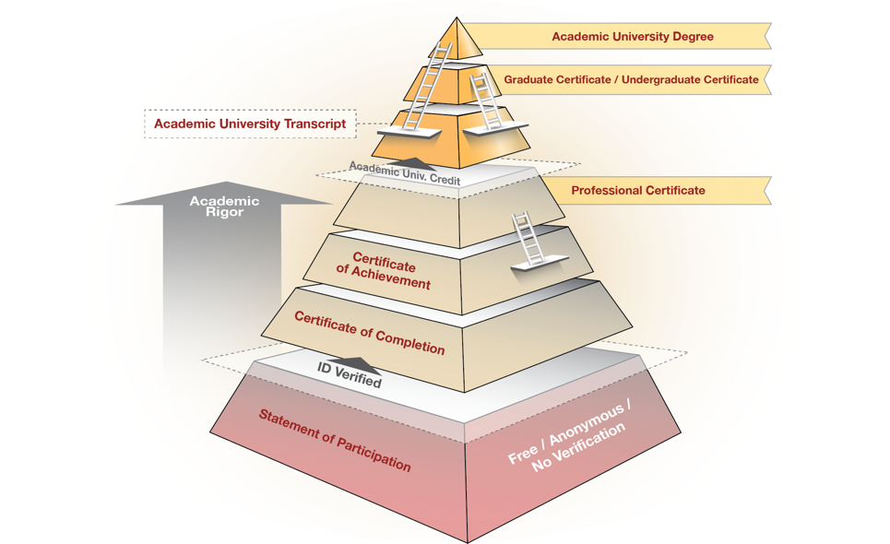

Schema Organization, Format, and Implementation
The Academic Credential and Experiential Learning schema is designed for:
- Credential records for both traditional academic learning and extra- and co-curricular experience
- Learning record data exchange and mobilization
- Records for credential artifact generation and presentation
- Expression of the contents of the program as learning outcomes and learning reflection
- Learning outcome proficiency assessment
- Learning outcome mapping to alternative systems such as HR system, Higher Ed student records system.
- Both PreK, K-12 and Work Force eco-systems as well as Higher Education
The schema includes the components of Academic Program, Academic Session, and College Transcript Course and it is structured to support the needs of both academic and experiential learning records. It also serves the purpose of data transmission using the Transcript Request and Response standard. The schema supports credential artifact generation and presentation.

Overview of Academic Credential and Experiential Learning Components
The standard proposes modifications based on the latest versions of CoreMain, AcademicRecord, and iso_3166 libraries.
The schema is composed of 3 main sections:
- Transmission Data Section: This section uses the existing PESC Request and Response of the XML Transcript standard [http://www.pesc.org/interior.php?page_id=174] and is for conveying data to other systems. It describes the requesting source, which is an education institute, and the destination, which indicates the school or an organization receives the document.
- Document Production Section: The section describes information for generating artifacts to present learning records. An artifact is a visual presentation of the learning result credential. It also describes the document format, such as XML, PDF, or PDF with attachment
- Credential Learning Record Detail Section: This section describes acknowledgment of credential learning records and expression of learning that is more explicit in terms of intellectual skills, outcomes, goals, or capacities. Learning outcomes can be assessed and can be mapped to alternative vocabularies defined in other frameworks.
The components of the schema are displayed below:
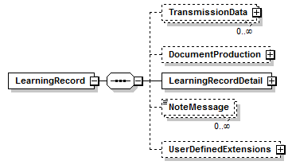

TransmissionData
LearningRecord/TransmissionData
** PESC Request Implementation Guide [http://www.pesc.org/library/docs/standards/College%20Transcript/XMLtranREQUESTigV1-2-0.pdf]
** PESC Negative Response Implementation Guide [http://www.pesc.org/library/docs/standards/College%20Transcript/XMLTRA_x005F_x007E_1.pdf]
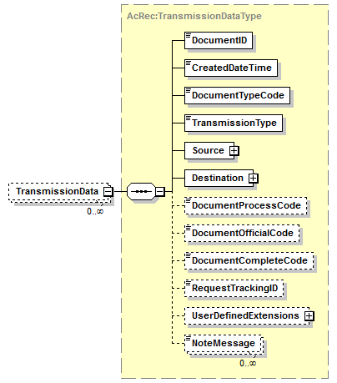

DocumentProduction
The Document Production component is designed for learning records artifact generation. The artifact holds the proof for credential awards including the standard elements of student identification data, including award title and program award endorsement information. With this information, the organization has the ability to design the credential artifact in forms including image, PDF, or Word document.
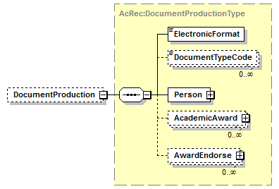

LearningRecordDetail
LearningRecordDetail component provides a structure for holding Academic Credential and Experiential Learning records. It is used to hold a learner’s identification record and both the traditional academic learning records as well as extra- and co-curricular experience records.
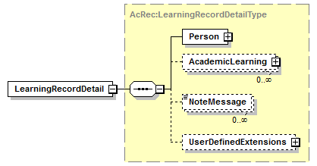

AcademicLearning
The AcademicLearning element provides a structure for storing learning records. The learning records can be academic, co-curricular, and extracurricular activities records.
The information is credited in elements shown in the following
- A credential program is provided by accredited organizations, such as a school or a department.
- A credential award should specify the level of the degree, certificate, or award granted for the successful completion of requirements of an academic program. Summary Type information (child of Academic Award) can also indicate if the award is credited to an academic degree.
- An Achievement Category is the category of the area in which achievement was earned.
- The Program Instruction Method is used for program and the courses.
- The Performance Evidence is a website location which keeps the result or products from the learning activities. It can be a community services reflection, project research document, or portfolio data.
- Learning Program is the plan of series courses learning and/or extracurricular activities. Program Outcomes Description identifies what the learner knows and is able to do at the end of the program.
- Academic Session holds information regarding courses taken by a learner and/or holds the learning experiences and reflection expressed by the learner during the session period.
- A course’s learning outcome describes in a comprehensive way what a student should be expected to demonstrate as a result of taking the course.
- A course learning outcome can be assessed based on the categories of proficiencies defined DQP.
- A course learning outcome has mapping to alternative vocabularies from third parties or career-building sites that can easily utilize learning outcomes as student capabilities.
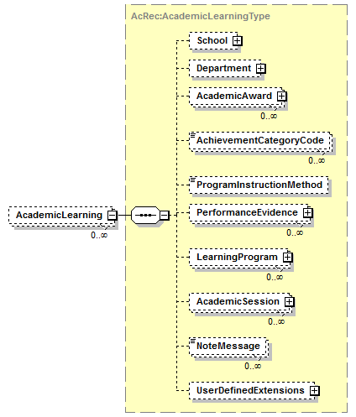

Academic Credential and Experiential Learning Details

Elements
Elements | Complex types
LearningRecord | LearningRecordType
Mentor | EndorseType
AwardEndorse | EndorseType
SponsorOrganization | AcRec:OrganizationType
PerformanceEvidence | URLType

Types
Complex types | Simple types
DocumentProductionType | LearningTopicType
EndorseType | LearningOutcomeDescriptionType
LearningRecordDetailType | LearningOutcomeSkillCodeType
AcademicLearningType | LearningOutcomeProficiencyCodeType
LearningProgramType | FrameworkOutcomeIdType
AcademicSessionType | FrameworkOutcomeValue
CourseType | DocumentTypeCodeType
CourseInstructorType | PlacementLocation
LearningOutcomeType | LearningReflection
LearningOutcomeQualificationAssessmentType | AcademicAwardLevel
AlternateOutcomeFrameworkType
FrameworkOutcomeType
LearningExperienceType

Schema Diagrams

LearningRecord
diagram | 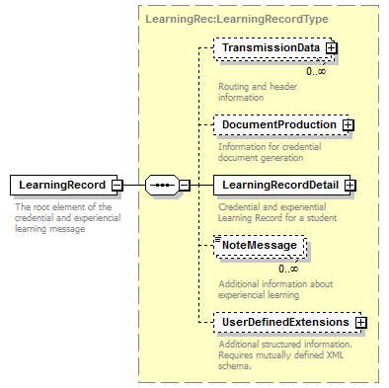
type | LearningRec:LearningRecordType
properties
  content | complex
children | TransmissionData DocumentProduction LearningRecordDetail NoteMessage UserDefinedExtensions
annotation
  documentation
  The root element of the credential and experiencial learning message
source | <xs:element name="LearningRecord" type="LearningRec:LearningRecordType">  <xs:annotation>  <xs:documentation>The root element of the credential and experiencial learning message</xs:documentation>  </xs:annotation>  </xs:element>

LearningRecordType
diagram | 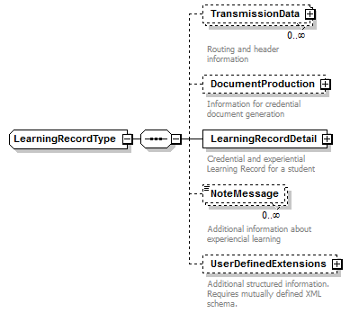
children | TransmissionData DocumentProduction LearningRecordDetail NoteMessage UserDefinedExtensions
used by
  element | LearningRecord
source | <xs:complexType name="LearningRecordType">  <xs:annotation>  <xs:documentation/>  </xs:annotation>  <xs:sequence>  <xs:element name="TransmissionData" type="AcRec:TransmissionDataType" minOccurs="0" maxOccurs="unbounded">  <xs:annotation>  <xs:documentation>Routing and header information</xs:documentation>  </xs:annotation>  </xs:element>  <xs:element name="DocumentProduction" type="AcRec:DocumentProductionType" minOccurs="0">  <xs:annotation>  <xs:documentation>Information for credential document generation</xs:documentation>  </xs:annotation>  </xs:element>  <xs:element name="LearningRecordDetail" type="AcRec:LearningRecordDetailType">  <xs:annotation>  <xs:documentation>Credential and experiential Learning Record for a student</xs:documentation>  </xs:annotation>  </xs:element>  <xs:element name="NoteMessage" type="core:NoteMessageType" minOccurs="0" maxOccurs="unbounded">  <xs:annotation>  <xs:documentation>Additional information about experiencial learning</xs:documentation>  </xs:annotation>  </xs:element>  <xs:element name="UserDefinedExtensions" type="core:UserDefinedExtensionsType" minOccurs="0">  <xs:annotation>  <xs:documentation>Additional structured information. Requires mutually defined XML schema.</xs:documentation>  </xs:annotation>  </xs:element>  </xs:sequence>  </xs:complexType>

DocumentProductionType
diagram | 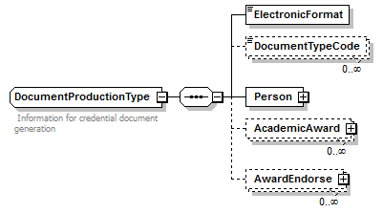
children | ElectronicFormat DocumentTypeCode Person AcademicAward AwardEndorse
used by
  element | LearningRecord/DocumentProduction
annotation
  documentation
  Information for credential document generation
source | <xs:complexType name="DocumentProductionType">  <xs:annotation>  <xs:documentation> Information for credential document generation </xs:documentation>  </xs:annotation>  <xs:sequence>  <xs:element name="ElectronicFormat" type="AcRec:ElectronicFormatType"/>  <xs:element name="DocumentTypeCode" type="core:DocumentTypeCodeType" minOccurs="0" maxOccurs="unbounded"/>  <xs:element name="Person" type="AcRec:PersonType"/>  <xs:element name="AcademicAward" type="AcRec:AcademicAwardType" minOccurs="0" maxOccurs="unbounded"/>  <xs:element name="AwardEndorse" type="core:EndorseType" minOccurs="0" maxOccurs="unbounded"/>  </xs:sequence>  </xs:complexType>

DocumentProductionType/AwardEndorse
diagram | 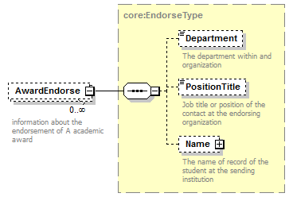
type | core:EndorseType
properties
  minOcc | 0
  maxOcc | unbounded
  content | complex
children | Department PositionTitle Name
annotation
  documentation
  information about the endorsement of A academic award
source | <xs:element name="AwardEndorse" type="core:EndorseType" minOccurs="0" maxOccurs="unbounded">  <xs:annotation>  <xs:documentation>information about the endorsement of A academic award</xs:documentation>  </xs:annotation>  </xs:element>

EndorseType
diagram | 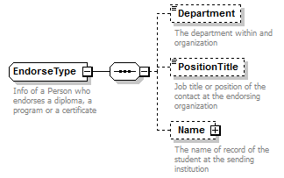
children | Department PositionTitle Name
used by
  elements | DocumentProductionType/AwardEndorse LearningExperienceType/Mentor
annotation
  documentation
  Info of a Person who endorses a diploma, a program or a certificate
source | <xs:complexType name="EndorseType">  <xs:annotation>  <xs:documentation>Info of a Person who endorses a diploma, a program or a certificate</xs:documentation>  </xs:annotation>  <xs:sequence>  <xs:element name="Department" type="core:OrganizationNameType" minOccurs="0">  <xs:annotation>  <xs:documentation>The department within and organization</xs:documentation>  </xs:annotation>  </xs:element>  <xs:element name="PositionTitle" type="core:PositionTitleType" minOccurs="0">  <xs:annotation>  <xs:documentation>Job title or position of the contact at the endorsing organization</xs:documentation>  </xs:annotation>  </xs:element>  <xs:element name="Name" type="core:NameType" minOccurs="0">  <xs:annotation>  <xs:documentation>The name of record of the student at the sending institution</xs:documentation>  </xs:annotation>  </xs:element>  </xs:sequence>  </xs:complexType>

LearningRecordDetailType
diagram | 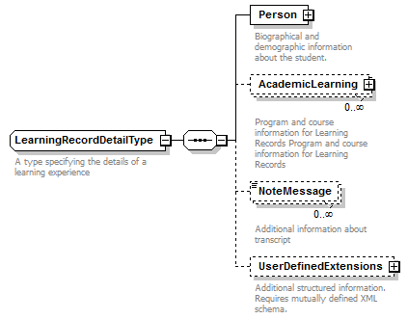
children | Person AcademicLearning NoteMessage UserDefinedExtensions
used by
  element | LearningRecordType/LearningRecordDetail
annotation
  documentation
  A type specifying the details of a learning experience
source | <xs:complexType name="LearningRecordDetailType">  <xs:annotation>  <xs:documentation>A type specifying the details of a learning experience</xs:documentation>  </xs:annotation>  <xs:sequence>  <xs:element name="Person" type="AcRec:PersonType">  <xs:annotation>  <xs:documentation>Biographical and demographic information about the student.</xs:documentation>  </xs:annotation>  </xs:element>  <xs:element name="AcademicLearning" type="AcRec:AcademicLearningType" minOccurs="0" maxOccurs="unbounded">  <xs:annotation>  <xs:documentation>Program and course information for Learning Records Program and course information for Learning Records</xs:documentation>  </xs:annotation>  </xs:element>  <xs:element name="NoteMessage" type="core:NoteMessageType" minOccurs="0" maxOccurs="unbounded">  <xs:annotation>  <xs:documentation>Additional information about transcript</xs:documentation>  </xs:annotation>  </xs:element>  <xs:element name="UserDefinedExtensions" type="core:UserDefinedExtensionsType" minOccurs="0">  <xs:annotation>  <xs:documentation>Additional structured information. Requires mutually defined XML schema.</xs:documentation>  </xs:annotation>  </xs:element>  </xs:sequence>  </xs:complexType>

AcademicLearningType
diagram | 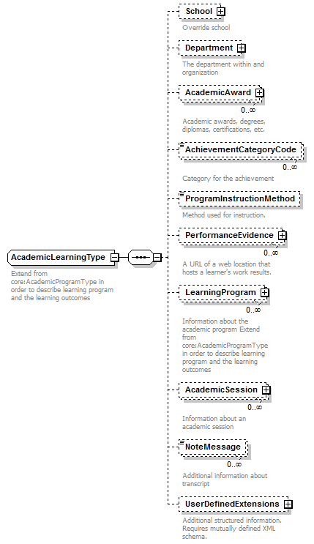
children | School Department AcademicAward AchievementCategoryCode ProgramInstructionMethod PerformanceEvidence LearningProgram AcademicSession NoteMessage UserDefinedExtensions
used by
  element | LearningRecordDetailType/AcademicLearning
annotation
  documentation
  Extend from core:AcademicProgramType in order to describe learning program and the learning outcomes
source | <xs:complexType name="AcademicLearningType">  <xs:annotation>  <xs:documentation>Extend from core:AcademicProgramType in order to describe learning program and the learning outcomes</xs:documentation>  </xs:annotation>  <xs:sequence>  <xs:element name="School" type="AcRec:SchoolType" minOccurs="0">  <xs:annotation>  <xs:documentation>Override school</xs:documentation>  </xs:annotation>  </xs:element>  <xs:element name="Department" type="AcRec:OrganizationType" minOccurs="0">  <xs:annotation>  <xs:documentation>The department within and organization</xs:documentation>  </xs:annotation>  </xs:element>  <xs:element name="AcademicAward" type="AcRec:AcademicAwardType" minOccurs="0" maxOccurs="unbounded">  <xs:annotation>  <xs:documentation>Academic awards, degrees, diplomas, certifications, etc.</xs:documentation>  </xs:annotation>  </xs:element>  <xs:element name="AchievementCategoryCode" type="AcRec:AchievementCategoryCodeType" minOccurs="0" maxOccurs="unbounded">  <xs:annotation>  <xs:documentation>Category for the achievement</xs:documentation>  </xs:annotation>  </xs:element>  <xs:element name="ProgramInstructionMethod" type="core:CourseInstructionMethodType" minOccurs="0">  <xs:annotation>  <xs:documentation>Method used for instruction.</xs:documentation>  </xs:annotation>  </xs:element>  <xs:element name="PerformanceEvidence" type="core:URLType" minOccurs="0" maxOccurs="unbounded">  <xs:annotation>  <xs:documentation>A URL of a web location that hosts a learner's work results.</xs:documentation>  </xs:annotation>  </xs:element>  <xs:element name="LearningProgram" type="AcRec:LearningProgramType" minOccurs="0" maxOccurs="unbounded">  <xs:annotation>  <xs:documentation>Information about the academic program Extend from core:AcademicProgramType in order to describe learning program and the learning outcomes</xs:documentation>  </xs:annotation>  </xs:element>  <xs:element name="AcademicSession" type="AcRec:AcademicSessionType" minOccurs="0" maxOccurs="unbounded">  <xs:annotation>  <xs:documentation>Information about an academic session</xs:documentation>  </xs:annotation>  </xs:element>  <xs:element name="NoteMessage" type="core:NoteMessageType" minOccurs="0" maxOccurs="unbounded">  <xs:annotation>  <xs:documentation>Additional information about transcript</xs:documentation>  </xs:annotation>  </xs:element>  <xs:element name="UserDefinedExtensions" type="core:UserDefinedExtensionsType" minOccurs="0">  <xs:annotation>  <xs:documentation>Additional structured information. Requires mutually defined XML schema.</xs:documentation>  </xs:annotation>  </xs:element>  </xs:sequence>  </xs:complexType>

LearningProgramType
diagram | 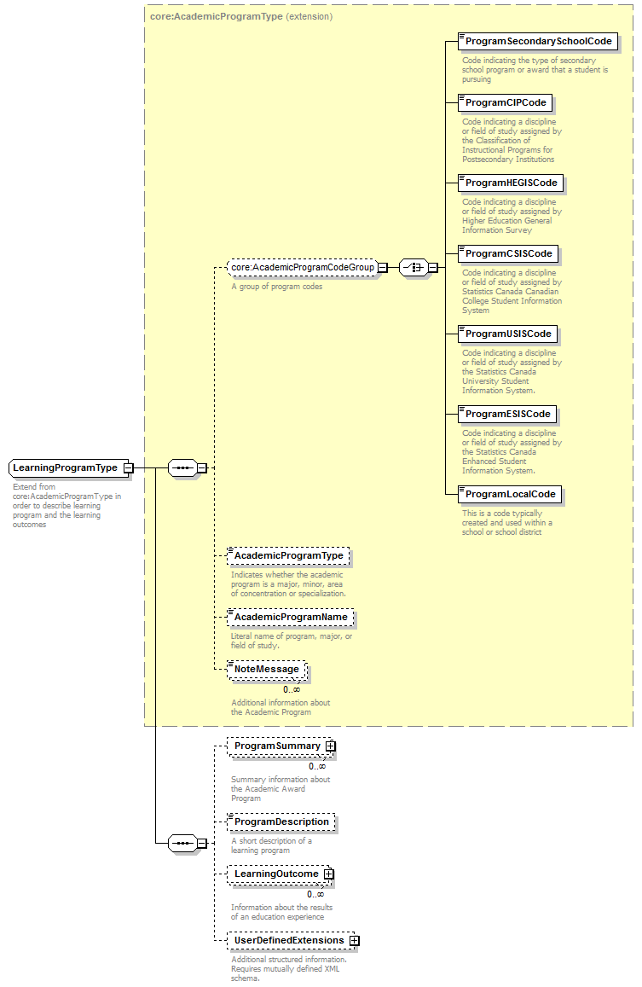
type | extension of core:AcademicProgramType
properties
  base | core:AcademicProgramType
children | ProgramSecondarySchoolCode ProgramCIPCode ProgramHEGISCode ProgramCSISCode ProgramUSISCode ProgramESISCode ProgramLocalCode AcademicProgramType AcademicProgramName NoteMessage ProgramSummary ProgramDescription LearningOutcome UserDefinedExtensions
used by
  element | AcademicLearningType/LearningProgram
annotation
  documentation
  Extend from core:AcademicProgramType in order to describe learning program and the learning outcomes
source | <xs:complexType name="LearningProgramType">  <xs:annotation>  <xs:documentation>Extend from core:AcademicProgramType in order to describe learning program and the learning outcomes</xs:documentation>  </xs:annotation>  <xs:complexContent>  <xs:extension base="core:AcademicProgramType">  <xs:sequence>  <xs:element name="ProgramSummary" type="AcRec:AcademicSummaryBaseType" minOccurs="0" maxOccurs="unbounded">  <xs:annotation>  <xs:documentation>Summary information about the Academic Award Program</xs:documentation>  </xs:annotation>  </xs:element>  <xs:element name="ProgramDescription" type="xs:string" minOccurs="0">  <xs:annotation>  <xs:documentation>A short description of a learning program</xs:documentation>  </xs:annotation>  </xs:element>  <xs:element name="LearningOutcome" type="core:LearningOutcomeType" minOccurs="0" maxOccurs="unbounded">  <xs:annotation>  <xs:documentation>Information about the results of an education experience</xs:documentation>  </xs:annotation>  </xs:element>  <xs:element name="UserDefinedExtensions" type="core:UserDefinedExtensionsType" minOccurs="0">  <xs:annotation>  <xs:documentation>Additional structured information. Requires mutually defined XML schema.</xs:documentation>  </xs:annotation>  </xs:element>  </xs:sequence>  </xs:extension>  </xs:complexContent>  </xs:complexType>

AcademicSessionType
diagram | 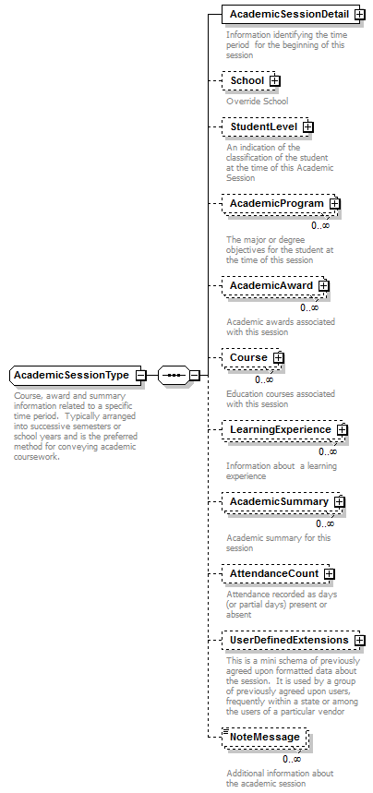
children | AcademicSessionDetail School StudentLevel AcademicProgram AcademicAward Course LearningExperience AcademicSummary AttendanceCount UserDefinedExtensions NoteMessage
used by
  elements | AcademicRecordType/AcademicSession AdmissionDecisionType/AcademicSession AcademicLearningType/AcademicSession
annotation
  documentation
  Course, award and summary information related to a specific time period. Typically arranged into successive semesters or school years and is the preferred method for conveying academic coursework.
source | <xs:complexType name="AcademicSessionType">  <xs:annotation>  <xs:documentation>Course, award and summary information related to a specific time period. Typically arranged into successive semesters or school years and is the preferred method for conveying academic coursework.</xs:documentation>  </xs:annotation>  <xs:sequence>  <xs:element name="AcademicSessionDetail" type="core:AcademicSessionDetailType">  <xs:annotation>  <xs:documentation>Information identifying the time period for the beginning of this session</xs:documentation>  </xs:annotation>  </xs:element>  <xs:element name="School" type="AcRec:SchoolType" minOccurs="0">  <xs:annotation>  <xs:documentation>Override School</xs:documentation>  </xs:annotation>  </xs:element>  <xs:element name="StudentLevel" type="core:StudentLevelType" minOccurs="0">  <xs:annotation>  <xs:documentation>An indication of the classification of the student at the time of this Academic Session</xs:documentation>  </xs:annotation>  </xs:element>  <xs:element name="AcademicProgram" type="AcRec:AcademicProgramType" minOccurs="0" maxOccurs="unbounded">  <xs:annotation>  <xs:documentation>The major or degree objectives for the student at the time of this session</xs:documentation>  </xs:annotation>  </xs:element>  <xs:element name="AcademicAward" type="AcRec:AcademicAwardType" minOccurs="0" maxOccurs="unbounded">  <xs:annotation>  <xs:documentation>Academic awards associated with this session</xs:documentation>  </xs:annotation>  </xs:element>  <xs:element name="Course" type="AcRec:CourseType" minOccurs="0" maxOccurs="unbounded">  <xs:annotation>  <xs:documentation>Education courses associated with this session</xs:documentation>  </xs:annotation>  </xs:element>  <xs:element name="LearningExperience" type="AcRec:LearningExperienceType" minOccurs="0" maxOccurs="unbounded">  <xs:annotation>  <xs:documentation>Information about a learning experience</xs:documentation>  </xs:annotation>  </xs:element>  <xs:element name="AcademicSummary" type="AcRec:AcademicSummaryFType" minOccurs="0" maxOccurs="unbounded">  <xs:annotation>  <xs:documentation>Academic summary for this session</xs:documentation>  </xs:annotation>  </xs:element>  <xs:element name="AttendanceCount" type="core:AttendanceCountType" minOccurs="0">  <xs:annotation>  <xs:documentation>Attendance recorded as days (or partial days) present or absent</xs:documentation>  </xs:annotation>  </xs:element>  <xs:element name="UserDefinedExtensions" type="core:UserDefinedExtensionsType" minOccurs="0">  <xs:annotation>  <xs:documentation>This is a mini schema of previously agreed upon formatted data about the session. It is used by a group of previously agreed upon users, frequently within a state or among the users of a particular vendor</xs:documentation>  </xs:annotation>  </xs:element>  <xs:element name="NoteMessage" type="core:NoteMessageType" minOccurs="0" maxOccurs="unbounded">  <xs:annotation>  <xs:documentation>Additional information about the academic session</xs:documentation>  </xs:annotation>  </xs:element>  </xs:sequence>  </xs:complexType>

CourseType
diagram | 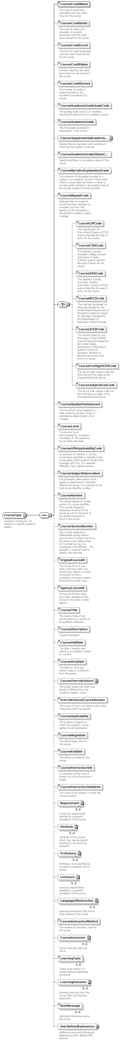
children | CourseCreditBasis CourseCreditUnits CourseCreditLevel CourseCreditValue CourseCreditEarned CourseAcademicGradeScaleCode CourseAcademicGrade CourseSupplementalAcademicGrade CourseAcademicGradeStatusCode CourseNarrativeExplanationGrade CourseRepeatCode CourseCIPCode CourseCSISCode CourseUSISCode CourseNCESCode CourseSCEDCode CourseFiveDigitSCEDCode CourseSubjectAreaCode CourseQualityPointsEarned CourseLevel CourseGPAApplicabilityCode CourseSubjectAbbreviation CourseNumber CourseSectionNumber OriginalCourseID AgencyCourseID CourseTitle CourseDescription CourseAddDate CourseDropDate CourseOverrideSchool OverrideSchoolCourseNumber CourseApplicability CourseBeginDate CourseEndDate CourseInstructionSite CourseInstructionSiteName Requirement Attribute Proficiency Licensure LanguageOfInstruction CourseInstructionMethod CourseInstructor LearningTopic LearningOutcome NoteMessage UserDefinedExtensions
used by
  elements | AcademicRecordType/Course AcademicSessionType/Course TransferCreditType/TransferCoursesAccepted
annotation
  documentation
  Academic coursework not related to a specific academic session.
source | <xs:complexType name="CourseType">  <xs:annotation>  <xs:documentation>Academic coursework not related to a specific academic session.</xs:documentation>  </xs:annotation>  <xs:sequence>  <xs:element name="CourseCreditBasis" type="core:CourseCreditBasisType">  <xs:annotation>  <xs:documentation>The type of enrollment associated with the credit hours for the course.</xs:documentation>  </xs:annotation>  </xs:element>  <xs:element name="CourseCreditUnits" type="core:CourseCreditUnitsType" minOccurs="0">  <xs:annotation>  <xs:documentation>The type of credit (unit, semester, or quarter) associated with the credit hours earned for the course.</xs:documentation>  </xs:annotation>  </xs:element>  <xs:element name="CourseCreditLevel" type="core:CourseCreditLevelType" minOccurs="0">  <xs:annotation>  <xs:documentation>The level of credit associated with the credit hours earned for the course.</xs:documentation>  </xs:annotation>  </xs:element>  <xs:element name="CourseCreditValue" type="core:CourseCreditValueType" minOccurs="0">  <xs:annotation>  <xs:documentation>Number indicating the credit hours that may be earned in the course.</xs:documentation>  </xs:annotation>  </xs:element>  <xs:element name="CourseCreditEarned" type="core:CourseCreditEarnedType" minOccurs="0">  <xs:annotation>  <xs:documentation>The number of credits a student earned by the successful completion of a course.</xs:documentation>  </xs:annotation>  </xs:element>  <xs:element name="CourseAcademicGradeScaleCode" type="core:CourseAcademicGradeScaleCodeType" minOccurs="0">  <xs:annotation>  <xs:documentation>The grading scale used by an academic educational institution for an academic course.</xs:documentation>  </xs:annotation>  </xs:element>  <xs:element name="CourseAcademicGrade" type="core:CourseAcademicGradeType" minOccurs="0">  <xs:annotation>  <xs:documentation>The final grade awarded for participation in the course.</xs:documentation>  </xs:annotation>  </xs:element>  <xs:element name="CourseSupplementalAcademicGrade" type="AcRec:CourseSupplementalAcademicGradeType" minOccurs="0">  <xs:annotation>  <xs:documentation>Grades that are reported, which combine to make the final grade in a course.</xs:documentation>  </xs:annotation>  </xs:element>  <xs:element name="CourseAcademicGradeStatusCode" type="core:CourseAcademicGradeStatusCodeType" minOccurs="0">  <xs:annotation>  <xs:documentation>Special enrollment or completion status of this course</xs:documentation>  </xs:annotation>  </xs:element>  <xs:element name="CourseNarrativeExplanationGrade" type="core:CourseNarrativeExplanationGradeType" minOccurs="0">  <xs:annotation>  <xs:documentation>The narrative of the grade awarded to a student in an academic course in those cases where a course does not receive a letter or numeric grade included in the grading scale of the Course Academic Grade Qualifier.</xs:documentation>  </xs:annotation>  </xs:element>  <xs:element name="CourseRepeatCode" type="core:CourseRepeatCodeType" minOccurs="0">  <xs:annotation>  <xs:documentation>Indicates that an academic course has been repeated by a student and how that repeat is to be computed in the student's academic grade average.</xs:documentation>  </xs:annotation>  </xs:element>  <xs:choice>  <xs:element name="CourseCIPCode" type="core:CourseCIPCodeType" minOccurs="0">  <xs:annotation>  <xs:documentation>The Classification of Instructional Programs (CIP) code to describe the area of study for the course.</xs:documentation>  </xs:annotation>  </xs:element>  <xs:element name="CourseCSISCode" type="core:CourseCSISCodeType" minOccurs="0">  <xs:annotation>  <xs:documentation>The Statistics Canada Canadian College Student Information System (CCSIS) code to describe the area of study for the course.</xs:documentation>  </xs:annotation>  </xs:element>  <xs:element name="CourseUSISCode" type="core:CourseUSISCodeType" minOccurs="0">  <xs:annotation>  <xs:documentation>The Statistics Canada University Student Information System (USIS) code to describe the area of study for the course.</xs:documentation>  </xs:annotation>  </xs:element>  <xs:element name="CourseNCESCode" type="core:CourseNCESCodeType" minOccurs="0">  <xs:annotation>  <xs:documentation>The code set developed (or being developed) by the United States Department of Education's National Center for Education Statistics for the Classification of Secondary School Courses</xs:documentation>  </xs:annotation>  </xs:element>  <xs:element name="CourseSCEDCode" type="core:CourseSCEDCodeType" minOccurs="0">  <xs:annotation>  <xs:documentation>The School Codes for the Exchange of Data (SCED) code set being developed for the United States Department of Education's National Center for Education Statistics to describe the content and level of a course</xs:documentation>  </xs:annotation>  </xs:element>  <xs:element name="CourseFiveDigitSCEDCode" type="core:CourseFiveDigitSCEDCodeType" minOccurs="0">  <xs:annotation>  <xs:documentation>This set of code values is derived from the first five digits of the CourseSCEDCode above.</xs:documentation>  </xs:annotation>  </xs:element>  <xs:element name="CourseSubjectAreaCode" type="core:CourseSubjectAreaCodeType" minOccurs="0">  <xs:annotation>  <xs:documentation>This set of code values is derived from the first two digits of the CourseSCEDCode above.</xs:documentation>  </xs:annotation>  </xs:element>  </xs:choice>  <xs:element name="CourseQualityPointsEarned" type="core:CourseQualityPointsEarnedType" minOccurs="0">  <xs:annotation>  <xs:documentation>The numerical value assigned to a letter grade to provide a basis of quantitative determination of an average.</xs:documentation>  </xs:annotation>  </xs:element>  <xs:element name="CourseLevel" type="core:CourseLevelType" minOccurs="0">  <xs:annotation>  <xs:documentation>The level of work demonstrated by successful completion of the academic course being described </xs:documentation>  </xs:annotation>  </xs:element>  <xs:element name="CourseGPAApplicabilityCode" type="core:CourseGPAApplicabilityCodeType" minOccurs="0">  <xs:annotation>  <xs:documentation>An indicator of whether or not this course being described is included in the computation of the student's Grade Point Average, and if so, if it weighted differently from regular courses.</xs:documentation>  </xs:annotation>  </xs:element>  <xs:element name="CourseSubjectAbbreviation" type="core:CourseSubjectAbbreviationType" minOccurs="0">  <xs:annotation>  <xs:documentation>The alphabetic abbreviation of the academic department or discipline offering the course. It is one part of the total course identifier number.</xs:documentation>  </xs:annotation>  </xs:element>  <xs:element name="CourseNumber" type="core:CourseNumberType" minOccurs="0">  <xs:annotation>  <xs:documentation>The official reference number portion of a course identifier. This number frequently designates the level of the course as well as the level of the student expected to enroll in the course</xs:documentation>  </xs:annotation>  </xs:element>  <xs:element name="CourseSectionNumber" type="core:CourseSectionNumberType" minOccurs="0">  <xs:annotation>  <xs:documentation>The number assigned to differentiate among distinct occurrences of courses that have the same course abbreviation and number but may be considered to be different . For example, it could be used to identify the instructor.</xs:documentation>  </xs:annotation>  </xs:element>  <xs:element name="OriginalCourseID" type="core:OriginalCourseIDType" minOccurs="0">  <xs:annotation>  <xs:documentation>The course ID as it was listed when the credit was earned (e.g. before a system conversion) to show consistency between present transcripts and older ones. </xs:documentation>  </xs:annotation>  </xs:element>  <xs:element name="AgencyCourseID" type="core:AgencyCourseIDType" minOccurs="0">  <xs:annotation>  <xs:documentation>The course ID that might have been assigned to this course by the state or other agency</xs:documentation>  </xs:annotation>  </xs:element>  <xs:element name="CourseTitle" type="core:CourseTitleType" minOccurs="0">  <xs:annotation>  <xs:documentation>The name or title of the course taken by a student at an academic institution.</xs:documentation>  </xs:annotation>  </xs:element>  <xs:element name="CourseDescription" minOccurs="0">  <xs:annotation>  <xs:documentation>Course Description</xs:documentation>  </xs:annotation>  <xs:simpleType>  <xs:restriction base="core:CourseDescriptionType">  <xs:maxLength value="255"/>  <xs:minLength value="1"/>  </xs:restriction>  </xs:simpleType>  </xs:element>  <xs:element name="CourseAddDate" type="core:CourseAddDateType" minOccurs="0">  <xs:annotation>  <xs:documentation>The date a student was added to an academic course at a school.</xs:documentation>  </xs:annotation>  </xs:element>  <xs:element name="CourseDropDate" type="core:CourseDropDateType" minOccurs="0">  <xs:annotation>  <xs:documentation>The date on which the student drops or withdraws from the course.</xs:documentation>  </xs:annotation>  </xs:element>  <xs:element name="CourseOverrideSchool" type="AcRec:SchoolType" minOccurs="0">  <xs:annotation>  <xs:documentation>The school where the credit was earned if different from the Academic Session School</xs:documentation>  </xs:annotation>  </xs:element>  <xs:element name="OverrideSchoolCourseNumber" type="core:OverrideSchoolCourseNumberType" minOccurs="0">  <xs:annotation>  <xs:documentation>The course ID as it was listed at the school where the credit was earned</xs:documentation>  </xs:annotation>  </xs:element>  <xs:element name="CourseApplicability" type="core:CourseApplicabilityType" minOccurs="0">  <xs:annotation>  <xs:documentation>The academic program to which this academic course applies toward graduation.</xs:documentation>  </xs:annotation>  </xs:element>  <xs:element name="CourseBeginDate" type="core:CourseBeginDateType" minOccurs="0">  <xs:annotation>  <xs:documentation>The official begin date for this course</xs:documentation>  </xs:annotation>  </xs:element>  <xs:element name="CourseEndDate" type="core:CourseEndDateType" minOccurs="0">  <xs:annotation>  <xs:documentation>The official end date for this course</xs:documentation>  </xs:annotation>  </xs:element>  <xs:element name="CourseInstructionSite" type="core:CourseInstructionSiteType" minOccurs="0">  <xs:annotation>  <xs:documentation>An indication of the type of location at which the course is taught.</xs:documentation>  </xs:annotation>  </xs:element>  <xs:element name="CourseInstructionSiteName" type="core:CourseInstructionSiteNameType" minOccurs="0">  <xs:annotation>  <xs:documentation>The name of the location at which the course is taught.</xs:documentation>  </xs:annotation>  </xs:element>  <xs:element name="Requirement" type="core:RAPType" minOccurs="0" maxOccurs="unbounded">  <xs:annotation>  <xs:documentation>Curriculum requirements satisfied by successful completion of this course</xs:documentation>  </xs:annotation>  </xs:element>  <xs:element name="Attribute" type="core:RAPType" minOccurs="0" maxOccurs="unbounded">  <xs:annotation>  <xs:documentation>Attributes of this course which may require special handling by the receiving institution</xs:documentation>  </xs:annotation>  </xs:element>  <xs:element name="Proficiency" type="core:RAPType" minOccurs="0" maxOccurs="unbounded">  <xs:annotation>  <xs:documentation>Proficiency level signified by successful completion of this course</xs:documentation>  </xs:annotation>  </xs:element>  <xs:element name="Licensure" type="core:LicensureType" minOccurs="0" maxOccurs="unbounded">  <xs:annotation>  <xs:documentation>Licensure requirements satisfied by successful completion of this course</xs:documentation>  </xs:annotation>  </xs:element>  <xs:element name="LanguageOfInstruction" type="core:LanguageOfInstructionType" minOccurs="0" maxOccurs="unbounded">  <xs:annotation>  <xs:documentation>Language associated with one or more aspects of the course</xs:documentation>  </xs:annotation>  </xs:element>  <xs:element name="CourseInstructionMethod" type="core:CourseInstructionMethodType" minOccurs="0">  <xs:annotation>  <xs:documentation>The method of instruction used for the course</xs:documentation>  </xs:annotation>  </xs:element>  <xs:element name="CourseInstructor" type="core:CourseInstructorType" minOccurs="0" maxOccurs="unbounded">  <xs:annotation>  <xs:documentation>Course instructor title and name</xs:documentation>  </xs:annotation>  </xs:element>  <xs:element name="LearningTopic" type="core:LearningTopicType" minOccurs="0" maxOccurs="unbounded">  <xs:annotation>  <xs:documentation>Topics to be taught in a course, learning experience or training</xs:documentation>  </xs:annotation>  </xs:element>  <xs:element name="LearningOutcome" type="core:LearningOutcomeType" minOccurs="0" maxOccurs="unbounded">  <xs:annotation>  <xs:documentation>Learning outcomes from the course taken and learning experience</xs:documentation>  </xs:annotation>  </xs:element>  <xs:element name="NoteMessage" type="core:NoteMessageType" minOccurs="0" maxOccurs="unbounded">  <xs:annotation>  <xs:documentation>Additional information about the course</xs:documentation>  </xs:annotation>  </xs:element>  <xs:element name="UserDefinedExtensions" type="core:UserDefinedExtensionsType" minOccurs="0">  <xs:annotation>  <xs:documentation>Additional structured information. Requires mutually defined XML schema.</xs:documentation>  </xs:annotation>  </xs:element>  </xs:sequence>  </xs:complexType>

CourseInstructorType
diagram | 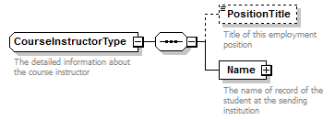
children | PositionTitle Name
used by
  element | CourseType/CourseInstructor
annotation
  documentation
  The detailed information about the course instructor
source | <xs:complexType name="CourseInstructorType">  <xs:annotation>  <xs:documentation>The detailed information about the course instructor</xs:documentation>  </xs:annotation>  <xs:sequence>  <xs:element name="PositionTitle" type="core:PositionTitleType" minOccurs="0">  <xs:annotation>  <xs:documentation>Title of this employment position</xs:documentation>  </xs:annotation>  </xs:element>  <xs:element name="Name" type="core:NameType" minOccurs="1">  <xs:annotation>  <xs:documentation>The name of record of the student at the sending institution</xs:documentation>  </xs:annotation>  </xs:element>  </xs:sequence>  </xs:complexType>

LearningOutcomeType
diagram | 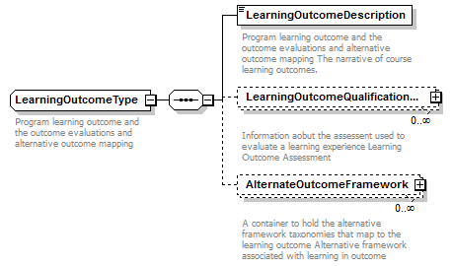
children | LearningOutcomeDescription LearningOutcomeQualificationAssessment AlternateOutcomeFramework
used by
  elements | CourseType/LearningOutcome LearningProgramType/LearningOutcome
annotation
  documentation
  Program learning outcome and the outcome evaluations and alternative outcome mapping
source | <xs:complexType name="LearningOutcomeType">  <xs:annotation>  <xs:documentation>Program learning outcome and the outcome evaluations and alternative outcome mapping</xs:documentation>  </xs:annotation>  <xs:sequence>  <xs:element name="LearningOutcomeDescription" type="core:LearningOutcomeDescriptionType">  <xs:annotation>  <xs:documentation>Program learning outcome and the outcome evaluations and alternative outcome mapping The narrative of course learning outcomes.</xs:documentation>  </xs:annotation>  </xs:element>  <xs:element name="LearningOutcomeQualificationAssessment" type="core:LearningOutcomeQualificationAssessmentType" minOccurs="0" maxOccurs="unbounded">  <xs:annotation>  <xs:documentation>Information aobut the assessent used to evaluate a learning experience Learning Outcome Assessment</xs:documentation>  </xs:annotation>  </xs:element>  <xs:element name="AlternateOutcomeFramework" type="core:AlternateOutcomeFrameworkType" minOccurs="0" maxOccurs="unbounded">  <xs:annotation>  <xs:documentation>A container to hold the alternative framework taxonomies that map to the learning outcome Alternative framework associated with learning in outcome </xs:documentation>  </xs:annotation>  </xs:element>  </xs:sequence>  </xs:complexType>

LearningOutcomeQualificationAssessmentType
diagram | 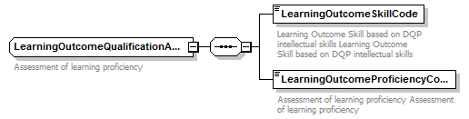
children | LearningOutcomeSkillCode LearningOutcomeProficiencyCode
used by
  element | LearningOutcomeType/LearningOutcomeQualificationAssessment
annotation
  documentation
  Assessment of learning proficiency
source | <xs:complexType name="LearningOutcomeQualificationAssessmentType">  <xs:annotation>  <xs:documentation>Assessment of learning proficiency</xs:documentation>  </xs:annotation>  <xs:sequence>  <xs:element name="LearningOutcomeSkillCode" type="core:LearningOutcomeSkillCodeType">  <xs:annotation>  <xs:documentation>Learning Outcome Skill based on DQP intellectual skills Learning Outcome Skill based on DQP intellectual skills</xs:documentation>  </xs:annotation>  </xs:element>  <xs:element name="LearningOutcomeProficiencyCode" type="core:LearningOutcomeProficiencyCodeType">  <xs:annotation>  <xs:documentation>Assessment of learning proficiency Assessment of learning proficiency</xs:documentation>  </xs:annotation>  </xs:element>  </xs:sequence>  </xs:complexType>

AlternateOutcomeFrameworkType
diagram | 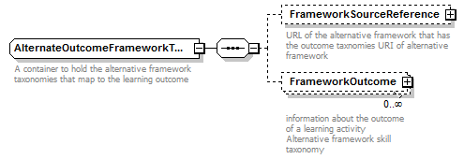
children | FrameworkSourceReference FrameworkOutcome
used by
  element | LearningOutcomeType/AlternateOutcomeFramework
annotation
  documentation
  A container to hold the alternative framework taxonomies that map to the learning outcome
source | <xs:complexType name="AlternateOutcomeFrameworkType">  <xs:annotation>  <xs:documentation>A container to hold the alternative framework taxonomies that map to the learning outcome</xs:documentation>  </xs:annotation>  <xs:sequence>  <xs:element name="FrameworkSourceReference" type="core:URLType" minOccurs="0">  <xs:annotation>  <xs:documentation>URL of the alternative framework that has the outcome taxnomies URI of alternative framework</xs:documentation>  </xs:annotation>  </xs:element>  <xs:element name="FrameworkOutcome" type="core:FrameworkOutcomeType" minOccurs="0" maxOccurs="unbounded">  <xs:annotation>  <xs:documentation>information about the outcome of a learning activity Alternative framework skill taxonomy</xs:documentation>  </xs:annotation>  </xs:element>  </xs:sequence>  </xs:complexType>

FrameworkOutcomeType
diagram | 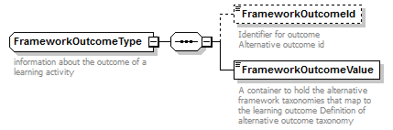
children | FrameworkOutcomeId FrameworkOutcomeValue
used by
  element | AlternateOutcomeFrameworkType/FrameworkOutcome
annotation
  documentation
  information about the outcome of a learning activity
source | <xs:complexType name="FrameworkOutcomeType">  <xs:annotation>  <xs:documentation>information about the outcome of a learning activity</xs:documentation>  </xs:annotation>  <xs:sequence>  <xs:element name="FrameworkOutcomeId" type="core:FrameworkOutcomeIdType" minOccurs="0" maxOccurs="1">  <xs:annotation>  <xs:documentation>Identifier for outcome Alternative outcome id </xs:documentation>  </xs:annotation>  </xs:element>  <xs:element name="FrameworkOutcomeValue" type="core:LearningOutcomeDescriptionType" minOccurs="1">  <xs:annotation>  <xs:documentation>A container to hold the alternative framework taxonomies that map to the learning outcome Definition of alternative outcome taxonomy</xs:documentation>  </xs:annotation>  </xs:element>  </xs:sequence>  </xs:complexType>

LearningExperienceType
diagram | 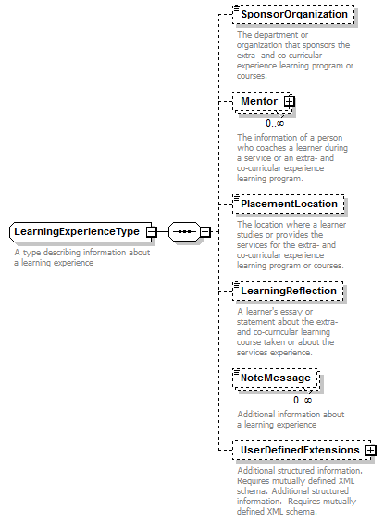
children | SponsorOrganization Mentor PlacementLocation LearningReflection NoteMessage UserDefinedExtensions
used by
  element | AcademicSessionType/LearningExperience
annotation
  documentation
  A type describing information about a learning experience
source | <xs:complexType name="LearningExperienceType">  <xs:annotation>  <xs:documentation>A type describing information about a learning experience</xs:documentation>  </xs:annotation>  <xs:sequence>  <xs:element name="SponsorOrganization" type="xs:string" minOccurs="0">  <xs:annotation>  <xs:documentation>The department or organization that sponsors the extra- and co-curricular experience learning program or courses.</xs:documentation>  </xs:annotation>  </xs:element>  <xs:element name="Mentor" type="core:EndorseType" minOccurs="0" maxOccurs="unbounded">  <xs:annotation>  <xs:documentation>The information of a person who coaches a learner during a service or an extra- and co-curricular experience learning program.</xs:documentation>  </xs:annotation>  </xs:element>  <xs:element name="PlacementLocation" type="xs:string" minOccurs="0">  <xs:annotation>  <xs:documentation>The location where a learner studies or provides the services for the extra- and co-curricular experience learning program or courses.</xs:documentation>  </xs:annotation>  </xs:element>  <xs:element name="LearningReflection" type="xs:string" minOccurs="0">  <xs:annotation>  <xs:documentation>A learner's essay or statement about the extra- and co-curricular learning course taken or about the services experience.</xs:documentation>  </xs:annotation>  </xs:element>  <xs:element name="NoteMessage" type="core:NoteMessageType" minOccurs="0" maxOccurs="unbounded">  <xs:annotation>  <xs:documentation>Additional information about a learning experience</xs:documentation>  </xs:annotation>  </xs:element>  <xs:element name="UserDefinedExtensions" type="core:UserDefinedExtensionsType" minOccurs="0">  <xs:annotation>  <xs:documentation>Additional structured information. Requires mutually defined XML schema. Additional structured information. Requires mutually defined XML schema.</xs:documentation>  </xs:annotation>  </xs:element>  </xs:sequence>  </xs:complexType>

LearningTopicType
type | restriction of xs:string
properties
  base | xs:string
used by
  element | CourseType/LearningTopic
facets
  Kind | Value | Annotation
  minLength | 1
  maxLength | 300
annotation
  documentation
  Topics to be taught for a course, learning experience or training
source | <xs:simpleType name="LearningTopicType">  <xs:annotation>  <xs:documentation>Topics to be taught for a course, learning experience or training</xs:documentation>  </xs:annotation>  <xs:restriction base="xs:string">  <xs:minLength value="1"/>  <xs:maxLength value="300"/>  </xs:restriction>  </xs:simpleType>

LearningOutcomeType/LearningOutcomeDescription
type | restriction of xs:string
properties
  base | xs:string
used by
  elements | FrameworkOutcomeType/FrameworkOutcomeValue LearningOutcomeType/LearningOutcomeDescription
facets
  Kind | Value | Annotation
  minLength | 1
  maxLength | 300
annotation
  documentation
  Text describing the outcome of a learning experience
source | <xs:simpleType name="LearningOutcomeDescriptionType">  <xs:annotation>  <xs:documentation>Text describing the outcome of a learning experience</xs:documentation>  </xs:annotation>  <xs:restriction base="xs:string">  <xs:minLength value="1"/>  <xs:maxLength value="300"/>  </xs:restriction>  </xs:simpleType>

FrameworkOutcomeType/FrameworkOutcomeId
type | restriction of xs:string
properties
  base | xs:string
used by
  element | FrameworkOutcomeType/FrameworkOutcomeId
facets
  Kind | Value | Annotation
  minLength | 1
  maxLength | 40
annotation
  documentation
  Program and course information for Learning Records
source | <xs:simpleType name="FrameworkOutcomeIdType">  <xs:annotation>  <xs:documentation>Program and course information for Learning Records</xs:documentation>  </xs:annotation>  <xs:restriction base="xs:string">  <xs:minLength value="1"/>  <xs:maxLength value="40"/>  </xs:restriction>  </xs:simpleType>

FrameworkOutcomeType/FrameworkOutcomeValue
diagram | 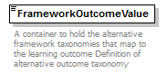
type | core:LearningOutcomeDescriptionType
properties
  content | simple
facets
  Kind | Value | Annotation
  minLength | 1
  maxLength | 300
annotation
  documentation
  A container to hold the alternative framework taxonomies that map to the learning outcome Definition of alternative outcome taxonomy
source | <xs:element name="FrameworkOutcomeValue" type="core:LearningOutcomeDescriptionType" minOccurs="1">  <xs:annotation>  <xs:documentation>A container to hold the alternative framework taxonomies that map to the learning outcome Definition of alternative outcome taxonomy</xs:documentation>  </xs:annotation>  </xs:element>

LearningOutcomeQualificationAssessmentType/LearningOutcomeSkillCode
type | restriction of xs:string
properties
  base | xs:string
used by
  element | LearningOutcomeQualificationAssessmentType/LearningOutcomeSkillCode
facets
  Kind | Value | Annotation
  enumeration | AnalyticInquiry
    documentation
    Analytic Inquiry
  enumeration | UseInformationResources
    documentation
    Use Information Resources
  enumeration | EngagingDiversePerspective
    documentation
    Engaging Diverse Perspective
  enumeration | EthicalReasoning
    documentation
    Ethical Reasoning
  enumeration | QuantitativeFluency
    documentation
    Quantitative Fluency
  enumeration | CommunicativeFluency
    documentation
    Communicative Fluency
  enumeration | ProgramSpecificIntellectualPracticalSkills
    documentation
    Program Specific Intellectual Practical Skills
annotation
  documentation
  Learning Outcome Skill based on DQP intellectual skills
source | <xs:simpleType name="LearningOutcomeSkillCodeType">  <xs:annotation>  <xs:documentation>Learning Outcome Skill based on DQP intellectual skills</xs:documentation>  </xs:annotation>  <xs:restriction base="xs:string">  <xs:enumeration value="AnalyticInquiry">  <xs:annotation>  <xs:documentation>Analytic Inquiry </xs:documentation>  </xs:annotation>  </xs:enumeration>  <xs:enumeration value="UseInformationResources">  <xs:annotation>  <xs:documentation>Use Information Resources </xs:documentation>  </xs:annotation>  </xs:enumeration>  <xs:enumeration value="EngagingDiversePerspective">  <xs:annotation>  <xs:documentation>Engaging Diverse Perspective </xs:documentation>  </xs:annotation>  </xs:enumeration>  <xs:enumeration value="EthicalReasoning">  <xs:annotation>  <xs:documentation>Ethical Reasoning </xs:documentation>  </xs:annotation>  </xs:enumeration>  <xs:enumeration value="QuantitativeFluency">  <xs:annotation>  <xs:documentation>Quantitative Fluency </xs:documentation>  </xs:annotation>  </xs:enumeration>  <xs:enumeration value="CommunicativeFluency">  <xs:annotation>  <xs:documentation>Communicative Fluency </xs:documentation>  </xs:annotation>  </xs:enumeration>  <xs:enumeration value="ProgramSpecificIntellectualPracticalSkills">  <xs:annotation>  <xs:documentation>Program Specific Intellectual Practical Skills </xs:documentation>  </xs:annotation>  </xs:enumeration>  </xs:restriction>  </xs:simpleType>

LearningOutcomeQualificationAssessmentType/LearningOutcomeProficiencyCode
type | restriction of xs:string
properties
  base | xs:string
used by
  element | LearningOutcomeQualificationAssessmentType/LearningOutcomeProficiencyCode
facets
  Kind | Value | Annotation
  enumeration | Novice
    documentation
    Novice
  enumeration | Intermediate
    documentation
    Intermediate
  enumeration | Proficient
    documentation
    Proficient
  enumeration | Distinguished
    documentation
    Distinguished
  enumeration | Master
    documentation
    Master
annotation
  documentation
  Assessment of learning proficiency
source | <xs:simpleType name="LearningOutcomeProficiencyCodeType">  <xs:annotation>  <xs:documentation>Assessment of learning proficiency</xs:documentation>  </xs:annotation>  <xs:restriction base="xs:string">  <xs:enumeration value="Novice">  <xs:annotation>  <xs:documentation>Novice </xs:documentation>  </xs:annotation>  </xs:enumeration>  <xs:enumeration value="Intermediate">  <xs:annotation>  <xs:documentation>Intermediate </xs:documentation>  </xs:annotation>  </xs:enumeration>  <xs:enumeration value="Proficient">  <xs:annotation>  <xs:documentation>Proficient </xs:documentation>  </xs:annotation>  </xs:enumeration>  <xs:enumeration value="Distinguished">  <xs:annotation>  <xs:documentation>Distinguished </xs:documentation>  </xs:annotation>  </xs:enumeration>  <xs:enumeration value="Master">  <xs:annotation>  <xs:documentation>Master </xs:documentation>  </xs:annotation>  </xs:enumeration>  </xs:restriction>  </xs:simpleType>

LearningExperienceType/SponsorOrganization
diagram | 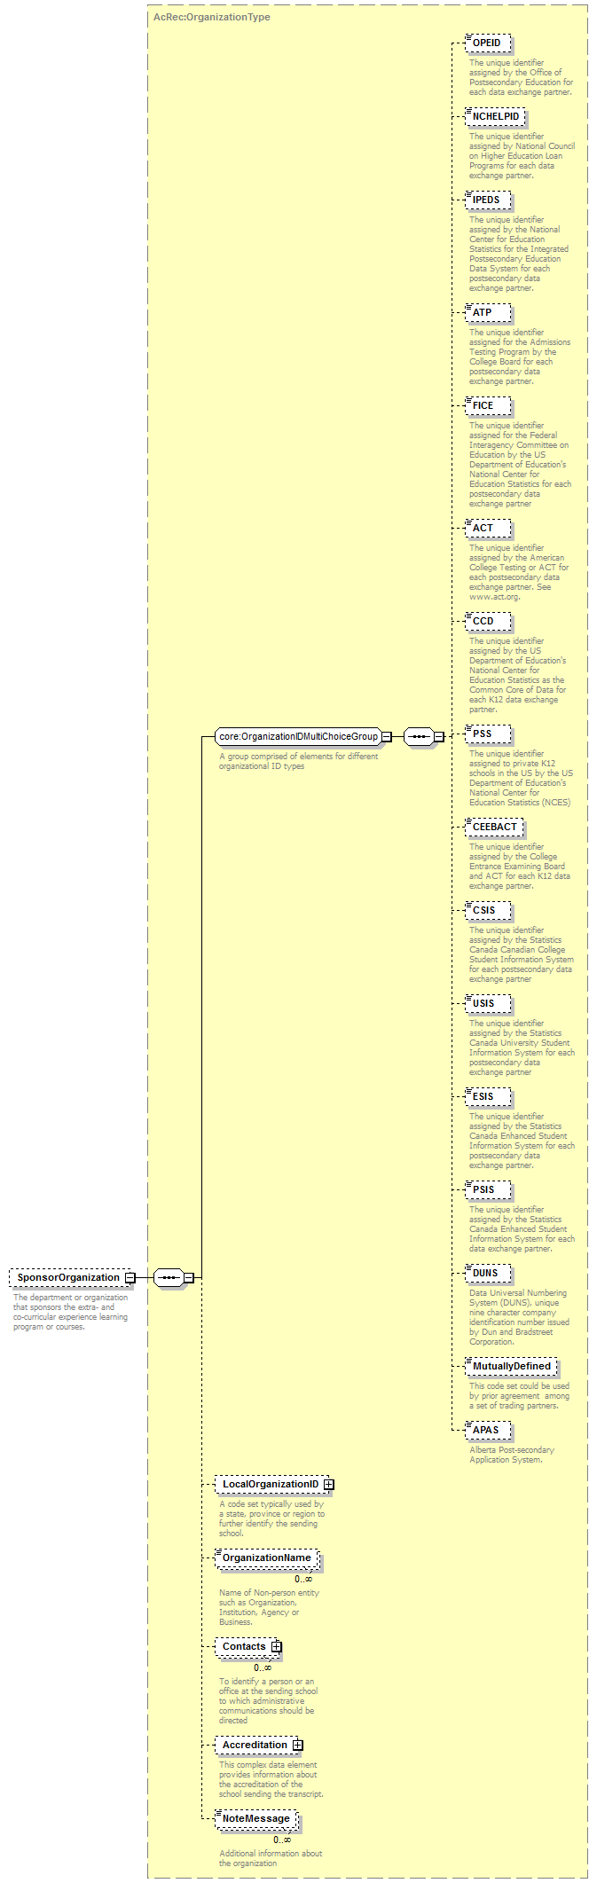
type | AcRec:OrganizationType
properties
  minOcc | 0
  maxOcc | 1
  content | complex
children | OPEID NCHELPID IPEDS ATP FICE ACT CCD PSS CEEBACT CSIS USIS ESIS PSIS DUNS MutuallyDefined APAS LocalOrganizationID OrganizationName Contacts Accreditation NoteMessage
annotation
  documentation
  The department or organization that sponsors the extra- and co-curricular experience learning program or courses.
source | <xs:element name="SponsorOrganization" type="AcRec:OrganizationType" minOccurs="0">  <xs:annotation>  <xs:documentation>The department or organization that sponsors the extra- and co-curricular experience learning program or courses.</xs:documentation>  </xs:annotation>  </xs:element>

AcRec:OrganizationType
diagram | 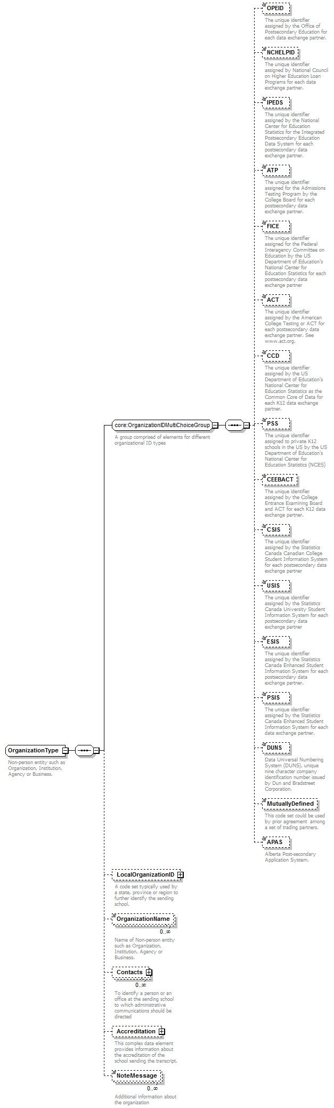
children | OPEID NCHELPID IPEDS ATP FICE ACT CCD PSS CEEBACT CSIS USIS ESIS PSIS DUNS MutuallyDefined APAS LocalOrganizationID OrganizationName Contacts Accreditation NoteMessage
used by
  elements | AcademicLearningType/Department EmploymentType/Employer SourceDestinationType/Organization LearningExperienceType/SponsorOrganization
annotation
  documentation
  Non-person entity such as Organization, Institution, Agency or Business.
source | <xs:complexType name="OrganizationType">  <xs:annotation>  <xs:documentation>Non-person entity such as Organization, Institution, Agency or Business.</xs:documentation>  </xs:annotation>  <xs:sequence>  <xs:group ref="core:OrganizationIDMultiChoiceGroup"/>  <xs:element name="LocalOrganizationID" type="core:LocalOrganizationIDType" minOccurs="0">  <xs:annotation>  <xs:documentation>A code set typically used by a state, province or region to further identify the sending school.</xs:documentation>  </xs:annotation>  </xs:element>  <xs:element name="OrganizationName" minOccurs="0" maxOccurs="unbounded">  <xs:annotation>  <xs:documentation>Name of Non-person entity such as Organization, Institution, Agency or Business.</xs:documentation>  </xs:annotation>  <xs:simpleType>  <xs:restriction base="core:OrganizationNameType">  <xs:maxLength value="60"/>  </xs:restriction>  </xs:simpleType>  </xs:element>  <xs:element name="Contacts" type="AcRec:ContactsType" minOccurs="0" maxOccurs="unbounded">  <xs:annotation>  <xs:documentation>To identify a person or an office at the sending school to which administrative communications should be directed</xs:documentation>  </xs:annotation>  </xs:element>  <xs:element name="Accreditation" type="core:AccreditationType" minOccurs="0">  <xs:annotation>  <xs:documentation>This complex data element provides information about the accreditation of the school sending the transcript.</xs:documentation>  </xs:annotation>  </xs:element>  <xs:element name="NoteMessage" type="core:NoteMessageType" minOccurs="0" maxOccurs="unbounded">  <xs:annotation>  <xs:documentation>Additional information about the organization</xs:documentation>  </xs:annotation>  </xs:element>  </xs:sequence>  </xs:complexType>

LearningExperienceType/Mentor
diagram | 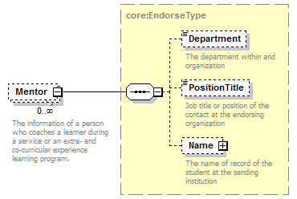
type | core:EndorseType
properties
  minOcc | 0
  maxOcc | unbounded
  content | complex
children | Department PositionTitle Name
annotation
  documentation
  The information of a person who coaches a learner during a service or an extra- and co-curricular experience learning program.
source | <xs:element name="Mentor" type="core:EndorseType" minOccurs="0" maxOccurs="unbounded">  <xs:annotation>  <xs:documentation>The information of a person who coaches a learner during a service or an extra- and co-curricular experience learning program.</xs:documentation>  </xs:annotation>  </xs:element>

LearningExperienceType/PlacementLocation
diagram | 
type | xs:string
properties
  minOcc | 0
  maxOcc | 1
  content | simple
annotation
  documentation
  The location where a learner studies or provides the services for the extra- and co-curricular experience learning program or courses.
source | <xs:element name="PlacementLocation" type="xs:string" minOccurs="0">  <xs:annotation>  <xs:documentation>The location where a learner studies or provides the services for the extra- and co-curricular experience learning program or courses.</xs:documentation>  </xs:annotation>  </xs:element>

LearningExperienceType/LearningReflection
diagram | 
type | xs:string
properties
  minOcc | 0
  maxOcc | 1
  content | simple
annotation
  documentation
  A learner's essay or statement about the extra- and co-curricular learning course taken or about the services experience.
source | <xs:element name="LearningReflection" type="xs:string" minOccurs="0">  <xs:annotation>  <xs:documentation>A learner's essay or statement about the extra- and co-curricular learning course taken or about the services experience.</xs:documentation>  </xs:annotation>  </xs:element>

AcademicLearningType/PerformanceEvidence
diagram | 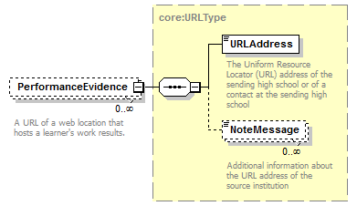
type | core:URLType
properties
  minOcc | 0
  maxOcc | unbounded
  content | complex
children | URLAddress NoteMessage
annotation
  documentation
  A URL of a web location that hosts a learner's work results.
source | <xs:element name="PerformanceEvidence" type="core:URLType" minOccurs="0" maxOccurs="unbounded">  <xs:annotation>  <xs:documentation>A URL of a web location that hosts a learner's work results.</xs:documentation>  </xs:annotation>  </xs:element>

AcademicAwardType/AcademicAwardLevel
type | restriction of xs:string
properties
  base | xs:string
used by
  element | AcademicAwardType/AcademicAwardLevel
facets
  Kind | Value | Annotation
  enumeration | B17
    documentation
    Did not complete secondary school
  enumeration | B18
    documentation
    Standard High School Diploma which may or may not include an exit test
  enumeration | B19
    documentation
    Advanced or honors diploma
  enumeration | B20
    documentation
    Vocational diploma
  enumeration | B21
    documentation
    Special Education Diploma normally for students with a disabilit
  enumeration | B22
    documentation
    Certificate of completion or attendance
  enumeration | B23
    documentation
    Special certificate of completion or attendance
  enumeration | B24
    documentation
    General Education Development Test Diploma (GED)
  enumeration | B25
    documentation
    Other high school equivalency diploma
  enumeration | B26
    documentation
    International diploma or certificate (such as International Baccalaureate)
  enumeration | B27
    documentation
    Standard High School Diploma with only 3 year curriculum
  enumeration | B28
    documentation
    Met all graduation requirements except for required exit test
  enumeration | B58
    documentation
    B58
  enumeration | B59
    documentation
    B59
  enumeration | B60
    documentation
    B60
  enumeration | 0.0
    documentation
    "Other" - value to represent an award that does not otherwise fit existing enumerations
  enumeration | 1.1
    documentation
    Certificate of completion,
  enumeration | 1.2
    documentation
    Certificate of proficiency
  enumeration | 1.3
    documentation
    Statement of participation
  enumeration | 1.4
    documentation
    Statement of completion
  enumeration | 1.5
    documentation
    Statement of achievement
  enumeration | 2.0
    documentation
    Certificate
  enumeration | 2.1
    documentation
    Postsecondary Certificate Or Diploma (less than one year)
  enumeration | 2.2
    documentation
    Postsecondary Certificate Or Diploma (one year or more but less than four years)
  enumeration | 2.3
    documentation
    Associate Degree (e.g., Associate In Arts, Associate In Science)
  enumeration | 2.4
    documentation
    Baccalaureate Degree
  enumeration | 2.5
    documentation
    Baccalaureate (Honors) Degree
  enumeration | 2.6
    documentation
    Postsecondary Certificate Or Diploma (one year or more but less than two years)
  enumeration | 2.7
    documentation
    Postsecondary Certificate Or Diploma (two years or more but less than four years)
  enumeration | 2.8
    documentation
    "Undergraduate non-degree" - value to represent an award from undergraduate coursework that is not a certificate or degree
  enumeration | 3.1
    documentation
    First Professional Degree
  enumeration | 3.2
    documentation
    Post-Professional Degree
  enumeration | 3.3
    documentation
    "Graduate Professional" - value to represent an award from graduate coursework in a professional program
  enumeration | 4.0
    documentation
    "Graduate non-degree" - value to represent an award from graduate coursework that is not a certificate or degree
  enumeration | 4.1
    documentation
    Graduate Certificate
  enumeration | 4.2
    documentation
    Master's Degree
  enumeration | 4.3
    documentation
    Intermediate Graduate Degree
  enumeration | 4.4
    documentation
    Doctoral Degree
  enumeration | 4.5
    documentation
    Post-doctoral Award
  enumeration | FrenchBaccalaureate
    documentation
    French Baccalaureate
  enumeration | CEGEP
    documentation
    CEGEP
  enumeration | 1
    documentation
    Postsecondary award, certificate or diploma of less than one academic year (less than 900 contact or clock hours)
  enumeration | 2
    documentation
    Certificate
  enumeration | 3
    documentation
    Associate's Degree
  enumeration | 4
    documentation
    Postsecondary award, certificate, or diploma of at least two but less than four academic years (at least 1800 contact or clock hours)
  enumeration | 5
    documentation
    Bachelor's Degree or equivalent
  enumeration | 6
    documentation
    Postbaccalaureate Certificate
  enumeration | 7
    documentation
    Master's Degree
  enumeration | 8
    documentation
    Post Masters Certificate
  enumeration | 9
    documentation
    Doctor's Degree
  enumeration | 10
    documentation
    First-Professional Degree
  enumeration | 11
    documentation
    First-Professional Certificate (Post-Degree)
  enumeration | 17
    documentation
    Doctor's degree - research/scholarship
  enumeration | 18
    documentation
    Doctor's degree - professional practice
  enumeration | 19
    documentation
    Doctor's degree - otherAward Levels.
annotation
  documentation
  The level of the degree, certificate, or award granted for the successful completion of requirements of an academic program.B17 Did not complete secondary schoolB18 Standard High School Diploma which may or may not include an exit testB19 Advanced or honors diplomaB20 Vocational diplomaB21 Special Education Diploma normally for students with a disabilityB22 Certificate of completion or attendanceB23 Special certificate of completion or attendanceB24 General Education Development (GED) DiplomaB25 Other high school equivalency diplomaB26 International diploma or certificate such as International Baccalaureate B27 Standard High School Diploma with only 3 year curriculumB28 Met all graduation requirements except for required exit testFrenchBaccalaureate is an award made to high school students who complete a rigorous program of student including foreign languages. It allows French and international students to obtain a standardized qualification, typically at the age of 18. This then qualifies holders to work in certain areas, or go on to tertiary education or acquire some other professional qualification or training.CEGEP is an award made by Canadian secondary schools that is typically equivalent to a high school diploma plus one year of college level courses
source | <xs:simpleType name="AcademicAwardLevelType">  <xs:annotation>  <xs:documentation>The level of the degree, certificate, or award granted for the successful completion of requirements of an academic program.B17 Did not complete secondary schoolB18 Standard High School Diploma which may or may not include an exit testB19 Advanced or honors diplomaB20 Vocational diplomaB21 Special Education Diploma normally for students with a disabilityB22 Certificate of completion or attendanceB23 Special certificate of completion or attendanceB24 General Education Development (GED) DiplomaB25 Other high school equivalency diplomaB26 International diploma or certificate such as International Baccalaureate B27 Standard High School Diploma with only 3 year curriculumB28 Met all graduation requirements except for required exit testFrenchBaccalaureate is an award made to high school students who complete a rigorous program of student including foreign languages. It allows French and international students to obtain a standardized qualification, typically at the age of 18. This then qualifies holders to work in certain areas, or go on to tertiary education or acquire some other professional qualification or training.CEGEP is an award made by Canadian secondary schools that is typically equivalent to a high school diploma plus one year of college level courses</xs:documentation>  </xs:annotation>  <xs:restriction base="xs:string">  <xs:enumeration value="B17">  <xs:annotation>  <xs:documentation>Did not complete secondary school</xs:documentation>  </xs:annotation>  </xs:enumeration>  <xs:enumeration value="B18">  <xs:annotation>  <xs:documentation>Standard High School Diploma which may or may not include an exit test</xs:documentation>  </xs:annotation>  </xs:enumeration>  <xs:enumeration value="B19">  <xs:annotation>  <xs:documentation>Advanced or honors diploma</xs:documentation>  </xs:annotation>  </xs:enumeration>  <xs:enumeration value="B20">  <xs:annotation>  <xs:documentation>Vocational diploma</xs:documentation>  </xs:annotation>  </xs:enumeration>  <xs:enumeration value="B21">  <xs:annotation>  <xs:documentation>Special Education Diploma normally for students with a disabilit</xs:documentation>  </xs:annotation>  </xs:enumeration>  <xs:enumeration value="B22">  <xs:annotation>  <xs:documentation>Certificate of completion or attendance</xs:documentation>  </xs:annotation>  </xs:enumeration>  <xs:enumeration value="B23">  <xs:annotation>  <xs:documentation>Special certificate of completion or attendance</xs:documentation>  </xs:annotation>  </xs:enumeration>  <xs:enumeration value="B24">  <xs:annotation>  <xs:documentation>General Education Development Test Diploma (GED)</xs:documentation>  </xs:annotation>  </xs:enumeration>  <xs:enumeration value="B25">  <xs:annotation>  <xs:documentation>Other high school equivalency diploma</xs:documentation>  </xs:annotation>  </xs:enumeration>  <xs:enumeration value="B26">  <xs:annotation>  <xs:documentation>International diploma or certificate (such as International Baccalaureate)</xs:documentation>  </xs:annotation>  </xs:enumeration>  <xs:enumeration value="B27">  <xs:annotation>  <xs:documentation>Standard High School Diploma with only 3 year curriculum</xs:documentation>  </xs:annotation>  </xs:enumeration>  <xs:enumeration value="B28">  <xs:annotation>  <xs:documentation>Met all graduation requirements except for required exit test</xs:documentation>  </xs:annotation>  </xs:enumeration>  <xs:enumeration value="B58">  <xs:annotation>  <xs:documentation>B58</xs:documentation>  </xs:annotation>  </xs:enumeration>  <xs:enumeration value="B59">  <xs:annotation>  <xs:documentation>B59</xs:documentation>  </xs:annotation>  </xs:enumeration>  <xs:enumeration value="B60">  <xs:annotation>  <xs:documentation>B60</xs:documentation>  </xs:annotation>  </xs:enumeration>  <xs:enumeration value="0.0">  <xs:annotation>  <xs:documentation> "Other" - value to represent an award that does not otherwise fit existing enumerations</xs:documentation>  </xs:annotation>  </xs:enumeration>  <xs:enumeration value="1.1">  <xs:annotation>  <xs:documentation>Certificate of completion,</xs:documentation>  </xs:annotation>  </xs:enumeration>  <xs:enumeration value="1.2">  <xs:annotation>  <xs:documentation>Certificate of proficiency</xs:documentation>  </xs:annotation>  </xs:enumeration>  <xs:enumeration value="1.3">  <xs:annotation>  <xs:documentation>Statement of participation</xs:documentation>  </xs:annotation>  </xs:enumeration>  <xs:enumeration value="1.4">  <xs:annotation>  <xs:documentation>Statement of completion</xs:documentation>  </xs:annotation>  </xs:enumeration>  <xs:enumeration value="1.5">  <xs:annotation>  <xs:documentation>Statement of achievement</xs:documentation>  </xs:annotation>  </xs:enumeration>  <xs:enumeration value="2.0">  <xs:annotation>  <xs:documentation>Certificate</xs:documentation>  </xs:annotation>  </xs:enumeration>  <xs:enumeration value="2.1">  <xs:annotation>  <xs:documentation>Postsecondary Certificate Or Diploma (less than one year)</xs:documentation>  </xs:annotation>  </xs:enumeration>  <xs:enumeration value="2.2">  <xs:annotation>  <xs:documentation>Postsecondary Certificate Or Diploma (one year or more but less than four years)</xs:documentation>  </xs:annotation>  </xs:enumeration>  <xs:enumeration value="2.3">  <xs:annotation>  <xs:documentation>Associate Degree (e.g., Associate In Arts, Associate In Science)</xs:documentation>  </xs:annotation>  </xs:enumeration>  <xs:enumeration value="2.4">  <xs:annotation>  <xs:documentation>Baccalaureate Degree</xs:documentation>  </xs:annotation>  </xs:enumeration>  <xs:enumeration value="2.5">  <xs:annotation>  <xs:documentation>Baccalaureate (Honors) Degree</xs:documentation>  </xs:annotation>  </xs:enumeration>  <xs:enumeration value="2.6">  <xs:annotation>  <xs:documentation>Postsecondary Certificate Or Diploma (one year or more but less than two years)</xs:documentation>  </xs:annotation>  </xs:enumeration>  <xs:enumeration value="2.7">  <xs:annotation>  <xs:documentation>Postsecondary Certificate Or Diploma (two years or more but less than four years)</xs:documentation>  </xs:annotation>  </xs:enumeration>  <xs:enumeration value="2.8">  <xs:annotation>  <xs:documentation> "Undergraduate non-degree" - value to represent an award from undergraduate coursework that is not a certificate or degree</xs:documentation>  </xs:annotation>  </xs:enumeration>  <xs:enumeration value="3.1">  <xs:annotation>  <xs:documentation>First Professional Degree</xs:documentation>  </xs:annotation>  </xs:enumeration>  <xs:enumeration value="3.2">  <xs:annotation>  <xs:documentation>Post-Professional Degree</xs:documentation>  </xs:annotation>  </xs:enumeration>  <xs:enumeration value="3.3">  <xs:annotation>  <xs:documentation> "Graduate Professional" - value to represent an award from graduate coursework in a professional program</xs:documentation>  </xs:annotation>  </xs:enumeration>  <xs:enumeration value="4.0">  <xs:annotation>  <xs:documentation> "Graduate non-degree" - value to represent an award from graduate coursework that is not a certificate or degree</xs:documentation>  </xs:annotation>  </xs:enumeration>  <xs:enumeration value="4.1">  <xs:annotation>  <xs:documentation>Graduate Certificate</xs:documentation>  </xs:annotation>  </xs:enumeration>  <xs:enumeration value="4.2">  <xs:annotation>  <xs:documentation>Master's Degree</xs:documentation>  </xs:annotation>  </xs:enumeration>  <xs:enumeration value="4.3">  <xs:annotation>  <xs:documentation>Intermediate Graduate Degree</xs:documentation>  </xs:annotation>  </xs:enumeration>  <xs:enumeration value="4.4">  <xs:annotation>  <xs:documentation>Doctoral Degree</xs:documentation>  </xs:annotation>  </xs:enumeration>  <xs:enumeration value="4.5">  <xs:annotation>  <xs:documentation>Post-doctoral Award</xs:documentation>  </xs:annotation>  </xs:enumeration>  <xs:enumeration value="FrenchBaccalaureate">  <xs:annotation>  <xs:documentation>French Baccalaureate</xs:documentation>  </xs:annotation>  </xs:enumeration>  <xs:enumeration value="CEGEP">  <xs:annotation>  <xs:documentation>CEGEP</xs:documentation>  </xs:annotation>  </xs:enumeration>  <xs:enumeration value="1">  <xs:annotation>  <xs:documentation>Postsecondary award, certificate or diploma of less than one academic year (less than 900 contact or clock hours)</xs:documentation>  </xs:annotation>  </xs:enumeration>  <xs:enumeration value="2">  <xs:annotation>  <xs:documentation>Certificate</xs:documentation>  </xs:annotation>  </xs:enumeration>  <xs:enumeration value="3">  <xs:annotation>  <xs:documentation>Associate's Degree</xs:documentation>  </xs:annotation>  </xs:enumeration>  <xs:enumeration value="4">  <xs:annotation>  <xs:documentation>Postsecondary award, certificate, or diploma of at least two but less than four academic years (at least 1800 contact or clock hours)</xs:documentation>  </xs:annotation>  </xs:enumeration>  <xs:enumeration value="5">  <xs:annotation>  <xs:documentation>Bachelor's Degree or equivalent</xs:documentation>  </xs:annotation>  </xs:enumeration>  <xs:enumeration value="6">  <xs:annotation>  <xs:documentation>Postbaccalaureate Certificate</xs:documentation>  </xs:annotation>  </xs:enumeration>  <xs:enumeration value="7">  <xs:annotation>  <xs:documentation>Master's Degree</xs:documentation>  </xs:annotation>  </xs:enumeration>  <xs:enumeration value="8">  <xs:annotation>  <xs:documentation>Post Masters Certificate</xs:documentation>  </xs:annotation>  </xs:enumeration>  <xs:enumeration value="9">  <xs:annotation>  <xs:documentation>Doctor's Degree</xs:documentation>  </xs:annotation>  </xs:enumeration>  <xs:enumeration value="10">  <xs:annotation>  <xs:documentation>First-Professional Degree</xs:documentation>  </xs:annotation>  </xs:enumeration>  <xs:enumeration value="11">  <xs:annotation>  <xs:documentation>First-Professional Certificate (Post-Degree)</xs:documentation>  </xs:annotation>  </xs:enumeration>  <xs:enumeration value="17">  <xs:annotation>  <xs:documentation>Doctor's degree - research/scholarship</xs:documentation>  </xs:annotation>  </xs:enumeration>  <xs:enumeration value="18">  <xs:annotation>  <xs:documentation>Doctor's degree - professional practice</xs:documentation>  </xs:annotation>  </xs:enumeration>  <xs:enumeration value="19">  <xs:annotation>  <xs:documentation>Doctor's degree - otherAward Levels.</xs:documentation>  </xs:annotation>  </xs:enumeration>  </xs:restriction>  </xs:simpleType>

URLType
diagram | 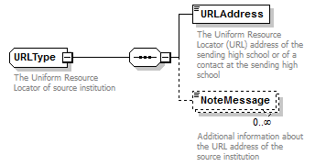
children | URLAddress NoteMessage
used by
  elements | AlternateOutcomeFrameworkType/FrameworkSourceReference AcademicLearningType/PerformanceEvidence ContactsType/URL ContactsType/URL
annotation
  documentation
  The Uniform Resource Locator of source institution
source | <xs:complexType name="URLType">  <xs:annotation>  <xs:documentation>The Uniform Resource Locator of source institution</xs:documentation>  </xs:annotation>  <xs:sequence>  <xs:element name="URLAddress" type="core:URLAddressType">  <xs:annotation>  <xs:documentation>The Uniform Resource Locator (URL) address of the sending high school or of a contact at the sending high school</xs:documentation>  </xs:annotation>  </xs:element>  <xs:element name="NoteMessage" type="core:NoteMessageType" minOccurs="0" maxOccurs="unbounded">  <xs:annotation>  <xs:documentation>Additional information about the URL address of the source institution</xs:documentation>  </xs:annotation>  </xs:element>  </xs:sequence>  </xs:complexType>

DocumentProductionType/DocumentTypeCodeType
type | restriction of xs:string
properties
  base | xs:string
used by
  elements | TransmissionDataType/DocumentType FFELDocumentResponseType/DocumentTypeCode CommonRecordResponseType/DocumentTypeCode TransmissionDataType/DocumentTypeCode DocumentProductionType/DocumentTypeCode
facets
  Kind | Value | Annotation
  enumeration | Acknowledgment
    documentation
    Acknowledgment
  enumeration | Application
    documentation
    Application
  enumeration | Cancel
    documentation
    Cancel
  enumeration | Certificate
    documentation
    Certificate
  enumeration | CertificationRequest
    documentation
    Certification Request
  enumeration | Change
    documentation
    Change
  enumeration | Credential
    documentation
    Credential
  enumeration | Diploma
    documentation
    Diploma
  enumeration | DisbursementAcknowledgement
    documentation
    Disbursement Acknowledgement
  enumeration | DisbursementForecast
    documentation
    Disbursement Forecast
  enumeration | DisbursementRoster
    documentation
    Disbursement Roster
  enumeration | InstitutionRequest
    documentation
    Institution Request
  enumeration | GainfulEmploymentStudentResponseFile
    documentation
    Gainful Employment Student Response File
  enumeration | GainfulEmploymentStudentSubmittal
    documentation
    Gainful Employment Student Submittal
  enumeration | IPEDS
    documentation
    Integrated PostSecondary Education Data System
  enumeration | NSLDSEnrollmentError
    documentation
    National Student Loan Data System Enrollment Error
  enumeration | NSLDSEnrollmentSubmittal
    documentation
    National Student Loan Data System Enrollment Submittal
  enumeration | Receipt
    documentation
    Receipt
  enumeration | Request
    documentation
    Request
  enumeration | RequestedRecord
    documentation
    Requested Record
  enumeration | Response
    documentation
    Response
  enumeration | ReverseTransfer
    documentation
    Reverse Transfer
  enumeration | StudentRequest
    documentation
    Student Request
  enumeration | TermEnroll
    documentation
    Term Enroll
  enumeration | TermGrade
    documentation
    Term Grade
  enumeration | ThirdPartyRequest
    documentation
    Third Party Request
annotation
  documentation
  Type and purpose of document being transmitted
source | <xs:simpleType name="DocumentTypeCodeType">  <xs:annotation>  <xs:documentation>Type and purpose of document being transmitted</xs:documentation>  </xs:annotation>  <xs:restriction base="xs:string">  <xs:enumeration value="Acknowledgment">  <xs:annotation>  <xs:documentation>Acknowledgment</xs:documentation>  </xs:annotation>  </xs:enumeration>  <xs:enumeration value="Application">  <xs:annotation>  <xs:documentation>Application</xs:documentation>  </xs:annotation>  </xs:enumeration>  <xs:enumeration value="Cancel">  <xs:annotation>  <xs:documentation>Cancel</xs:documentation>  </xs:annotation>  </xs:enumeration>  <xs:enumeration value="Certificate">  <xs:annotation>  <xs:documentation>Certificate </xs:documentation>  </xs:annotation>  </xs:enumeration>  <xs:enumeration value="CertificationRequest">  <xs:annotation>  <xs:documentation>Certification Request</xs:documentation>  </xs:annotation>  </xs:enumeration>  <xs:enumeration value="Change">  <xs:annotation>  <xs:documentation>Change</xs:documentation>  </xs:annotation>  </xs:enumeration>  <xs:enumeration value="Credential">  <xs:annotation>  <xs:documentation>Credential </xs:documentation>  </xs:annotation>  </xs:enumeration>  <xs:enumeration value="Diploma">  <xs:annotation>  <xs:documentation>Diploma </xs:documentation>  </xs:annotation>  </xs:enumeration>  <xs:enumeration value="DisbursementAcknowledgement">  <xs:annotation>  <xs:documentation>Disbursement Acknowledgement</xs:documentation>  </xs:annotation>  </xs:enumeration>  <xs:enumeration value="DisbursementForecast">  <xs:annotation>  <xs:documentation>Disbursement Forecast</xs:documentation>  </xs:annotation>  </xs:enumeration>  <xs:enumeration value="DisbursementRoster">  <xs:annotation>  <xs:documentation>Disbursement Roster</xs:documentation>  </xs:annotation>  </xs:enumeration>  <xs:enumeration value="InstitutionRequest">  <xs:annotation>  <xs:documentation>Institution Request</xs:documentation>  </xs:annotation>  </xs:enumeration>  <xs:enumeration value="GainfulEmploymentStudentResponseFile">  <xs:annotation>  <xs:documentation>Gainful Employment Student Response File</xs:documentation>  </xs:annotation>  </xs:enumeration>  <xs:enumeration value="GainfulEmploymentStudentSubmittal">  <xs:annotation>  <xs:documentation>Gainful Employment Student Submittal</xs:documentation>  </xs:annotation>  </xs:enumeration>  <xs:enumeration value="IPEDS">  <xs:annotation>  <xs:documentation>Integrated PostSecondary Education Data System</xs:documentation>  </xs:annotation>  </xs:enumeration>  <xs:enumeration value="NSLDSEnrollmentError">  <xs:annotation>  <xs:documentation>National Student Loan Data System Enrollment Error</xs:documentation>  </xs:annotation>  </xs:enumeration>  <xs:enumeration value="NSLDSEnrollmentSubmittal">  <xs:annotation>  <xs:documentation>National Student Loan Data System Enrollment Submittal</xs:documentation>  </xs:annotation>  </xs:enumeration>  <xs:enumeration value="Receipt">  <xs:annotation>  <xs:documentation>Receipt</xs:documentation>  </xs:annotation>  </xs:enumeration>  <xs:enumeration value="Request">  <xs:annotation>  <xs:documentation>Request</xs:documentation>  </xs:annotation>  </xs:enumeration>  <xs:enumeration value="RequestedRecord">  <xs:annotation>  <xs:documentation>Requested Record</xs:documentation>  </xs:annotation>  </xs:enumeration>  <xs:enumeration value="Response">  <xs:annotation>  <xs:documentation>Response</xs:documentation>  </xs:annotation>  </xs:enumeration>  <xs:enumeration value="ReverseTransfer">  <xs:annotation>  <xs:documentation>Reverse Transfer</xs:documentation>  </xs:annotation>  </xs:enumeration>  <xs:enumeration value="StudentRequest">  <xs:annotation>  <xs:documentation>Student Request</xs:documentation>  </xs:annotation>  </xs:enumeration>  <xs:enumeration value="TermEnroll">  <xs:annotation>  <xs:documentation>Term Enroll</xs:documentation>  </xs:annotation>  </xs:enumeration>  <xs:enumeration value="TermGrade">  <xs:annotation>  <xs:documentation>Term Grade</xs:documentation>  </xs:annotation>  </xs:enumeration>  <xs:enumeration value="ThirdPartyRequest">  <xs:annotation>  <xs:documentation>Third Party Request</xs:documentation>  </xs:annotation>  </xs:enumeration>  </xs:restriction>  </xs:simpleType>

URLType
diagram
children | URLAddress NoteMessage
used by
  elements | AlternateOutcomeFrameworkType/FrameworkSourceReference AcademicLearningType/PerformanceEvidence ContactsType/URL ContactsType/URL
annotation
  documentation
  The Uniform Resource Locator of source institution
source | <xs:complexType name="URLType">  <xs:annotation>  <xs:documentation>The Uniform Resource Locator of source institution</xs:documentation>  </xs:annotation>  <xs:sequence>  <xs:element name="URLAddress" type="core:URLAddressType">  <xs:annotation>  <xs:documentation>The Uniform Resource Locator (URL) address of the sending high school or of a contact at the sending high school</xs:documentation>  </xs:annotation>  </xs:element>  <xs:element name="NoteMessage" type="core:NoteMessageType" minOccurs="0" maxOccurs="unbounded">  <xs:annotation>  <xs:documentation>Additional information about the URL address of the source institution</xs:documentation>  </xs:annotation>  </xs:element>  </xs:sequence>  </xs:complexType>

Appendix A: Sample XML Document
<LearningRec:LearningRecord xmlns:LearningRec="urn:org:pesc:message:LearningRecord:v1.0.0"
xmlns:xsi="http://www.w3.org/2001/XMLSchema-instance"
xsi:schemaLocation="urn:org:pesc:message:LearningRecord:v1.0.0 LearningRecord_v1.0.0.xsd">
<TransmissionData>
<DocumentID>1e65ffb9-9576-3aae-9456-38b498abf95a</DocumentID>
<CreatedDateTime>2016-10-04T18:59:06</CreatedDateTime>
<DocumentTypeCode>Request</DocumentTypeCode>
<TransmissionType>Original</TransmissionType>
<Source>
<Organization>
<DUNS>009214214</DUNS>
<OrganizationName>ABC University</OrganizationName>
</Organization>
</Source>
<Destination>
<Organization>
<OPEID />
<OrganizationName>Creative Company</OrganizationName>
</Organization>
</Destination>
<DocumentProcessCode>PRODUCTION</DocumentProcessCode>
</TransmissionData>
<DocumentProduction>
<ElectronicFormat>PDFWithEmbeddedData</ElectronicFormat>
<DocumentTypeCode>Certificate</DocumentTypeCode>
<Person>
<Name>
<FirstName>John</FirstName>
<MiddleName>T</MiddleName>
<LastName>Doe</LastName>
<NameSuffix>II</NameSuffix>
</Name>
</Person>
<AcademicAward>
<AcademicAwardLevel>1.5</AcademicAwardLevel>
<AcademicAwardDate>2016-06-12</AcademicAwardDate>
<AcademicAwardTitle>Certificate of Achievement</AcademicAwardTitle>
<AcademicSummary>
<AcademicSummaryType>NonDegreeApplicable</AcademicSummaryType>
<AcademicProgram>
<AcademicProgramName>Corporate Innovation</AcademicProgramName>
</AcademicProgram>
</AcademicSummary>
<NoteMessage>1.5 statement of achievement</NoteMessage>
</AcademicAward>
<AwardEndorse>
<Department>Graduate School of Business</Department>
<PositionTitle>Dean</PositionTitle>
<Name>
<FirstName>Jim</FirstName>
<LastName>Smith</LastName>
</Name>
</AwardEndorse>
<AwardEndorse>
<PositionTitle>Faculty Director</PositionTitle>
<Name>
<FirstName>Joe</FirstName>
<LastName>Huy</LastName>
</Name>
</AwardEndorse>
</DocumentProduction>
<LearningRecordDetail>
<Person>
<Name>
<FirstName>John</FirstName>
<MiddleName>T</MiddleName>
<LastName>Doe</LastName>
<NameSuffix>II</NameSuffix>
</Name>
<AlternateName />
</Person>
<AcademicLearning>
<School>
<OrganizationName>ABC University</OrganizationName>
<OPEID>00xxxxxx</OPEID>
<SchoolLevel>Postsecondary</SchoolLevel>
<NoteMessage>CheaID=xxxxxx</NoteMessage>
</School>
<Department>
<OPEID>00xxxxxx</OPEID>
<OrganizationName>Graduate School of Business</OrganizationName>
</Department>
<AcademicAward>
<AcademicAwardLevel>1.5</AcademicAwardLevel>
<AcademicAwardDate>2016-06-12</AcademicAwardDate>
<AcademicAwardTitle>Certificate of Achievement</AcademicAwardTitle>
<AcademicSummary>
<AcademicSummaryType>NonDegreeApplicable</AcademicSummaryType>
<AcademicProgram>
<AcademicProgramName>Corporate Innovation</AcademicProgramName>
</AcademicProgram>
</AcademicSummary>
<NoteMessage>1.5 statement of achievement</NoteMessage>
</AcademicAward>
<AchievementCategoryCode>Academic</AchievementCategoryCode>
<ProgramInstructionMethod>FieldStudy</ProgramInstructionMethod>
<PerformanceEvidence>
<URLAddress>http://www.abc.edu/johndoeclasswork</URLAddress>
</PerformanceEvidence>
<LearningProgram>
<LearningOutcome>
<LearningOutcomeDescription>Apply foundational financial and logical analysis to understand and develop organizational strategy</LearningOutcomeDescription>
</LearningOutcome>
<LearningOutcome>
<LearningOutcomeDescription>Collaborate with a diverse, global executive cohort to analyze existing companies' successes and challenges related to corporate innovation</LearningOutcomeDescription>
</LearningOutcome>
</LearningProgram>
<AcademicSession>
<AcademicSessionDetail>
<SessionDesignator>2016-06</SessionDesignator>
</AcademicSessionDetail>
<Course>
<CourseCreditBasis>ContinuingEducation</CourseCreditBasis>
<CourseCreditUnits>ContinuingEducationUnits</CourseCreditUnits>
<CourseCreditValue>3</CourseCreditValue>
<CourseSubjectAbbreviation>FINLEAD</CourseSubjectAbbreviation>
<CourseNumber>27</CourseNumber>
<CourseTitle>Financing Innovation: The Creation of Value</CourseTitle>
<CourseDescription>Learn the difference between earnings and cash flow, the importance of net working capital, and the determinants of a firm's cost of capital</CourseDescription>
<CourseInstructionMethod>InternetInstruction</CourseInstructionMethod>
<CourseInstructor>
<PositionTitle>Professor</PositionTitle>
<Name>
<FirstName>Dainel</FirstName>
<LastName>Lu</LastName>
</Name>
</CourseInstructor>
<LearningOutcome>
<LearningOutcomeDescription>Build a financial model using the discounted cash flow, weighted average cost of capital method</LearningOutcomeDescription>
</LearningOutcome>
<LearningOutcome>
<LearningOutcomeDescription>Analyze capitalization tables and calculate key terms in venture capital financing</LearningOutcomeDescription>
<LearningOutcomeQualificationAssessment>
<LearningOutcomeSkillCode>AnalyticInquiry</LearningOutcomeSkillCode>
<LearningOutcomeProficiencyCode>Proficient</LearningOutcomeProficiencyCode>
</LearningOutcomeQualificationAssessment>
<LearningOutcomeQualificationAssessment>
<LearningOutcomeSkillCode>UseInformationResources</LearningOutcomeSkillCode>
<LearningOutcomeProficiencyCode>Distinguished</LearningOutcomeProficiencyCode>
</LearningOutcomeQualificationAssessment>
<AlternateOutcomeFramework>
<FrameworkSourceReference>
<URLAddress>http://www.onetonline.org/link/summary/13-2051.00</URLAddress>
</FrameworkSourceReference>
<FrameworkOutcome>
<FrameworkOutcomeId>13-2051.10</FrameworkOutcomeId>
<FrameworkOutcomeValue>Analyzing Data or Information</FrameworkOutcomeValue>
</FrameworkOutcome>
</AlternateOutcomeFramework>
</LearningOutcome>
<LearningOutcome>
<LearningOutcomeDescription>Use strategies for basing conclusions about society in data including causal reasoning, historical contextualization, hypothesis testing, modeling, and critical analysis of behavior and institutions</LearningOutcomeDescription>
<LearningOutcomeQualificationAssessment>
<LearningOutcomeSkillCode>AnalyticInquiry</LearningOutcomeSkillCode>
<LearningOutcomeProficiencyCode>Master</LearningOutcomeProficiencyCode>
</LearningOutcomeQualificationAssessment>
<LearningOutcomeQualificationAssessment>
<LearningOutcomeSkillCode>QuantitativeFluency</LearningOutcomeSkillCode>
<LearningOutcomeProficiencyCode>Proficient</LearningOutcomeProficiencyCode>
</LearningOutcomeQualificationAssessment>
<AlternateOutcomeFramework>
<FrameworkSourceReference>
<URLAddress>http://www.onetonline.org/link/summary/13-2051.00</URLAddress>
</FrameworkSourceReference>
<FrameworkOutcome>
<FrameworkOutcomeId>13-2051.00</FrameworkOutcomeId>
<FrameworkOutcomeValue>Critical Thinking</FrameworkOutcomeValue>
</FrameworkOutcome>
<FrameworkOutcome>
<FrameworkOutcomeValue>Analyzing Data or Information</FrameworkOutcomeValue>
</FrameworkOutcome>
</AlternateOutcomeFramework>
<AlternateOutcomeFramework>
<FrameworkSourceReference>
<URLAddress>http://www.onetonline.org/link/summary/13-1199.04</URLAddress>
</FrameworkSourceReference>
<FrameworkOutcome>
<FrameworkOutcomeValue>Critical Thinking</FrameworkOutcomeValue>
</FrameworkOutcome>
</AlternateOutcomeFramework>
</LearningOutcome>
</Course>
</AcademicSession>
<AcademicSession>
<AcademicSessionDetail>
<SessionDesignator>2016-01</SessionDesignator>
</AcademicSessionDetail>
<LearningExperience>
<SponsorOrganization>
<DUNS>009214214</DUNS>
<OrganizationName>Haas Center for Public Service</OrganizationName>
</SponsorOrganization>
<Mentor>
<PositionTitle>Professor</PositionTitle>
<Name>
<FirstName>Jane</FirstName>
<LastName>Doe</LastName>
</Name>
</Mentor>
<PlacementLocation>Fresno Renewable Energy. Fresno, California</PlacementLocation>
<LearningReflection>I worked with the Fresno Engineering team to help size solar photovoltaic systems for schools and houses in Fresno. I also supported the team's efforts</LearningReflection>
</LearningExperience>
</AcademicSession>
</AcademicLearning>
</LearningRecordDetail>
</LearningRec:LearningRecord>

