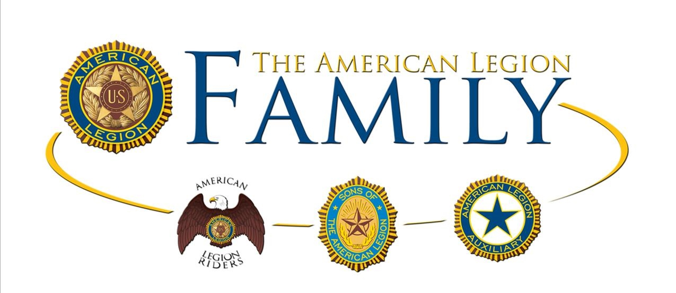

The
“Frank B. Huddleston”
American Legion Post 81

MELBOURNE, FLORIDA

NEW MEMBER

HANDBOOK

POST COMMANDER’S WELCOME LETTER

Welcome Legionnaire!

We are excited to have you as a member of American Legion Post 81, Melbourne, Florida. We hope that as a member of The American Legion you will feel a part of something bigger than the individual. We are an organization dedicated to focusing on service to veterans, their families and the community in which you reside. We are guided by the principals of Americanism and by the Constitution of the United States of America.
We recognize that each post is unique and we are pleased that you chose Post 81 as your American Legion home. You will come to find that we are an active post involved with many events and programs that you and your family can participate in, such as Friday night dinners, parades, karaoke, darts, pool leagues and bike nights. Our organization consist of the Legionnaires, the American Legion Auxiliary, the Sons of the Legion and the American Legion Riders group.
This membership handbook should help you better understand The American Legion organization and give you guidance about the American Legion’s core belief system, such as the Four Pillars of the American Legion, The American Legion Emblem, The American Legion cap, our commitment to veterans issues, and many other values too numerous to list. Please feel free at any time to talk with myself or any member with questions or concerns. We are honored to have you on board and look forward to having a lifelong relationship.

Sincerely,

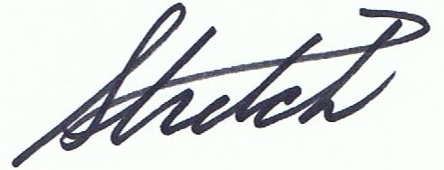

Tracy “Stretch” Spence, Commander
American Legion Post 81
Melbourne, Florida

Table of Contents

History of The American Legion………………………………................1

The American Legion Organizational Structure………………………….2 - 3

The Four Pillars of The American Legion……………………………….4 - 5

The American Legion Emblem………………………………..................6

Wearing of the American Legion cap……………………………….........7

Post Operations………………………………...........................................8 - 11

Preamble to the Constitution of The American Legion…………………..12 - 14

Frank B. Huddleston Post 81 Namesake biography……………………….15

HISTORY OF THE AMERICAN LEGION

A group of 20 officers who served in the American Expeditionary Forces (AEF) in France During World War I is credited with founding The American Legion. AEF Headquarters asked the officers to suggest ideas on how to improve troop morale. One officer, Lieutenant Colonel Theodore Roosevelt Jr., proposed an organization of veterans. In February 1919, the group formed a temporary committee and selected several hundred officers who had the confidence and respect of the whole army.

About 1,000 officers and enlisted men attended the Paris caucus in March 1919. They adopted a temporary constitution and the name The American Legion. The group also elected an executive committee to complete the organization’s work. It considered each soldier of the AEF a member of the Legion. The executive committee named a subcommittee to organize veterans at home in the United States.

In May 1919, the Legion held a second organizing caucus in St. Louis. It completed the constitution and made plans for a permanent organization, setting up a temporary headquarters in New York City and beginning its relief, employment and Americanism programs.

Congress granted the Legion a National Charter in September 1919. The first national convention convened in Minneapolis on November 10-12, 1919, adopting a permanent constitution and electing officers to head the organization. Delegates also voted to locate the Legion’s national headquarters in Indianapolis, Indiana. The Legion continues to support the four pillars of service and advocacy upon which it was founded: Veterans Affairs and Rehabilitation, National Security, Americanism and Children and Youth.

1
THE AMERICAN LEGION ORGANIZATIONAL STRUCTURE

The American Legion was created by an Act of Congress on September 16, 1919. It is a federally chartered corporation. The National Headquarters of The American Legion is located at the site of the Indiana World War Memorial in the city of Indianapolis, Indiana. It is a civilian organization and is absolutely nonpolitical. It does not endorse nor promote the candidacy of any person seeking public office.

An individual is eligible for membership in the American Legion only if the individual has served in the armed forces of the United States at any time during any period from:
(I) April 6, 1917 through November 11, 1918;
(II) December 7, 1941 through December 31, 1946;
(III) June 25, 1950 through January 31, 1955;
(IV) February 28, 1961 through May 7, 1975;
(V) August 24, 1982 through July 31, 1984;
(VI) December 20, 1989 through January 31, 1990; or
served in a government associated with the United States during a period referred to above and was a citizen of the United States when the individual entered that service; and was honorably discharged or separated from that service or continues to serve honorably during or after that period; provided, further, that no person shall be entitled to membership who, being in such service during any of said periods, refused on conscientious, political or other grounds to subject himself to military discipline or unqualified service.

No person may be a member at any one time of more than one post. Additionally, no person, who has been expelled by a post shall be admitted to membership in another post without the consent of the expelling post.

The American Legion is segmented in the following manner:
1) The National officers and National Executive Committee (National Headquarters)
2) The Department (Florida State Officers).
3) Area Officers (East and West).
4) District Officers (District 6 and 12 for Post 81).
5) Posts

National Headquarters

The top legislative body of The American Legion is the national convention. The National Executive Committee is vested with administrative authority between national conventions. Through the offices of National Headquarters in Indianapolis and Washington, D.C., the policies of the Legion are clarified and its activities are centered and directed. Thus, the influence of nearly 14,000 posts is coordinated and directed along the lines of Legion policy.

2

Department

There is one department in each state and the District of Columbia, and there may be one in each territory and insular possession of the United States (Puerto Rico). Each Department may prescribe the constitution of the posts, and the department has supervision of the posts within its boundaries and the posts assigned to it by the National Executive Committee. There are also foreign departments in the Philippines, France and Mexico. In All, there are 55 departments.

Area Posts

Florida is divided into two areas: East and West. These posts oversee the district and post activities and offer guidance and suggestions when needed.

District Posts

Departments have the authority to create intermediate bodies between the posts and department to assist as a liaison between such organizations. Depending upon the powers delegated, the district does have some supervisory powers over the posts comprising the district, but the primary purpose is to promote, stimulate and coordinate programs so the posts’ work becomes more effective.

Posts

The post is the combat unit of The American Legion. Depending upon its abilities to realize American Legion policies and properly interpret them to others, and to successfully carry out unselfish activities for the community, state or nation, our organization will stand or fall. Simply put, the post is the Legion. Its duties are spelled out in the Preamble to the Constitution of The American Legion. Membership is by post only. The responsibility given to the individual post is the source of our strength and growth. The post is to a large degree autonomous, restricted only by broad general guidelines made clear in the national or department constitution and by-laws. The post must never forget, however, its responsibility to the veterans and children of its community and to the community itself. What the community thinks of The American Legion is just as basic as what a Legion post thinks of itself. A good post will know the needs of the community.

3

THE FOUR PILLARS OF THE AMERICAN LEGION

The American Legion’s Four Pillars-Veterans Affairs And Rehabilitation, National Security, Americanism and Children And Youth-are as relevant today as when our organization was founded in 1919. Each of these pillars encompasses a variety of programs that benefit our nations veterans, its service members, their families, the youth of America and ordinary citizens.

Veterans Affairs

The Legion was instrumental in the creation of the Veterans Administration (VA) in1930 and an ardent supporter of its elevation to Cabinet status when it became the Department of Veterans Affairs in 1989. The American Legion continues to aggressively lobby for adequate funding of VA health care, timely access to facilities, fair rulings on benefit claims and economic opportunities for those who have come home changed by their military experiences. A Nationwide network of American Legion Department service officers works diligently to assist veterans as they pursue benefits and care they earned and deserve. The American Legion provides professional representation in claims appeals, discharge disputes and transition assistance from active-duty to civilian status throughout the country. Additional services The American Legion can assist in:
* Care for female veterans.
* Long wait times for VA health care appointments.
* Veterans with special needs.
* Career opportunities for veterans.
* Final Respects.

National Security

Since its founding in 1919, The American Legion remains steadfast in its support of a strong national defense. The American Legion’s national security position is multifaceted. Key aspects include:
* A well-funded, well equipped and well trained military.
* Support for the Department of Homeland Security and urging its steadfast protection of
U.S. borders, ports and other points of access.
* Comprehensive disaster preparedness.
* A decent quality of life for troops and their families.
* Full accounting of POW/MIAs.

Americanism

Many cultural, moral, and patriotic values have come under serious attack in the United States in recent years. Prayer has been removed from schools. The U.S. flag is no longer protected from anarchists.

4
Boy Scouts of America faces serious legal duels in the communities it serves. The institution of marriage is under siege. Immigration laws are defiled. Our nations very identity is at stake as more and more values are driven toward extinction. As an organization dedicated to God and country, with a membership of military veterans that take deep pride in the U.S. flag and all it means, The American Legion has always been a stalwart champion of patriotism, morality, and citizenship. Upon the pillar of Americanism is The American Legion’s devotion to law and order, the raising of wholesome youth, respectful observance of patriotic holidays, education, and law-abiding citizenship. Among The American Legion’s highest priorities are:
* U.S. flag protection.
* Opposing illegal immigration.
* Voter registration and participation.
* The pledge of Allegiance.
* American Legion Boys Nation (Oratorical program).

Children and Youth

The American Legion’s Commission on Children and Youth manages a pillar of service guided by three main objectives: to strengthen the family unit, to support organizations that provide services for children and youth, and to provide communities with well-rounded programs that meet the physical, educational, emotional and spiritual needs of young people. The American Legion’s Children and Youth pillar includes positions on:
* Child pornography (against laws that weaken enforcement).
* Catastrophic illness.
* Immunization for needy children.
* Family integrity (the family unit is centered on the voluntary union of a man and
woman in a covenant of marriage).
* Drug abuse.
* Child sexual exploitation.

5

THE AMERICAN LEGION EMBLEM

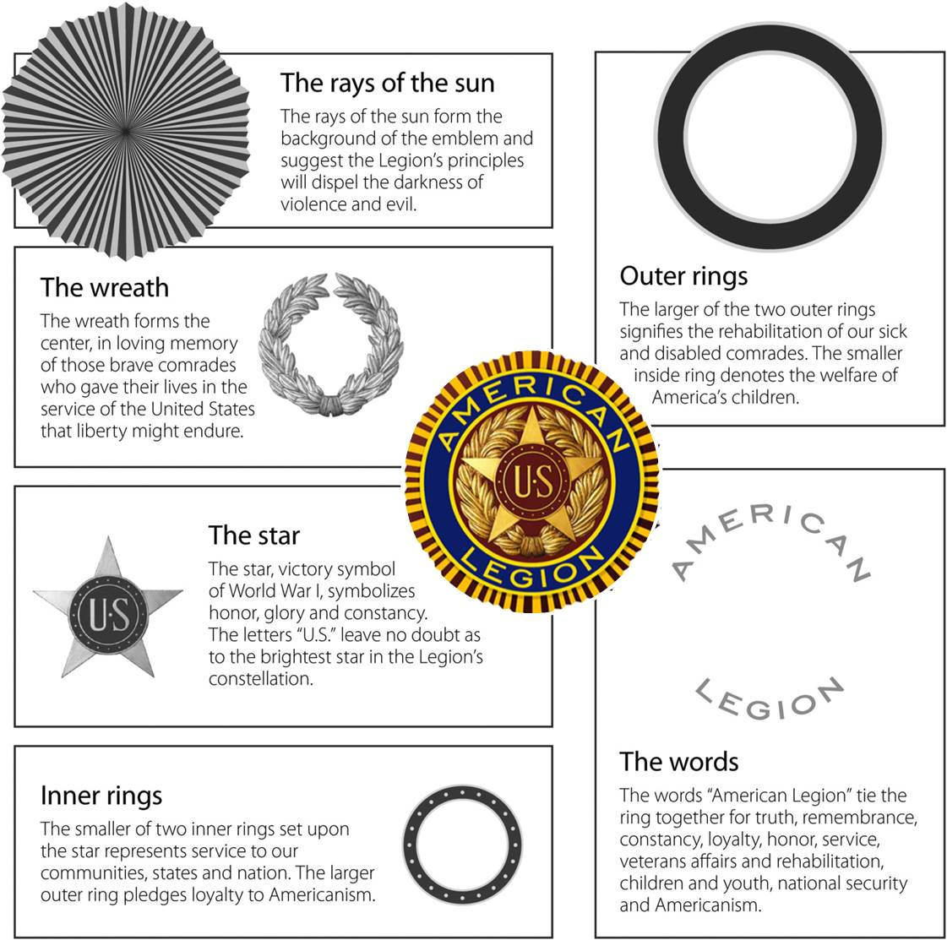

6
THE WEARING OF THE AMERICAN LEGION CAP

The Legion cap is considered the official Legion uniform. It should be worn by its members only when in attendance at official Legion meetings or ceremonies, as official guests at patriotic or other civil functions, or by individuals when officially representing The American Legion on public occasions. It is not proper to wear a Legion cap while eating a meal at an official American Legion or civic luncheon or dinner.

The cap should be worn in a place of worship only by the guard of honor, color guard and commander of the same while in marching order or standing guard. When one is seated, the cap should be removed.

Posts marching in formation into a place of worship should uncover at the door, hold the cap with the right hand over the heart until arriving in the pews and commanded to take seats, and remain uncovered during the entire service. The Legionnaire will re-cover after leaving the place of worship.

In meetings, the cap should be worn except during the pledge of allegiance, prayer and while standing in silent reverence in memory of departed comrades, when it should be held with the right hand over the heart.

Post caps are all blue, piped in gold and lettered in gold with optional basic lettering and additional lettering and restrictions. Post numerals are at right front between piping and crease. Department name in full on left side beneath emblem. Where additional lettering is desired, it must be on the right side of the cap. Names or nicknames of individual members cannot be used on caps.

Restrictions: The left side (emblem side) of any American Legion cap cannot contain anything other than the official American Legion emblem.

Where additional lettering is desired, it must be worn on the right side of the cap. Lettering is restricted to the name of the post and officer title (such as commander).

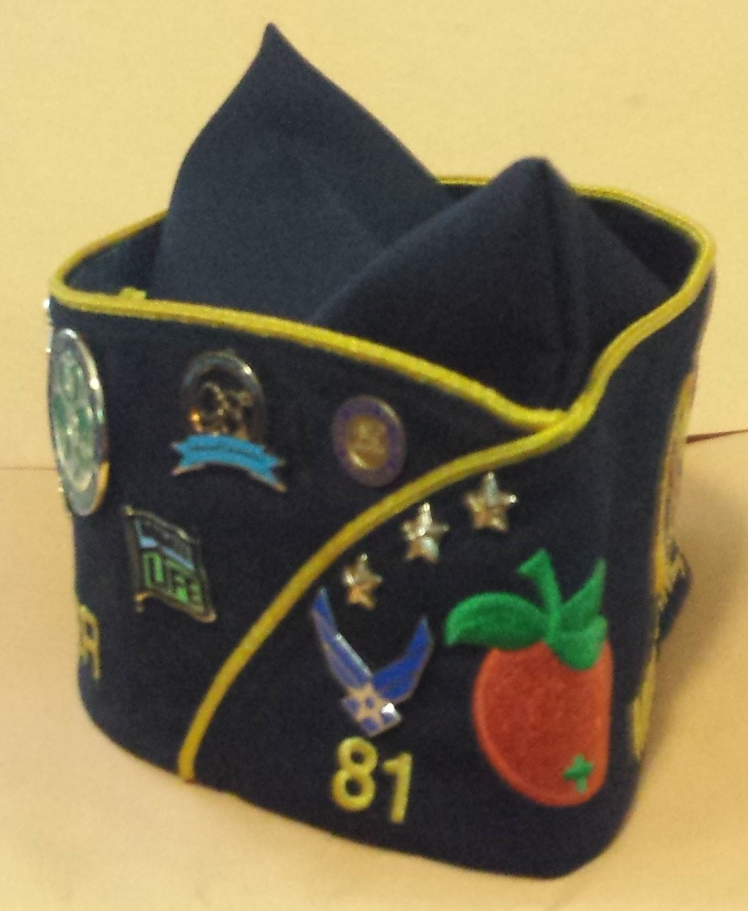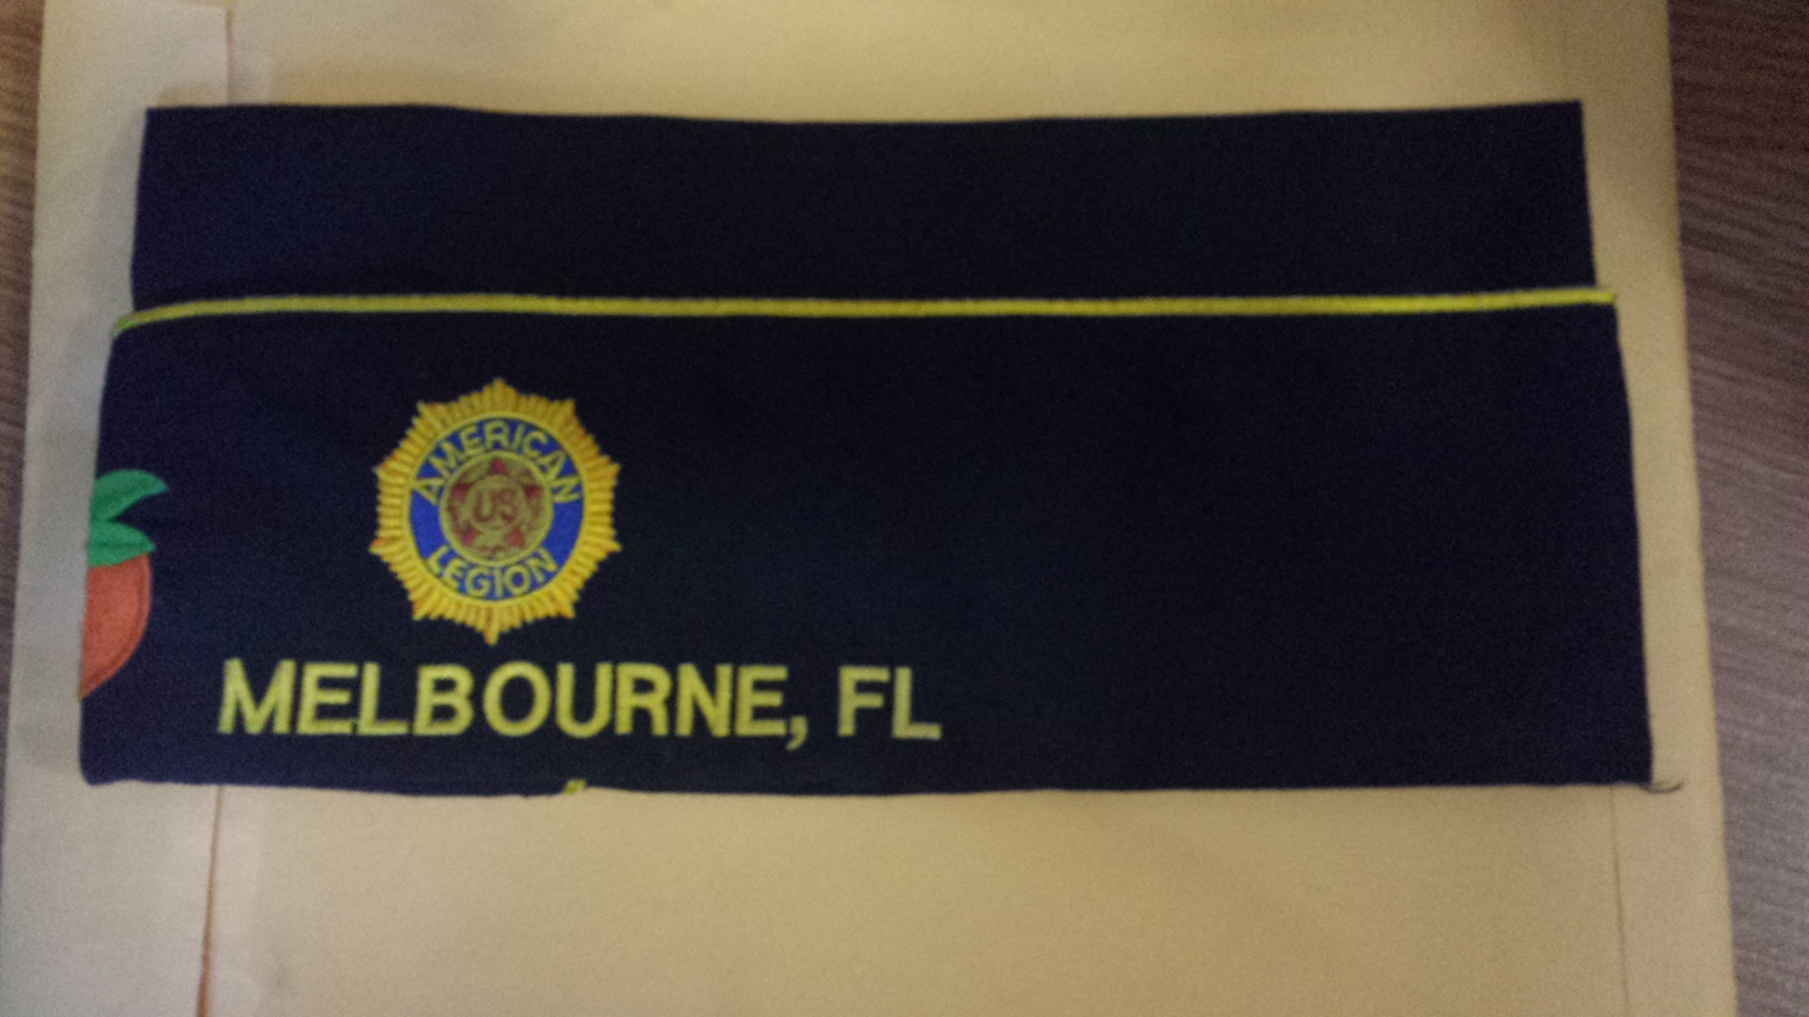
The American Legion hat tells the story of you and your Post.
- The gold stars = 5 years membership each
- The Orange is for the Department of Florida
- 81 indicates you Post
- The assorted pins tell your story of events, classes, and personal military connections. This is unique to each member.
- The Legion crest and your city are hallowed ground and should never be placed side down. Only Religious pins received from the National Chaplain are allowed on this side.
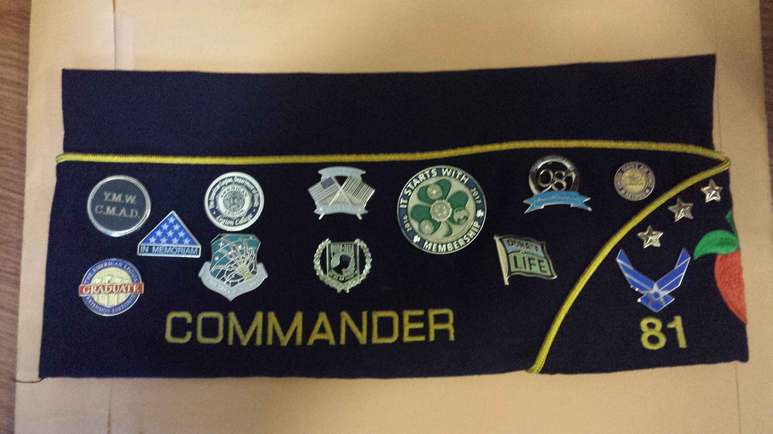

7

POST OPERATIONS

Each post has elected officers that are tasked with the operation of the post as per the department constitution and by-laws. Post leaders are volunteers and are found among the general body of the post. First, a veteran becomes a member. Then, experience, education and exposure through serving on committees and attending leadership schools, conventions and conferences prepare that person for other positions of responsibility.

Post Commander

In many ways the Post Commander is the most important person in the American Legion. When a Post Commander has organized the Post, is meeting his/her responsibilities, and keeping a constant watch on Post and district activities, the Post is on the move. The Post commanders responsibilities are many, from ensuring that the Post is following all by-laws to making sure that all documentation of the Post is in order to motivating the Post members in becoming involved with Post activities.

Adjutant

The adjutant has the same position in the post as the secretary of any organized body, and a bit more. While the commander’s duties are largely inspirational and executive, an adjutant’s duties are administrative. The adjutant is the personnel officer and personal point of contact for individual members of the post. He or she maintains membership records and minutes of meetings, checks up and assists the work of other officers and committees, and publishes official orders, announcements and instructions.

First vice commander

Membership is the primary concern of the first vice commander. They secure the majority of dues and ensure members receive their membership card. The first vice commander can also have many other duties. He or she should become familiar with the ceremonial protocol for regular meetings. Knowing how to prepare a meaningful and fruitful agenda is very important. The first vice commander must be ready to fill in for the commander at a moment’s notice.

Second vice commander

The post commander depends on the second vice commander to help run the programs that spice up meetings and attract attendance. One of the second vice commander’s first duties should be to contact other veterans and civic groups to see that each patriotic holiday and observance receives the attention it deserves.

8

Finance officer

The finance officer must be a person of proven integrity and experience in handling financial affairs. The finance officer usually serves as the chair of the finance committee and is in charge of all receiving and disbursing of funds. They maintain financial records and gives a summary of all financial activities of the post at general meetings.

Service officer

The service officer is responsible for bringing to the attention of all veterans and their dependents the rights and benefits granted them by law-law The American Legion helped craft. The service officer must know how to access and utilize the expert services available through Legion channels and other community agencies. Beyond the post, The American Legion maintains a full staff of appeals representatives in Washington. Other Legion representatives assist veterans who petition Department of Defense boards for review of less than fully honorable discharges or dismissal from the military. They also help veterans obtain deserved decorations and medals.

Chaplain

The chaplain need not necessarily be a clergyman, but must be a person capable of moral and intellectual leadership and one who gives dignity and respect to the office. The chaplain has an important place during meetings, the observance of patriotic occassions, funeral services and dedication ceremonies. At all these events, the chaplain is the moral leader.

Sergeant-at-arms

The sergeant-at-arms helps with meetings by arranging the meeting hall. He or she should be an expert on flag etiquette and know the proper flag display and procedures in operating a meeting. The sergeant-at-arms controls the access in and out of a meeting, maintains a log-in book, and is responsible for properly and with the utmost respect display the POW/MIA banner over an empty chair, rendering proper protocols when placing the banner and removing the banner at the end of the meeting.

Historian

The post historian is tasked with the researching and publication of historical interests. Copies of whatever is printed concerning the post should be deposited in a local or post library or archives. This will prevent complete loss of valuable records through fire or other calamity, as well as provide material for those looking for information about the post or Legion.

9
Judge advocate

The primary duty of the judge advocate is to supply professional advice in the conduct of post business or to procure proper counsel. They can also supply valuable assistance to other post committees and officers-to the service officer for legal advice, for example, and to the Americanism committee on matters relating to education and naturalization laws.

Executive committee

In the suggested post constitution and by-laws, the government and management of the post is entrusted to the executive committee. They are charged with hiring such employees as may be necessary, authorizing and approving all expenditures, requiring adequate bonds from those with custody of post funds, hearing reports of post committee chairpersons, and generally managing post affairs.

Additional committees/organizations you can find at a post:

Sons of The American Legion (SAL)

All male descendants, adopted sons and stepsons of members of The American Legion, along with male descendants of veterans who died in service during World War I, World War II, the Korean War, the Vietnam War, Lebanon/Grenada, Panama, the Gulf War, or the war on terrorism during the delimiting periods set forth in Article IV, Section I, of the National Constitution of The American Legion or who died subsequent to their honorable discharge from such service, are eligible for membership in Sons of The American Legion.

American Legion Auxiliary

The mission of the American Legion Auxiliary is to support The American Legion and to honor the sacrifice of those who serve by enhancing the lives of veterans, the military and their families. Membership is open to wives, mothers, daughters, sisters, grandmothers, granddaughters, and directed and adopted female descendants of The American Legion, and great-granddaughters of veterans who served during wartime.

10
American Legion Riders

A group of dedicated veteran motorcyclists who have gathered together to create an organization dedicated to veterans and the community. They are involved in many
events and programs such as the Legacy run, an annual ride from National headquarters to the convention city. This event generates close to $75,000.00 which is set up to provide college scholarships to the offspring of fallen service men and women. Other events include providing motorcycle escorts for veterans and their families; Toys for Tots; and participation in ceremonies that honor community fallen heroes such as first responders and law enforcement personnel. Applicants must be current and in good
standing with The American Legion, Legion Auxiliary, or the Sons of The American
Legion. They must own and legally operate a registered motorcycle at least 350cc.

11

PREAMBLE TO THE CONSTITUTION OF THE AMERICAN LEGION

Identifying the principal aims of The American Legion is the purpose of the preamble to the Constitution of The American Legion. It begins:

For God and country, we associate ourselves together for the following purposes

The American Legion recognizes the influence of Almighty God in all worthwhile endeavors and declares the allegiance of Legionnaires to both God and nation.

to uphold and defend the Constitution of the United States of America

The Constitution of the United States is the written bulwark of our free way of life and representative government. It is our guarantee of liberty, freedom, justice and democracy. Members of the American Legion bore arms and went to war to defend and uphold this document of freedom.

to maintain law and order

Without law and order, liberty would become license. Law and order protect our pursuit of happiness, one of our god given rights. Members of The American Legion served in wars to uphold law and order among nations. It is just as important to maintain the due process of law in our domestic affairs. It binds Legionnaires to obey the laws of the land and to support the constituted authorities in enforcing those laws.

to foster and perpetuate a 100 percent Americanism

Americanism is the gist of the American ideals of freedom, justice, individual rights and unlimited opportunities. It embraces all the freedoms we cherish and all the rights that are guaranteed to us. It is the very opposite of hatred, bigotry, and intolerance. Americanism is the creed that has blazed the world wide trail for justice, fair play, decency, belief in God, private enterprise, universal education, and progress in all human endeavors. It puts a premium on the virtues of loyalty, patriotism, hard work and thrift.

to preserve the memories and incidents of our associations in the great wars

Service in defense of America is the greatest experience in the lifetime of all veterans. Recalling the highlights of that service means more than flashbacks to tense moments of excitement and danger in battle: the grime of muddy trenches, the perils of sub-infested oceans and the combat in the wild blue yonder. It means also the inerasable recollection of the comradeships, the bravery of pals, the team work, the sacrifices, the miseries and hardships of military campaigns shared in common. It means the bond that binds all ex-servicemen and women together in mutual affection, respect and gratitude. It also means keeping green forever the memories of the supreme sacrifices of gallant American patriots, sacrifices necessary to the winning of wars. It means faithful annual observance of Memorial Day and Veterans Day.
12

to inculcate a sense of individual obligation to the community, state and nation

Always interested in building a better nation, the founders of The American Legion believed that such building must start first with the individual in their own community. So they made it one of the cardinal principles of The American Legion to inculcate that
sense of personal obligation to the community, state and nation into the individual citizen. That means educating the citizen-young, old and future-in his and her responsibility to be active in making the hometown a better place in which to live, in discharging the duty of voting in elections, in paying taxes promptly, in contributing to community chest funds and to blood banks. The word “inculcate” means “to impress by frequent admonitions” and “to enforce by frequent repetitions”. Like the duties themselves, the reminders that they remain to be carried forward are never finished.

to combat the autocracy of both the classes and the masses

This clause places the Legionnaire on the side of right in opposing autocracy by either class or mass when this threatens. In a democracy such as ours, composed as it is of all nationalities, races, creeds, and economic groups, there are bound to be both classes and masses. Indeed, the masses are composed of classes-but all groups within the mass must feel assured that in this nation, reason and fairness will prevail in all human activities and relations.

to make right the master of might

Many wars have been started by dictators who wanted their might to be right. If human freedom is not to perish from the earth, right must always be master of might. The rights of small nations must be protected against the tyranny that powerful neighbors may seek to impose on them, just as the rights of minorities in our society must be protected and respected. Legionnaires are pledged by this clause always to stand with the right, protect the weak and preserve the liberties of the individual. This concept is the basis of the American Legion’s continued advocacy of a strong national preparedness so as to achieve the ideal situation that right will be backed by adequate might.

to promote peace and good will on earth

Until the entire world becomes a good neighborhood, Legionnaires must continue the effort to promote peace and good will on earth. It is in pursuance of this founding ideal that The American Legion has supported from the beginning and seeks to strengthen the United Nations organization. Obliquely, The American Legion also contributes to this ideal by firmly supporting a strong national defense to discourage breaking of the peace by aggressors.

13

to safeguard and transmit to posterity the principles of justice, freedom and democracy

On this ideal of safeguarding and transmitting the principles of justice, freedom and democracy, all of the youth training programs of The American Legion are built. All
Americans can be proud that in our international relations we have tried to live by the golden rule, the mark of justice. We have granted to others, as we prize it ourselves, the great boon of freedom. Through the Monroe doctrine, we called a halt to foreign imperialism in the western hemisphere. We gave freedom to the Philippines. These principles are part of the American heritage. Legionnaires are pledged to protect and preserve that heritage.

to consecrate and sanctify our comradeship by our devotion to mutual helpfulness

This is the most important ideal expressed in our preamble. We can hail The American Legion today as an unparalleled force in these United States for social betterment. American Legion concepts and its ideal of devotion to mutual helpfulness warmed the entire social climate of America. Today America is extending its helpful hands all over the world through our assistance programs of foreign aid. This all came about because the veterans of World War I came home enriched with wonderful ties of friendship and gave those ties meaning by consecrating them to the ideal of mutual helpfulness.

14

FRANK B. HUDDLESTON
POST 81
MELBOURNE, FLORIDA

According to the Constitution of The American Legion, Article IX, Section 3, “no post shall be named after any living person“. Post 81 chose to honor a true war hero whose spirit is the driving force of the post.

Frank Bernard Huddleston was born in Beckwith, West Virginia on October 29, 1892. He served in the U.S. army first with Battery F, 315 FA and then with Company B, 7th infantry. He was shipped overseas to France during World War I, where he saw combat on the battlefields of France. Frank B. Huddleston was killed in action in the Argonne forest on June 22, 1918. He was only 26 years old. The good people of France provided a gravesite for the many men killed during World War I and Frank Huddleston was interred there. Frank’s mother, Mrs. A. B. Myles, wanted Frank returned to the country he loved and died for so she petitioned the U.S. government to have him returned for burial here in the United States. In 1921, the government granted Mrs. Myles her request and Frank Huddleston returned home to Melbourne, Florida where he now rests in peace in the Melbourne cemetery, Zone A, Section 2.

It should be noted that every Memorial Day, a service is held at the gravesite of Frank Huddleston, complete with a color guard, bugler, and inspirational words from the Post Commander. We honor Frank Huddleston not only because he is the namesake of our post, but he is the epitome of what it means to serve his country in “the war to end all wars” and what it means when veterans say:

ALL GAVE SOME BUT SOME GAVE ALL!

15

