**April 18, 2021**

**Third Sunday of Easter**

**Gathering**

*The Holy Spirit calls us together as the people of God.*

**Welcome**

**Prelude:** *Now the Green Blade Riseth (Lani Smith)*

*Trent DeVerter, Trumpet*

**MEDITATION**

**O Radiant Light**

*An Easter Acclamation*

Chris Neufelderdman

O Radiant Light,

O Flame Divine,

as shines the light of Easter’s dawn—

Come, bless the embers of the earth,

sparks flung from our eternal birth.

O Word of God,

the Source of Life,

you rouse us from the night of fears

to open souls and minds and ears

and hear the music of the spheres.

You are the Fire that birth’d all things,

the Force that spins the galaxies;

you are the Flame within all flames,

the Hidden Power that knows no name.

From you all things that are were sent,

and into you does all extend.

Peal back the bark of any tree,

lift up a stone—they blaze with Thee!

O Happy Light

We feel your heat

The starlight shining in our bones

You fill us all with cosmic grace,

We host your presence in this place.

O Risen Christ,

you shine in us,

the radiance of your holiness;

against the curse of death and strife,

we rise to dance this Dance of Life.

**Gathering Song:*Alleluia! Sing to Jesus* (ELW 392) V. 1, 2, 4**

**Greeting**

The grace of our Lord Jesus Christ, the love of God,

and the communion of the Holy Spirit be with you all.

**And also with you.**

**Prayer of the Day**

Holy and righteous God, you are the author of life, and you adopt us to be your children. Fill us with your words of life, that we may live as witnesses to the resurrection of your Son, Jesus Christ, our Savior and Lord, who lives and reigns with you and the Holy Spirit, one God, now and forever. **Amen.**

**Canticle of Praise:** *Christ Is Alive! Let Christians Sing (ELW 389) v. 1,2, 4*

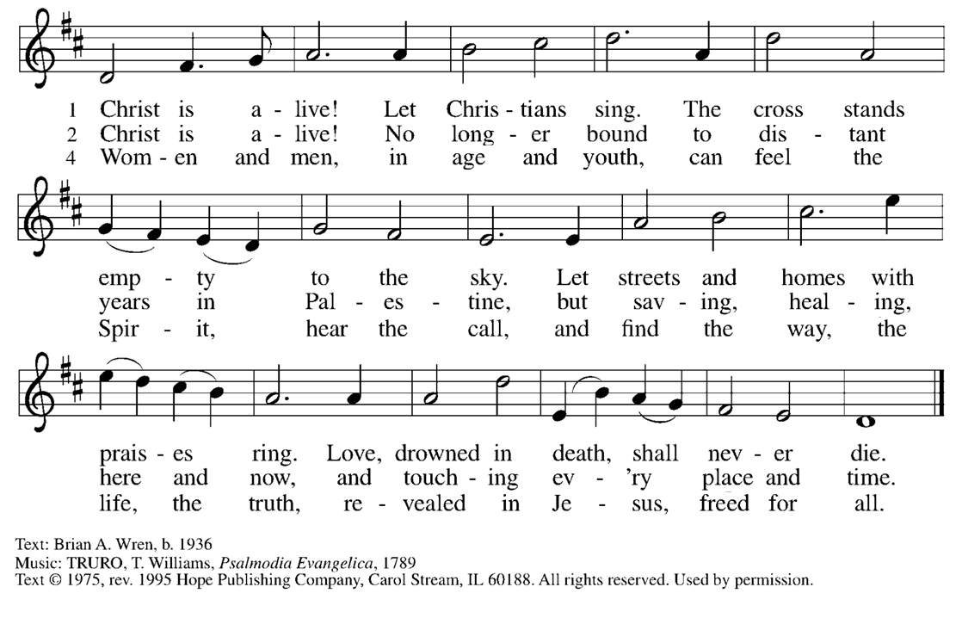

**Word**

*God speaks to us in scripture reading, preaching, and song.*

**The Word: Acts 6:1-15, 7:2a; 7:44-60**

Now during those days, when the disciples were increasing in number, the Hellenists complained against the Hebrews because their widows were being neglected in the daily distribution of food.

And the twelve called together the whole community of the disciples and said, "It is not right that we should neglect the word of God in order to wait on tables. Therefore, friends, select from among yourselves seven men of good standing, full of the Spirit and of wisdom, whom we may appoint to this task, while we, for our part, will devote ourselves to prayer and to serving the word."

What they said pleased the whole community, and they chose Stephen, a man full of faith and the Holy Spirit, together with Philip, Prochorus, Nicanor, Timon, Parmenas, and Nicolaus, a proselyte of Antioch. They had these men stand before the apostles, who prayed and laid their hands on them.

The word of God continued to spread; the number of the disciples increased greatly in Jerusalem, and a great many of the priests became obedient to the faith. Stephen, full of grace and power, did great wonders and signs among the people.

Then some of those who belonged to the synagogue of the Freedmen (as it was called), Cyrenians, Alexandrians, and others of those from Cilicia and Asia, stood up and argued with Stephen. But they could not withstand the wisdom and the Spirit with which he spoke. Then they secretly instigated some men to say, "We have heard him speak blasphemous words against Moses and God." They stirred up the people as well as the elders and the scribes; then they suddenly confronted him, seized him, and brought him before the council.

They set up false witnesses who said, "This man never stops saying things against this holy place and the law; for we have heard him say that this Jesus of Nazareth will destroy this place and will change the customs that Moses handed on to us." And all who sat in the council looked intently at him, and they saw that his face was like the face of an angel.

And Stephen replied: “Siblings in the faith, listen to me. Our ancestors had the tent of testimony in the wilderness, as God directed when he spoke to Moses, ordering him to make it according to the pattern he had seen. Our ancestors in turn brought it in with Joshua when they dispossessed the nations that God drove out before our ancestors. And it was there until the time of David, who found favor with God and asked that he might find a dwelling place for the house of Jacob. But it was Solomon who built a house for him. Yet the Most High does not dwell in houses made with human hands; as the prophet says, 'Heaven is my throne, and the earth is my footstool. What kind of house will you build for me, says the Lord, or what is the place of my rest? Did not my hand make all these things?'

"You stiff-necked people, uncircumcised in heart and ears, you are forever opposing the Holy Spirit, just as your ancestors used to do. Which of the prophets did your ancestors not persecute? They killed those who foretold the coming of the Righteous One, and now you have become his betrayers and murderers. You are the ones that received the law as ordained by angels, and yet you have not kept it."

When they heard these things, they became enraged and ground their teeth at Stephen. But filled with the Holy Spirit, he gazed into heaven and saw the glory of God and Jesus standing at the right hand of God. "Look," he said, "I see the heavens opened and the Son of Man standing at the right hand of God!"

But they covered their ears, and with a loud shout all rushed together against him. Then they dragged him out of the city and began to stone him; and the witnesses laid their coats at the feet of a young man named Saul. While they were stoning Stephen, he prayed, "Lord Jesus, receive my spirit." Then he knelt down and cried out in a loud voice, "Lord, do not hold this sin against them." When he had said this, he died.

Word of God,

**word of life.**

**Response: *How Great is Our God (****Chris Tomlin, Ed Cash and Jesse Reeves)*

*Cheryl Miller, Flute*

**Children's Sermon**

**Sermon**

**Hymn of the Day: *Light Dawns on a Weary World* (ELW 726)**

**An Affirmation of Faith** *–*

**We are not alone, we live in God's world.**

**We believe in God:**

**who has created and is creating,**

**who has come in Jesus, the Word made flesh, to reconcile and make new,**

**who works in us and others by the Spirit.**

**We trust in God. We are called to be the Church:**

**to celebrate God's presence,**

**to live with respect in Creation,**

**to love and serve others,**

**to seek justice and resist evil,**

**to proclaim Jesus, crucified and risen, our judge and our hope.**

**In life, in death, in life beyond death,**

**God is with us. We are not alone. Thanks be to God.**

**Prayers of Intercession**

Alive in the risen Christ by the power of the Holy Spirit, we bring our prayers before God who promises to hear us and answer in steadfast love.

Living God, in the midst of Easter joy we are still filled with questions and wondering. Open our hearts and minds as we encounter the scriptures, so that the church embodies repentance and forgiveness in the name of Jesus to all nations. Hear us, O God.

**Your mercy is great.**

Creating God, like a master artist you have fashioned the universe out of your love and delight. Heal your creation where it is in need of restoration. Provide all the inhabitants of earth a peaceful and sustainable home. Hear us, O God.

**Your mercy is great.**

God of all, the nations hunger and thirst for your righteousness. Many call on you for guidance and strength. Answer their hopes with the peace of Christ and give your lovingkindness to national, state, and local leaders of people. Hear us, O God.

**Your mercy is great.**

Healing God, you hear the cries of those in need and answer them in their distress. Grant to those who are sick and suffering your compassion and nurse them back to health and wholeness (especially). Be close to the hearts of the lonely. Hear us, O God.

**Your mercy is great.**

Loving Parent, you have given us such love that we should be called the children of God. Reveal yourself to us so that we in this community of faith will become more and more like you in our mutual love and bold witness. Hear us, O God.

**Your mercy is great.**

God of all times and ages, those who have died in you now see you as you are. We thank you for their lives among us. Assure us of the peace you have promised, that we may join them in everlasting life. Hear us, O God.

**Your mercy is great.**

In the hope of new life in Christ, we raise our prayers to you, trusting in your never-ending goodness and mercy; through Jesus Christ our Lord.

**Amen.**

**Thanksgiving for Baptism**

Alleluia! Christ is risen.

**Christ is risen indeed. Alleluia!**

Refreshed by the resurrection life we share in Christ, let us give thanks for the gift of baptism. We thank you, risen Christ, for these waters where you make us new, leading us from death to life, from tears to joy. We bless you, risen Christ, that your Spirit comes to us in the grace-filled waters of rebirth, like rains to our thirsting earth, like streams that revive our souls, like cups of cool water shared with strangers. Breathe your peace on your church when we hide in fear. Clothe us with your mercy and forgiveness. Send us companions on our journey as we share your life. Make us one, risen Christ. Cleanse our hearts. Shower us with life. To you be given all praise, with the Holy Spirit, in the glory of God, now and forever.

**Amen.**

**Peace**

The peace of Christ be with you always.

**And also with you.**

**Meal**

*God feeds us with the presence of Jesus Christ.*

**Offering/Announcements**

**Offering*Come to the Water of Life* (ACS 955)**



**Offering Prayer**

God of love, you call us beloved children and welcome us to your table. Receive our lives and the gifts we offer. Abide with us and send us in service to a suffering world; for the sake of your beloved Child, Jesus Christ.

**Amen.**

**Thanksgiving at the Table**

Holy, living, and loving God, we praise you for creating the heavens and the earth. We bless you for bringing Noah and his family through the waters of the flood, for freeing your people Israel from the bonds of slavery, and for sending your Son to be our Redeemer.

We give you thanks for Jesus who, living among us, healed the sick, fed the hungry, and with a love stronger than death, gave his life for others.

**In the night in which he was betrayed, our Lord Jesus took bread, and gave thanks; broke it, and gave it to his disciples, saying: Take and eat; this is my body, given for you.**

**Do this for the remembrance of me.**

**Again, after supper, he took the cup, gave thanks, and gave it for all to drink, saying: This cup is the new covenant in my blood, shed for you and for all people for the forgiveness of sin.**

**Do this for the remembrance of me.**

Remembering, therefore,his life-giving death and glorious resurrection,we await your promised life for all this dying world Breathe your Spirit on us and on this bread and cup:carry us in your arms from death to life,that we may live as your chosen ones,clothed in the righteousness of Christ.

Through him all glory and honor is yours,Almighty Father, with the Holy Spirit,in your holy Church,both now and forever.

**Amen**

**Lord’s Prayer**

Lord, remember us in your kingdom and teach us to pray.

**Our Father in heaven,**

**hallowed be your name,**

**your kingdom come,**

**your will be done,** **on earth as in heaven.**

**Give us today our daily bread.**

**Forgive us our sins**

**as we forgive those** **who sin against us.**

**Save us from the time of trial**

**and deliver us from evil.**

**For the kingdom, the power,**

**and the glory are yours,**

**now and forever. Amen.**

**Invitation to Communion**

The risen Christ invites us to this table. Come, eat and be satisfied.

**Communion**

*The body of Christ, given for you. The blood of Christ, shed for you.*

**Prayer after Communion**

Wellspring of joy, through this meal you have put gladness in our hearts. Satisfy the hunger still around us, and send us as joyful witnesses, that your love may bring joy to the hearts of all people, through Jesus Christ our Lord.

**Amen.**

**Sending**

*God blesses us and sends us in mission to the world.*

**Blessing**

May our glorious God grant you a spirit of wisdom to know and to love the risen Lord Jesus. The God of life, Father, ☩ Son, and Holy Spirit, bless you now and forever.

**Amen.**

**Sending Song:*Christ the Lord Is Risen Today; Alleluia! (ELW 369)***

**Dismissal**

Alleluia! Christ is risen.

**Christ is risen indeed. Alleluia!**

Go in peace. Share the good news. Alleluia!

**Thanks be to God. Alleluia!**

**Postlude:** *Now the Green Blade Riseth (Thomas Keesecker)*

**All liturgy, music & lyrics in this bulletin are covered by copyright licenses for publishing & streaming.**

* Copyright ©2016 Augsburg Fortress. All rights reserved. Reprinted and streamed by permission under license #SAS003678.
* Some music used with permission for publishing and streaming under CCLI License #2262125.
* Some music used with permission for publishing and streaming under LicenSing #623195.
* New Revised Standard Version Bible, copyright ©1989, Division of Christian Education of the National Council of Churches of the Churches of Christ in the United States of America. Used by permission. All rights reserved.