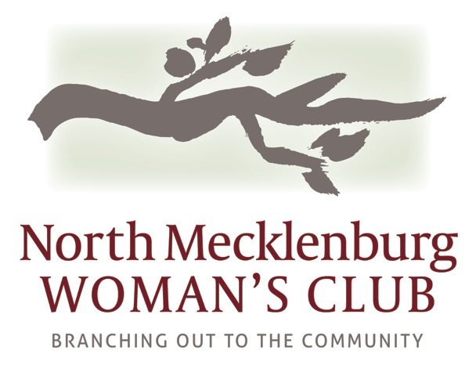

2018/2019 NMWC CHARITABLE CONTRIBUTION APPLICATION
APPLICANT INFORMATION
Legal Name of Organization: __________________________________________________________________
Mailing Address: ____________________________________________________________________________
City: _____________________________________ State: _________ Zip Code: ________________________
Email: ____________________________________________________________________________________
Website Address: ___________________________________________________________________________

CONTACT INFORMATION
Executive Director Name: _______________________________ Phone: _____________________________
Program Coordinator Name: _____________________________ Phone: _____________________________
Alternate Contact: _____________________________________ Phone: _____________________________

OVERALL ORGANIZATIONAL INFORMATION
Mission Statement: __________________________________________________________________________
__________________________________________________________________________________________
__________________________________________________________________________________________
Number of Paid Employees: ____________________ Number of Volunteers: __________________________
501C3 Number: _____________________ Approx. Number of Persons Served Annually: _________________
Geographic Area Served: _____________________________________________________________________

Signature of Executive Director
or Authorized Representative:_________________________________________ Date: __________________

“North Mecklenburg Woman’s Club is organized to bring women together to
promote and support social, educational, and civic progress in the community.”

2018/2019 CHARITABLE CONTRIBUTION REQUEST REQUIRMENTS
Applications will be accepted postmarked from February 1st to April 1st 2018 to: “Charitable Request” PO BOX 1782, Huntersville, NC 28078 or charityrequest.nmwc@gmail.com
NMWC proudly announces an opportunity to apply for 2018/2019 charitable contributions. NMWC members believe that in creating a better life for people in our communities we create a better life for each other. NMWC solicits applications from programs and projects that involve community organizing and/or economic development, seek to affect positive change in the community, provide opportunity for the women of the club to apply for volunteer positions within the organization and indicate potential for change and the empowerment of the people and the community involved. To be considered for an award, applicant organizations and projects for which funding is sought must operate in accordance with the NMWC mission of creating a better life for people in our community.
Eligibility Criteria
In order to be eligible for consideration the following minimum requirements must be met:
- 501(c)(3) designation providing services related to the stated purposes of providing and promoting social, educational and civic progress in the community. (Please attach a copy of IRS letter)
- Provide the services in North Mecklenburg County. If an organization provides services outside North Mecklenburg County or is not based in the county award funds may only be used for services provided in North Mecklenburg County.
- May not discriminate base on race, color, national origin, disability or any other status protected under law however, organizations that serve a specific population (e.g. women) will be considered.
- Religious organizations may apply for funding but only if the project requested seeks to address the stated purposes of the fund without regard to a particular religious belief.
- The ability to demonstrate a significant demand for services and ability to respond.
Questions
On a separate sheet of paper please answer the following with as much relevant information as needed to describe your need for funding and attach to the Charitable Contribution Request Form.
- Describe the mission and vision of your organization. (500 word maximum)
- Describe how much funding you are requesting, how this funding will be used and how your request aligns with the short and long term goals/mission/focus of your organization. (500 word maximum)
- What opportunities can you provide for volunteers from NMWC to help advance your mission? (500 word maximum) Please be specific with this answer as we wish to connect the women of our club with excellent opportunities to serve and/or volunteer.
- What percentage of your organizations budget is represented by this request?
- What are the current sources of funding received by your organization and how much do you receive? What percentage of funding is from government agencies? What percentage of funding goes to administrative costs?
- Have you received financial support from NMWC before? If yes, please give the most recent year and amount received.
- How will partnering with NMWC provide for future growth of your organization?
- Please share an anecdotal story that demonstrates success within your organization. (500 word maximum)
Thank you for your interest in NMWC. All applications will be reviewed and voted on by the Board in June 2018. Applicants will be notified by mail in July 2018. Currently no minimum or maximum awards have been established. Awards will be made based on need, impact and contributions received. For more information please visit our website at www.nmwclub.org.

