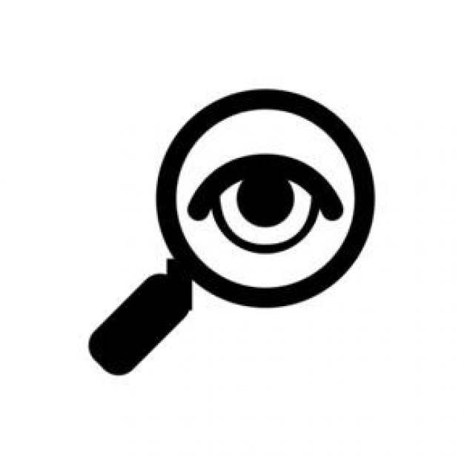
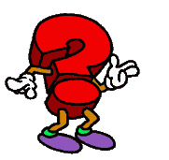
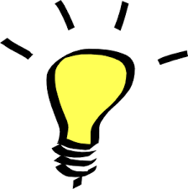
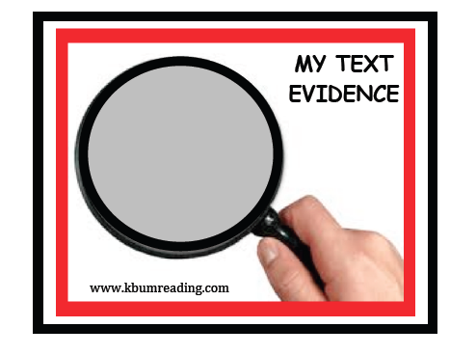
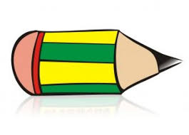
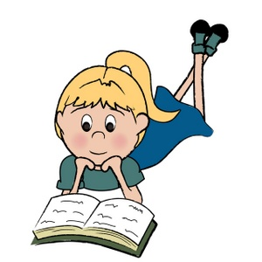
www.kbumreading.com

MY CLOSE READING
________________________________________

Read with pencil in hand.
________________________________________
What does the text say?

Mark the BIG IDEAS and
KEY DETAILS.

___________________________________
How does the text say it?

Look for patterns,
repetitions, word choice, similarities, and contradictions.
_______________________________________
What does that mean?
Ask questions about
patterns, word choice, message, structures,
and viewpoints.
_______________________________________________
How? Why?
Reread and Think.
Look for Text Evidence
to support your thinking.

