Trouble Rock

Social Emotional Value: The "trouble rock" gives children an outlet for talking about their problems and frustrations. In addition, it encourages them to think about what they can do to solve their own problems.

You will need:
- Go on a nature walk and find a rock about the size of your fist with a nice flat bottom.
- Paint or markers
- Wiggly eyes
- Yarn or feathers for hair
- Elmer's Glue-All

Directions:

1. Begin by telling about a problem that you might be dealing with in your life, or about a frustration you had when you were a child. Ask your child to share troubles that they might have too.

2. Let your child suggest what they might do when they have a problem. Brainstorm ways to solve problems.

3. Explain that sometime we might not be ready to talk to someone else about a problem. A “trouble rock” is the perfect solution, because it won’t tell anyone else!

4. Decorate your rock with paint or markers, “hair” and wiggly eyes. Ask your child to think of a name for his/her rock.

5. If you have a little piece of felt, glue it to the bottom of the rock to prevent the rock from scratching your furniture.
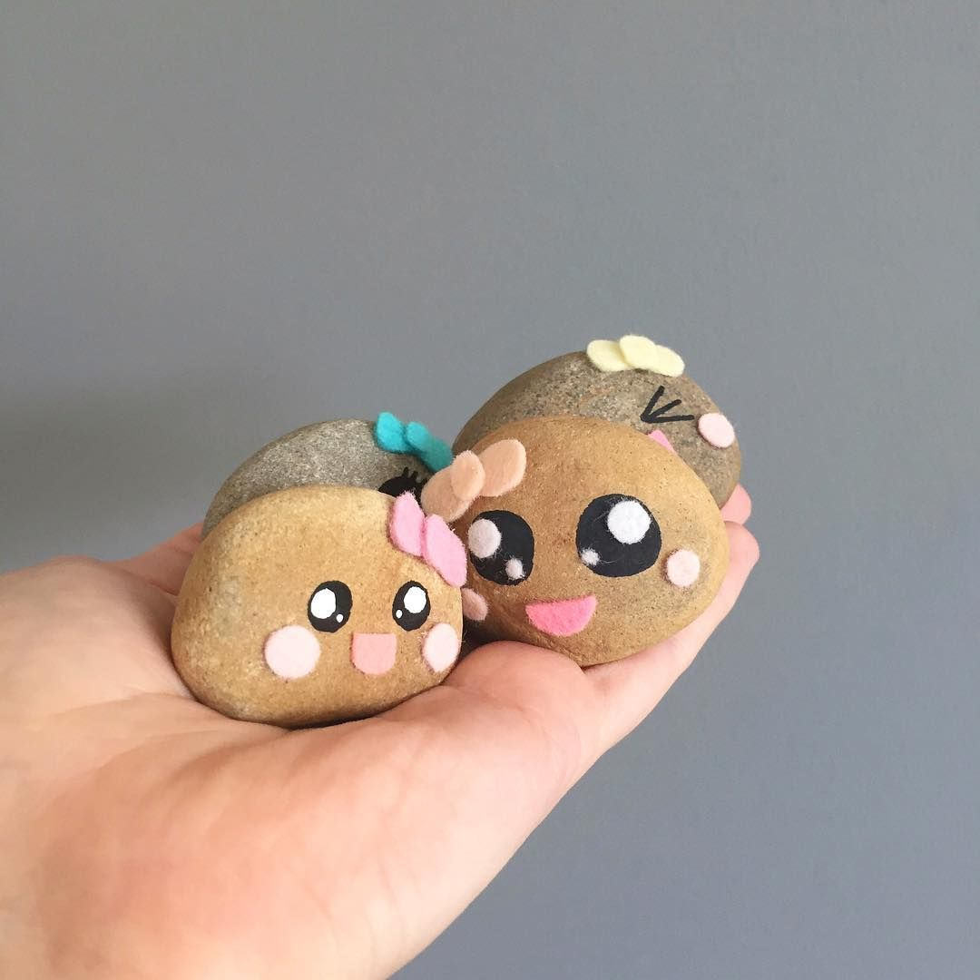
6. Bonus: One day, take your rock to College with you.

