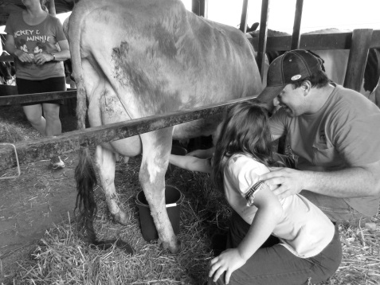

Ag in the Classroom  Adopt-a-Classroom  Summer Ag Institutes

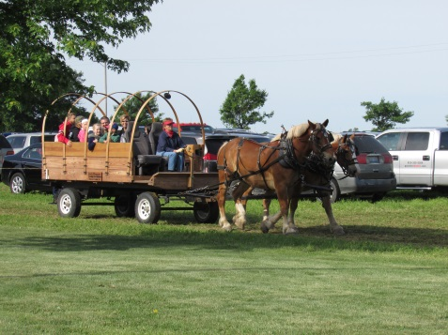Summer Camps   Farm Breakfast

Rockford City Market  County Fairs 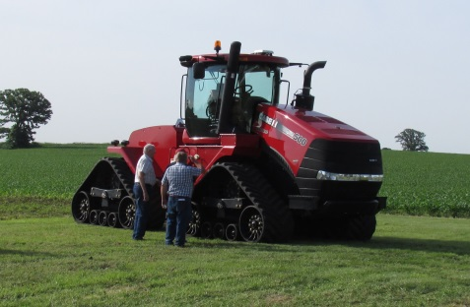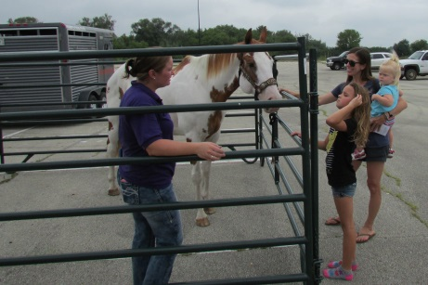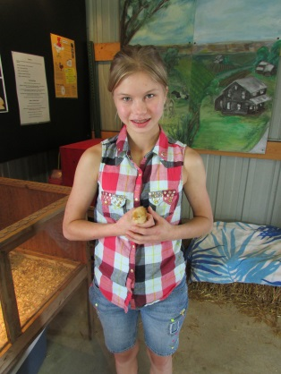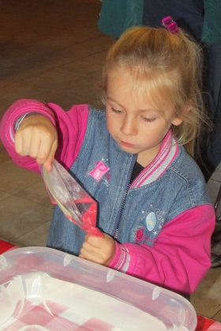and more!

**WINNEBAGO-BOONE FARM BUREAU INTERNSHIP**

AGRICULTURAL FIELDS OF STUDY

**Location:** Rockford, Illinois

**Dates:** May-August 2019

**Pre-requisites:** Graduating high school senior or current college student, enrolled in a college/university for the upcoming semester studying Agriculture, Communications, Marketing, or Education

**Requirements:** Approximately of 25 hrs./week

(days with occasional evenings and weekends)

**Salary:** $10/hour

**Responsibilities:**

* Promote and facilitate Ag-in-the-Classroom and Consumer Education projects
* Assist with a week-long, graduate credit Summer Ag Institute for teachers.
* Assist with public relations efforts through social media, newsletters, press releases and other correspondence
* Coordinate County Fair activities with volunteer committees
* Assist with fundraising for the comprehensive Ag Ed program in

Boone and Winnebago counties.

* Other duties as assigned

Contact: Ann Marie Cain, Manager at 815-962-0653 or

email [wbfbmanager@live.com](mailto:wbfbmanager@live.com)

Applications are available at [www.winnebagoboonefarmbureau.org](http://www.winnebagoboonefarmbureau.org)

**Application Deadline is March 1st.**