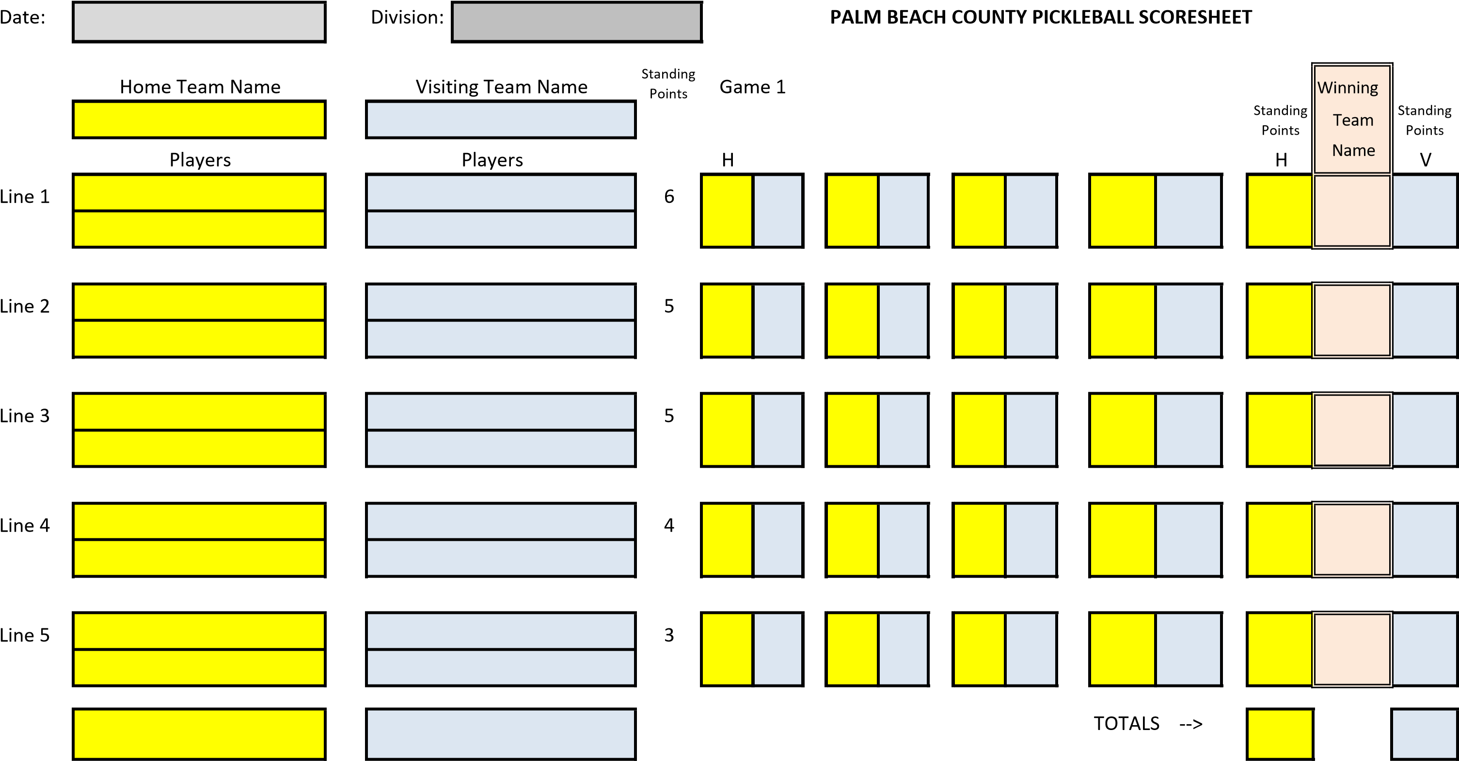 Home Captain's Signature Visiting Captain's Signature

**SEND COMPLETED SCORESHEETS TO APPROPRIATE DIVISION COORDINATOR AND LEAGUE COORDINATOR:**

Div 1 - TabakinEHS@aol.com Div 2 - hrowling@comcast.net Div 3 - fmr12@aol.com Div 4 - Seth@dinsky.com

Div 5 - richardneal45@hotmail.com Div 6 - paulKhonig@gmail.com Div 7- smtjr51@yahoo.com Div 8 - howard_shames@yahoo.com

Div 9 - sbjoconnor19@gmail.com Div 10 - jayneweiss117@gmail.com Div 11 - Ronabordonaro@gmail.com Div 12 - bbfink00@aol.com League Coordinator - Walter Gassner - pbcPickleballLeague@gmail.com