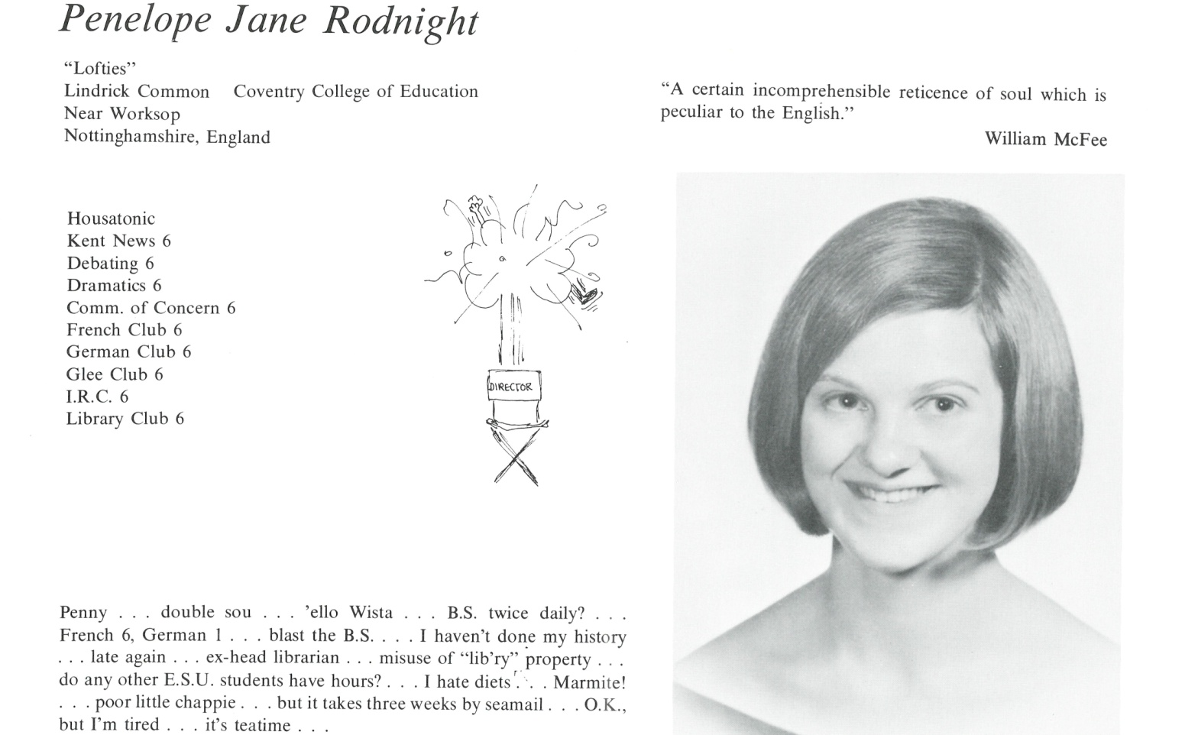

Penelope J. Rodnight Ware

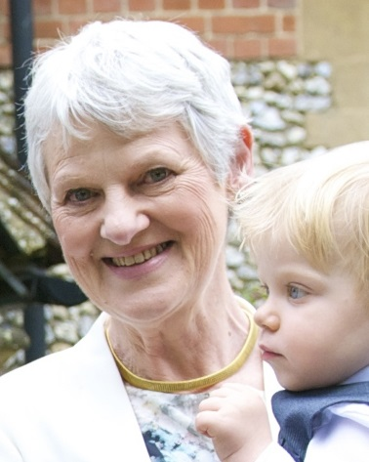My life now is dominated by my grandchildren (Justin 4 and Rowan 1) and by the fact that I have become a Quaker. Having trained as a counsellor, until recently I volunteered on a helpline for children. This kept me up to the moment but I’m hoping the grandchildren will keep me moderately youthful in outlook.

I live in a little village just outside London (they often film Midsomer Murders here!). I help with the local history group and with maintaining the common land in the village. I helped to oversee the renovation and refurbishment of our 17th century Quaker meeting house and can tell you all about brick-making and pegs on tiles.

Have I changed at all? I’ve almost never dieted; I still love Marmite; I still say “I’m tired”; and teatime is still the highlight of my day.

Come and visit me for tea and cake – and I’ll let you off the Marmite. Near to Heathrow and 30 minutes to London by train. [pennyware@dooega.com](mailto:pennyware@dooega.com).



______________________________________________________________

______________________________________________________________ ______________________________________________________________ ______________________________________________________________ ______________________________________________________________ ______________________________________________________________ ______________________________________________________________ ______________________________________________________________ ______________________________________________________________

Attach Picture in .jpg Format

______________________________________________________________

______________________________________________________________

___________________________________________________________________________________ _________________________________________________________________________________________________________________________________________________________________________________________________________________________________________________________________________________________________________________________________________________________________________________________________________________________________________________________________________________________________________________________________________________________________________________________________________________________________________________________________________________________________________________________________________________________________________________________________________________________________________________________________________________________________________________________________________________________________________________________________________________________________________________________________________________________________________________________________________________________________________________________________________________________________________________________________________________________________________________________________________________________________________________________________________________________________________________________________________________________________________________________________________________________________________________________________________________________________________

___________________________________________________________________________________