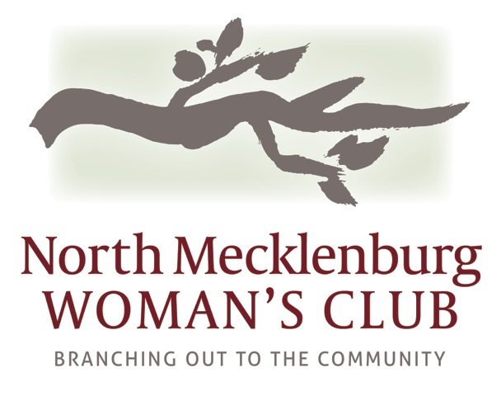 2017-2018 Sponsorship Form

Name:________________________________________________________

Company:_____________________________________________________

Phone:_______________________ Email: _________________________

Chosen Sponsorship Level:

____ Platinum Partner $5000+

____ Gold Partner $2500+

____ Silver Partner $1000+

____ Friends of NMWC $250+

_____ I can not be a sponsor this year but I would like to donate $_____

I would like to commit to NMWC sponsorship for:
____ one year ____two years ___three years (billed annually in September)

____ My employer offers matching donation funds.

I can not become a sponsor this year but I would like to donate $_________

100% of all donated funds go to the charities we serve.
NMWC is a 501c3 organization. Your donation to NMWC is 100% tax deductible.

Please make checks payable to NMWC.
Please mail to:
Barb Kasprzak, 8742 Branchside Lane, Huntersville, NC 28078
For more information contact Barb at 248-935-7539, bkasprzak55@gmail.com

