RSAI Legislative Update
April 11, 2024

This RSAI Weekly Report from the 2024 Legislative Session includes:
- Appropriations Bills Move
- Highlight on Education Appropriations
- Other Legislative Action
- Finishing the Session
- Advocacy Actions and Resources

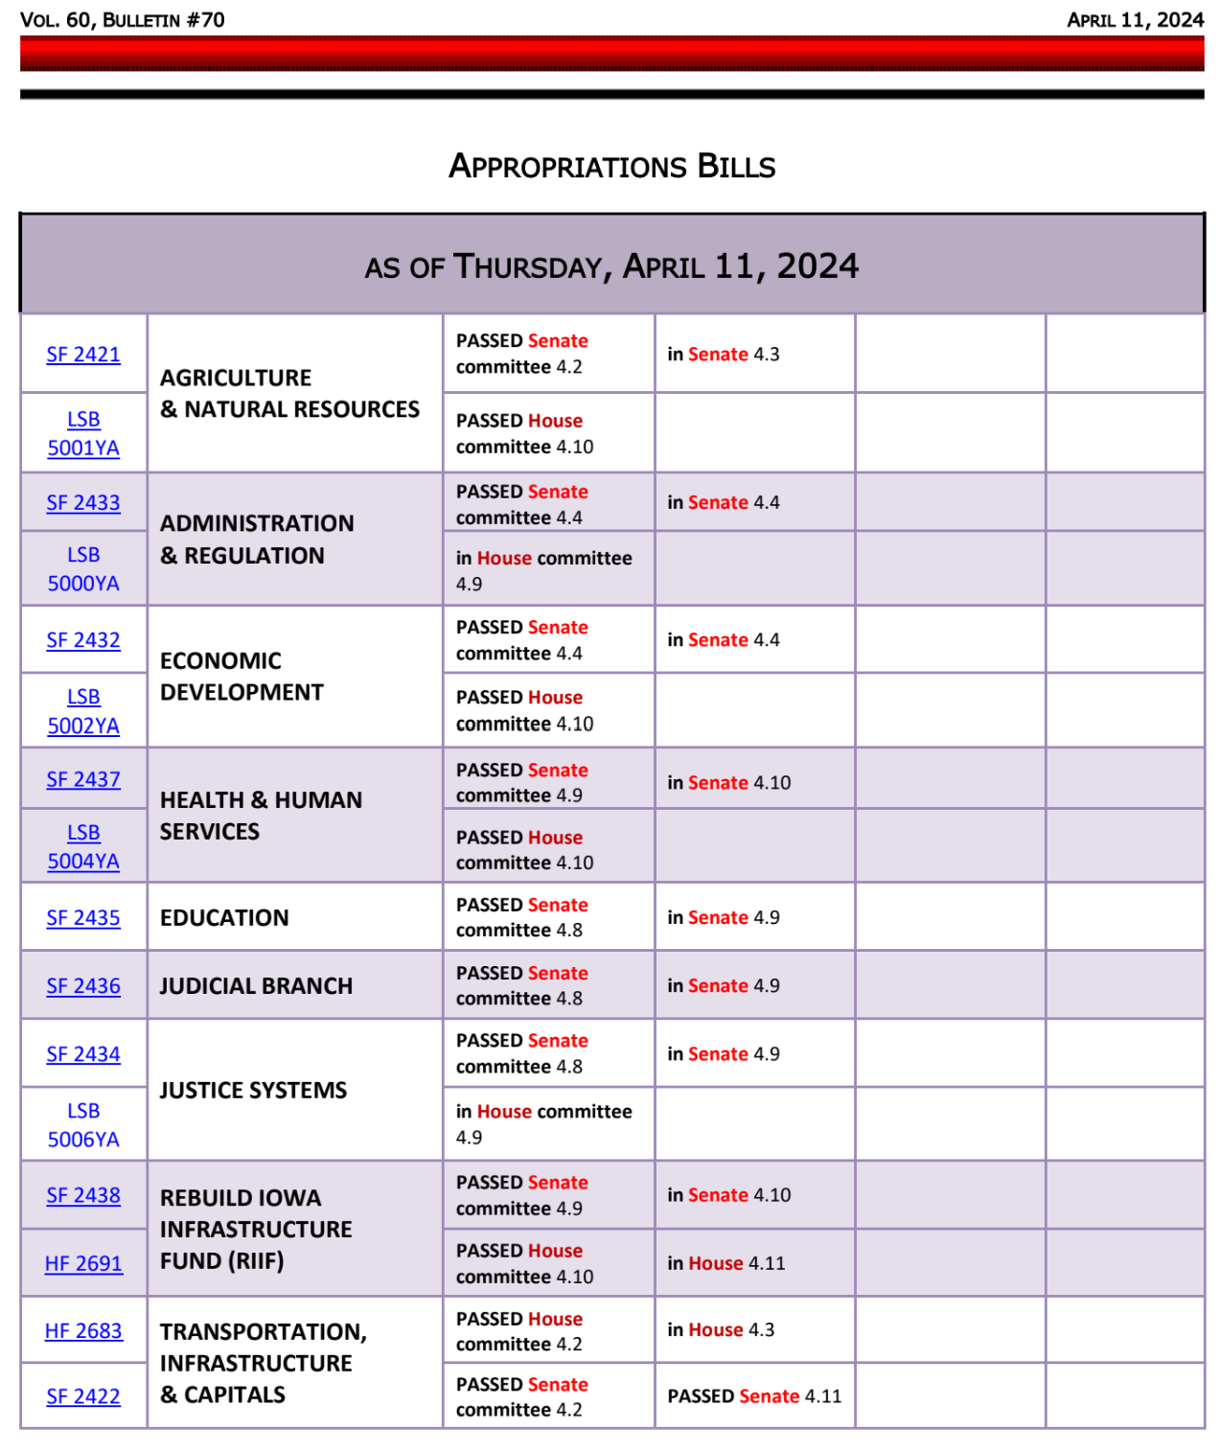
This chart from the Iowa Legislative News Service shows progress so far on appropriations bills needing to be completed in order to shut down the Session:
Progress is seen on all State Government appropriations bill, except the Standings Appropriations bill, which has not yet been introduced. The Standings bill will include school aid, and historically, AEA deappropriations have been included.

SF 2422, Transportation, Infrastructure and Capitals Appropriations, was approved by the Senate Thursday, 45:0, and moves over to the House.

SF 2435, Education Appropriations, was approved by the Appropriations Committee and is now on the Senate Calendar.

The following information comes from the Legislative Services Agency’s Notes on Bills and Amendments, known as SF 2435 NOBA.
- Department of Education: Appropriates $439.5 million from the General Fund and 416.1 FTE positions. This is an increase of $20.3 million and 65.0 FTE positions. The General Fund changes include:
  - An increase of $688,000 for the Department of Education Administration.
  - An increase of $5.7 million for General Aid for Community Colleges.
  - An increase of $286,000 for the Iowa School for the Deaf.
  - An increase of $120,000 for the Education Services for the Blind and Visually Impaired.
  - A new appropriation of $10.0 million for a new Special Education Division under the Department of Education.
  - A new appropriation of $2.2 million for the establishment of the Professional Development fund.
  - An increase of $1.3 million for the Tuition Grant Program.
  - An increase of $3,000 for the Tuition Grant For-Profit.
- Programs for At-Risk Children: Limits the standing appropriation under Iowa Code section 279.51 for at-risk children to $10,524,389 (overrides the General Fund appropriation of $12,606,196 specified in the Code). Prorates among the programs. (No change compared to FY 2024.)

- Student Achievement and Teacher Quality Program: Maintains required allocations for FY 2025.
  - $728,216 PD requirements of chapter 284, including evaluator training (up to 4 FTEs).
  - $1,077,810 Teacher Development academies.
  - $50,000 Fine Art Teacher Mentoring Program.
  - $626,191 to DE for a Delivery System in conjunction with AEAs to assist with teacher career development and leadership (up to 5 FTEs).
  - $10,000,000 for High Needs Schools grants (no more than $100,000 for DE administration and 1 FTE).
- DE provides oversight, supervision, and support for the State education system, including all of the following, the last four of which were added to DE’s area of authority in the 2023 State Government Reorganization bill:
  - Public elementary and secondary schools.
  - Community Colleges.
  - Area Education Agencies (AEAs).
  - Elementary and secondary schools under the purview of the Department of Health and Human Services (HHS).
  - Nonpublic schools that receive State accreditation.
  - Teacher preparation programs.
  - The Board of Educational Examiners.
  - The College Student Aid Commission.
  - The Iowa School for the Deaf Iowa.
  - Educational Services for the Blind and Visually Impaired (IESBVI).
Other Policy Language
- Allows DE to transfer unencumbered or unobligated funds from the FY 2024 General Fund appropriation for the Therapeutic Classroom Transportation Claims Reimbursement to the Therapeutic Classroom Incentive Fund before the close of the fiscal year.
- Requires the General Fund appropriation to DE for Early Head Start projects to be used for the implementation and expansion of Early Head Start pilot projects addressing the comprehensive cognitive, social, emotional, and developmental needs of children from birth to three years of age, including prenatal support for qualified families. Requires the projects to promote healthy prenatal outcomes and healthy family functioning, and to strengthen the development of infants and toddlers in low-income families.
- Requires DE to provide reading assessments for prekindergarten through grade six to identify students not proficient in reading. Allows the DE to charge school districts for the cost of the assessment, which school districts may pay out of Early Intervention Funds.

Eight of the 49 line items in the Education Appropriations bill show an increase for a combined $20.2 million. However, the $10 million for the new Division of Special Education and $2.2 million for Professional Development are likely to be reduced from the AEAs in the Standings Appropriations bill, so the net increase to education is closer to $8 million. RSAI is registered as undecided.

Also, Please Note: There is NO SUPPLEMENTAL APPROPRIATION for $14 million in this bill, for school districts to increase pay for education support personnel that was anticipated with language in HF 2612 to increase pay for hourly staff. Such an appropriation could be amended on to this bill, be included in the Standings Appropriations bill, or not be appropriated at all. Stay tuned.

Other Legislative Action
HF 2487 Reporting Grooming Behavior: the House concurred with the Senate’s changes, 89-0, sending it to the Governor. RSAI is undecided.
HJR 2006 Income Tax Constitutional Amendment: was approved in the Senate on a 31-13 vote. This resolution would amend the Iowa Constitution to require a 2/3 supermajority in the legislature for income tax increases. It now needs to be approved in a second General Assembly (either in the 2025 or 2026 Legislative Session) before it goes to the voters as a ballot initiative. RSAI is opposed.
HF 2586 School Security: the Senate amended the bill to strike the school security personnel grant program, leaving the sections requiring security personal for large district high schools unless the school board votes not to, requiring authorized school employees to be issued permits to carry weapons (based on school board decision), requiring training for those staff, protecting the district and staff from liability, and requiring confidentiality for staff authorized to carry. The bill was amended and approved by the Senate, 30-14, sending it back to the House. RSAI is undecided.
SF 2411 Work-Based Learning: Division II allows credit for internships/apprenticeships outside of normal school time. Division III gives apprentices and experienced substitute teachers work credit that offsets student teaching requirements under certain circumstances. Approved by the Senate, 33-13, sending it over to the House. RSAI supports.

Governor’s Signature
SF 2331 Local Government Publication Requirements. Signed by the Governor on April 10. RSAI supports.
HF 2393: Dental Examinations excluded from screening requirements, surveys, and screenings conducted by school districts, charter schools, and innovation zone schools. Signed by the Governor on April 10. RSAI supports.
HF 2152: DE’s Commission on Educator Leadership and Compensation Reporting Requirements. Signed by the Governor on April 10. RSAI is undecided.
HF 2653 Use of Management Fund for Perry Retention Bonuses. Signed by the Governor on April 5. RSAI supports.
SF 2096 Repeal of Gender Balance Requirements for Appointed Boards. Signed by the Governor on April 10. RSAI did not register on this bill.
HF 2612 AEAs, Teacher Salary and School Funding/SSA Signed by the Governor on March 27. RSAI is undecided.

Finishing the Session
April 16 is the last day of legislative per diem payments and legislators generally try to finish the Session by that time. The legislature has to debate some policy bills if they intend to enact them. They need to move appropriations bills forward and come to a consensus between the House and Senate budget targets and individual line item appropriations. They must approve whatever additional tax policy they intend to pass. Stay attentive to your email inbox this week in case some bad policies come back as amendments. Watch for moments to thank legislators for their work that supports your school district staff, students and communities.

Advocacy Actions
- Stay tuned for any last-minute RSAI Calls to Action for advocacy requested regarding an amendment to an appropriations bill, a dead bill resurfacing, or for requested notes to the Governor asking for a veto.
- Find something to say thank you for – write a note this week (they aren’t getting much positive feedback, and the last two weeks are a grind, so this will be remembered).
- Make a plan for summer contact – go for an ice cream or invite them to a summer school event. Share how the bills they passed are working out (balance – what’s good, what needs to be fixed and what’s just plain unworkable).
- Attend organizational and planning meetings for next year’s priorities, answer RSAI’s legislative issues survey (coming out this summer) about important issues to your district, keep legislators in the loop (send a copy of your board’s priorities to them, or send a copy to the media and send the newspaper clipping to your legislators).
- Keep telling the stories of great things happening in your school district.
- Stay tuned for contact information for candidates running for House and Senate. Get an advocacy team organized with a plan for connecting and informing new people about key needs and issues before the election (resources such as 2024 RSAI Advocacy Handbook have tips and ideas).

Connecting with Legislators: To call and leave a message at the Statehouse during the Legislative Session, the House switchboard operator number is 515.281.3221 and the Senate switchboard operator number is 515.281.3371. You can ask if they are available or leave a message for them to call you back. You can also ask them what’s the best way to contact them during session. They may prefer email or text message or phone call based on their personal preferences.
Find biographical information about legislators gleaned from their election websites on the ISFIS site here: http://www.iowaschoolfinance.com/legislative_bios. Learn about your new representatives and senators or find out something you don’t know about incumbents.
Find out who your legislators are through the interactive map or address search posted on the Legislative Website here: https://www.legis.iowa.gov/legislators/find

RSAI Advocacy Resources: Check out the RSAI Website at https://www.rsaia.org/2024-legislative-session.html to find Advocacy Resources such as Position Papers, RSAI Weekly Legislative Recap Reports and Videos, RSAI Calls to Action when immediate advocacy action is required, testimony presented to the State Board of Education, the DE or any legislative committee or public hearing, and links to fiscal information that may inform your work. Be sure to review the 2024 RSAI Advocacy Handbook, which is also available on the RSAI website.

Contact us with any questions, feedback or suggestions to better prepare your advocacy work:
*Margaret Buckton, RSAI Professional Advocate, margaret@iowaschoolfinance.com , 515.201.3755 Cell
*Dave Daughton, RSAI Grassroots Advocate, dave.daughton@rsaia.org, 641-344-5205 Cell

Thanks to our RSAI Corporate Sponsors
Special thank you to your RSAI Corporate Sponsors for their support of RSAI programs and services. Find information about how these organizations may help your district on the Corporate Sponsor page of the RSAI website at www.rsaia.org/corporate-sponsors.html.
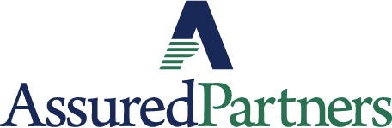 | www.linkedin.com/in/thomas-p-o-brien-03320616/
 | www.classroomclinic.com
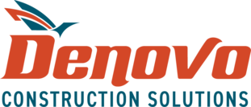 | www.teamdenovo.com
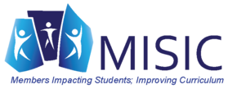 | www.misiciowa.org
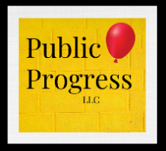 | thepublicprogress.com
 | www.solutiontree.com/st-states/iowa
 | www.wgu.edu

