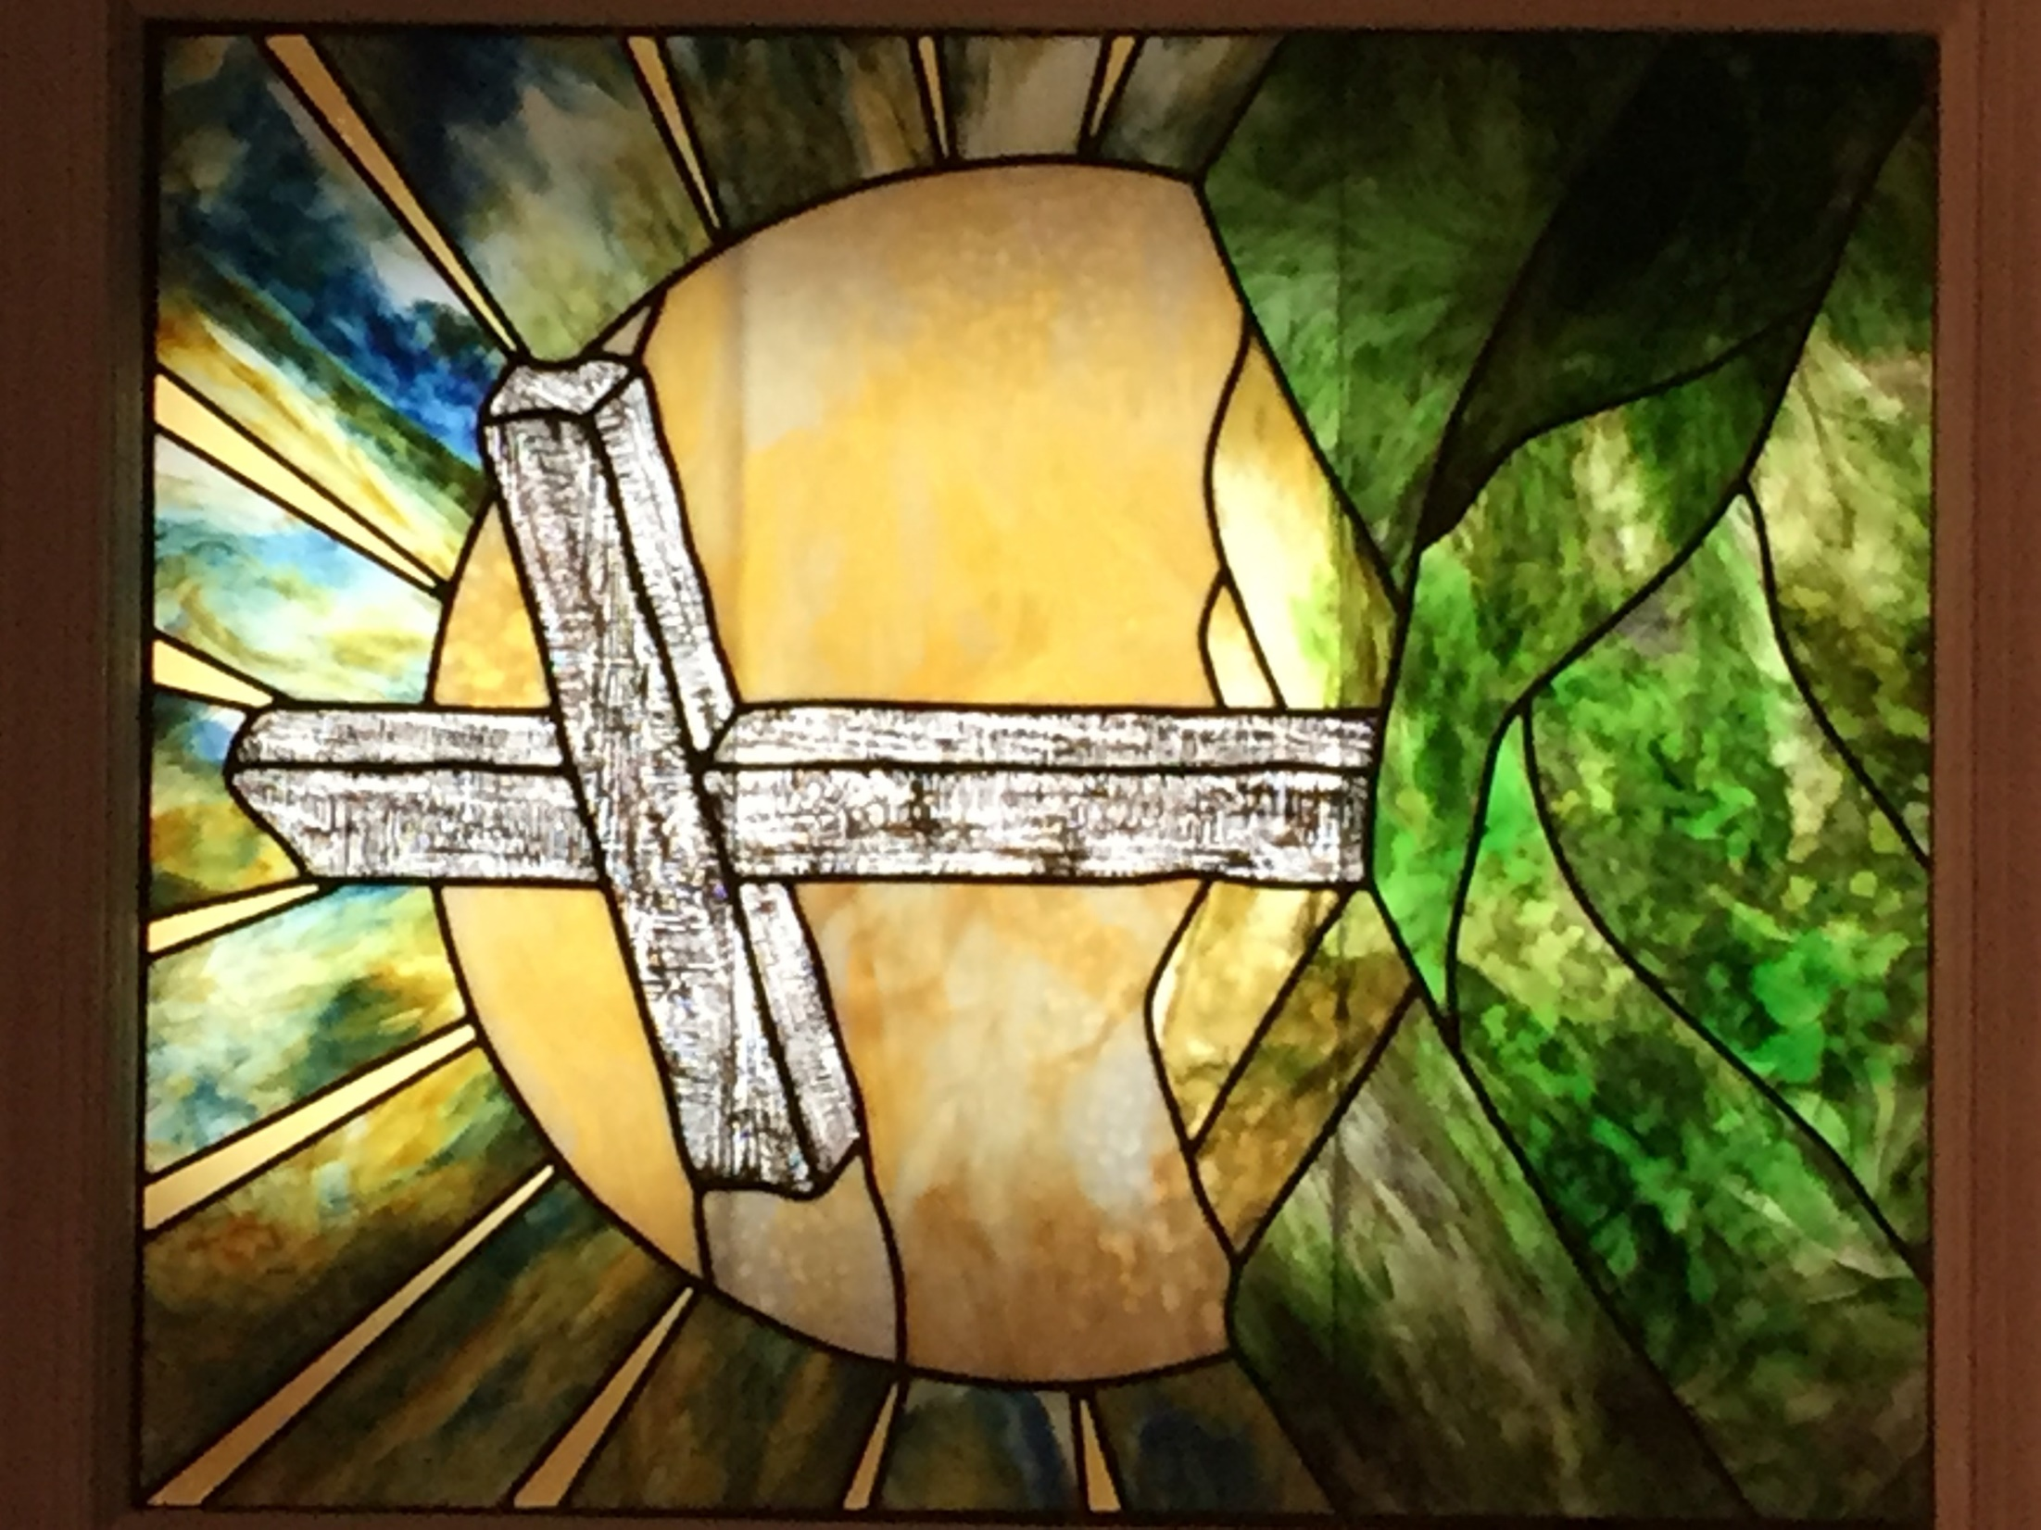
Wake Union Baptist Church Sunday School Devotion
Opening Prayer
Dear Heavenly Father,
Thank you for sustaining and blessing us through another week. We pray for all that are sick, for all that are grieving, and for all those with needs known only to You. Thank you for loving us and extending great mercy. Speak to us through your scripture this morning that we might grow in our faith and live according to your will for each of us. In Jesus’ name, Amen.

Welcome and Announcements
This is now the 22nd Sunday of cancelled services. The governor has extended Phase 2 for yet another 5 weeks. I pray for an end to this current virus so we can meet together again.

Memory Verses
²Behold, God is my salvation; I will trust, and not be afraid: for the LORD JEHOVAH is my strength and my song; he also is become my salvation. ³Therefore with joy shall ye draw water out of the wells of salvation. ⁴And in that day shall ye say, Praise the LORD, call upon his name, declare his doings among the people, make mention that his name is exalted. ⁵Sing unto the LORD; for he hath done excellent things: this is known in all the earth. Isaiah 12:2-5
We’ve been on this song related theme for several weeks now, so I plan to wrap up this topic with 3 particular Psalms. Today we’ll consider Psalm 46 which encourages us to take comfort, trust, and hope in God even in discouraging times.

Psalm 46 – Confidence in God’s Very Present Help
¹God is our refuge and strength, a very present (abundantly available) help in trouble.
God is always present and available to help his people, especially in times of trouble, providing refuge, security, and peace. “Trust in him at all times; ye people, pour out your heart before him:” (Psalm 62:8). “The LORD is nigh unto all them that call upon him, to all that call upon him in truth” (Psalm 145:18). “The name of the LORD is a strong tower: the righteous runneth into it, and is safe” (Proverbs 18:10).

²Therefore will not we fear, though the earth be removed (should change/end), and though the mountains be carried (fall) into the midst of the sea; ³Though the waters thereof roar and be troubled (foam), though the mountains shake with the swelling thereof. Selah
In Psalm 82, in referring to the wicked, we find “They know not, neither will they understand; they walk on in darkness: all the foundations of the earth are out of course” (Psalm 82:5). Sounds a little like today doesn’t it? No matter how the world changes, or even if it ends, we need not fear for our confidence is in God’s ability to save. God is our eternal refuge and strength even in the face of catastrophe.

⁴There is a river, the streams whereof shall make glad (bring joy to) the city of God, the holy place of the tabernacles (dwelling) of the most High. ⁵God is in the midst of her; she shall not be moved: God shall help her, and that right early (at the break of day, when morning dawns).
Many large cities developed along rivers which provided a means of sustenance and trade. God, like a river, sustains his people. John in Revelation 22 was allowed to see God’s city, new Jerusalem and described what he saw: “¹And he showed me a pure river of water of life, clear as crystal, proceeding out of the throne of God and of the Lamb. ²In the midst of the street of it, and on either side of the river, was there the tree of life, which bare twelve manner of fruits, and yielded her fruit every month: and the leaves of the tree were for the healing of the nations. ³And there shall be no more curse: but the throne of God and of the Lamb shall be in it; and his servants shall serve him:” (Revelation 22:1-3). Just reading this description makes me glad I’m a Christian. Herein is reason for joy to the church, even in the midst of discouraging times.

⁶The heathen raged (nations are in uproar), the kingdoms were moved (fall): he uttered his voice, the earth melted.
Jesus will return to judge the earth; “And his feet shall stand in that day upon the mount of Olives, which is before Jerusalem on the east, and the mount of Olives shall cleave in the midst thereof toward the east and toward the west, and there shall be a very great valley; and half of the mountain shall remove toward the north, and half of it toward the south. … and the LORD my God shall come, and all the saints with thee. …And it shall be in that day, that living waters shall go out from Jerusalem; …And the LORD shall be king over all the earth:” (Zechariah 14:4-9).

⁷The LORD of hosts is with us; the God of Jacob is our refuge (stronghold, fortress). Selah
God is all powerful and his ultimate victory is certain. He will not fail to rescue or save those who love him.

⁸Come, behold the works of the LORD, what desolations he hath made in (wrought upon) the earth. ⁹He maketh wars to cease unto the end of the earth; he breaketh the bow, and cutteth the spear in sunder (two); he burneth the chariot in the fire.
Wars, conflicts, and destruction are inevitable; but so is God’s judgment and ultimate victory. “And he shall judge among many people, and rebuke strong nations afar off; and they shall beat their swords into plowshares, and their spears into pruninghooks: nation shall not lift up a sword against nation, neither shall they learn war anymore” (Micah 4:3). “For every battle of the warrior is with confused noise, and garments rolled in blood; but this shall be with burning and fuel of fire. For unto us a child is born, unto us a son is given: and the government shall be upon his shoulder: and his name shall be called Wonderful, Counsellor, The mighty God, The everlasting Father, The Prince of Peace” (Isaiah 9:5-6).

¹⁰Be still, and know that I am God: I will be exalted among the heathen (nations), I will be exalted in the earth. ¹¹The LORD of hosts is with us; the God of Jacob is our refuge. Selah
In the midst of trouble take time to be still, cease striving, and relax. Honor, worship, and exalt God in his power and majesty. God has glorified his name and will glorify it yet again. “Know ye that the LORD he is God: it is he that hath made us, and not we ourselves; we are his people, and the sheep of his pasture. Enter into his gates with thanksgiving, and into his courts with praise: be thankful unto him, and bless his name. For the LORD is good; his mercy is everlasting; and his truth endureth to all generations” (Psalm 100:3-5).

Closing Prayer
Dear Heavenly Father,
Thank you for your very present help. Thank you for comforting us when we are discouraged and for always loving us. We lift up your name in praise this day for your goodness and everlasting mercy and truth. Please help us each day to live in a manner that honors you and points others to your salvation. I pray everyone will be kept safe and well until we can meet together again. In Jesus’ name, Amen.

