RSAI Legislative Update
March 19, 2020
In this RSAI Report of the 2020 Legislative Session, find information about:
- Instructional Time Waiver Signed by the Governor
- SF 2408 Appropriations and Emergency Provisions
- State Budget and Surplus
- Legislature Shuts down until April 15
- Advocacy Resources
Contact us with any questions, feedback or suggestions to better prepare your advocacy work:
Margaret Buckton, RSAI Professional Advocate, margaret@iowaschoolfinance.com 515.201.3755 Cell
Find RSAI 2020 Legislative Priorities and Position Papers here: http://www.rsaia.org/2020-legislative-session.html
Instructional Time Waiver Signed by the Governor: On March 15, 2020, Iowa Governor Kim Reynolds recommended closure of all public and private K-12 schools in Iowa until April 13, 2020 to contain the spread of COVID-19.
Previous DE guidance prohibited virtual instructional days to count in the minimum number of mandated days (180) or hours (1,080) of instruction. Schools districts advocated for waiver from a requirement to make up any days closed due to containment of COVID-19. RSAI’s statement was sent to the Governor and Legislative Leaders on March 16 requesting relief from the mandate to make up instructional days. The Legislature included relief of the mandate through April 13 in SF 2408 and extended authority to the Governor to waive the requirement for additional days beyond April 13 through July 1, 2020. RSAI registered in favor of Division VI of the bill regarding instructional days.
SF 2408 Provisions: In addition to waiving the requirement to make up instructional days, SF 2408 also made the following appropriations and provisions as reporting in the Notes on Bills and Amendments (NOBA):
- Makes supplemental General Fund appropriations of $91.8 million for FY 2020.
  - $89.0 million to DHS for Medicaid
  - $1.7 million to DHS for HAWK-I program
  - $596,000 to DHS for State Resource Center at Glenwood
  - $526,000 to U of I Hygienic Lab
- Economic Emergency Fund: appropriates $19.6 million (10%) for purposes approved by the Governor.
- Specifies if that amount is not sufficient, provides a contingent appropriation of the maximum balance of the EEF, requiring funds to be used based on purposes approved by the Governor and the Legislative Council. Max balance of EEF in FY 2020 is $196 million.
- Reduces FY 2021 standing appropriations by an estimated $32.8 million:
  - Limits FY 2021 appropriation to DE for nonpublic school transportation to $8.2 million, requires the appropriation to be prorated if the claims exceed the amount (no change compared to the funding level for FY 2020).
  - Suspends the General Fund standing appropriation of $14.8 million for the Instructional Support Program for FY 2021 (no change compared to FY 2020).
  - Reduces the FY 2021 State school aid funding to Area Education Agencies (AEAs) by $15.0 million (no change compared to FY 2020).
- Provides two months of FY 2021 appropriations based on FY 2020 amounts, an estimated $1.305 billion in spending authority to state agencies for FY 2021.
- Suspends limitation on Governor’s authority to transfer funds between general fund line item appropriations through Aug. 31, 2020.

The Legislative Services Agency published a Fiscal Update Article, Fiscal Services Division, March 13, 2020, which shows the projected condition of the State’s General Fund following the March 12 Revenue Estimating Conference updated estimate. The Update was after enactment of the 2.3% SSA and transportation and formula equity bills, so those fiscal impacts are included in the built-in expenditures amount, but was published before the fiscal impacts of SF 2408 were anticipated. SF 2408 would have the following additional impact:

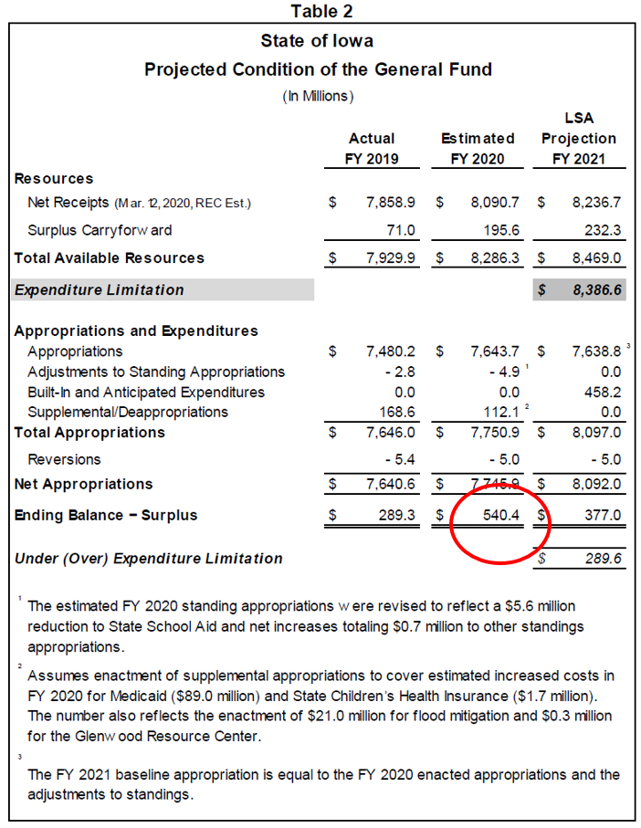
SF 2408 increased FY20 supplemental Approps of $91.8 million will reduce carry forward into FY 21 and FY 20 ending balance.
SF 2408 reduced FY 21 General Fund standing appropriations by $32.8 million would lower the built-in expenditures for FY 2021. Those reductions continue the $15 million cut to AEAs and $14.8 million continued cut to ISL.
The $458.2 million built-in expenditures include the 2.3% increase per pupil in SSA and the Transportation and Formula Equity.
Legislative Shut Down: the Legislature adjourned after completing their work on SF 2408 (the Senate on Monday, March 16 and the House on Tuesday, March 17) until April 15, but is likely working behind the scenes (and virtually like many of us) to draft budget bills. When they convene, we expect to see them proceed quickly. The 100th day of the Legislative Session specified in current rule is April 21; that is the final day of per diem reimbursement for legislators. Of course, in extraordinary times, it is unknown if the Session will be delayed further. Providing the Governor and Executive Branch with 2/12ths of the state’s appropriations beginning July 1, 2020 in addition to transfer and emergency fund authority has set up a contingency plan if the Session delay is further extended.

Advocacy Resources
Connecting with Legislators: See the RSAI Jan. 23, 2020 weekly Report for information about legislator biographies, contact information and committee assignments.
Advocacy Resources:
To find Advocacy Resources such as Position Papers, RSAI Weekly Legislative Reports and video updates, RSAI Calls to Action when immediate advocacy action is required, testimony presented to the State Board of Education, the DE or any legislative committee or public hearing, and links to fiscal information that may inform your work, visit the RSAI legislative web page here: http://www.rsaia.org/legislative.html

