Executive Summary - 2021 Session in Review
The 2021 Session followed on strong Republican gains in the Iowa House and Senate in the last election, with the party trifecta of leadership. Many policies of the GOP previously considered saw the light of day and eventually the Governor’s pen, as Republican leaders celebrated their strong super-majority margins with action. But the further shift in representational politics was not the only distinguishing quality of this Session; as the COVID-19 pandemic impacted nearly every facet of life early in 2021, the Iowa Legislature operated under strained rules of access. The Senate only allowed attendance at subcommittee meetings virtually via ZOOM while the House required attendance in person to testify. Both chambers provided public access virtually to watch subcommittee and committee meetings. Governor Reynolds monthly revisited and updated her public health declarations of emergency.
Although the 2021 Session will be remembered as the year of the pandemic, it will also be remembered as the year of School Choice. It began with a surprising early announcement in the Governor’s Condition of the State Address followed by pressure and legislative action rewarding private education advocates. This Session included several big policy changes (accreditation and prohibition of mask mandates are good examples) which were passed exceptionally fast, with very little understanding of the impact on schools and no opportunity for legislators to connect with their own school leaders back home to weigh in. This was a departure from prior sessions when big policy changes followed only after several subcommittee meetings and lots of conversation with stakeholders during forums or phone calls along the way.
This Session was challenging for Legislators and advocates alike. Given this context, a restart is in order; look for supports from RSAI to recreate connections and restore a sense of normalcy as we (hopefully) leave COVID-19 and the 2021 Session in our rear-view mirrors and prepare for the 2022 Session to focus on the needs of students in public schools.
Three such supports for your advocacy are now available on the RSAI website:
- RSAI Advocacy Handbook –Background and suggestions to help you advocate for Iowa rural schools
- Sample Questions for Legislators - Updated Fall 2021 - download and personalize for your district's fall 2021 legislator discussions
- 2021 Legislative Session Successes – See this list of accomplishments so you can start your advocacy conversations with a thank you for legislative actions that RSAI supported.

RSAI members are grateful for the continued progress of transportation/formula equity, connecting rural Iowa to broadband Internet services, additional flexibility in providing student-centered programs, and telehealth and mental health services for students discussed throughout the Session. Many proposals that could have negatively impacted public schools, such as vouchers and unfunded mandates were effectively held at bay due to strong collaborative work among many education organizations. Much work remains in key areas of quality teaching/teacher and other staff shortages in rural Iowa, funding adequacy and flexibility for Iowa school districts. Advocates will likely have to continue to ward off private school choice expansion in the future, which could be devastating for rural schools. Bills introduced this year carry forward to the 2022 Session, and their future success may depend on how legislators and Governor Reynolds anticipate political opinion in preparation of the 2022 November election with strategies to preserve Republican control.

State Revenues and the Economy: deep and rational concerns for the negative impact of COVID-19 on the Iowa Economy and subsequently state General Fund revenues were, in hindsight, not realized. Again, many forces were at play, not the least of which included billions of federal dollars to support the unemployed, small and large businesses, local governments (including schools), and the State of Iowa.
The Legislative Services Agency’s Monthly Revenue Memo June 30, 2021 provides a good picture of the Revenue Estimating Conference estimate compared to actual receipts, even after the adjustment for the tax cut impact of SF 619, which is described further below. See the Monthly Revenue Member, June 30, 2021, the source of the following table, here. Although dated June 30, 2021, this revenue picture for FY 2021 is not yet final as the state is finishing up closing the fiscal year for typically the following 60 days.

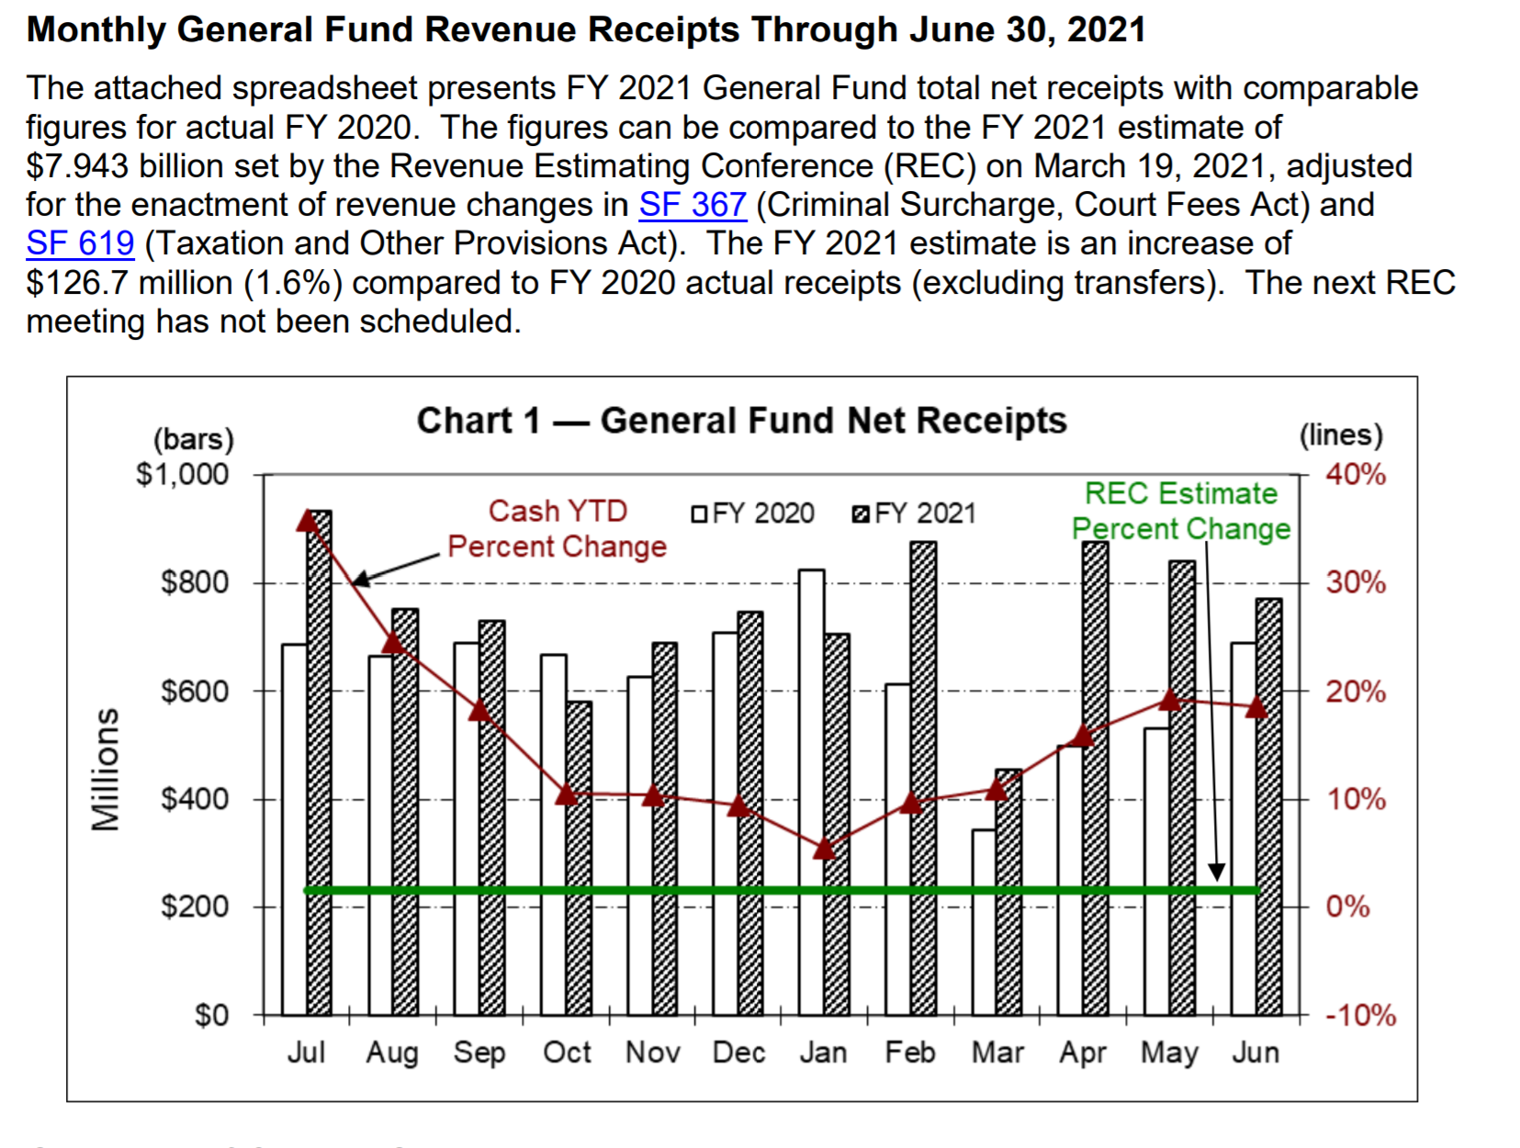
With full cash reserves and economic emergency funds anticipated at the close of FY 2021, a significant surplus, and promise of significant federal assistance to help with COVID-19 impacts, the Legislature was able to set a mostly status quo budget, but also chose to advance income tax reductions and provide additional property tax relief. Other states experienced a much greater impact of COVID on their state revenues, but the make-up of Iowa’s economy and relatively strong initial financial position insulated us well from what some feared would be the economic impacts of the pandemic.
The REC typically meets quarterly, next in October. The new COVID delta variant and Iowa’s lower levels of vaccination than suggested for herd immunity may yet dampen economic gains this fall and into 2022. The REC will also meet in December 2021, when they will set the revenue estimate for the 2022 and 2023 fiscal years. That estimate will bind the Legislature’s and Governor’s budget limitations for the 2022 Session.
Relative Context of PK-12 Funding as a Priority: the increase in the state cost per pupil, known as State Supplemental Assistance, SSA, (formerly known as Allowable Growth) was set at 2.4% and signed by the Governor February 23, just a few days beyond the 30-day deadline in Iowa law for enacting SSA. This amount is the second highest per pupil increase in twelve years and exceeded the REC revised revenue growth estimate of a 1.8% for the 2022 Fiscal Year. Although those two comparisons would normally be indicative of priority, it was also the lowest investment of increased state dollars for school foundation aid since 2009 due to a nearly 6,000 student enrollment decline recorded Oct. 1, 2020.
The one-time funding for increased costs of in-person instruction during a pandemic, known as the Qualified Instructional Supplement bill HF 532, failed to gain consensus as it was approved in different forms in the House and Senate, eventually dying on the Senate Calendar with the close of the Session. That bill would have added another $20+ million for public schools. In hindsight, FY 2022 revenue growth was solid, yielding very high surpluses, even after tax cuts were enacted.
School tuition organization tax credits were expanded by 30%. New legislation creates charter schools possibly authorized without school board approval. Open enrollment opportunities were expanded, voluntary diversity plans eliminated, local authority to determine how best to safely open schools was replaced with a state prohibition of local action to mandate masks for staff and/or students, and confusing restrictions on how to teach about race and free speech rights were enacted. These combined policy choices, in context of public school funded whereby only about one fourth of the average annual increase in state dollars spent on school foundation aid, paint a clear picture of the 2021 Legislative and Gubernatorial priorities; Iowa public schools did not enjoy the typical fiscal or policy priority and deference to local control to which our advocates are accustomed.

