Over 450 bicyclists from all over the world ranging in age from 9 yrs. old to 90 yrs. old made their way to Newark on July 13, 2014. The 16th annual “Cycling the Erie Canal” Tour is an 8 day, 400 mile ride from Buffalo to Albany along the Erie Canal. Many stopped here in Newark to enjoy our restaurants, amenities, and hospitality.

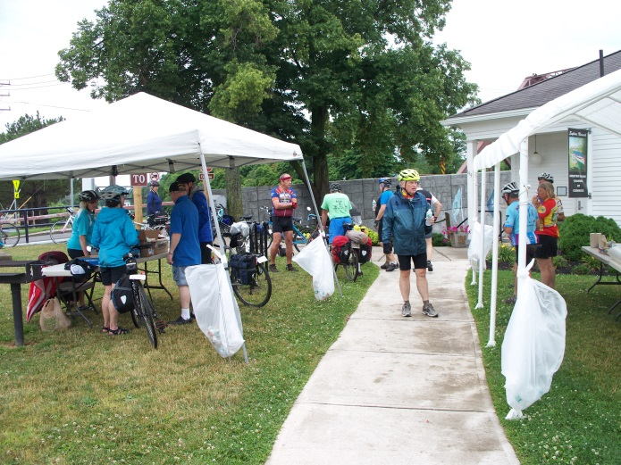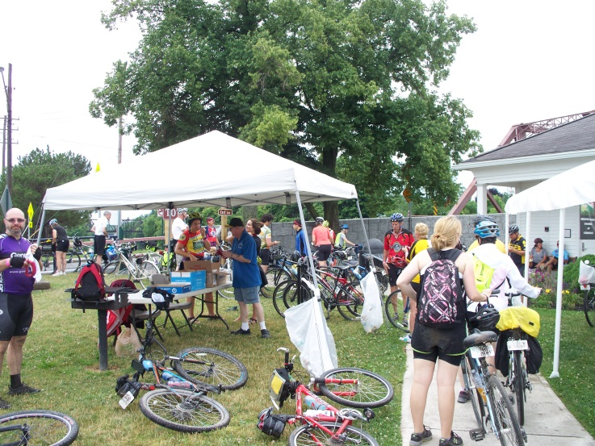

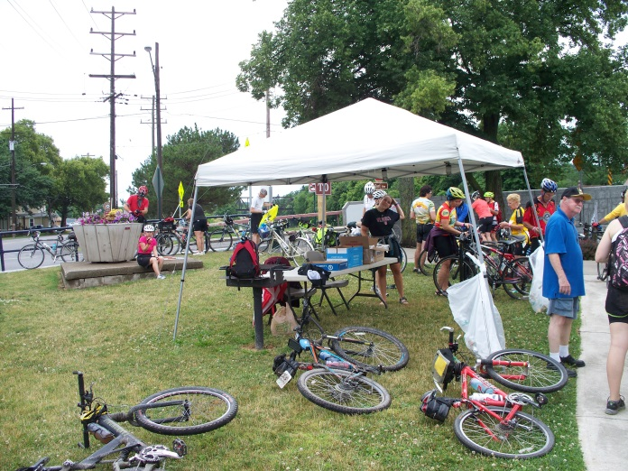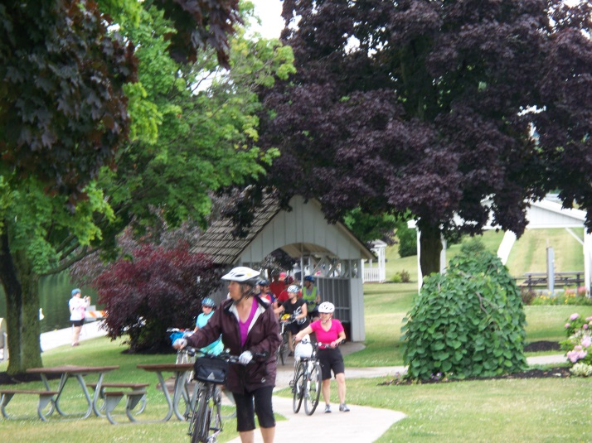

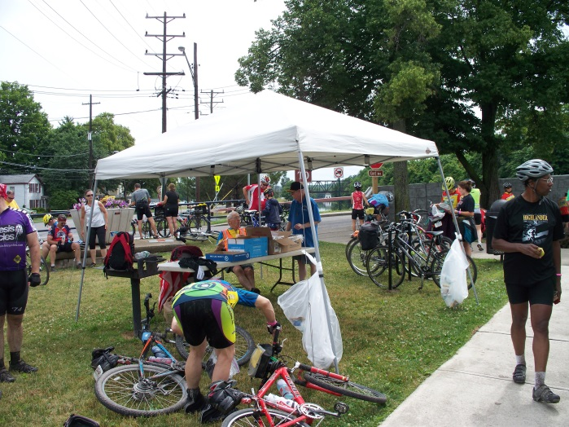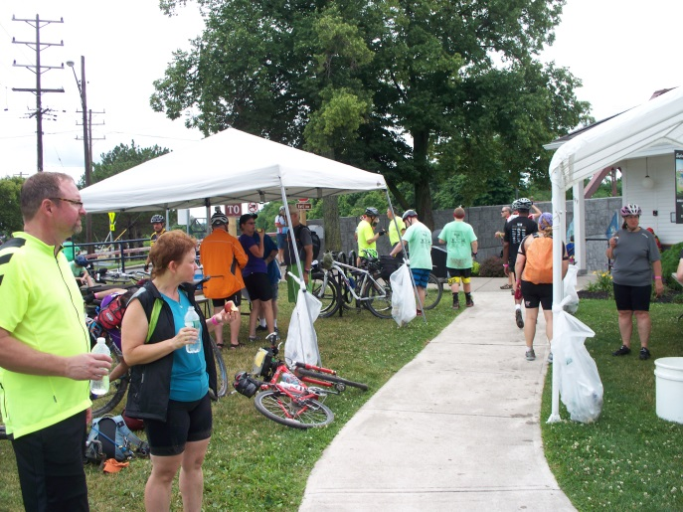

Scroll down for more pictures…

