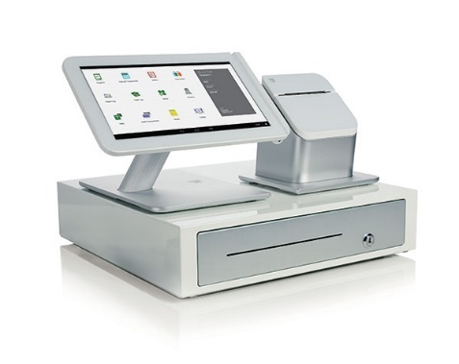**Office: (316) 269-4592**

**Fax: (316) 269-4593 1st National Bankcard**

**Bank Verification Examples**

Please include one of the following with your Merchant Processing Application and Agreement.

** Please make sure that you are not submitting a temporary check. The business name and address must be imprinted by the bank. We cannot accept checks that have hand-written information. **

**Voided Check:**

Business Name

Business Address

City, State, Zip

VOIDED CHECK

**Bank Letter on Bank Letterhead:**

Example:

____________________________ is doing business as _____________________________.

The owner of the business is _______________________ and ________________________.

The Transit Routing Number is _________________ and DDA Number is ________________.

New Accounts Officer – Name

Signature