2/14/2018 The 5th Tav on Ash Wednesday, the Maiden Stands Up

Today, 2/14/2018, is Ash Wednesday. It's also Valentine's Day.

Ash Wednesday is the day when some Christians have a mark, an "X" (ancient Paleo Hebrew Tav) consisting of ashes, placed on their foreheads by a Pastor or Priest. YaHuWaH Elohim placed an ancient Paleo Hebrew Tav "X" on Cain's forehead after Cain slew Abel.

The last time that Ash Wednesday fell on Valentine's Day was exactly 73 years ago today on 2/14/1945.

February 14,1945 was known as the Ash Wednesday Holocaust of 1945 when Dresden, Germany, was firebombed 2/13-15/1945 during World War II resulting in 200,000 to 300,000 deaths by burning. http://abundanthope.net/pages/Political_Information_43/THE-ASH-WEDNESDAY-HOLOCAUST-OF-1945_printer.shtml

The Fifth Tav

Several years ago YaHuWaH Elohim revealed to me a special sequence of solar eclipses that had the special qualities of revealing the constellation Leo, signifying Israel's Messiah King, the Lion of Judah during the month of Elul, and then a second total solar eclipse falling on Aviv 1 exactly 2422 days later. The two related solar eclipses formed ancient Hebrew Tavs ("X's") on the face of certain nations.

Aviv 1 is the time of the year when Kings go out to war according to 1 Chronicles 20:1. So the solar eclipse Tavs relate to Israel's Messiah going out to war.

Five pairs of these Tav eclipses were found to exist between 1900 AD and 2100 AD.

Four of these Tav sequences are examined here: http://www.joybysurprise.com/the-four-tavs.html

There was a 5th Tav that I didn't know what to do with for several years. Itwas ignored from the initial investigation of the solar eclipse sequences. The 5th Tav just sort of existed out there around the years 2047 to 2052 AD. I didn't know how it related with the other four until a few months ago.

Here's a graphic that shows the 5th Tav and it's direct relationship with the 100th anniversary of the forming of the modern sovereign State of Israel.

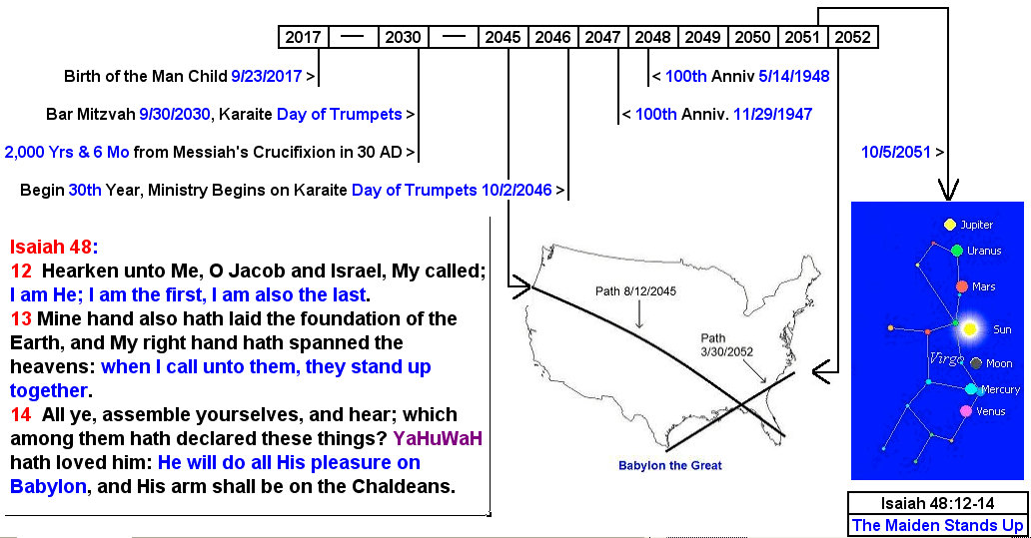

Note in the graphic above that if there is a cold Spring resulting in late aviv barley and a Karaite Adar II in the year 2051, that 10/5/2051 will probably be the Karaite Day of Trumpets instead of the September 7, 2051 Day of Trumpets listed on the current Hillel calendar.

Note that the 5th Tav, which places an "X" "end mark" on the USA, is also related with the symbolic birth of the Man Child on 9/23/2017.

Some people said the event of 9/23/2017 was a nothing-burger, but that was certainly not the case. Some astronomers said that the rare event of 9/23/2017 wasn't that rare and that it had occurred many times in the last several centuries. That is incorrect because the planet Jupiter spent a full 9 months prior to 9/23/2017 retrograding in the constellation Virgo, symbolic of the gestation period of a human. Jupiter has not spent and entire 9 months retrograding in Virgo at any time during the past 3,000 years and will not again for the next 2,000 years in the future. The 9/23/2017 was a rare one-off event as far as can be determined at this time.

Note that the Bar Mitzvah for a male child born on 9/23/2017 will occur on 9/30/2030 which will be the Karaite Day of Trumpets if the sky is clear in Israel and the New Moon is sighted on 9/29/2030. Here's a link to a Bar Mitzvah calculator: http://www.chabad.org/calendar/bar-bat-mitzvah_cdo/aid/6227/jewish/BarBat-Mitzvah.htm

If you put the birth of a male child during the daytime in Israel on 9/23/2017 into the above Bar Mitzvah calculator, it will give 9/30/2030 as the date for the child's Bar Mitzvah. Although 9/30/2030 is the the 3rd of Tishrei according to the Jewish Hillel calendar, it will be the Karaite Day of Trumpets, 1st Tishrei, according to an astronomy program that allows at least 1/2 hour after sunset for sighting the New Moon.

The relevance of the 2030 date is that prior research has determined that the crucifixion of Messiah probably took place on Passover in 30AD. The 2030 AD Bar Mitzvah date places Messiah near the very beginning of the 3rd 1,000 year day from His death and resurrection in the Spring of 30AD. So the 9/23/2017 sign of the Woman travailing in birth synchronizes perfectly with the crucifixion event 2,000 years and 6 months earlier.

You can study the above graphic if you want and see what happens at the 100th anniversary of the founding of the modern sovereign State of Israel. Note that the children of Israel spent about 400 years in ancient Egypt, that sojourn being counted as four 100 year generations.

There are other relevant relationships between the 5th Tav and the other 4 Tavs that will probably be revealed in a future email.

