Karl Swihart, Indiana State Director
NSA Great Lakes Regional Director
574-806-7727
indianansafastpitch@gmail.com
www.indianansafastpitch.com
www.playnsa.com

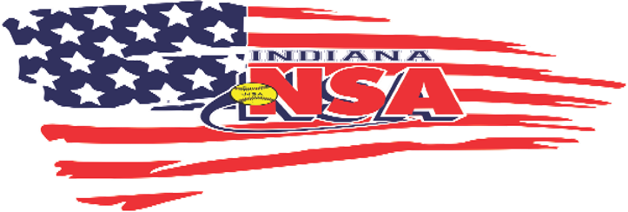
Team Welcome Packet

Thank you for becoming a member of the NSA family. Our goal is to provide affordable and quality events for your team during weekend events, and to provide support when questions arise. Our goal is to create the best tournaments for your team and the best trained umpires.

Please read the entire welcome letter as it contains some very important information that will assist you as the season begins.

The NSA World Series this year will again be in Northwest Indiana July 15-20, 2025. You are encouraged to sign up for that event as soon as possible. You do not have to pay for that event until the end of June.

There are 4 State Tournaments in Indiana, and you MUST play in at least one of them to activate your berth to the World Series. Sign up for these dates Immediately to make sure you can attend the NSA World Series. These dates are;
June 13-15th B State Warsaw, IN
June 20-22nd Open State Michigan City, IN
June 20-22nd Odd Age State Michigan City, IN
June 27-29th C State Knox, IN

You can earn your World Series berth by winning an NSA Qualifier, or receiving a pass down berth from the team that wins and has already earned their berth. These are passed down to the next highest finishing team that does not already have one. The final way to receive a berth is an At-Large berth. You earn this berth by playing in 3 NSA qualifiers. ALL BERTHS MUST BE ACTIVATED BY PLAYING IN YOUR STATE TOURNAMENT.

NEW IN 2025
This year we are offering a FREE tournament entry for any team that signs up and pays for 4 Indiana NSA Qualifiers (Indoor and post season events not included). Your team will receive their fifth event with no entry fee. You only pay your gate fee for the fifth event. If a tournament is cancelled due to weather or lack of teams, we will transfer that entry to another qualifying event of your choice.

We are also offering a organizational promotion. When an organization sends 3 or more teams to a tournament from their organization, the 4th team will get half off their entry fee. Again, this is for qualifying events only and not applicable for indoor events or post season.

We have also secured some new facilities for the 2025 season. We have secured 5 dates at the new indoor facility in Columbus, Indiana. It is a beautiful, brand new steel structure that has 2- 190’ turf fields. We have also secured 2 dates in Decatur, Indiana that has new complex and 2 dates in Rensselaer, Indiana with a newer complex.

GETTING STARTED
Once you have your membership number (Sanction number) you can begin entering the NSA events.

INSURANCE
Please consider purchasing the NSA West Point Insurance for your team. This is required for all NSA tournaments and is the best and most affordable insurance in the industry. By having this policy, you are awarded a $25 discount on ALL NSA events. If you choose to purchase another insurance, you will not be afforded the discount. In turn, we will purchase your team that weekend insurance through West Point.

ROSTER
Begin entering your players on your roster. You are allowed up to 25 players on your roster. Once a player is on your roster, they are securing that spot whether they remain on your roster or are released.

TOURNAMENTS
All NSA tournaments are listed on www.playnsa.com and can be entered from that site. You can also pay for tournaments on that site or www.indianansafastpitch.com website or simply send a check.

We recommend you sign up for tournaments as soon as possible. Space is limited in every tournament. This also serves the purpose of attracting more teams in your age group. You do not have to pay for tournaments right away, although it is recommended to secure your spot. Tournaments must be paid for 2 weeks prior to the start date in order to get the brackets out so teams can prepare their travel plans. Some tournaments, especially the indoor events, fill up very fast.

If at anytime you have questions or concerns, please feel free to contact me.

Thanks for your interest and support of the National Softball Association.

