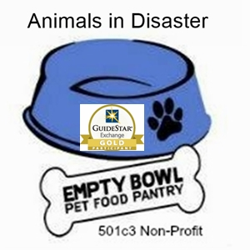Animals in Disaster
Bowl Pet Food Pantry
- 602/909-7153
Please: How you can HELP
if you belong to a group, church or business which has volunteers or corporate giving, get US involved with them!
General Need:  > Cash for administration and deliveries of service  >Pet Food  If opened and resealed, this will go to non-profit agencies immediately.  Sealed from Manufacturer are used for special projects.  > High Quality pet food  (goes to Service animals &  people with mobility challenges.)  >Plastic food crates  (like milk crates use)  >Zip lock Bags, quart or gallon with zipper | Disaster Services & Veterans:  (besides pet food)  > Leashes, Collars, harnesses, muzzles, toys, beds  kitty litter, pans and towers,  travel crates/wire cages  (All Species / Pet items)  - Grooming products (used/new)  Shampoos, conditioners, brushes, nail/hair clippers, etc  - Veterinary/First Aid items:  Specialty food, eye/ear/foot,  Vitamins, health products.  - Blankets for our Bed Making Project https://www.facebook.com/groups/Arizonablanketproject/
>Donation Drives (short/long term) at your Veterinary office, Business, clubs, Churches, Birthday Party events  Cash donations welcomed too!  >Leadership Volunteers | >Wet & Veterinary specialty pet food (goes to 501c3 Rescues for special need sick, injured, disabled and senior animals instead of euthanasia.)

Helping People & their pets stay together during challenging times:
Lost job, home, catastrophic illness, Traditional disasters,
Veterans, Functionally Disabled, Seniors, Domestic Violence & more.
Partnered with Agencies across Arizona to help Communities.
(see “Get Pet Help Map” right side, at www.emptybowlpetfoodpantry.org )

