3/8/2018 YaHuShua’s Warning to Iran

The Action of the 104th Congress

On October 24, 1995, the Jerusalem Embassy Act of 1995 was passed by the 104th Congress of the United States.

Wikipedia apparently mistakenly lists the date of passage of the Jerusalem Embassy Act as 10/23/1995.

There are U.S. government sites that confirm that passage of the Jerusalem Embassy Act by the U.S. Senate was at 11:47 AM on 10/24/1995. https://www.senate.gov/legislative/LIS/roll_call_lists/roll_call_vote_cfm.cfm?congress=104&session=1&vote=00496#position

Passage by the House of Representatives was at 6:07 PM on 10/24/1995. http://clerk.house.gov/evs/1995/roll734.xml

The Jerusalem Embassy Act recognized Jerusalem as the capital of the modern sovereign State of Israel. Its purpose was to facillitate the move of the U.S. Embassy from Tel Aviv to Jerusalem by 5/31/1999 by setting aside finances for the move.

The Act became law on 11/8/1995 without Presidential signature. However, the law allowed the President to sign a waiver each 6 months if he wanted to delay the move of the Embassy from Tel Aviv to Jerusalem.

On December 6, 2017, President Trump officially recognized Jerusalem as Israel's capital. President Trump then signed the 6 month waiver again. On 2/23/2018 President Trump announced that the U.S. Embassy in Israel would officially open in Jerusalem on 5/14/2018, the 70th anniversary of modern Israel's Independence.

The Total Solar Eclipse of 10/24/1995

On 10/24/1995 , the very same day that Congress passed the Jerusalem Embassy Act, a total solar eclipse began precisely at sunrise 70 miles south of Tehran, Iran.

Below is a graphic showing the path of the eclipse.

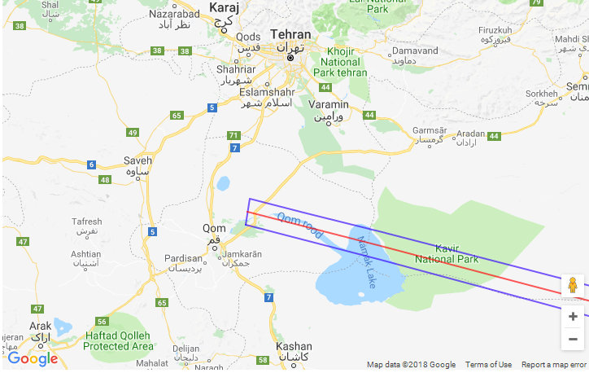
Graphic courtesy NASA and Google Maps

In the graphic above, the area enclosed by the blue lines indicates the path of totality of the total solar eclipse of 10/24/1995. The abrupt left hand edge of totality is where the sun appeared to rise from the earth at sunrise, but completely darkened by the moon.

The eclipse occurred below the horizon, before sunrise, and was unviewable, for people located to the left (west) of the path of totality.

In Isaiah 13:10, YaHuWaH Elohim speaks of the sun being "darkened at his going forth", and the moon not giving its light. That is exactly the description of a total solar eclipse that occurs precisely at sunrise.

Isaiah 13:9 Behold, the day of YaHuWaH cometh, cruel both with wrath and fierce anger, to lay the land desolate: and he shall destroy the sinners thereof out of it.
10 For the stars of heaven and the constellations thereof shall not give their light: the sun shall be darkened in his going forth, and the moon shall not cause her light to shine.

The Eclipse at 104 Degrees in Iran

The total solar eclipse of 10/24/1995 at sunrise appeared to rise from the horizon in Iran in the east at an azimuth of 104 degrees as indicated by the graphic below.

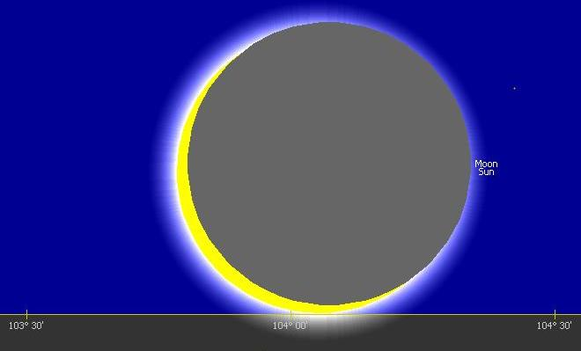

Above: The sun as it appeared to rise from the horizon on 10/24/1995 for a viewer in Tehran, Iran.

The sun isn't completely obscured by the moon in the graphic above because the city of Tehran was about 70 miles north of the path of eclipse totality.

The sun and moon moved diagonally together, lower left to upper right in the graphic above, precisely crossing 104 degrees of azimuth, as they emerged from below the horizon at sunrise as seen in Iran.

104 and the Signature of our Creator Elohim

Elohim said that the sun, moon, and stars, were for signs and appointed times.

Genesis 1:14 And Elohim said, Let there be lights in the firmament of the heaven to divide the day from the night; and let them be for signs (distinguishing mark, warning, omen, signal), and for seasons, and for days, and years:
Notice that the number 104 was a common feature of two unusual events that occurred on 10/24/1995.

1. The darkened sun (Isaiah 13:9-10) rose from the horizon precisely at sunrise in Iran at an azimuth of 104 degrees on 10/24/1995.

2. The Jerusalem Embassy Act was passed by the 104th session of the United States Congress on 10/24/1995.

There is One who says that He is the Creator of Heaven and Earth, and that He also rules and overrules in the affairs of the nations. There is evidence of His workings in the information presented above.

The Name "YaHuShua" is found to be the number 104 in what is known as "Simple Gematria". http://www.gematrix.org/?word=yahushua

We now have a third "104" to add to the two 104's mentioned above, one that signifies the Jewish Messiah Himself.

It appears that our Creator Elohim has left His gematria signature, 104, in the unusual events of nations on 10/24/1995.

YaHuShua's Warning to Iran

Jewish Sages tell us that solar eclipses are omens of woe for the nations.

Therefore, the nation of Iran was precisely warned of coming woe by YaHuWaH Elohim about 2700 years ago through the prophet Isaiah, and also by YaHuShua Messiah Himself via this information, concerning the movement of the United States Embassy from Tel Aviv to Jerusalem currently scheduled for Israel's 70th anniversary on 5/14/2018.

Isaiah 13:9 Behold, the day of YaHuWaH cometh, cruel both with wrath and fierce anger, to lay the land desolate: and he shall destroy the sinners thereof out of it.
10 For the stars of heaven and the constellations thereof shall not give their light: the sun shall be darkened in his going forth (rising), and the moon shall not cause her light to shine.

